TravelPort User Manual
Local use, customer booking, administration, and operator portals
Version 1.0
September 2026
About this manual
This manual explains how to run TravelPort locally and how customers, administrators, hotel managers, and transport operators use the application. It includes safe configuration practices and troubleshooting guidance. It intentionally contains no passwords, tokens, API keys, connection-string secrets, private account details, or credential workbook contents.
TravelPort
Travel booking platform for flights, hotels, buses, trains, and cabs

Contents
1 Getting started
2 Customer account and navigation
3 Searching and booking travel
4 Payments bookings and profile
5 AI assisted travel features
6 Administrator guide
7 Hotel manager guide
8 Transport operator guide
9 Local installation and startup
10 Configuration and security
11 Troubleshooting
12 Support checklist

Who should use this manual
Reader | Use this manual for
Customer | Create an account, search, book, pay, manage bookings, and maintain a profile.
Administrator | Review platform activity and manage users, bookings, coupons, hotels, operators, flights, and announcements.
Hotel manager | Maintain hotel details, rooms, availability, bookings, and operational actions.
Transport operator | Manage flight or bus inventory, view passenger bookings, and review performance dashboards.
Local developer | Configure dependencies, start services, run tests, and diagnose local issues safely.

Access note. Available screens depend on the signed-in user role and on which optional integrations are enabled.

1 Getting started
TravelPort combines a React web application, an ASP.NET Core API, and SQL Server. The browser handles searches and forms, the API applies validation and authorization, and SQL Server stores users, travel inventory, bookings, wallets, and operational data.

Local addresses
Service | Address | Purpose
Web application | http://localhost:5173 | Customer and role-based web interface
API | http://localhost:5000 | Backend application service
Swagger | http://localhost:5000/swagger | Interactive API reference for local development

Quick start for an existing local setup
1. Confirm that the SQL Server Express service is running.
2. Open a terminal in the repository root and start the backend.
dotnet run --project backend/src/API --launch-profile http
3. Open a second terminal in the repository root and start the frontend.
npm --prefix frontend run dev
4. Open http://localhost:5173 in a browser.
5. Confirm that http://localhost:5000/swagger loads before testing booking or AI features.
Important. Do not run npm run dev from the repository root without --prefix frontend. The package.json file is located inside the frontend directory.

Service startup order
Order | Service | Ready when
1 | SQL Server | The configured instance accepts connections and the TravelPort database exists.
2 | Backend API | Swagger returns a page at port 5000.
3 | Frontend | The homepage loads at port 5173 and API requests succeed.

Homepage reference
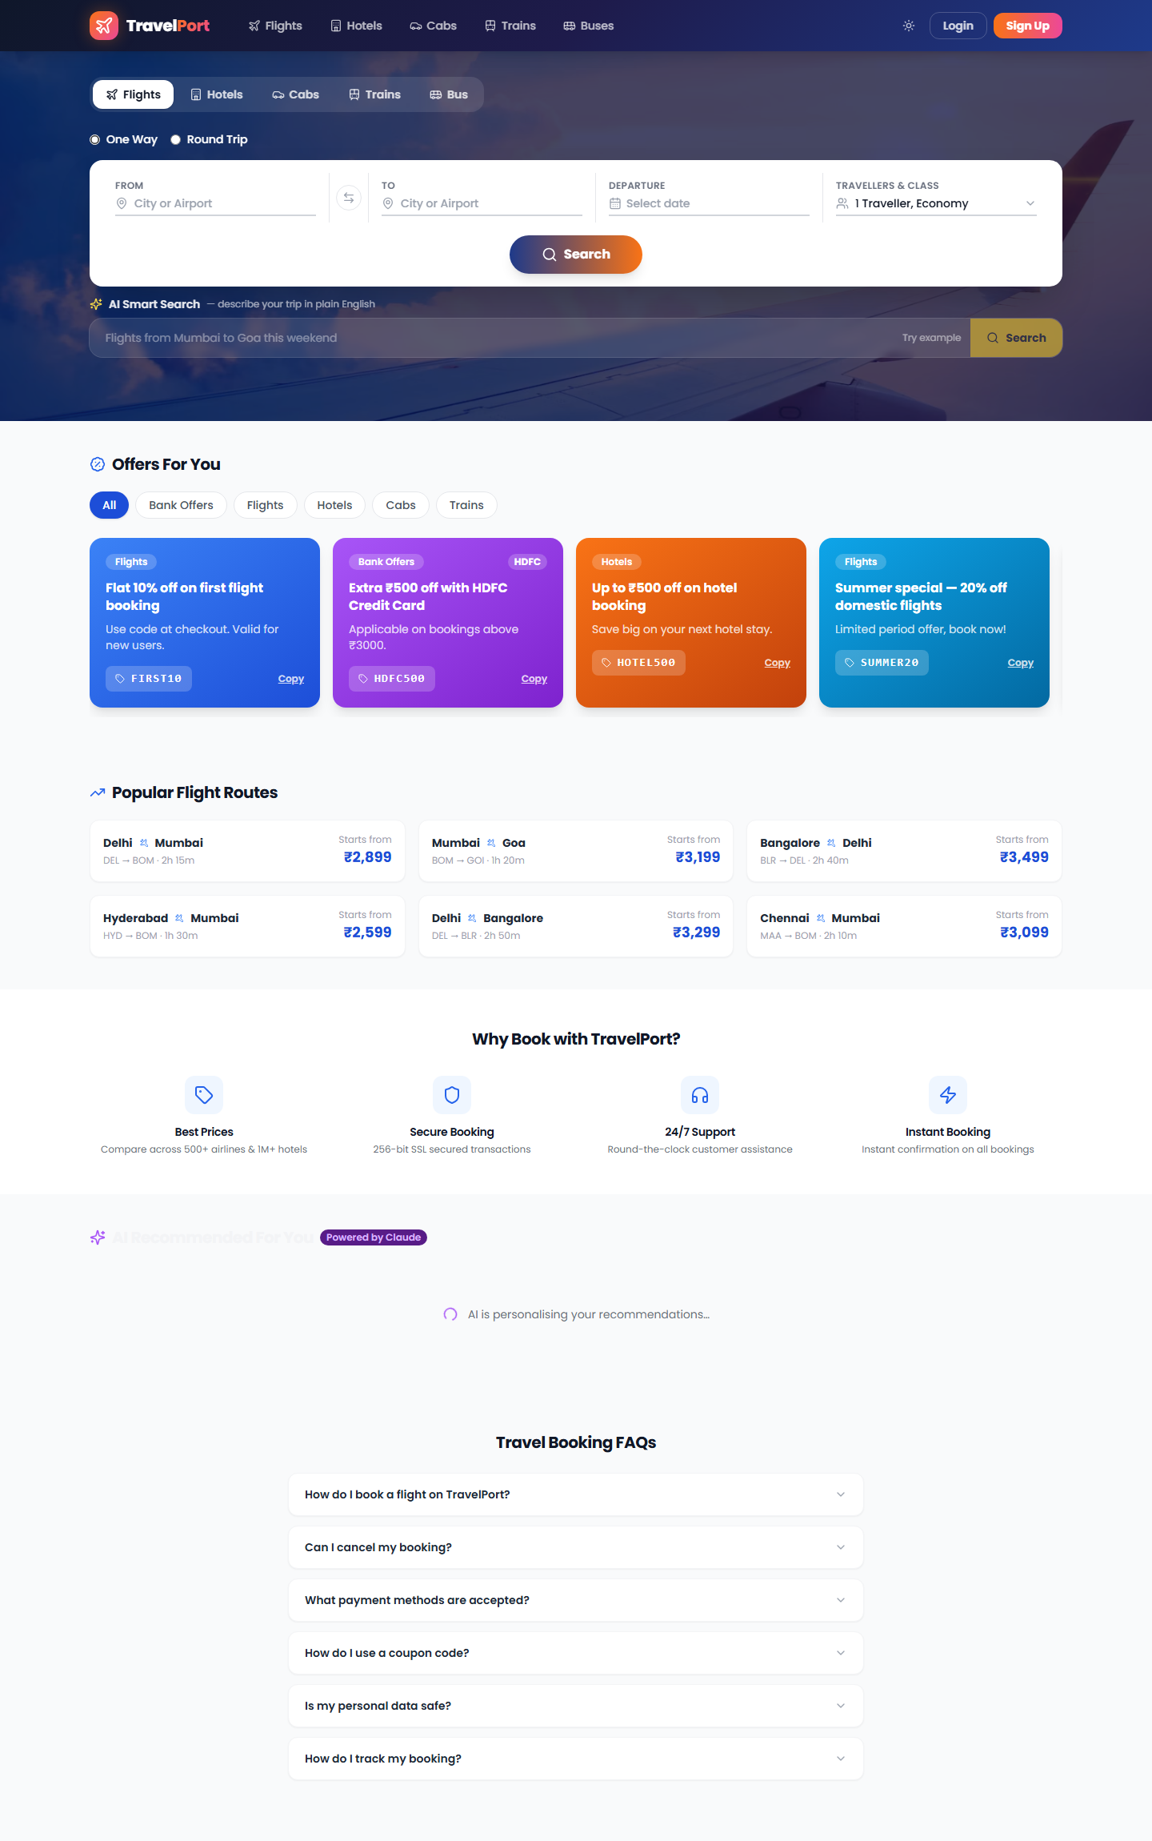
Figure 1 TravelPort homepage with search, offers, popular routes, and booking guidance

2 Customer account and navigation

Create an account
1. Select Sign Up from the navigation bar or login window.
2. Enter the requested name, email address, phone number, and password.
3. Use a password with at least eight characters, including uppercase, lowercase, numeric, and special characters.
4. Submit the form. If email delivery is enabled, follow any verification message sent by the system.
Privacy. Use test identities for local demonstrations. Do not enter real passport or payment information into an untrusted or shared development environment.

Sign in and recover access
- Select Login and enter the account email and password.
- Use Forgot password when email delivery is configured for the environment.
- If a session expires, sign in again. The application uses short-lived access tokens and renewable sessions.
- Select Logout before leaving a shared computer.

Main navigation
Area | What you can do
Home | Start a travel search, view featured offers, review popular routes, and open AI search.
Flights | Search available flights, compare options, select a fare, and begin booking.
Hotels | Search by destination and dates, view property details, choose a room, and book.
Cabs | Search one-way or round-trip transport and continue to passenger details.
Trains | Search scheduled rail options and choose an available class.
Buses | Search services, review seating, and book selected seats.
My Bookings | Review booking status, open details, cancel eligible bookings, and download documents.
Profile | Update basic details, view wallet activity, and manage saved travellers and cards.
AI Trip Planner | Create an itinerary when the Groq integration is configured and available.

Login screen reference
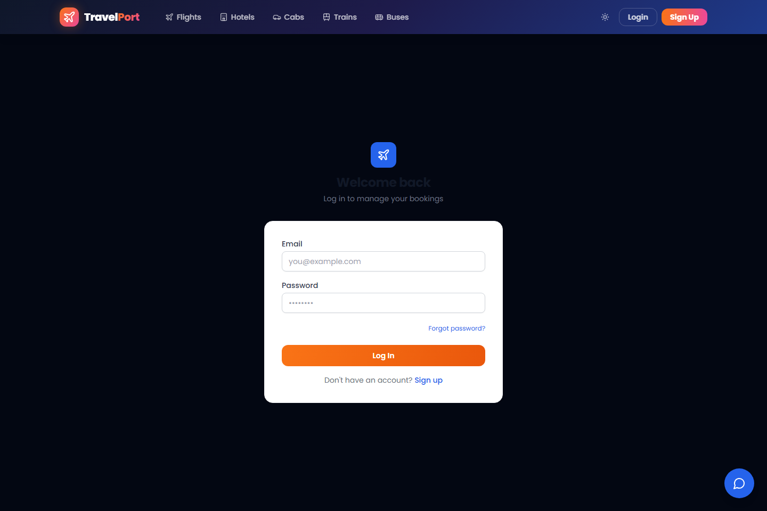
Figure 2 Login screen with empty example fields and password recovery link

3 Searching and booking travel

Standard booking flow
1. Choose the travel type from the homepage or navigation bar.
2. Enter origin, destination, travel dates, passenger count, and any travel-specific options.
3. Select Search and review the returned inventory.
4. Open an option to review schedule, property, pricing, facilities, or seat details.
5. Select Book and sign in if the route requires authentication.
6. Enter traveller or guest details and apply an eligible coupon if available.
7. Review the final amount and continue to payment or confirmation.
8. Save the booking reference and download the available ticket or invoice.

Travel-specific guidance
Travel type | Search inputs | Booking considerations
Flight | Route, departure date, optional return date, travellers, cabin | Check schedule, stops, baggage or fare information, passengers, and seat availability.
Hotel | Destination, check-in, check-out, guests | Review property information, room type, capacity, nightly cost, and stay dates.
Bus | Origin, destination, travel date | Choose an available service and seats before confirming traveller details.
Train | Origin, destination, journey date | Review class, schedule, fare, and availability.
Cab | Origin, destination, pickup time, trip type | Confirm vehicle type, displayed route, pickup details, and whether pricing is one-way or round-trip.

Availability. Search results depend on local seed data and any enabled external travel providers. Empty results do not necessarily indicate that the web application is offline.

Coupons
- Enter the coupon code before final confirmation when a coupon field is available.
- Check minimum booking value, category, validity dates, usage limits, and discount cap.
- A rejected coupon may be inactive, expired, outside its travel category, or below its minimum value.

Flight and hotel search references
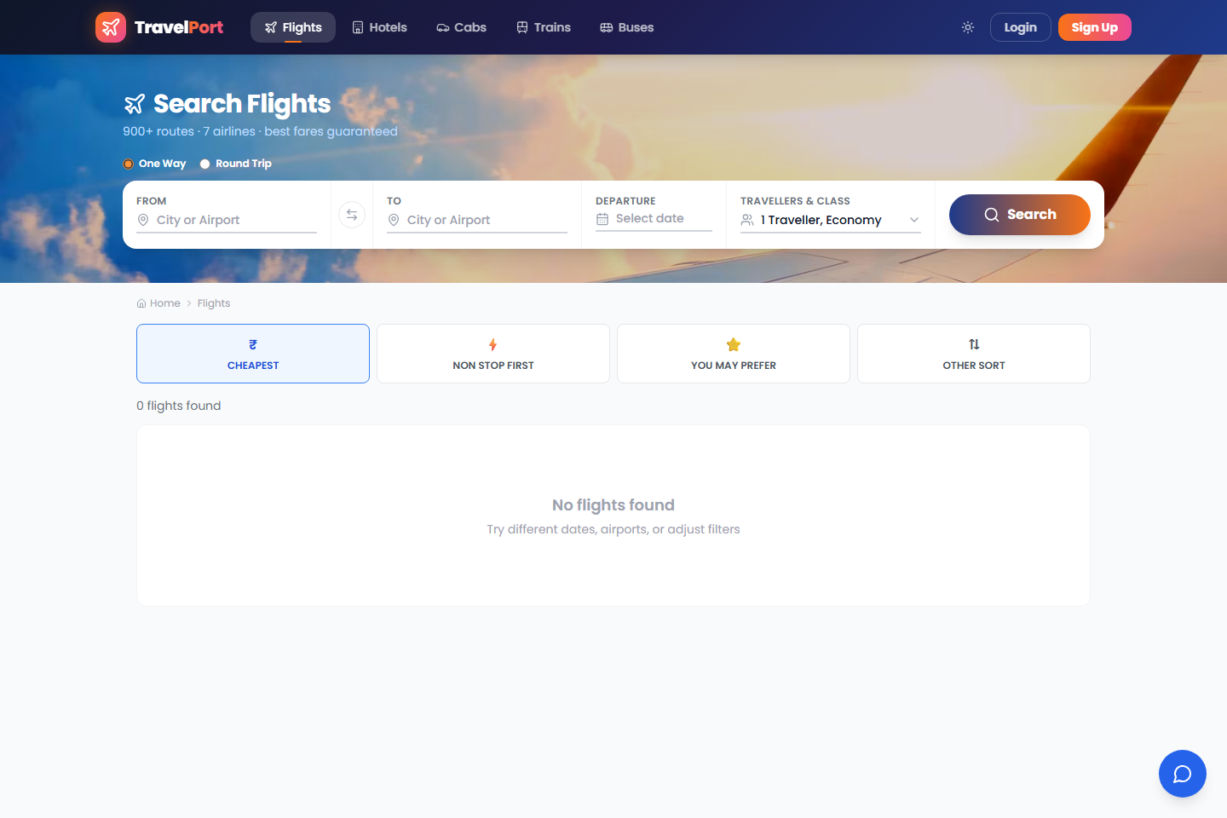
Figure 3 Flight search screen before route and date criteria are entered
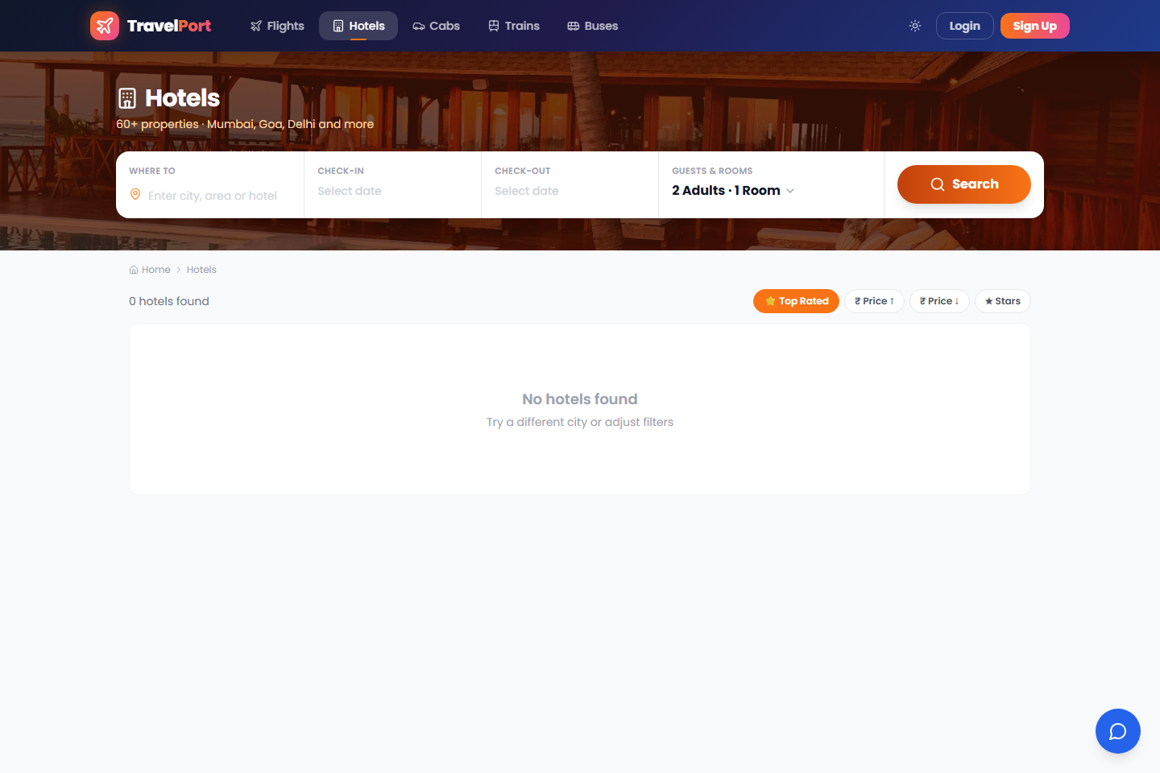
Figure 4 Hotel search screen before destination and stay dates are entered

4 Payments bookings and profile

Payments
TravelPort can support wallet payments and an optional Razorpay flow. The available choice depends on environment configuration and the booking route. Always verify the amount, booking reference, and payment result before closing the page.
- If the payment window does not open, confirm that the payment provider is enabled and configured by an authorized maintainer.
- Do not retry repeatedly after an uncertain payment result. Check My Bookings and the wallet or payment status first.
- TravelPort stores only limited saved-card metadata. The external payment provider handles full payment-card details when that integration is enabled.

Manage bookings
1. Open My Bookings after signing in.
2. Select a booking to view the timeline, traveller details, route or stay information, and amount.
3. Use Download Invoice or the available ticket action to save a PDF.
4. Use Cancel only when the booking status allows cancellation, then review and confirm the warning.
Cancellation. The current customer interface states that eligible cancellations credit 90 percent of the fare to the TravelPort wallet. Confirm the displayed policy before completing any cancellation because business rules may change.

Profile wallet and saved data
Profile area | Actions
Personal information | Update the account name and phone number. The account email is displayed as a fixed identity field.
Wallet | View the balance and recent transactions. Refunds from cancellations may appear here.
Saved travellers | Add frequently used traveller details and remove entries that are no longer needed.
Saved cards | Manage the limited card metadata exposed by the application. Never store or share full card numbers outside the approved payment flow.
Notifications | Review account and booking notifications from the navigation area when signed in.

5 AI assisted travel features
AI features are optional. They depend on a valid Groq API key, a model that is available to the configured Groq account, outbound network access, and a running backend. The application can still support standard search and booking when AI is unavailable.

Available AI features
Feature | Purpose | Expected result
Trip planner | Turn a plain-language trip brief into a day-by-day itinerary. | Streaming itinerary with suggested activities and booking links when recognized.
Natural-language search | Convert a conversational request into structured travel search inputs. | Search criteria and navigation to matching results.
Recommendations | Personalize homepage suggestions. | Suggested destinations or travel ideas.
Chat assistant | Answer travel and application navigation questions. | Streaming conversational response.
Price insight | Provide a short interpretation of flight pricing. | Price guidance when sufficient inputs are available.

Use the trip planner
1. Open AI Trip Planner.
2. Describe destination, trip length, travellers, interests, and approximate budget without including private identifiers.
3. Select Generate and wait for the streamed itinerary to complete.
4. Review all dates, prices, routes, and venue details before using any booking link.
AI limitation. AI output can be incomplete or incorrect and does not confirm real-time availability. Treat it as planning assistance, not as a confirmed reservation or authoritative travel advice.

If AI is unavailable
- Confirm that Swagger loads and that ordinary API-backed searches work.
- Ask an authorized maintainer to verify that the Groq key is active without sharing it in chat, screenshots, tickets, or documentation.
- Verify that the configured model appears in the account's current Groq model list.
- Restart the backend after changing AI configuration.

Trip planner screen reference
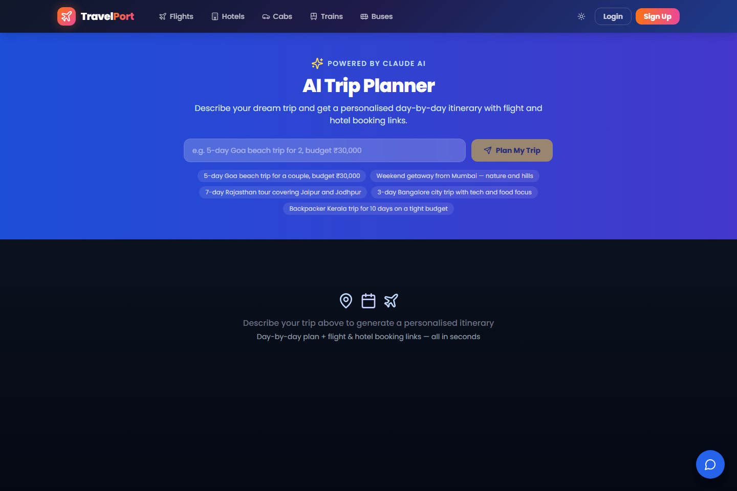
Figure 5 AI Trip Planner input screen before an itinerary is generated
Provider label. The interface may display a product branding label. The active runtime provider and model are controlled by the backend configuration.

6 Administrator guide
The administrator portal is available only to accounts with the Admin role. Administrators should use test data in local environments and should avoid exporting or sharing personal data unless the action is authorized.

Administrator areas
Area | Typical actions
Dashboard and analytics | Review booking, revenue, status, and travel-type summaries.
Users | Search users, review account summaries, inspect recent bookings, and apply supported account controls.
Bookings | Filter platform bookings by status or type, review records, and export authorized CSV data.
Coupons | Create, edit, deactivate, and review coupon usage analytics.
Hotels | Register hotels and review the registered property list.
Operators | Register flight, bus, or cab operators and activate or deactivate operator access.
Flights | Search and update supported flight inventory fields.
Announcements | Create and manage messages displayed to users.

Register a hotel or operator
1. Open the relevant Hotels or Operators section.
2. Select Register and enter the organization and contact information requested by the form.
3. Enter a unique login email and an initial password through the protected form.
4. Submit the registration and communicate credentials only through an approved private channel.
5. Ask the new manager or operator to sign in and confirm access to the correct portal.
Security. Never place generated account passwords in this manual, source control, screenshots, or public tickets. Rotate credentials that are accidentally exposed.

7 Hotel manager guide
Hotel accounts are scoped to their assigned property. After sign-in, the hotel portal uses a sidebar layout with Dashboard, Bookings, Rooms, Availability, and Profile areas.
Area | Primary tasks
Dashboard | Review booking totals, active and cancelled bookings, revenue, room counts, occupancy indicators, and summary metrics.
Bookings | Search and filter bookings, open booking details, record supported operational actions, and generate invoices where available.
Rooms | Create, edit, activate, deactivate, or remove room types and maintain capacity, prices, amenities, and images.
Availability | Check availability by date, review booked and available counts, and use supported bulk-booking actions.
Profile | Maintain property description, address, contact information, policies, facilities, and images.

Recommended daily workflow
1. Review the dashboard for new, active, and cancelled bookings.
2. Open Bookings and address arrivals, departures, charges, or other available operational actions.
3. Check room availability for near-term dates and verify that room totals are accurate.
4. Update room or property information before customers search and book.
5. Sign out when work is complete, especially on a shared front-desk computer.
Data scope. If a hotel account displays another property's data, stop using the portal and report the issue immediately. Do not attempt to modify the unexpected records.

8 Transport operator guide
TravelPort includes separate portals for flight, bus, and cab operators. Access is role-based and should be issued by an administrator.
Role | Portal areas | Main responsibilities
Flight operator | Dashboard, Flights, Bookings | Review performance, add or edit flights, inspect seat maps, and review passenger bookings.
Bus operator | Dashboard, Buses, Bookings | Review performance, add or edit buses and schedules, inspect seat layouts, and review passenger bookings.
Cab operator | Dashboard, Bookings | Review booking totals, revenue indicators, and passenger booking details.

Inventory maintenance
- Check dates, times, origin, destination, vehicle or aircraft details, prices, and capacity before saving.
- Use edit actions for corrections instead of creating duplicate services.
- Confirm seat-map or seat-layout changes against the physical configuration.
- Do not expose passenger contact details outside the authorized operational workflow.

Booking review
1. Open Bookings from the operator sidebar.
2. Review the booking status and passenger count for the selected service.
3. Use service dates and identifiers to reconcile bookings with operational records.
4. Report discrepancies rather than changing unrelated passenger or payment records.

9 Local installation and startup

Prerequisites
- Git
- Node.js 20 or later and npm
- .NET 8 SDK
- SQL Server Express or another supported SQL Server instance
- SqlPackage when publishing the authoritative DACPAC locally
- Optional provider accounts only for the integrations being tested

Prepare local configuration
Copy the committed templates to ignored local files. Add values directly on the development machine or use an approved secret store. Never paste real values into documentation, commits, screenshots, issue descriptions, or chat messages.
Copy-Item .env.example .env
Copy-Item backend/src/API/appsettings.Development.json.example backend/src/API/appsettings.Development.json
Copy-Item frontend/.env.example frontend/.env
At minimum, configure a valid local database connection and a strong JWT signing secret. Optional AI, email, travel-provider, and payment integrations should remain disabled or empty unless they are being tested.

Prepare and run the database
The SSDT DACPAC is the authoritative database deployment artifact. Build and publish it to the selected local database before starting the API. Review any deployment plan before applying it to an existing database.
dotnet build backend/src/Database/TravelPort.Database.sqlproj --configuration Release
sqlpackage /Action:Publish /SourceFile:backend/src/Database/bin/Release/TravelPort.Database.dacpac /TargetConnectionString:"<local-connection-string>" /p:BlockOnPossibleDataLoss=True
Local fallback. EF migrations can be enabled explicitly for local development, but deployed environments should publish the DACPAC and keep automatic migration startup disabled.

Start and stop
# Terminal 1 from the repository root
dotnet run --project backend/src/API --launch-profile http

# Terminal 2 from the repository root
npm --prefix frontend run dev
Stop each development server with Ctrl+C in its terminal. If a server was launched in the background, stop the process that owns port 5000 or 5173 rather than terminating unrelated Node.js or .NET processes.

10 Configuration and security
Configuration files define database access, authentication, allowed browser origins, and optional providers. Treat all non-template development configuration as private even when it is stored only on a workstation.
Configuration area | Safe practice
Database | Use a least-privilege account outside local development. Keep passwords and full connection strings outside source control.
JWT | Use a long random signing secret. Rotate it after exposure and expect existing sessions to become invalid.
AI provider | Keep API keys in ignored configuration or a secret store. Verify the configured model is currently available.
Email | Enable SMTP only when host, sender, account, and transport security are correct. Never document the password.
Payments | Use test-mode credentials in development and never store full payment-card numbers.
Travel providers | Enable only the provider being tested and rotate any token exposed outside its approved secret store.
CORS | Allow only the exact frontend origins required for the environment.

Information that must never appear in a manual
- API keys, access tokens, refresh tokens, JWT signing secrets, or OAuth credentials
- Database, SMTP, payment-provider, or operator passwords
- Private connection strings, certificates, recovery codes, or credential workbook contents
- Real customer contact, passport, payment, booking, or wallet information
- Default or demonstration account credentials

If a secret is exposed
1. Revoke or rotate the credential at its provider.
2. Update the approved local or deployment secret store.
3. Restart the affected service and verify the integration.
4. Remove the exposed value from current files and investigate repository or message history.
5. Do not assume deletion from the latest commit makes an exposed secret safe.

11 Troubleshooting
Symptom | Likely cause | Action
npm cannot find package.json | Command was run from the repository root without a prefix. | Run npm --prefix frontend run dev or change to the frontend directory.
Frontend loads but data fails | API is stopped, API address is wrong, or CORS blocks the browser origin. | Open Swagger, check the frontend API base URL, and verify the allowed local origin.
ConnectionString has not been initialized | The backend development configuration does not contain a database connection. | Create the ignored development settings file from its template and configure the local database.
Failed to generate SSPI context | Windows Integrated Security cannot authenticate to SQL Server through the selected instance path or user context. | Use the correct local instance alias and run the API as the Windows account authorized for that database.
Database table errors | The database has not been deployed or is behind the application schema. | Build and publish the DACPAC after reviewing the deployment plan.
Port already in use | Another process is listening on port 5000 or 5173. | Stop the existing local service or intentionally choose and configure another port.
AI returns Unauthorized | The provider key is invalid, expired, revoked, or not loaded by the running API. | Rotate the key privately, update the active backend configuration, and restart the API.
AI returns NotFound | The configured model is not available to the provider account. | Select a model returned by the provider's current model list and restart the API.
Payment window does not open | Payment integration is disabled, misconfigured, or blocked by the browser. | Confirm test-mode provider configuration and inspect the API response without exposing credentials.
No search results | Search criteria do not match local inventory or an optional provider is unavailable. | Try known seeded routes and dates, then check API logs and provider status.
Login repeatedly fails | Incorrect credentials, rate limiting, disabled account, or stale browser state. | Confirm the account privately, wait after repeated attempts, then sign in again.

Diagnostic order
1. Confirm SQL Server is running.
2. Confirm Swagger loads at port 5000.
3. Confirm the frontend loads at port 5173.
4. Test a public API endpoint before testing authentication, payments, or AI.
5. Review backend logs for the status code and provider name, redacting any sensitive values.
6. Restart the backend after changing backend configuration.

12 Support checklist
Provide enough context to reproduce an issue without including private data. Use the following checklist when reporting a problem to the project maintainer.
Include | Example of safe information
Area and action | AI Trip Planner after selecting Generate
Time and environment | Local development, approximate local time
Page address | The route path without tokens or query-string secrets
Expected result | A day-by-day itinerary should stream into the page
Observed result | The page displayed a generic generation error
HTTP status | 401, 404, 429, 500, or 502
Relevant log message | Provider returned Unauthorized, with secrets removed
Recent safe change | Backend configuration was updated and the service restarted

Do not include
- Credential values or screenshots showing configuration files
- Authorization headers, tokens, cookies, or password-reset links
- Private customer, passenger, employee, or operator information
- Full database backups or private credential workbooks

Final local readiness check
- [ ] SQL Server is running and the expected database is deployed.
- [ ] Backend Swagger loads successfully.
- [ ] Frontend homepage loads successfully.
- [ ] A public search or featured-offer request succeeds.
- [ ] Registration and login use a test account.
- [ ] Optional integrations are enabled only when valid test credentials are stored privately.
- [ ] No sensitive files are staged for commit.
TravelPort is ready for local use when the core database, API, and frontend checks pass. Optional AI, email, payment, and travel-provider failures should be diagnosed independently so they do not obscure the health of the core booking application.

