1. Lab Overview
Modern web developers need to understand what happens inside the browser when a webpage loads and when a user interacts with it. In this lab, students use Chrome, or Firefox Developer Tools to inspect HTML, and CSS.
Register to https://onecompiler.com/. You will use this online compiler to share your ongoing labs with your tutor for review.
2. Learning Outcomes
1. Open and navigate browser Developer Tools.
2. Identify HTML elements using the Elements/Inspector panel.
3. Modify HTML and CSS temporarily using Developer Tools.
4. Use responsive/device emulation to test different screen sizes.
5. Use Developer Tools as part of a modern web-development workflow.
3. Software Requirements
Students need the following:
- Google Chrome / Mozilla Firefox
- Internet connection
- A text editor such as VS Code
4. Developer Tools Overview
Chrome | Firefox | Purpose
Elements | Inspector | Examine HTML and CSS
Console | Console | Execute JavaScript and view errors
Sources | Debugger | Examine JavaScript/source files
Network | Network | Examine HTTP requests
Application | Storage | Examine cookies/storage
Lighthouse | Lighthouse | Performance/accessibility analysis
Device Toolbar | Responsive Design Mode | Test different screen sizes

PART A — Opening Developer Tools
Activity 1: Open Developer Tools
a. Open https://www.w3schools.com/html/default.asp or another publicly accessible website of your choice).
b. Open Developer Tools using right-click → Inspect, F12, Ctrl+Shift+I on Windows, or Cmd+Option+I on macOS.

Question 1. What is the name of the panel used to inspect the webpage's HTML?
The Elements panel in Google Chrome, which is called the Inspector panel in Mozilla Firefox.
Question 2. List five panels available in Developer Tools.
1. Elements 2. Console 3. Sources
4. Network 5. Application
PART B — Inspecting HTML
Activity 2: Examine the HTML Structure
Select the Elements/Inspector panel. Locate <html>, <head>, <body>, headings, paragraphs, links, images and navigation elements.
Question 3. Identify one heading element. Record the HTML tag and the text inside it.
HTML tag: <h1>
Text: HTML Tutorial
Question 4. Find one hyperlink. Record the HTML element and its href value.
HTML element: <a href="/html/html_intro.asp">HTML Introduction</a>
href: /html/html_intro.asp (resolves to https://www.w3schools.com/html/html_intro.asp)
Activity 3: Modify HTML
Find a visible heading. Right-click the element and select Edit as HTML (or double-click it). Temporarily change it to:
<h1>CIT2011 Developer Tools Lab</h1>

Question 5. What happened to the webpage?
The heading text on the rendered page changed immediately to "CIT2011 Developer Tools Lab" without the page being reloaded. The browser re-rendered that element as soon as the edited HTML was committed, and the new heading kept the same CSS styling as the original because the styles are applied by tag and class rather than by content.
Question 6. Was the original website permanently changed? Explain why.
No. Developer Tools only edits the local copy of the Document Object Model that the browser has built in memory on this machine. The HTML file stored on the web server was never touched, and no request was sent to the server to save the change. Refreshing the page discards the edited DOM and rebuilds it from the original source, so the heading returns to its normal text and no other visitor ever sees the edit.
PART C — Inspecting CSS
Activity 4: Examine CSS
Select an HTML element containing visible text. Examine the Styles panel and identify CSS properties controlling font size, font family, margin, padding, text colour and background colour.
Property | Value
font-size | 32px
font-family | Verdana, sans-serif
margin | 21.44px 0px (top/bottom), 0px (left/right)
padding | 0px
color | rgb(0, 0, 0) / #000000
background-color | rgba(0, 0, 0, 0) — transparent

Activity 5: Modify CSS
Add the following declaration to a heading in the Styles panel:
font-size: 50px;
Then change it to:
font-size: 20px;
Question 1. What happened when the font-size value changed?
At 50px the heading text became noticeably larger and took up more horizontal space, which pushed the content below it further down the page. Changing the value to 20px made the text much smaller and the surrounding content moved back up. Each change took effect instantly because the browser recalculates the layout and repaints the affected area as soon as the declaration is applied.
Question 2. Add text-transform: uppercase; What happened?
Every letter in the heading was displayed in capital letters. The underlying text in the HTML was not altered, since text-transform only changes how the characters are rendered, so copying the text still returns it in its original casing.
Question 3. Change margin and padding. Explain the difference between margin and padding.
Increasing the padding pushed the border away from the text, so the element itself became larger and its background colour filled the extra space. Increasing the margin moved the whole element away from its neighbours without changing the size of the element, and the extra space stayed transparent. Padding is therefore the space inside the element, between its content and its border, while margin is the space outside the border that separates the element from other elements. Vertical margins between adjacent elements can also collapse into a single margin, which never happens with padding.
PART D — Understanding the Box Model
Activity 6: Inspect the Box Model
Select an element and locate the Box Model diagram.
Question 4. Identify the four major components of the CSS box model.
1. Content 2. Padding 3. Border 4. Margin
PART I — Responsive Web Design
Activity 15: Device Emulation
Open Device Toolbar / Responsive Design Mode and test mobile, tablet, laptop and desktop sizes such as 375×667, 768×1024 and 1366×768.
Question 5. What happened to the webpage when the screen width became smaller?
The layout reflowed rather than simply shrinking. Content that sat side by side on the desktop stacked vertically, columns became narrower, text wrapped onto more lines and some non-essential elements such as sidebars and advertisements were hidden entirely. Where an element had a fixed pixel width it did not shrink, which produced horizontal scrolling at the narrowest sizes.
Question 6. Did the navigation change? Describe what happened.
Yes. The horizontal menu bar that runs across the top on a wide screen was replaced at the smaller widths by a collapsed menu represented by a hamburger icon, and the links only appeared as a vertical list once that icon was clicked. This change is triggered by a media query that hides the full menu below a set breakpoint and displays the toggle button instead.
Question 7. Did images resize? Explain your observation.
The images that were styled with a relative width such as max-width: 100% or width: 100% scaled down in proportion with their container and kept their aspect ratio because the height was set to auto. Images with a fixed width attribute or a fixed pixel width in CSS stayed at their original size and overflowed the viewport. It is also worth noting that scaling an image down in CSS does not reduce the size of the file that is downloaded, so the full image is still transferred over the network.
Activity 16: Test Your Own Responsive Design
Create a file named responsive.html using the following code:
<!DOCTYPE html>
<html>
<head>
<title>Responsive Test</title>
<style>
body { font-family: Arial; margin: 20px; }
.container { display: flex; gap: 20px; }
.box { padding: 30px; background-color: lightblue; flex: 1; }
@media (max-width: 600px) {
.container { flex-direction: column; }
}
</style>
</head>
<body>
<h1>Responsive Web Design</h1>
<div class="container">
<div class="box">Box 1</div>
<div class="box">Box 2</div>
<div class="box">Box 3</div>
</div>
</body>
</html>

Use Developer Tools to test 1200px, 900px, 700px, 600px, 500px and 375px.
Question 8. At approximately what width does the layout change from rows to columns? 600px — the three boxes sit in a row at 1200px, 900px and 700px, and stack vertically at 600px and below.
Question 9. Which CSS feature caused the layout to change? The CSS media query @media (max-width: 600px), which overrides the flex container and sets flex-direction: column.
Question 10. Complete the table above. Completed — see the Property/Value table in Activity 4 above.
FINAL CHALLENGE — Activity 20: Become the Web Detective
A student reports that a webpage is displaying incorrectly on their mobile phone, although it works correctly on a laptop. Use Developer Tools to investigate responsive layout, CSS rules, media queries, images, JavaScript errors, network requests and HTTP status codes.
Question 11. Identify three possible reasons why a webpage may work correctly on desktop but incorrectly on mobile.
1. The viewport meta tag is missing or incorrect. Without <meta name="viewport" content="width=device-width, initial-scale=1.0"> a mobile browser assumes a desktop-width viewport and scales the whole page down, so the text becomes too small to read.
2. The layout uses fixed pixel widths and has no media queries, or the breakpoints are set at the wrong values. Elements that are wider than the screen cannot reflow, which forces horizontal scrolling and pushes content out of view.
3. Images and other media are not fluid. An image with a fixed width, or one that lacks max-width: 100%, overflows its container, and very large image files may fail to load fully on a slow mobile connection. Related causes that the Network and Console panels will expose are resources returning a 404 or 500 status code, files blocked because they are requested over HTTP from an HTTPS page, and JavaScript errors that stop a script such as the mobile menu toggle from running.

FINAL REFLECTION
Question 12. How does Developer Tools help a web developer understand a webpage?
Developer Tools expose the page as the browser actually sees it rather than as it appears on screen. The Elements panel shows the live DOM that was built from the HTML, the Styles panel shows every rule applied to a selected element and which declarations have been overridden in the cascade, the Console reports the output and errors produced by JavaScript, and the Network panel records every file that was requested in order to build the page. Because edits made in the panels take effect immediately, a developer can test an idea or a fix in the browser and confirm that it works before writing it into the source files.
Question 13. Why is it useful to inspect HTML and CSS rather than simply looking at the webpage?
It is important to inspect HTML and CSS because looking at a webpage only shows the final result and gives no indication of how that result was produced. Inspecting the code reveals the semantic structure of the document, the class and id names in use, the values that elements have inherited and the computed values the browser has finally settled on. Many problems are invisible on the rendered page but obvious in the panels: an unexpected gap is explained by the box model diagram, a style that appears to be ignored is shown struck through because a more specific rule has won, and an element that seems to be missing may in fact be present in the DOM but hidden by a display or visibility declaration.
Question 14. Why is the Network panel important to a web developer?
The Network panel is important because it lists every HTTP request the page makes, together with the method used, the status code returned, the size of the response, the time it took and the full set of request and response headers. It identifies files that failed to load with a 404 or 500 status, requests blocked by cross-origin or mixed-content rules, images that are far larger than they need to be, and requests that are delaying the rendering of the page. It is also the quickest way to establish whether a fault lies in the front-end code or in the response coming back from the server.

Question 15. Why is responsive testing important?
Most visitors now reach websites on phones and tablets, and a layout that is perfectly usable at 1366 pixels can break completely at 375 pixels. Responsive testing confirms that content reflows sensibly, that text remains readable without zooming, that touch targets are large enough to be tapped accurately and that no horizontal scrolling appears. Finding these faults in the browser during development is considerably cheaper than discovering them after the site has been deployed, and it also supports accessibility, since a layout that adapts well to a small screen usually adapts well to enlarged text.
Question 16. How can Developer Tools help identify bugs?
The Console reports JavaScript errors together with the file name and line number at which they occurred, so a broken script can be traced directly to its source. The Sources panel allows breakpoints to be set so that execution can be paused and variables inspected while the code is running. The Elements panel shows whether an element was actually created in the DOM or is merely hidden by CSS, and the Styles panel shows which rule is overriding another. The Network panel exposes missing or failing resources, and the device toolbar reproduces faults that only occur at particular screen sizes.
Question 17. Explain how HTML, CSS and JavaScript work together to create an interactive webpage.
HTML provides the structure and the content of the page, marking up headings, paragraphs, images, links and sections so that the browser can build them into the Document Object Model. CSS controls presentation, describing how those elements should look and how they should be positioned, including how the layout should change at different screen sizes. JavaScript supplies behavior; it listens for events such as clicks, scrolling, and form submissions, and responds by reading and modifying the DOM and the styles applied to it, or by requesting further data from a server. The three work on the same document, so a script can add a class to an element and the CSS rule attached to that class immediately changes what the user sees. HTML is therefore the skeleton of the page, CSS is its appearance, and JavaScript is what makes it respond to the user.
Question 18 – Build a webpage
Use the template provided by your tutor to build a webpage using HTML5 and basic CSS3. Webpage must include, basic HTML5 tags such as image, paragraph, navigation, heading, sections, footer, links, etc.
The page below uses the semantic HTML5 elements <header>, <nav>, <main>, <section> and <footer>, together with headings, paragraphs, an unordered list, an image with alternative text, internal anchor links and external hyperlinks. The CSS3 styling covers colour, typography, spacing, a fluid image rule and a media query that stacks the navigation links on narrow screens. The file is saved as index.html.
<!DOCTYPE html>
<html lang="en">
<head>
<meta charset="UTF-8">
<meta name="viewport" content="width=device-width, initial-scale=1.0">
<title>CIT2011 - Web Development Tools</title>
<style>
* { box-sizing: border-box; }
body { font-family: Arial, Helvetica, sans-serif; margin: 0;
line-height: 1.6; color: #222; }
header { background-color: #1f3b57; color: #ffffff; padding: 30px 20px; }
header h1 { margin: 0 0 6px 0; }
nav { background-color: #2e5c85; padding: 10px 20px; }
nav a { color: #ffffff; text-decoration: none; margin-right: 18px; }
nav a:hover { text-decoration: underline; }
main { padding: 20px; max-width: 960px; margin: 0 auto; }
section { margin-bottom: 30px; }
h2 { border-bottom: 2px solid #2e5c85; padding-bottom: 5px; }
img { max-width: 100%; height: auto; display: block; margin: 10px 0; }
footer { background-color: #1f3b57; color: #ffffff;
text-align: center; padding: 15px; }
@media (max-width: 600px) {
nav a { display: block; margin: 6px 0; }
}
</style>
</head>
<body>

<header>
<h1>Web Development Tools</h1>
<p>CIT2011 Web Programming - Week 1 Practical</p>
</header>

<nav>
<a href="#workflow">Workflow</a>
<a href="#collaboration">Collaboration</a>
<a href="#frontend">Front-End</a>
<a href="#resources">Resources</a>
</nav>

<main>
<section id="workflow">
<h2>Workflow Tools</h2>
<p>Workflow tools provide the environment in which code is written,
built and deployed. Cloud-based environments such as AWS Cloud9
allow a developer to work from any machine with a browser.</p>
<img src="images/workflow.png" alt="Cloud based development workflow">
</section>

<section id="collaboration">
<h2>Collaboration Tools</h2>
<p>Design and collaboration tools such as Figma allow teams to build
wireframes and prototypes together before any code is written.</p>
<ul>
<li>Figma - browser based interface design</li>
<li>Sketch - vector design for macOS</li>
<li>Git and GitHub - version control and code sharing</li>
</ul>
</section>

<section id="frontend">
<h2>Front-End Development</h2>
<p>Visual Studio Code is a lightweight editor with syntax highlighting,
extensions and an integrated terminal, while frameworks such as
Bootstrap supply a responsive grid and pre-built components.</p>
</section>

<section id="resources">
<h2>Resources</h2>
<p>Further reading is available from the
<a href="https://www.w3schools.com/html/default.asp">W3Schools HTML
Tutorial</a> and the
<a href="https://developer.mozilla.org/">MDN Web Docs</a>.</p>
</section>
</main>

<footer>
<p>&copy; 2026 CIT2011 Web Programming | School of Computing and IT</p>
</footer>

</body>
</html>

Screenshots
Image 1
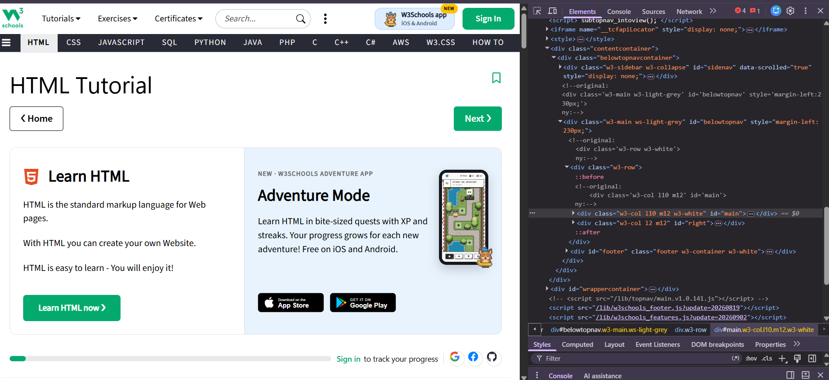
Inspecting the HTML document structure and <h1> tag in the Chrome Elements panel.

Image 2
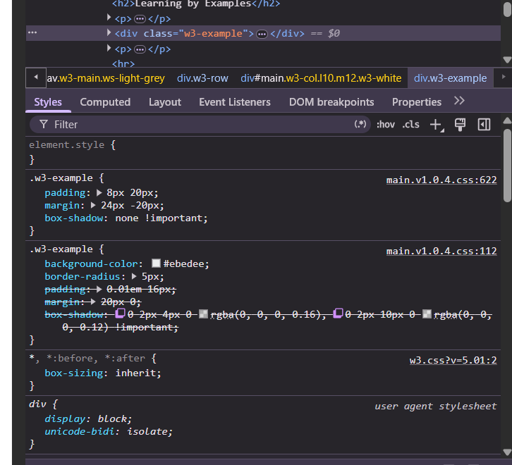
Viewing computed CSS styles and font properties applied to the selected heading

.Image 3
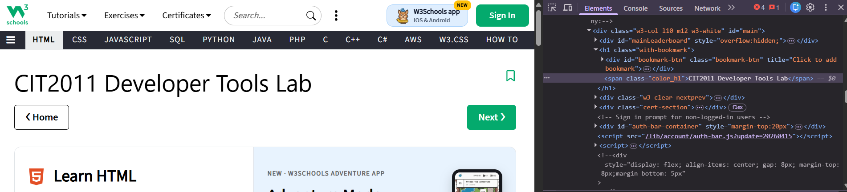
Temporarily editing the heading text in the live DOM via the Elements panel.
Image 4 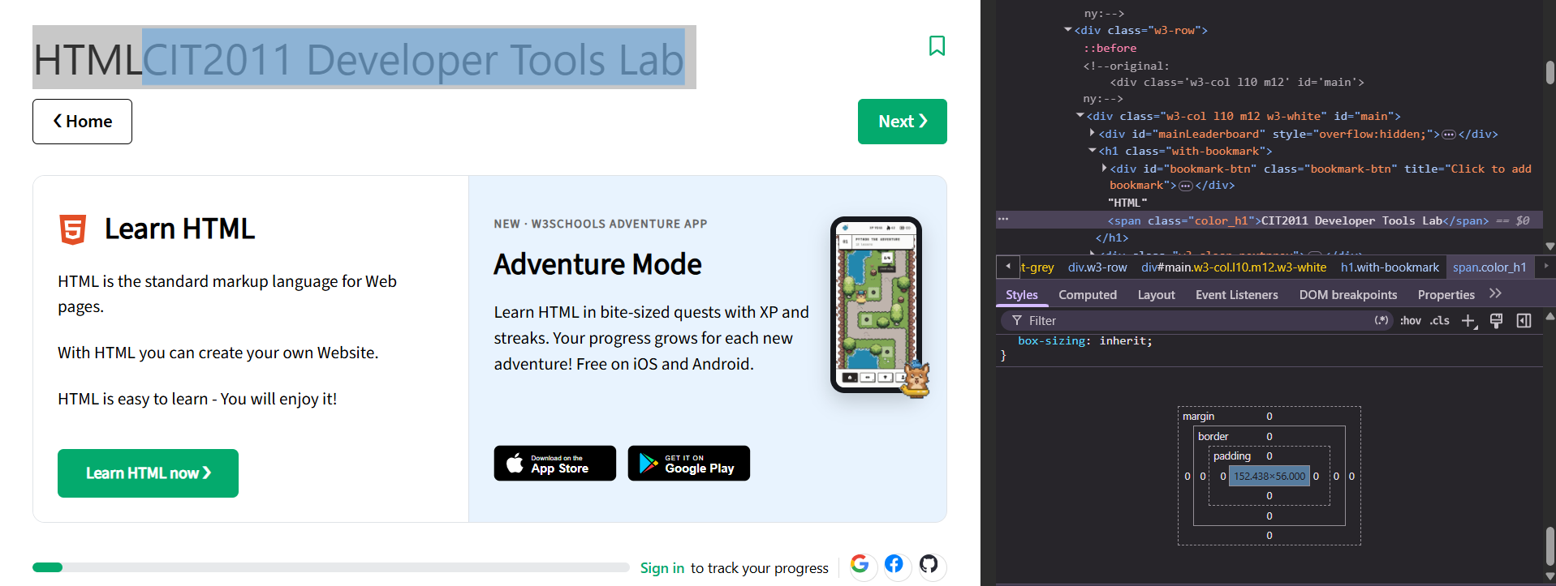
Inspecting the element's CSS Box Model layout showing margin, border, padding, and content dimensions.
Image 5 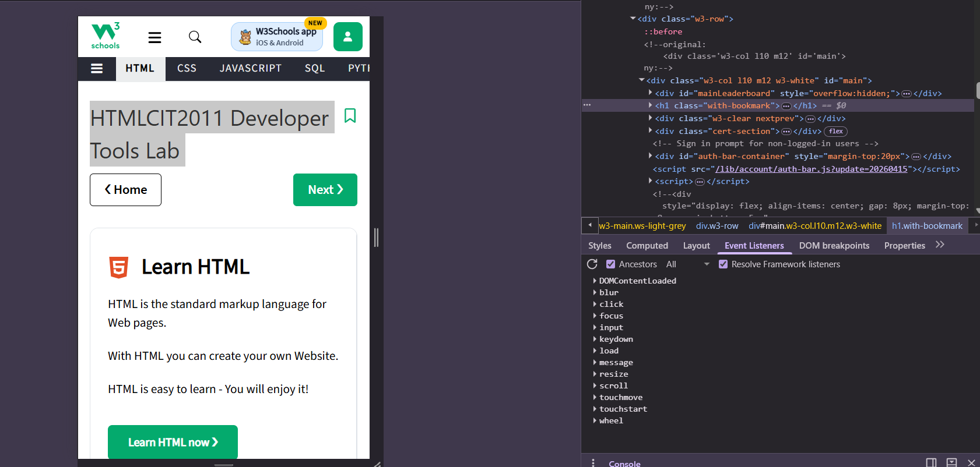
Emulating a mobile viewport in Responsive Design Mode to test layout reflow.
Image 6 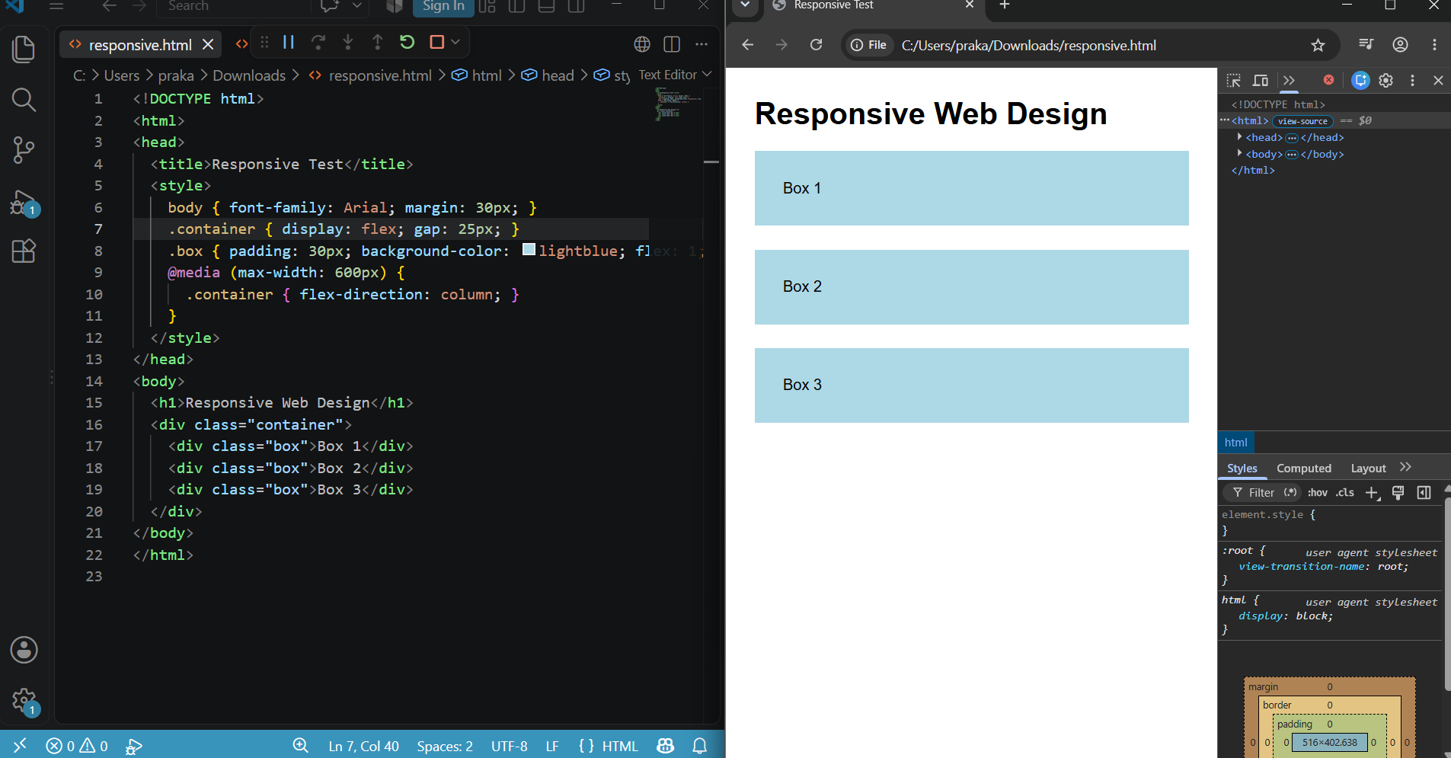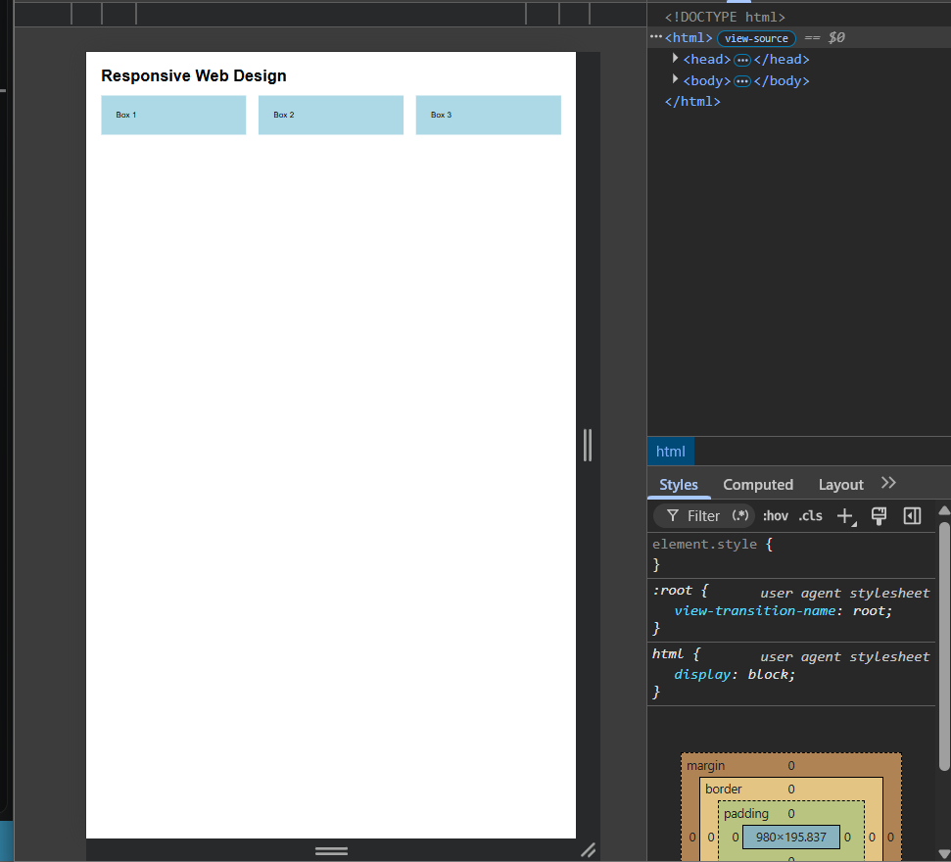
Testing responsive.html layout change at the 575px breakpoint using DevTools.

Practical Deliverables
- Completed lab sheet (Questions 1–18).
- At least six screenshots: HTML inspection, CSS inspection
- responsive.html

