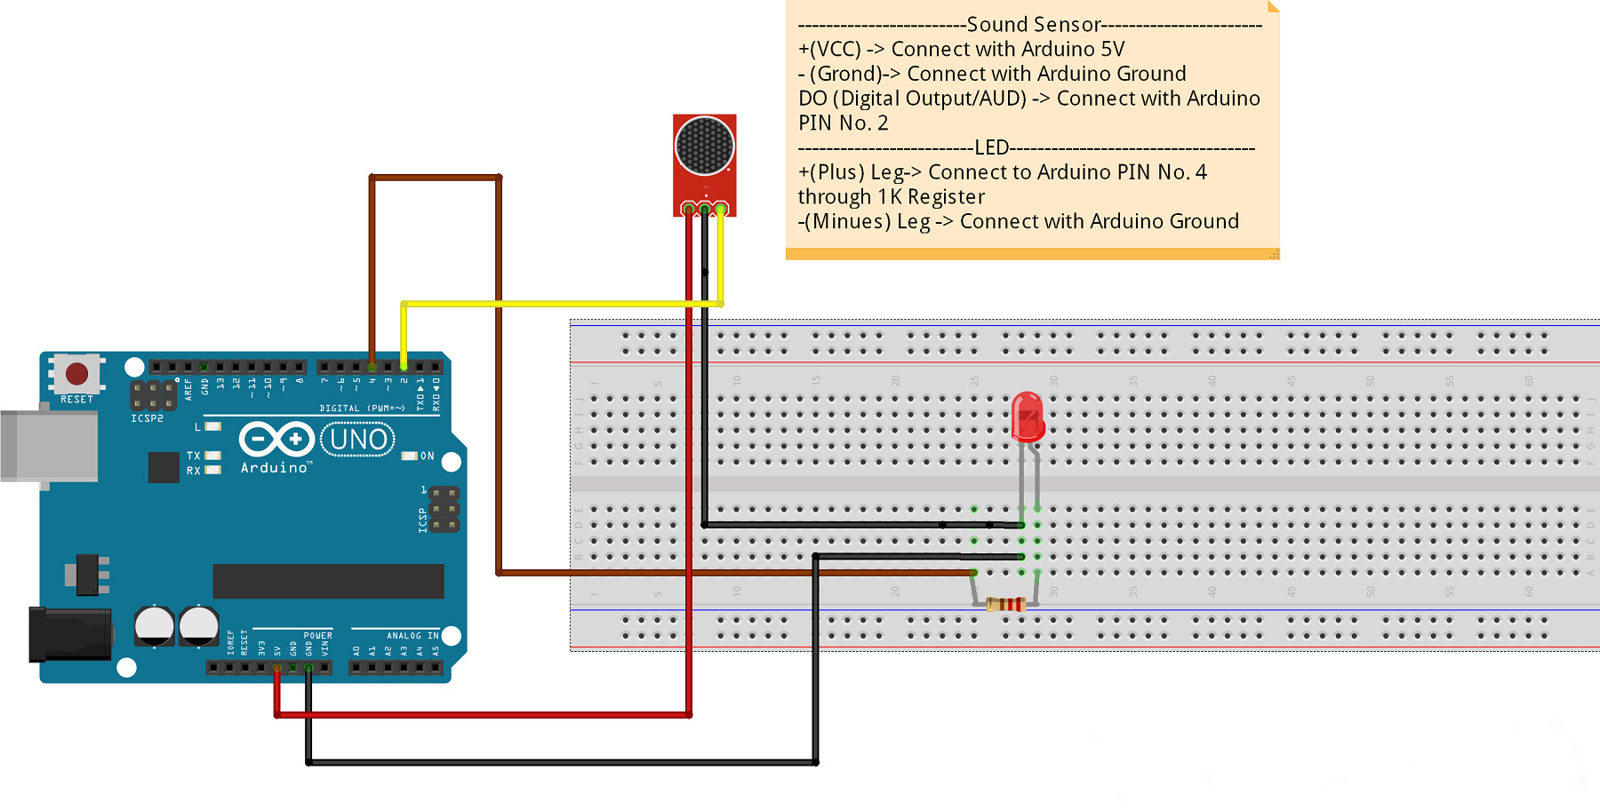

**Theory:**

Concept used:As the task says that**Design a system for car stereo systems such that whenever the increase volume button is pressed, a red background given by red LED blinks the number of times the button is pressed.**

Learning and observation: learned about connecting circuits and the mechanism used in this task.

Problems and troubleshooting: the problem encountered was int the idea genetration but then the concept used in refrigerators gave a hint.

Precautions:

1. The lights should stay on till the switch is kept pressed.

Learning Outcomes: when the car stereo system incress the volum button is pressed the red led was blinked the number of times the button was pressed