
SUBMITTED BY
Khant Prakashkumar S.
Seat No : [1038]
GUIDED BY:
Ms. Maitri Hingu
VEER NARMAD SOUTH GUJARAT UNIVERSITY
University Campus, Udhna-Magdalla Road, Surat – 395001, Gujarat, India.

Department of Information and Communication Technology M.Sc. (ICT) Programme

PROJECT TITLE
Healthy Recipes
(Recipes Sharing Platform)
AS PARTIAL REQUIREMENT FOR THE DEGREE
OF
MASTER OF SCIENCE IN INFORMATION AND COMMUNICATION TECHNOLOGY (MSC ICT 2 Year Course)

2025-26
(SEMESTER – I)



Department of Information and Communication Technology

M.Sc.(Information and Communication Technology) Program
Certificate
This is to certify that Mr. Khant Prakashkumar Shaileshbhai with exam seat number 1038 and PG Enroll Number R25110018000710033 has worked on his project work entitled as Health Recipes at Department of ICT as a partial fulfillment of requirement of M.Sc. (Information and Communication Technology) - 1st Semester, during the academic year 2025-2026.

Date: 15/12/2025

Place: Department of ICT, VNSGU, Surat

Internal Project Guide  MSc(ICT) 1st semester  Department of ICT  VNSGU, Surat |  | Head Of Department  Department Of ICT  VNSGU, Surat

ACKNOWLEDGEMENT

At the completion of the project, giving credit becomes important, as without the support of other so many people’s help and guidance, this project couldn’t be completed successfully.
Success in such a comprehensive project cannot be achieved single-handled. It is team effort that sails the ship to the coast. So, we would like to express our sincere thanks to all the dignitaries who were involved in making this project a great joy and turning it into successful piece of work.
We would like to take opportunity to thank our Department J.P. Dawar Institute of Information Science & Technology, Surat for giving us this tremendous opportunity to work in the real-time project.
Ms. Maitri Hingu, our professor and project coordinator, has been very prudent to us throughout our college studies. She is the person who has been giving direction to our work and the shape to our imagination and always ready to give best guidance, give solutions whenever required. We express our regards to her from the core of our heart.
Last but not the least, our heartfelt appreciation goes to all those not named here, but who have rendered their co-operation, little or more, directly or indirectly involved in the development of this system.

Thanking All.

Khant Prakashkumar

INDEX
Sr No. | Description | Page No.
1 | Introduction  1.1 Objective of the System  1.2 Problem Definition  1.3 Core Components  1.4 Project Profile  1.5 Advantages of the Proposed System  1.6 Future Enhancement  1.7 Project Scope
2 | Requirement Gathering and Requirement Analysis  2.1 Requirement Gathering  2.2 Feasibility Study
3 | System Design  3.1 Entity Relationship Diagram  3.2 Use Case Diagram  3.3 Class Diagram  3.4 Sequence Diagram  3.5 Database Design
4 | Interface Design  4.1 Detailed Design Description
5 | Testing
6 | Conclusion
7 | Bibliography

1. Introduction

Healthy Recipes is a Java EE–based web application designed to help users discover, share, and manage cooking recipes that promote a healthy lifestyle. The system provides a user-friendly platform where food lovers can explore recipes by categories, learn cooking steps, and contribute their own healthy meal ideas.

  - Objective of the System

- To provide a platform for browsing healthy recipes category-wise.
- To allow users to upload, update, and manage their own recipes.
- To improve social interaction through features like likes and comments.
- To maintain proper and approved content with admin supervision.
- To promote healthy eating by highlighting nutritious food categories.
- To offer a secure login system with role-based access (User & Admin).

1. 2 Problem Definition
Many people today face difficulties in choosing the right food for a healthy lifestyle. When searching online, they come across recipes that are unhealthy, confusing, or lack proper nutritional information. People who are beginners in cooking also struggle to find simple and guided healthy recipes in one place. Additionally, there is no centralized platform that allows users to share their healthy food ideas and learn from others in a secure and trusted environment.
Because of these issues:
- Users cannot easily identify which foods are healthy
- Lack of guidance leads to unhealthy eating habits
- There is no proper system to organize healthy recipes based on diet types, calories, and ingredients
- Interaction and sharing of healthy knowledge among users is limited
Therefore, a Healthy Recipes website is required, where users can:
- View and follow healthy recipes with ingredients and preparation steps
- Learn about nutrition and maintain a better lifestyle
- Share their own recipes with the community
- Interact with others through comments and feedback
This system will help users adopt healthier daily eating habits and create a more health-focused online community.

1.3 Core Components of the System

- User Interface (UI)
- Built using JSF for an attractive and interactive design
- Easy recipe browsing and profile management
- Recipe detail page with ingredients, steps, and images
- Backend Logic
    - EJB & Servlets used to perform business operations
    - Handles recipe uploads, updates, comments, and likes
- Admin Dashboard
      - Manage categories, users, and recipe
      - Remove inappropriate content
- Database Management (MySQL)
      - Stores all recipes, ingredients, categories, user details, likes & comments
      - Ensures secure and organized data storage
- Role-Based Security
      - Admin: Full control of system data
      - User: Add, interact & explore only allowed features

1.4 Project Profile

Project Title | Healthy Recipes (Recipes Sharing Platform)
Front-End | JSF, Prime Faces,  HTML & CSS
Back-End | Java EE (Enterprise Edition),  EJB (Enterprise Java Beans),  Servlets,  MySQL Database,  Payara Server (Deployment & Execution)
Hardware Requirement | Processor of 800 MHz Pentium (R), Minimum 512 MB RAM and Above, Minimum 40 GB Hard Disk and Above and Mouse, Keyboard.
Software Specification | Front End Software: Net beans-13 Back End: MySQL 9.0  Operating System: Windows 11
Development Tools | Net beans-13,  MySQL 9.0
Submitted By | Mr. Khant Prakashkumar Shaileshbhai

1.5 Advantages of the Proposed System
The Healthy Recipes system offers several advantages over the existing and traditional recipe-sharing methods:
- Promotes Healthy Eating Habits
- Users can easily find recipes focused on nutrition and well-being, encouraging a healthier lifestyle.
- User-Friendly Platform
- Clear recipe instructions, categories, and search features help users quickly access what they need.
- Recipe Sharing Community
- Users can upload and share their own healthy recipes, promoting knowledge exchange and interaction.
- Accurate Ingredient and Step Details
- Each recipe provides proper ingredients and step-by-step guidance, helping beginners cook confidently.
- Efficient Data Management
- Admin can monitor activities, manage content, and ensure only quality recipes are published on the platform.
- Time Saving
- Users don’t need to spend time searching different websites, as all healthy recipes are available in one place.
- Secure and Reliable
- User authentication ensures secure access and safe storage of data.

1.6 Future Enhancement
Even though the Healthy Recipes system provides useful features, there are still opportunities to improve and expand the platform in the future:
- Nutritional Calculator
- Automatically calculate calories, protein, fats, and other nutrients for each recipe.
- AI-Based Recommendations
- Suggest recipes based on user preferences, diet goals, and health conditions.
- Mobile Application Support
- Develop a dedicated Android and iOS app for better accessibility and convenience.
- Video Recipe Upload Feature
- Allow users to upload step-by-step cooking videos along with written instructions.
- Diet Tracking System
- Help users monitor their daily food intake and maintain a balanced diet.
- Multi-Language Support
- Enable users to access recipes in different regional languages.
- Feedback and Rating System
- Improve recipe selection by allowing users to rate and review recipes.
- Social Media Sharing
- Allow one-click sharing of recipes on platforms like WhatsApp, Instagram, and Facebook.

1.7 Project Scope
The scope of the Healthy Recipes project includes the development of a web-based platform that allows users to explore, share, and learn healthy cooking techniques. The system aims to provide reliable recipe information along with easy interaction between users and administrators.

The key scope areas include:
- User Registration & Login System
- Only authenticated users can access recipe-sharing and interaction features.
- Healthy Recipes Collection
- Users can view detailed recipes including ingredients and preparation methods.
- Recipe Sharing
- Users can upload their own healthy recipes to contribute to the community.
- Category-Based Recipe Search
- Recipes can be browsed through categories, search options, and filters.
- Admin Management
- Admin can manage users, review recipes, and oversee system activities for quality assurance.
- Secure Data Storage
- All user and recipe data is securely stored and managed using a database.
- Responsive Web Experience
- System can be accessed smoothly on desktops and laptops.
This project has strong potential to help people maintain a healthy lifestyle through better food choices and community engagement.

2. Requirement Gathering & Analysis

2.1 Requirement Gathering:
To develop the Healthy Recipes website successfully, both functional and non-functional requirements are identified.
Functional Requirements :
- User Registration & Login : Users should be able to create an account and log in securely.
- Browse & View Recipes : Users can view recipes with ingredients, steps, and category details.
- Search & Filter Recipes : Users can search based on name, category, ingredients, etc.
- Upload Recipes : Registered users can submit their own healthy recipes.
- Manage Users : Admin can view, update, or block users if needed.
- Manage Category : Admin can manage category .
- Interaction : Users can like or comment on recipes (optional module).
- Data Storage : System must save all recipe and user details in the database.
These requirements ensure proper functionality for both admin and users.

Non-Functional Requirements :
Usability : Interface must be simple and easy to navigate for all age groups.
Performance : Average page load time must be minimal with optimized queries.
Security : Secure login, password hashing, and restricted admin operations.
Reliability : System must run smoothly without sudden failures.
Scalability : Platform should support future increases in recipes and users.
Compatibility : Should run on popular modern browsers (Chrome, Edge, Firefox).
Maintainability : Easy updates and improvements with modular code structure.

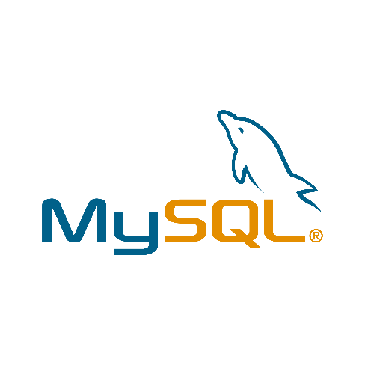
In this project, I have used the following technologies:







  - Feasibility Study
The feasibility of the Healthy Recipes project is evaluated based on time, technology, and project scope:

- Time Feasibility
The major modules of this system, such as user management, recipe upload, category handling, and interaction features (likes & comments), can be developed within an estimated duration of 3 months. Therefore, the project is feasible within the given time frame.
  - Technical Feasibility
The project is developed using widely adopted and stable technologies like Java EE, JSF, EJB, Servlets, MySQL, and Apache NetBeans with Payara Server deployment. As all required technologies are available, the technical risk is minimal, making the project technically feasible.
  - Operational/Project Size Feasibility
The overall project size is moderate and manageable. System functionalities are clearly defined for admin and users, making the project implementation practical with available resources. Thus, the project size is considered feasible.
3. System Design

Key Aspects of System Design:
1. High-Level Design (HLD):
- Focuses on the overall architecture of the system.
- Defines components like databases, servers, APIs, and their relationships.
Example: Identifying microservices in a distributed system or the tech stack.
2. Low-Level Design (LLD):
- Details the internal workings of individual components.
- Includes class diagrams, data structures, algorithms, and database schemas.
Example: How a user authentication service handles login requests.

Components of System Design:
1. Architecture Design:
- Determines how the system is structured, including monolithic, client-server,
or microservices architecture.
Example: A social media platform may use a three-tier architecture with a presentation layer, application layer, and database layer.
2. Data Flow:
- Describes how data moves through the system.
Example: A payment gateway that processes user inputs and forwards them to a payment processor.
3. Scalability and Performance:
- Ensures the system can handle increasing loads by scaling vertically or horizontally.
- Includes considerations for caching, load balancing, and database partitioning.
4. Security:
- Focuses on protecting the system against unauthorized access and data breaches.
- Example: Implementing HTTPS, encryption, and role-based access control.
5. Fault Tolerance:
- Ensures the system can recover from failures with minimal downtime.
- Example: Using redundant servers in a failover setup.
Common Tools and Techniques:
1. Unified Modeling Language (UML) : For diagrams like class and sequence
diagrams.
2. Entity-Relationship (ER) Modelling: For database structure.
3. Architecture Patterns: Examples include MVC, Microservices, and Event-Driven
Architecture.

3.1 Entity Relationship Diagram

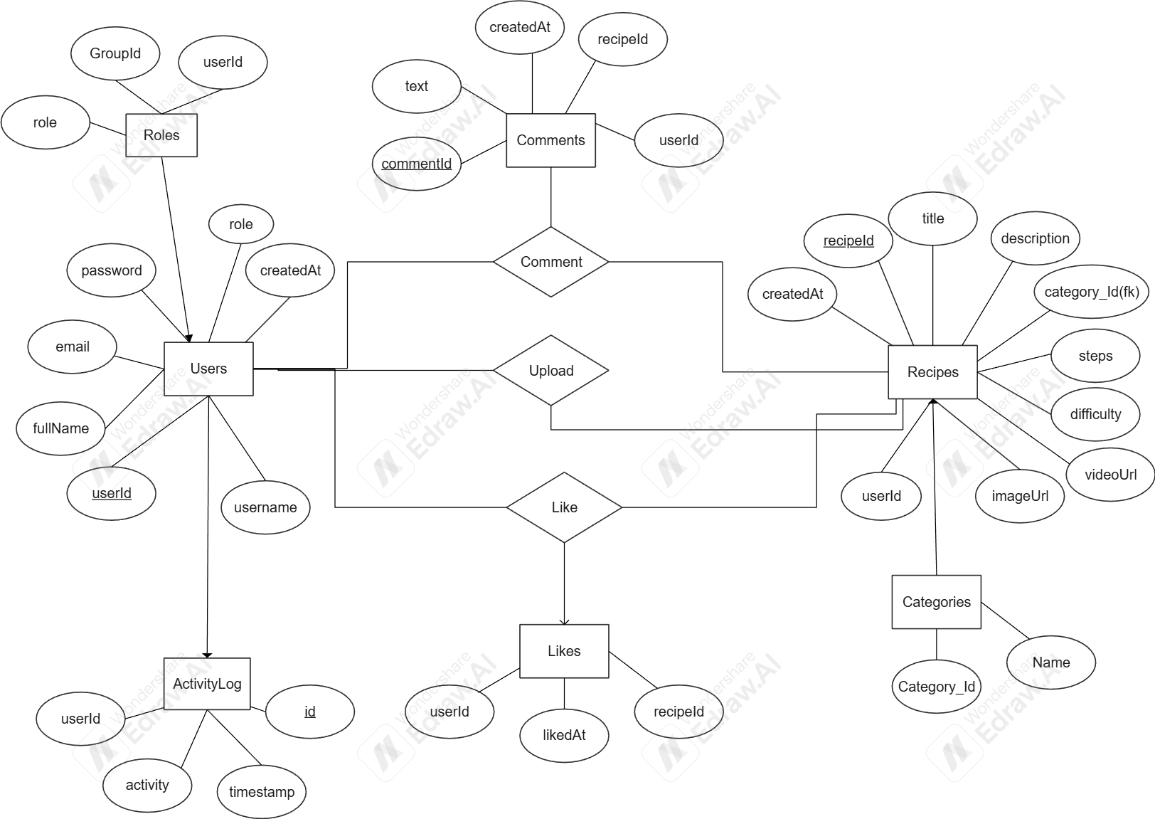

3.2 Use Case Diagram
User :
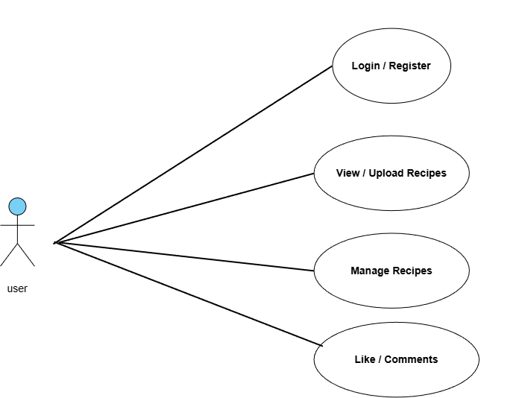

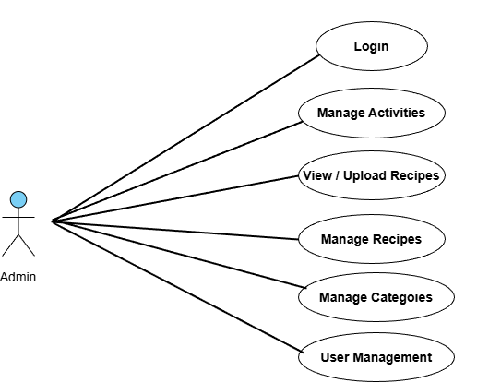
Admin :

3.3 Class Diagram
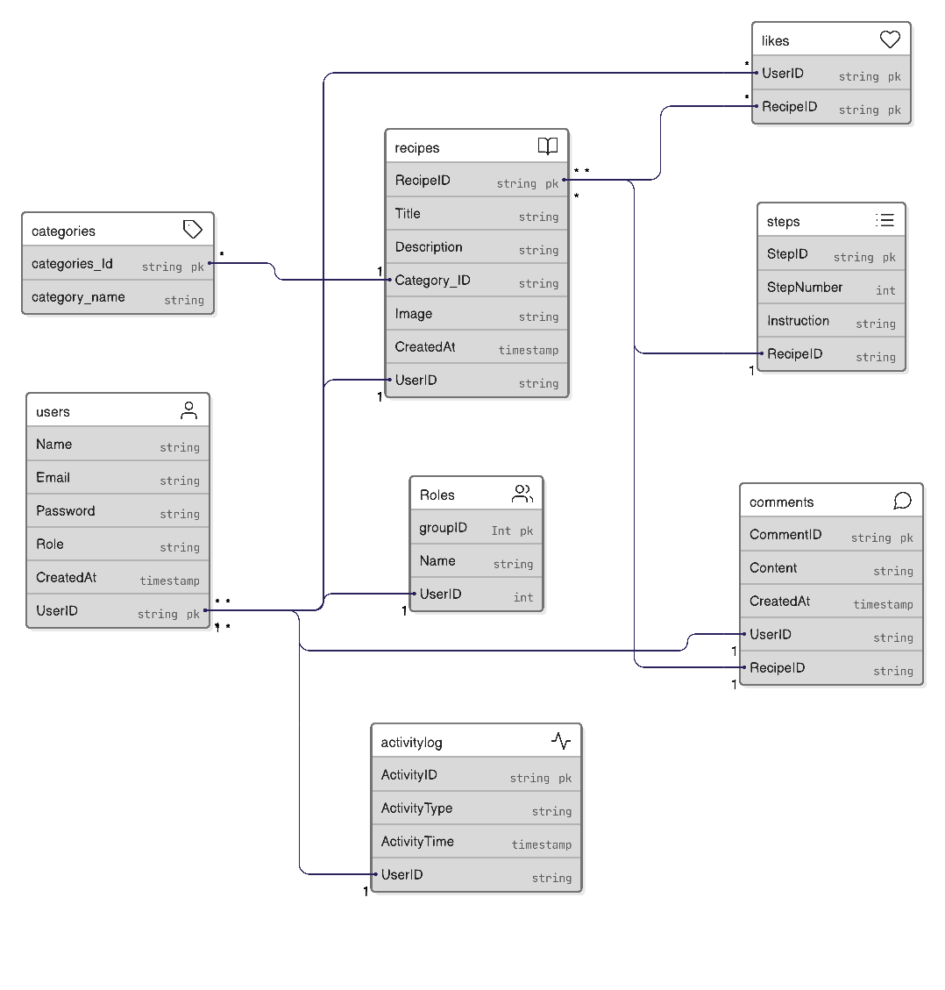

3.4 Sequence Diagram
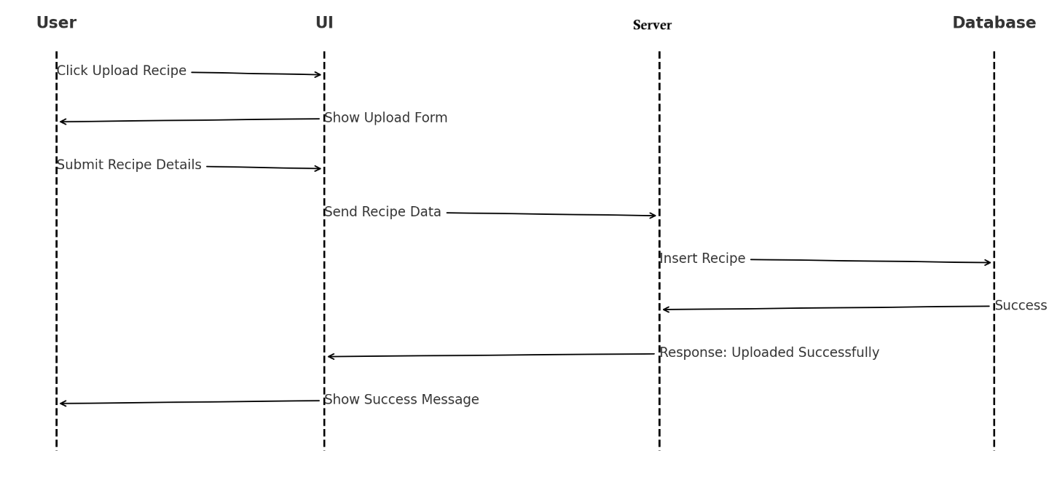

( Upload Recipe Sequence Diagram )

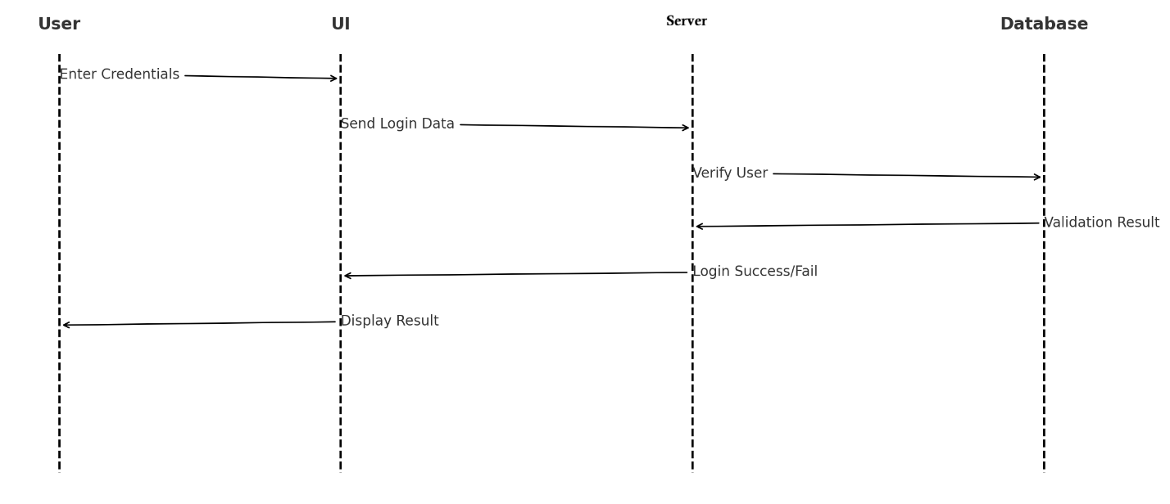

(Login Sequence Diagram )

3.5 Database Design
1. Users
Column Name | Data Type | Constraints | Description
user_id | INT | PK, AUTO_INCREMENT | Unique user identifier
full_name | VARCHAR(100) | NOT NULL | User full name
email | VARCHAR(100) | UNIQUE, NOT NULL | Used for login
password | VARCHAR(255) | NOT NULL | Hashed password
username | VARCHAR(50) | UNIQUE, NOT NULL | Public display name
profile_image | VARCHAR(255) | NULL | Uploaded profile picture
phone | VARCHAR(15) | NULL | Contact number
role | ENUM('User','Admin') | DEFAULT 'User' | User type

2. Recipes
Column Name | Data Type | Constraints | Description
recipe_id | INT | PK, AUTO_INCREMENT | Unique recipe identifier
title | VARCHAR(150) | NOT NULL | Recipe name
description | TEXT | NOT NULL | Recipe details & steps
ingredients | TEXT | NOT NULL | All ingredients listed
image | VARCHAR(255) | NULL | Recipe image
created_at | DATETIME | NOT NULL | Upload date
user_id | INT | FK REFERENCES users(user_id) | Recipe owner
Category_ID | INT | FK REFERENCES Categories(category_ID) | Category

3. Comments
Column Name | Data Type | Constraints | Description
comment_id | INT | PK, AUTO_INCREMENT | Unique comment ID
text | TEXT | NOT NULL | Comment text
created_at | DATETIME | NOT NULL | Comment timestamp
user_id | INT | FK REFERENCES users(user_id) | Comment author
recipe_id | INT | FK REFERENCES recipes(recipe_id) | Recipe commented on

4. Categories
Column Name | Data Type | Constraints | Description
Category_ID | INT | PK, AUTO_INCREMENT | Unique category ID
Category_Name | TEXT | NOT NULL | Category Name

5. Likes
Column Name | Data Type | Constraints | Description
like_id | INT | PK, AUTO_INCREMENT | Unique like entry
user_id | INT | FK REFERENCES users(user_id) | Who liked
recipe_id | INT | FK REFERENCES recipes(recipe_id) | Recipe liked

6. Role ( Group Master)
Column Name | Data type | Constraints
roleid | Integer | Primary Key
userid | Integer | FK REFERENCES users(user_id)
role | Varchar(20) | Role(‘Admin’,’Users’)

7. ActivityLog
Column Name | Data Type | Constraints | Description
activity_id | INT | PK, AUTO_INCREMENT | Unique activity log entry
name | INT | Varchar (20) | Activity name
user_id | INT | FK REFERENCES users(user_id) | Usersname

4. Interface Design
4.1 Detailed Design Description
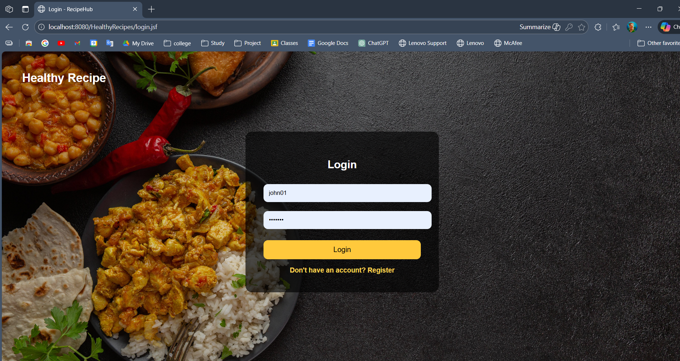

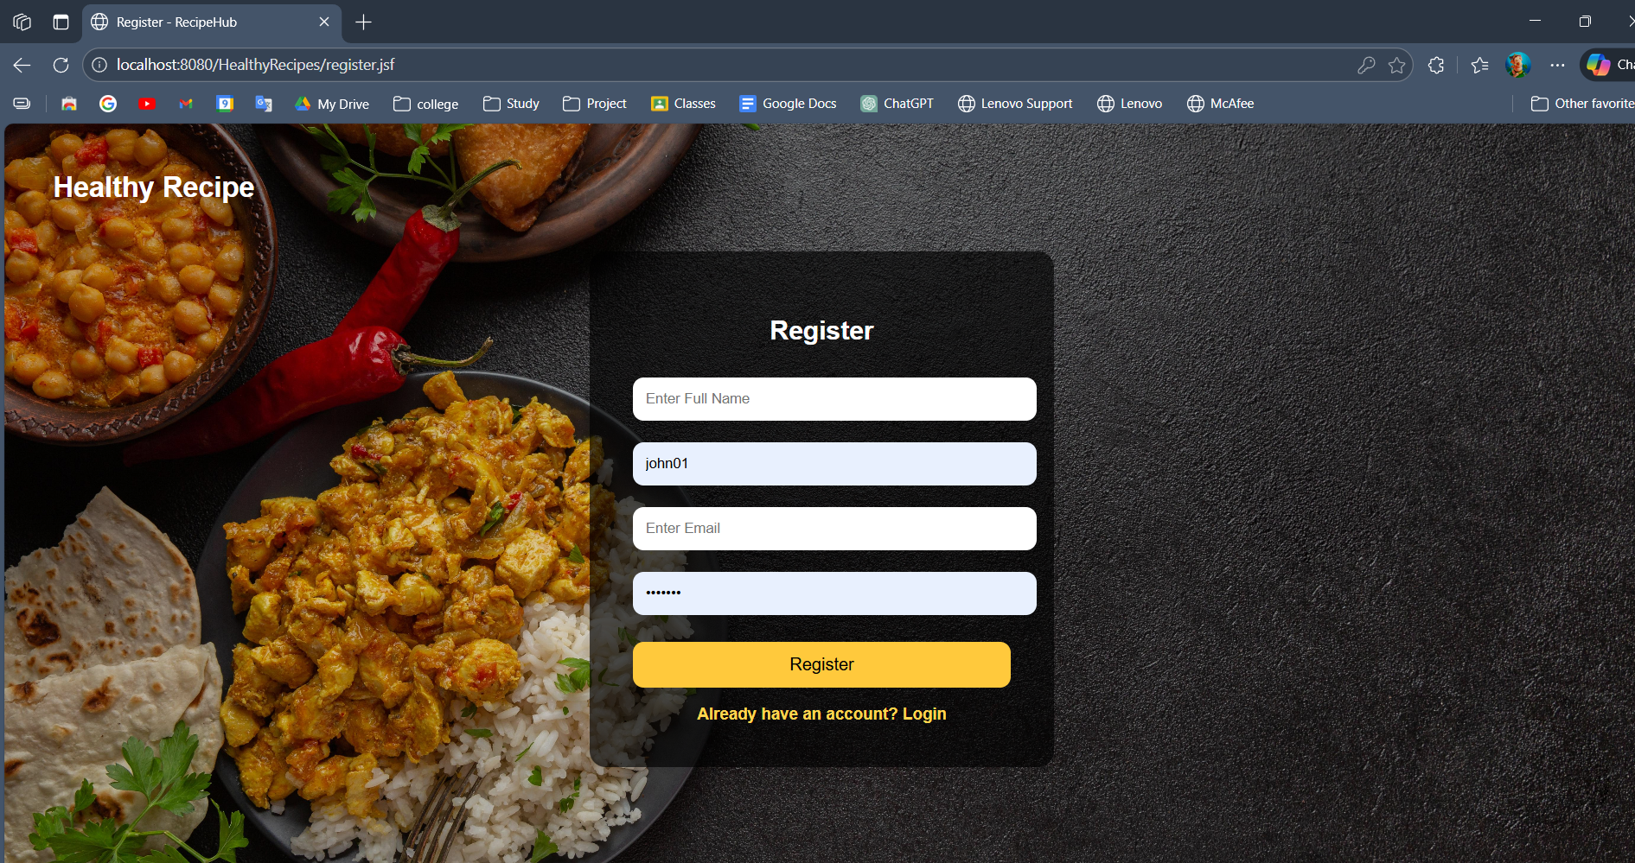
(Login/Register)

Home :
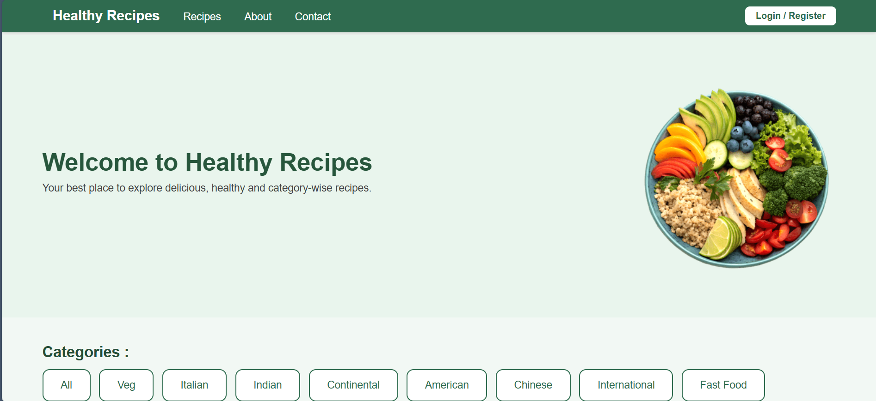
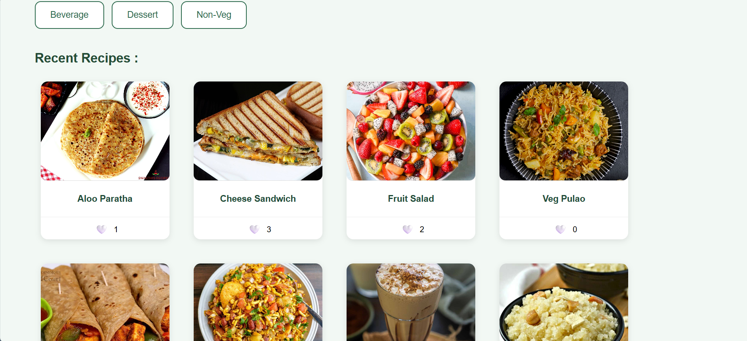
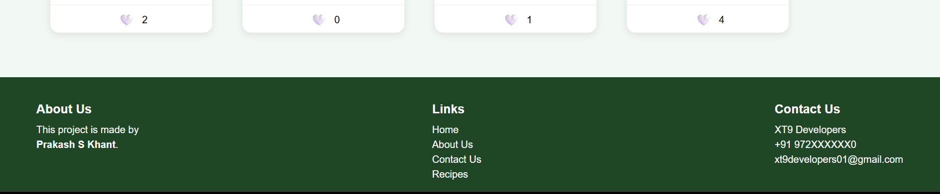

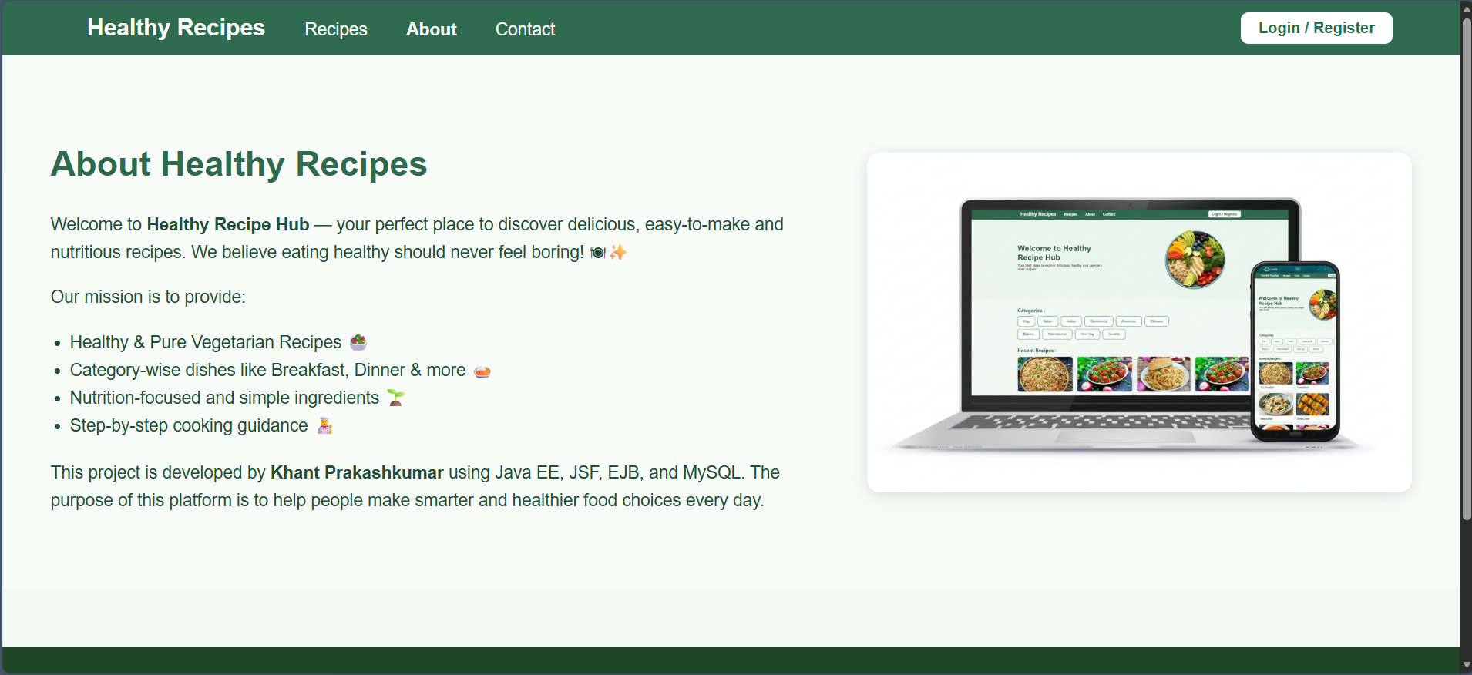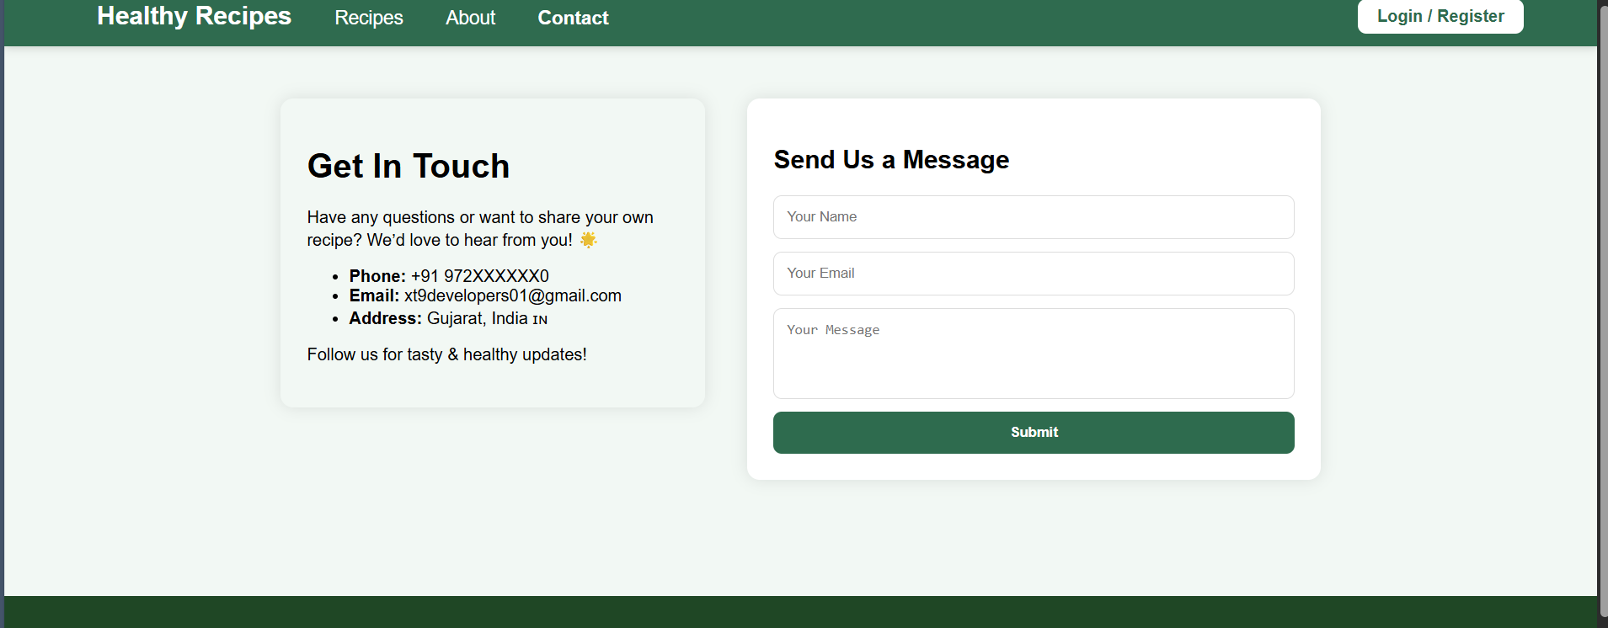

Admin Dashboard
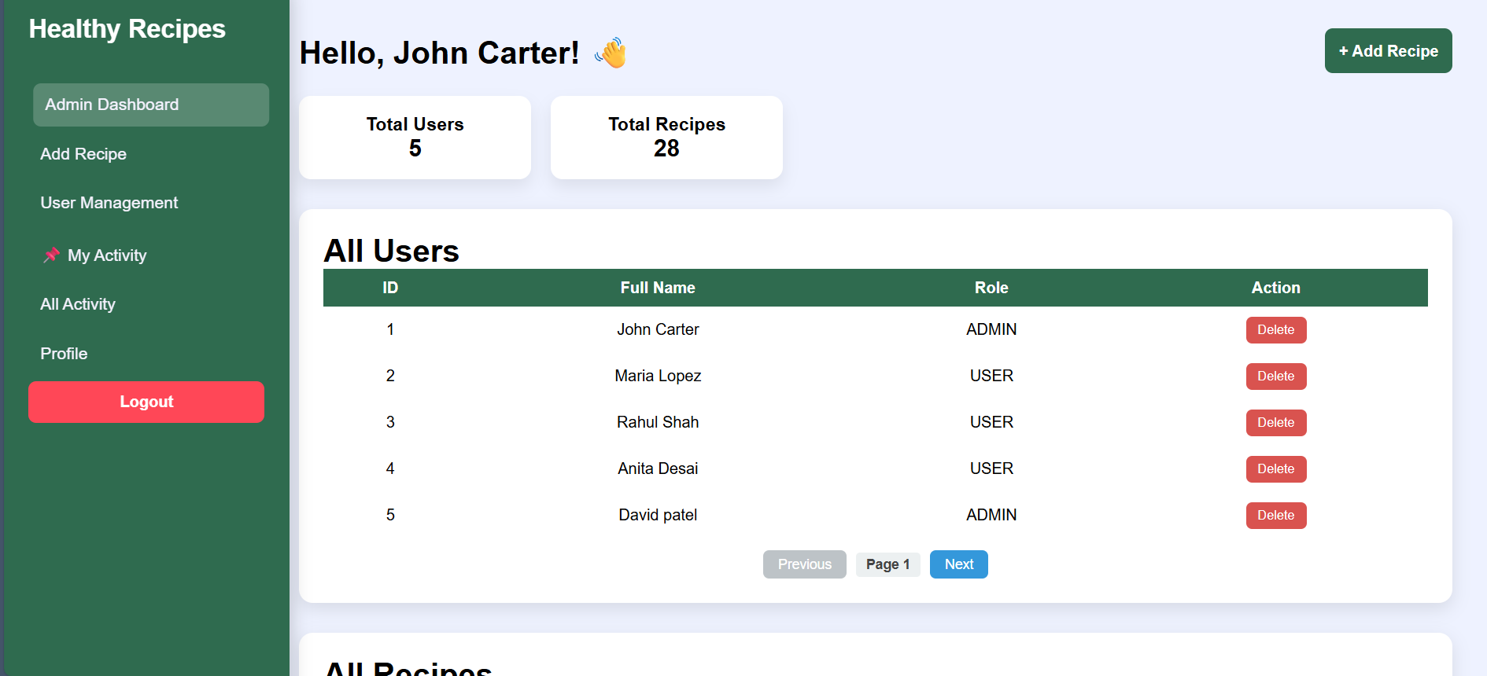
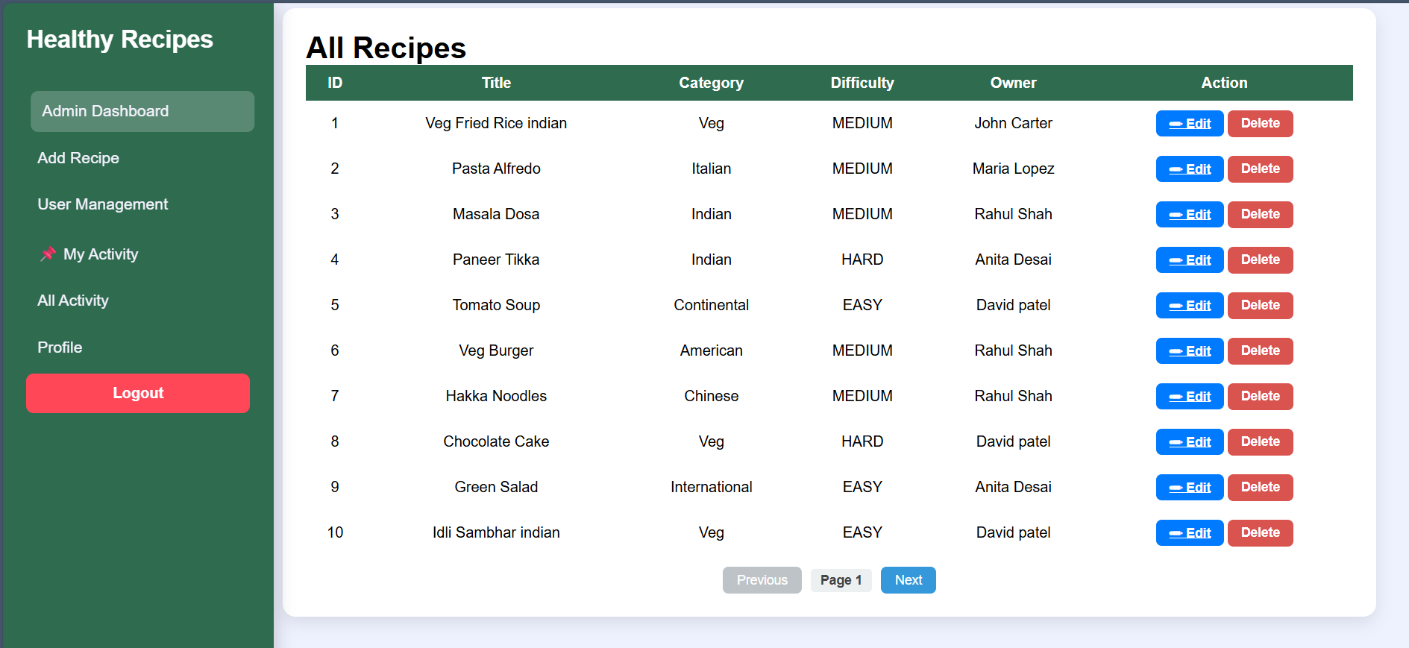
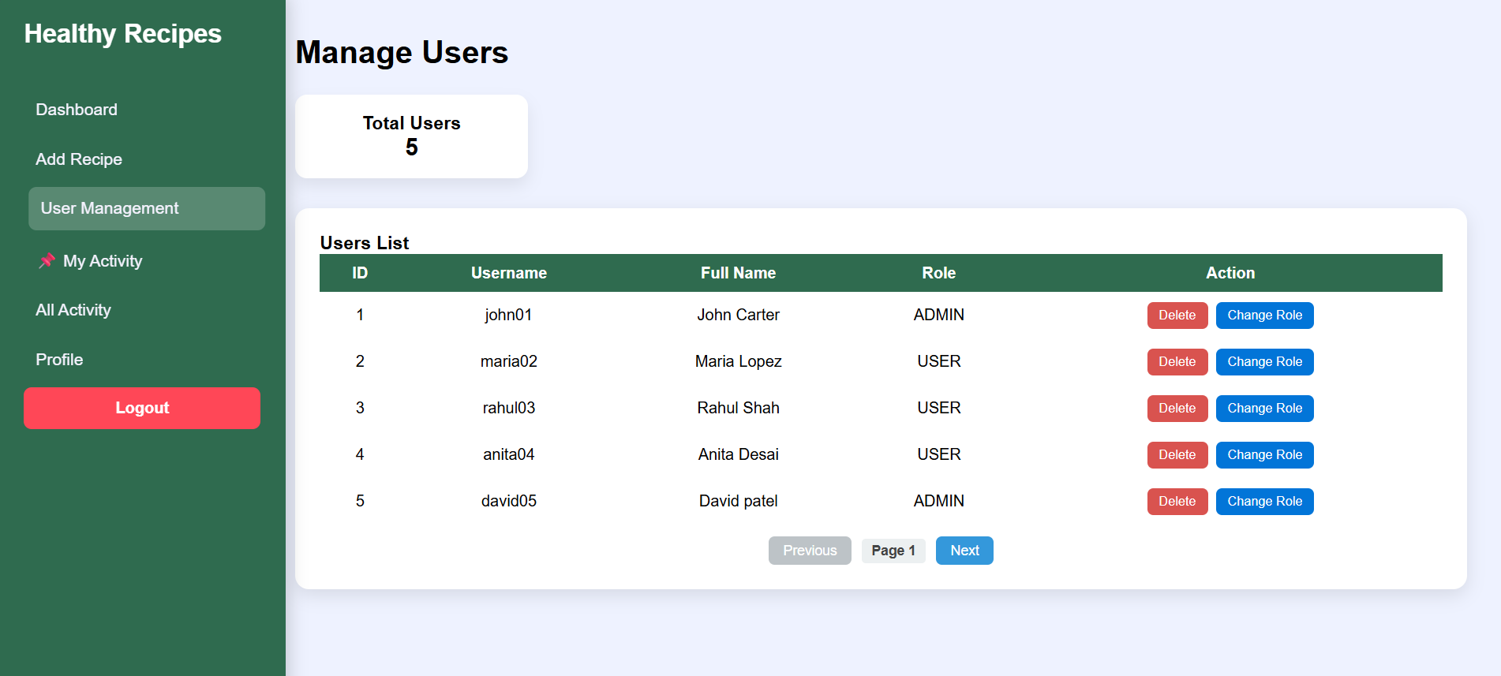
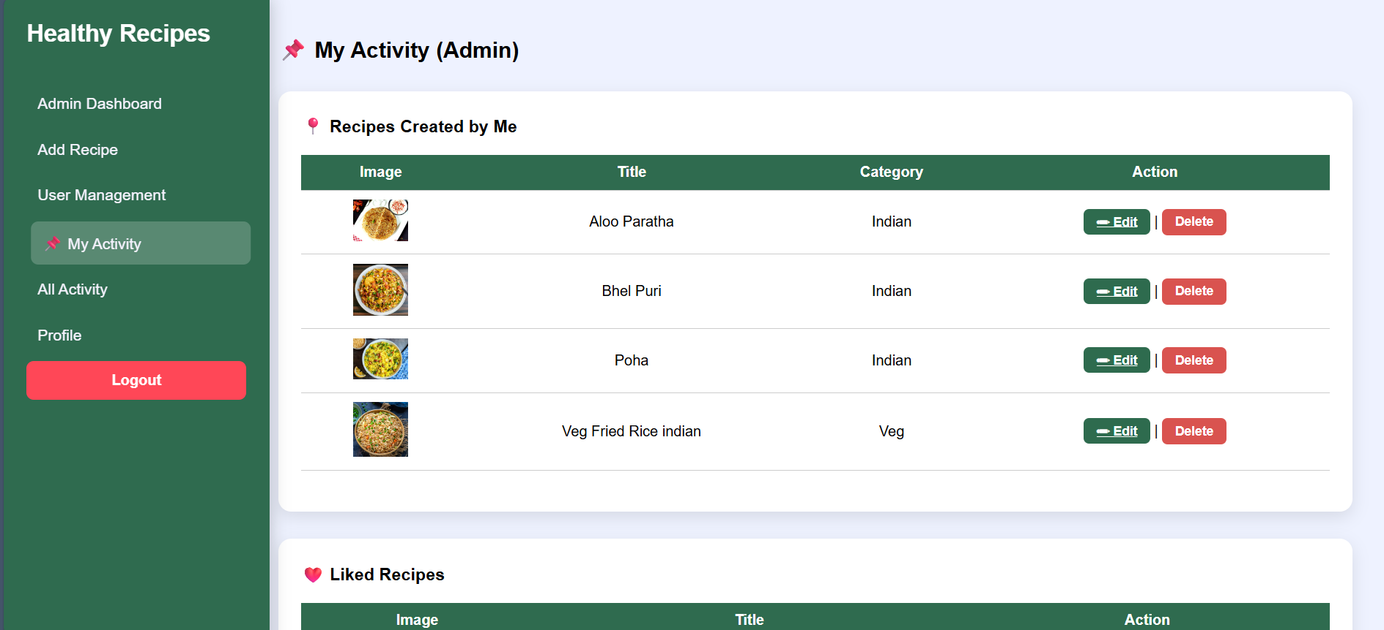
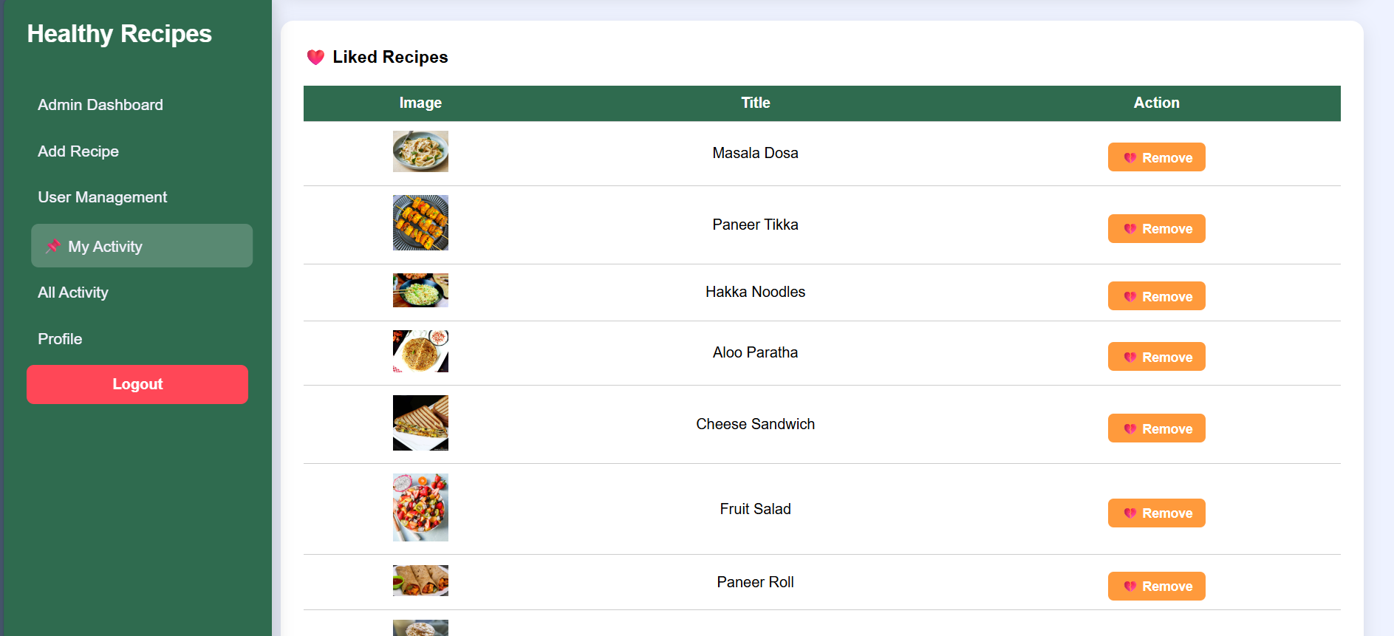

User Dashboard :
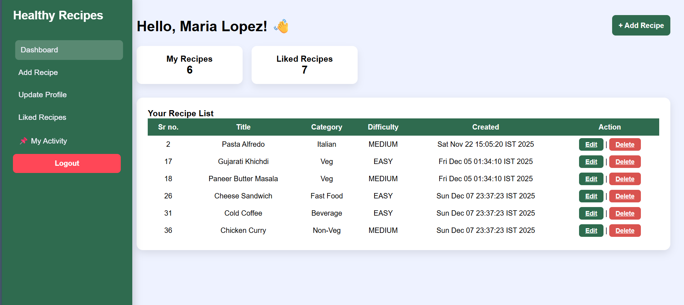
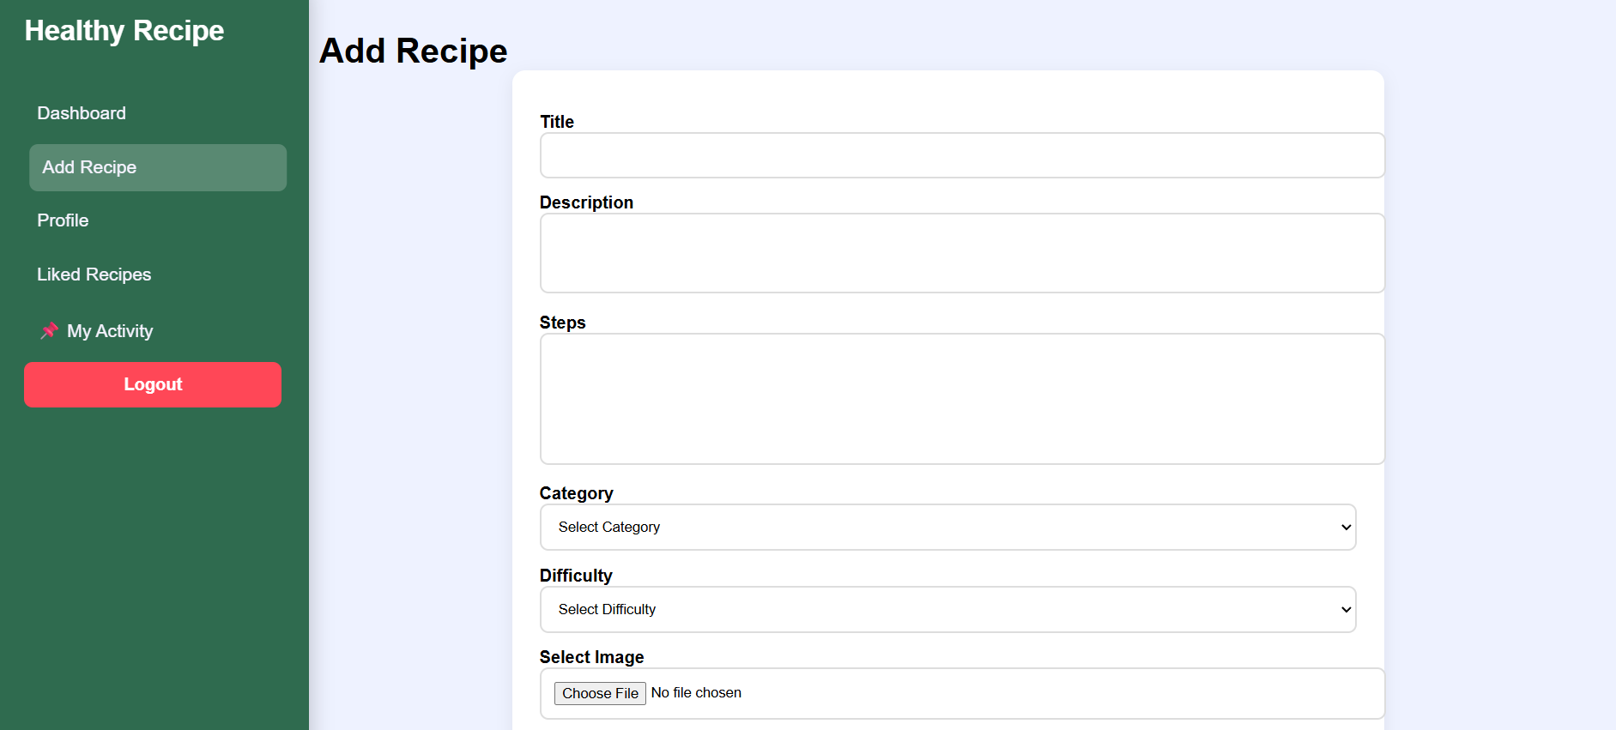
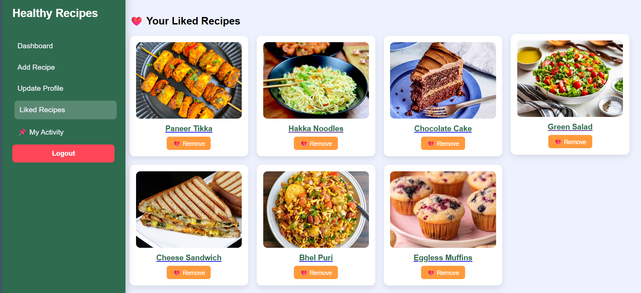
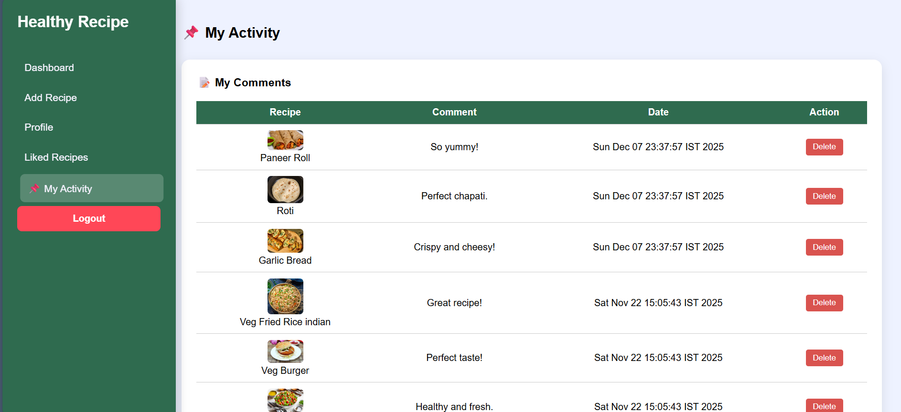
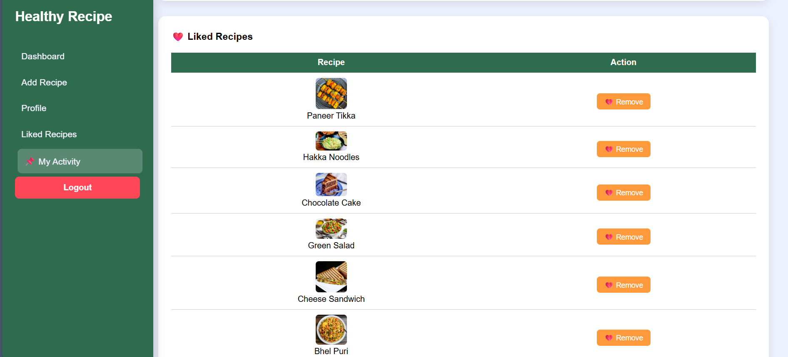
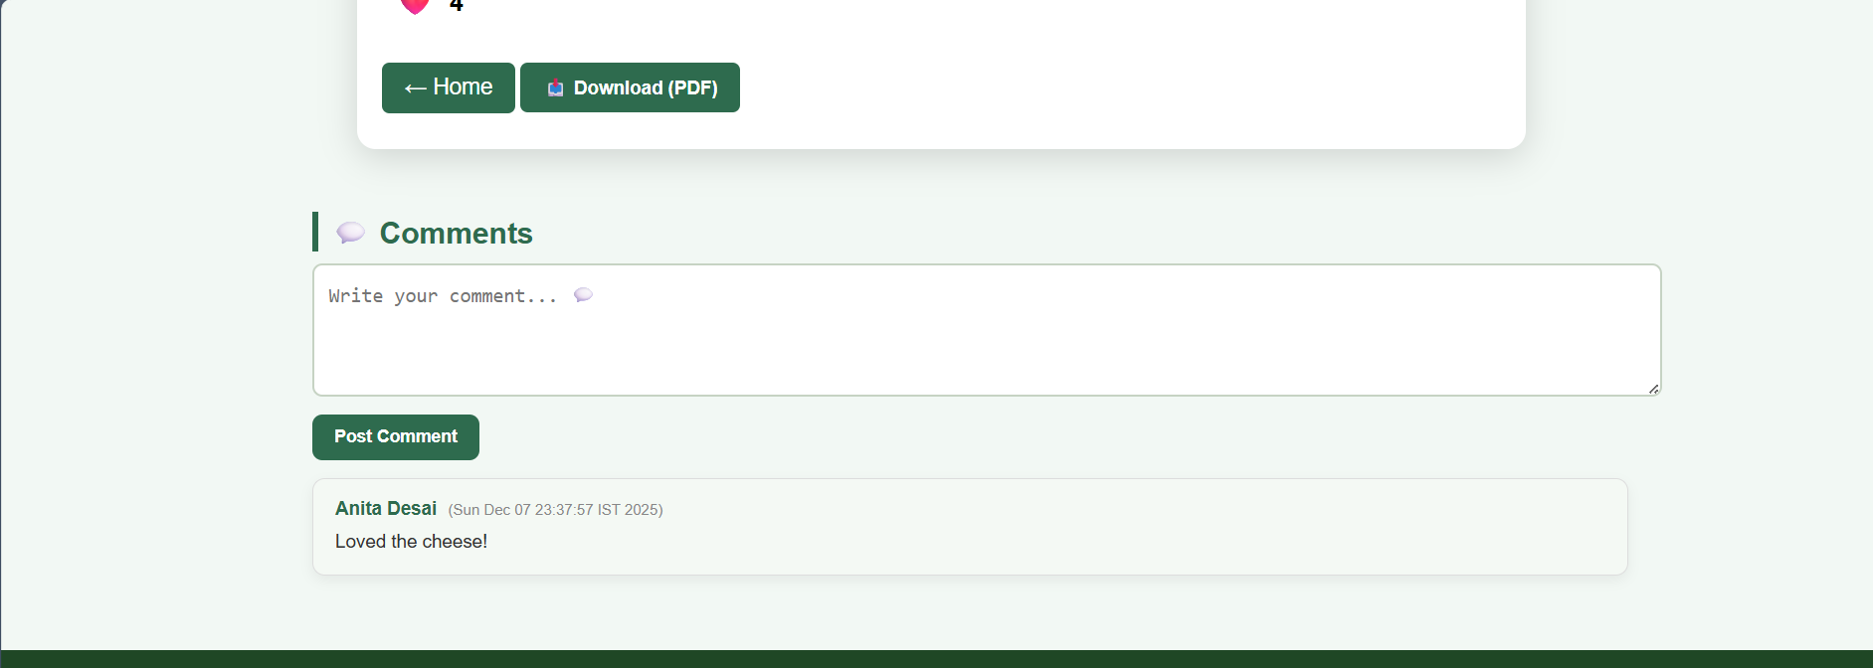

5. Testing
TEST CASE ID | DESCRIPTION | INPUT | EXPECTED OUTPUT | ACTUAL OUTPUT | STATUS
Case 1.1 | User Login (Invalid User) | Wrong Username/Password | Show error message “Invalid login” | Error message displayed | Successful
Case 1.2 | User Login (Valid User) | Correct Username & Password | Redirect to Home Page | Redirected successfully | Successful
Case 2 | Home Page Access | Click on “View Recipes” | Home page should open | Home page opened | Successful
Case 2.1 | View Recipes | Select “View Recipes” option | Show all approved recipes | Proper recipe list displayed | Successful
Case 2.2 | View Recipe Details | Click on specific recipe | Show recipe details page | Recipe details displayed | Successful
Case 3 | Upload Recipe | Fill recipe form and submit | Success message and recipe added | Recipe added successfully | Successful
Case 3.1 | Upload Recipe (Invalid Input) | Blank fields / missing data | Show validation error message | Validation error displayed | Successful
Case 4 | Comment on Recipe | Enter a comment and submit | Comment should be saved and visible | Comment stored and displayed | Successful
Case 5 | Like Recipe | Click on Like button | Like count should increase | Like added correctly | Successful
Case 6 | Logout | Click logout button | Redirect to login page | Logged out successfully | Successful

6. Conclusion

The Healthy Recipes system successfully provides an easy-to-use and interactive platform where users can learn, explore, and share healthy food ideas. It encourages better eating habits by offering well-organized recipes with proper cooking instructions. The system also ensures security and data management through authentication and admin control features.

This project has improved the efficiency of accessing healthy recipes online and promotes a community-driven approach to food awareness. With a simple interface and secure backend, this system serves as a reliable platform for users of all age groups.

Overall, this project has fulfilled its objectives by creating a practical, user-friendly, and health-focused web application that supports a healthier lifestyle for its users.

7. Bibliography
This section includes references, tools, technologies, frameworks, and learning resources that contributed to the development of the Healthy Recipes – Recipe Sharing Platform project. Proper acknowledgment ensures that all supporting materials are credited.

Books and Articles
- “Java: The Complete Reference” by Herbert Schildt
▪ For understanding Java programming concepts, Servlets, and backend development.
- “Web Technologies” by Uttam K. Roy
▪ For guidance on web application design, HTML & CSS structure, and UI principles.
- “Software Engineering: A Practitioner’s Approach” by Roger S. Pressman
▪ For SDLC methodologies, requirement gathering, and designing system architecture.

Web Resources
- Oracle Java EE Documentation
▪ For Enterprise Java Beans (EJB), Servlets, and Java EE features
▪ URL: https://www.oracle.com/java/technologies/
- PrimeFaces Documentation
▪ For JSF UI components and integration
▪ URL: https://primefaces.org/documentation
- MySQL Official Documentation
▪ For database design, queries, and relationships
▪ URL: https://dev.mysql.com/doc/
- W3Schools / GeeksforGeeks
▪ For frontend learning, CSS styling, and form validation
▪ URLs:
– https://www.w3schools.com
– https://www.geeksforgeeks.org
- phpMyAdmin Documentation
▪ For managing relational database schema visually
▪ URL: https://www.phpmyadmin.net/

Tools and Technologies
- Java EE – Backend development environment
- JSF & PrimeFaces – Frontend user interface development
- MySQL Database – Storing user and recipe data
- Payara Server – Deployment and execution of the application
- Apache NetBeans IDE 13 – Coding, testing, and debugging
- Lucidchart / Draw.io – Creating ERD, Use Case & UML diagrams

Other Resources
- YouTube Tutorials & Developer Communities
▪ Programming guidance and UI design ideas
▪ Channels: CodeWithHarry, ProgrammingWithMosh
- Peer and Mentor Support
▪ Suggestions and feedback during development and testing

Thank You

