

PROJECT WORK ON
LIBRARY MANAGEMENT SYSTEM

SUBMITTED BY:

PRAKASH KUMAR

Table of Content : -

- Introduction
- Objective
- Benefits
- 4W'S and 1H
- SWOT Analysis
- Requirements
- Architecture
- Testing
- Images
- Conclusion

INTRODUCTION

Library Management System : -

Library management is a project that manages and stores books information electronically according to students needs. The system helps both students and library manager to keep a constant track of all the books available in the library. It allows both the admin and the student to search for the desired book.

The project titled Library Management System is Library Management software for monitoring and controlling the transactions in a library. The project “Library Management System” is developed in C, which mainly focuses on basic operations in a library like adding new books, and updating new information, searching books and members and return books.

This project “LIBRARY MANAGEMENT SYSTEM” gives us the complete information about the library. We can enter the record of new books and retrieve the details of books available in the library. We can issue the books to the students and maintain their records and can also check how many books are issued and stock available in the library. In this project we can maintain the late fine of students who returns the issued books after the due date.

Challenges Faced and How Was It Overcome
1.I have faced issues in file handling. so, I used strings.

2.Updating and Deleting a file was overcame by using a temporary file to store data for some time.

OBJECTIVES

a) To build a system that can receive input and generate automatically output in easy way and short time.

b) To build a monitoring system that is able to monitor and manage all library operations efficiently.

c) Give an opportunity to librarians to reduce mistakes that always happen during manual method.

d) To store properly the library items in order to maintain their security.

e) To enter and preserve details of the various issues and keep a track on their returns.

BENEFITS

a) Record Maintenance.

b) Web-Based Solution.

c) Saves Time and Cost.

d) Secure and Reliable.

e) Increases Efficiency.

f) Simple and Easy to Use.

4W'S and 1H

#Who
This Library Management System is an application is used by all the students, and staff who are having id's.

#What:
Library Management Systems is software that helps to maintain a database that is useful to enter new books & record books borrowed by the members, with the respective submission dates.

#When:
This Library Management System is very useful when there are large no of readers visit library to return, renewal, or take books. It is very tedious to enter the records manually so here this project come into handy.

#Where:
The Library management system is nowadays essential for schools, colleges, private libraries, and other organizations. They can use this software as the purpose of books issuing and returning for renewal.

#How:
This project is implemented to do the book issuing, retunrn, or renewal purpose by entering the student or faculty id as input.

Swot Analysis

#Strengths:
a) Simple & Easy to Use.

b) Increased Library Engagement.

c) Efficient Cloud Data Management.

d) Highly Secure, Scalable & Reliable.

e) Mobile Access.

#Weakness:
a) The data stored is prone to cyber hacks.

b) Costly and Expensive.

c) Complicated to operate.

d) Online Systems require high-speed internet connectivity.

e) Risk of computer virus.

#Opportunities:
The LMS leaks outward into new spaces, spaces which it didn’t inhabit before, such as reading lists repositories, learning systems, research data management and so forth. Furthermore, it is likely that the future of library systems will consist of a mixture of open and closed systems as well as local and shared (or hosted) services. With an increasing move towards closed platforms (like Facebook, for example) and proprietary ecosystems (like Apple), libraries will be required tonavigate these different spaces and ecosystems.

#Threats:
Libraries now send and retrieve data from databases to help better manage inventory and the like, but some libraries don’t have the right data encryption practices in place. This can often lead to lost data and sometimes, the data easily obtainable by criminals.

REQUIREMENTS

HIGH LEVEL REQUIREMENTS:
RID | DESCRIPTION | STATUS
HLR1 | C LANGUAGE | IMPLEMENTED
HLR2 | OS WINDOWS | IMPLEMENTED
HLR3 | OS LINUX | IMPLEMENTED
HLR4 | HARD DISK | IMPLEMENTED
HLR5 | RAM 4GB | IMPLEMENTED

LOW LEVEL REQUIREMENTS:
RID | DESCRIPTION | STATUS
LLR1 | ADD BOOKS | IMPLEMENTED
LLR2 | DELETE BOOKS | IMPLEMENTED
LLR3 | SEARCH BOOKS | IMPLEMENTED
LLR4 | ISSUE BOOKS | IMPLEMENTED
LLR5 | VIEW BOOKS | IMPLEMENTED

ARCHITECTURE

# STRUCTURE DIAGRAMS
1. High level design
a) Use-case diagram
B) class diagram

# BEHAVIOUR DIAGRAMS
- Low level design
a) state diagram
b) sequence diagram

CLASS DIAGRAM

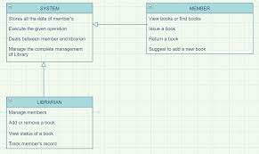

STATE DIAGRAM

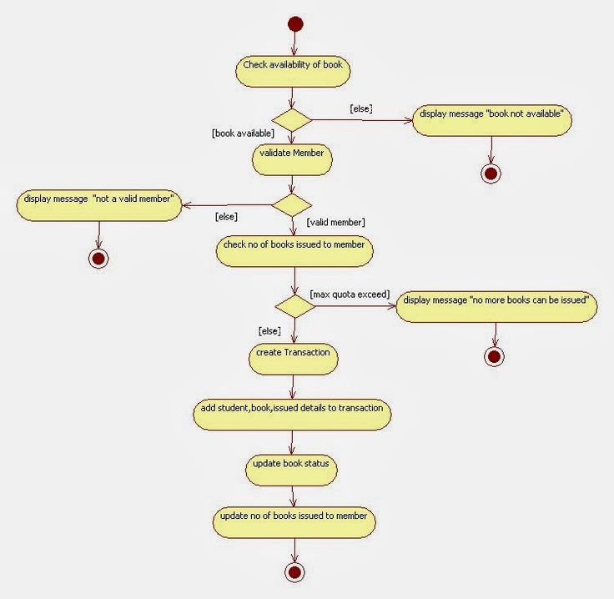

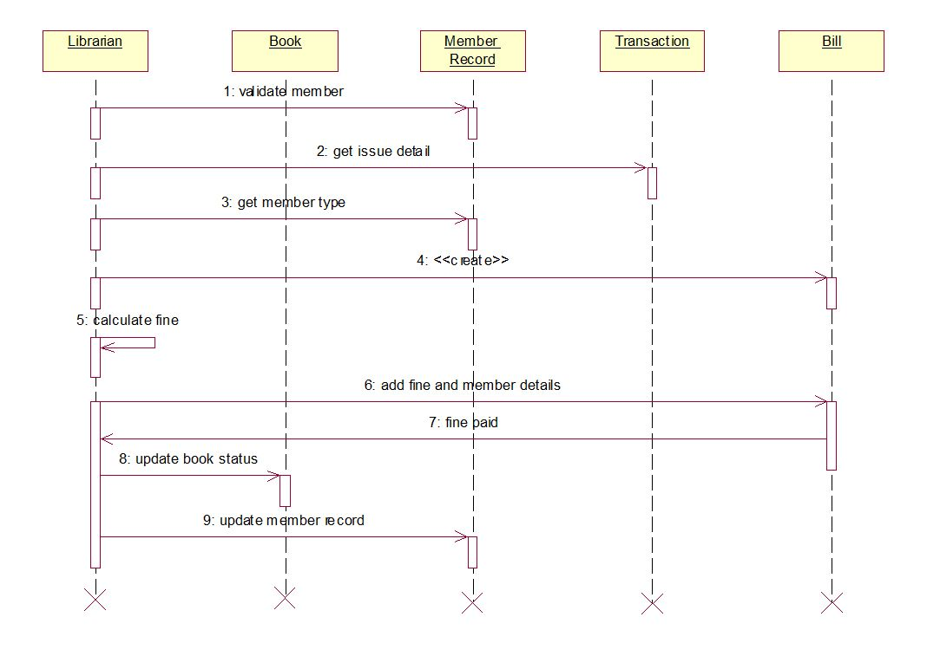
SEQUENCE DIAGRAM

USECASE DIAGRAM

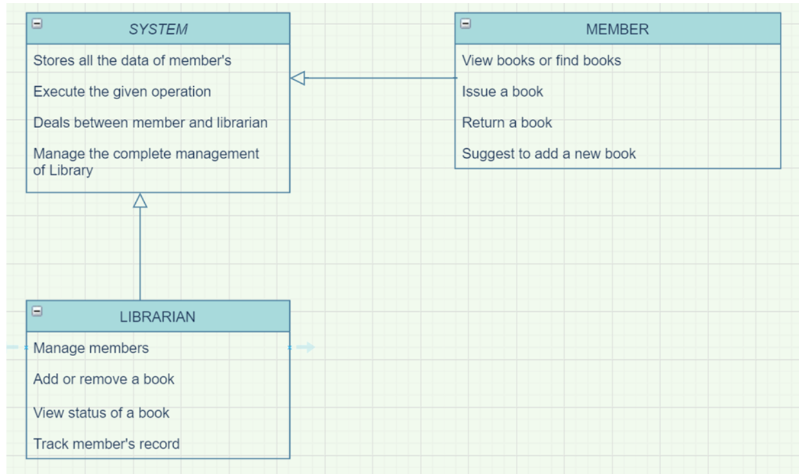

IMAGES

1.ADDBOOK.

2.DELETEBOOK.

3.SEARCHBOOK.

4.ISSUEBOOK.

5.VIEWBOOK.

6.DISPLAY VIEW.

ADD BOOKS
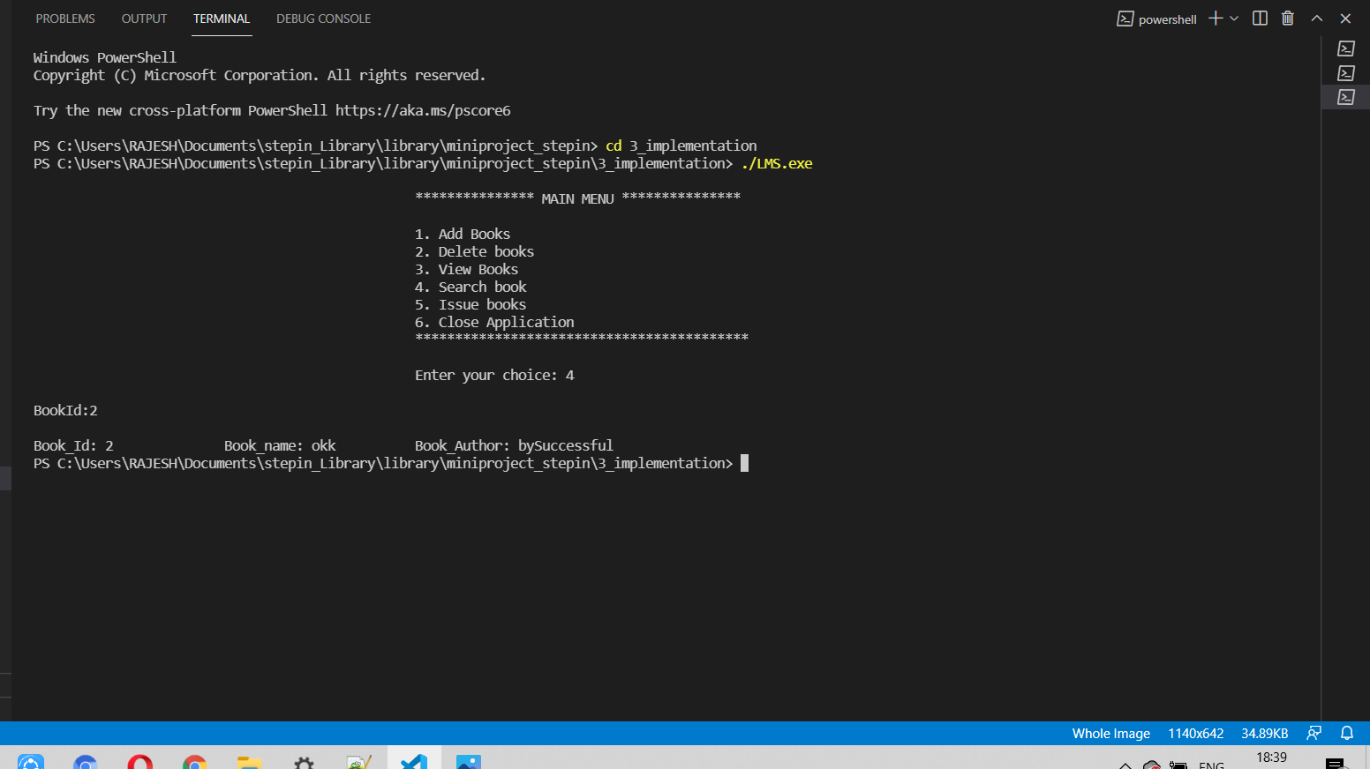

DELETE BOOKS

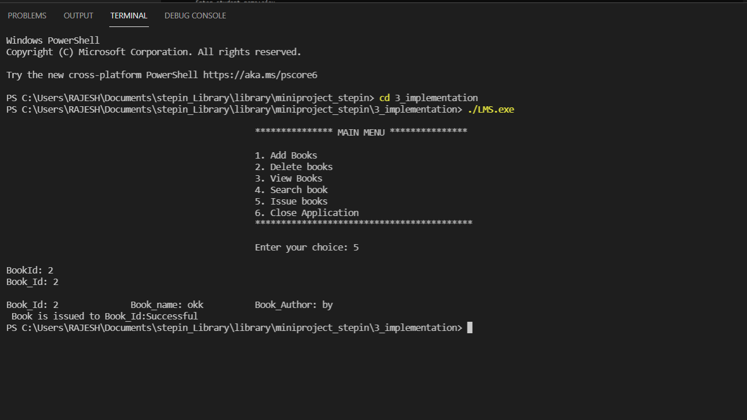

SEARCH BOOKS

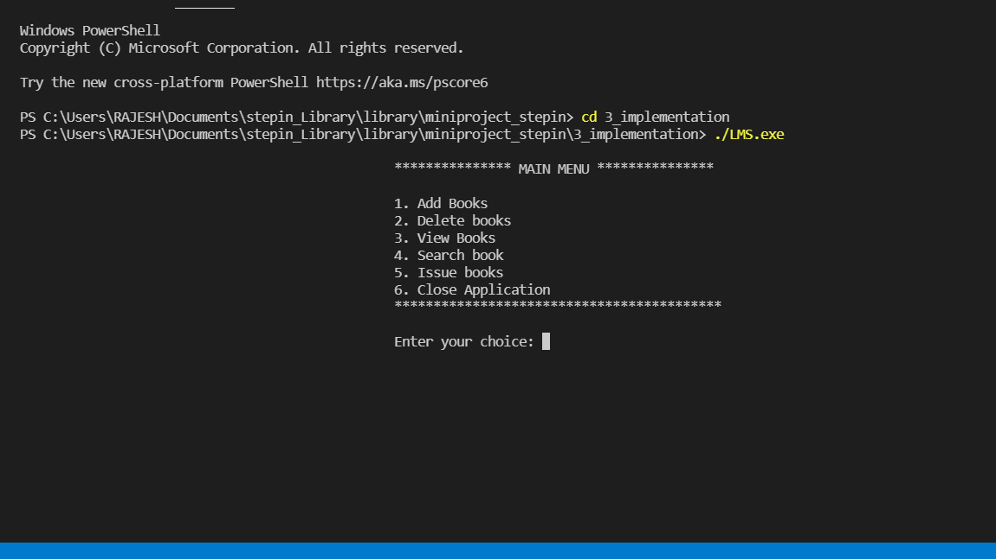

ISSUE BOOKS

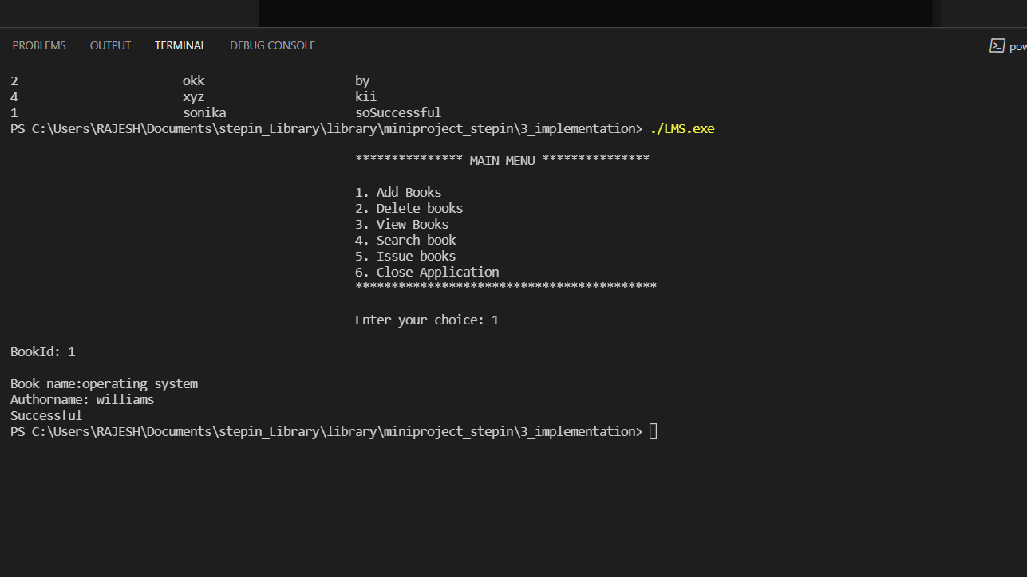

VIEW BOOKS

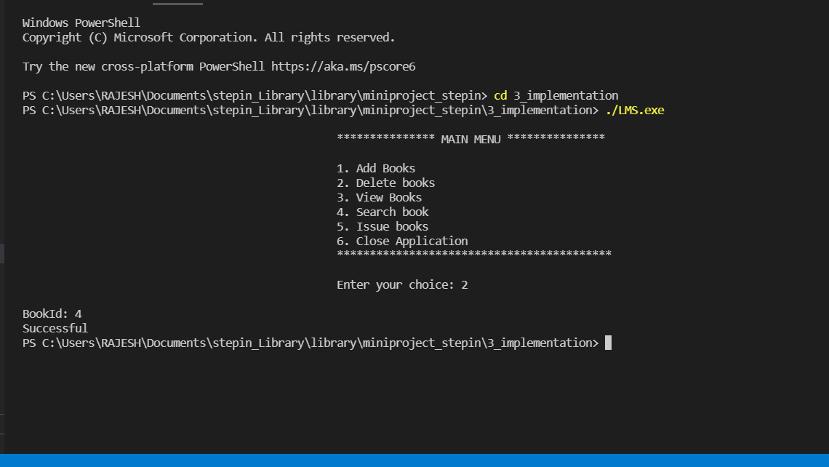

DISPLAY VIEW

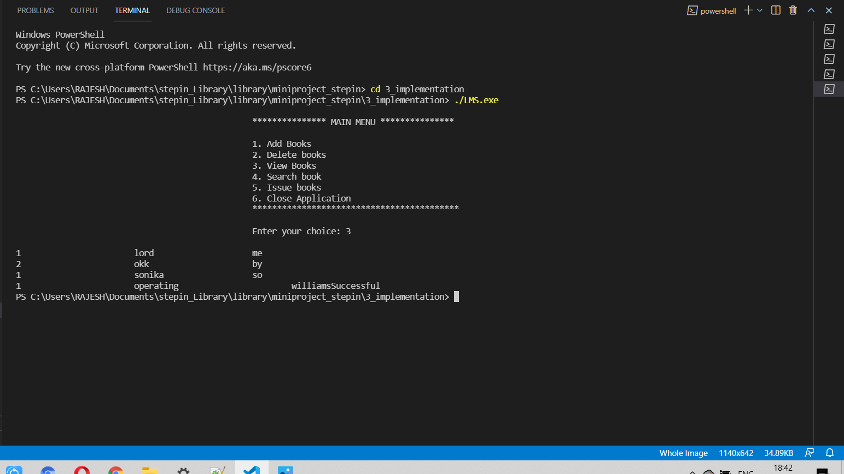

TESTING

The aim of the system testing process was to determine all defects in our project.
The program was subjected to a set of test inputs and various observations were made
and based on these observations it will be decided whether the program behaves as expected or not.
Our Project went through two levels of testing

a.) Unit testing
Unit testing is undertaken when a module has been created and successfully reviewed .In order to test a single module we need to provide a complete environment i.e. besides the module we would require

The procedures belonging to other modules that the module under test calls

Non local data structures that module accesses

A procedure to call the functions of the module under test with appropriate parameters

1. Test For the admin module
Testing admin login form-This form is used for log in of administrator of the system.
In this we enter the username and password if both are correct administration page will
open other wise if any of data is wrong it will get redirected back to the login page
and again ask for username and password

Student account addition- In this section the admin can verify student details from
student academic info and then only add student details to main library database it
contains add and delete buttons if user click add button data will be added to student
database and if he clicks delete button the student data will be deleted

Book Addition- Admin can enter details of book and can add the details to the main
book table also he can view the books requests.
Test for Student login module

Test for Student login Form-This form is used for log in of Student In this we enter
The library id, username and password if all these are correct student login page will
open other wise if any of data is wrong it will get redirected back to the login page
and again ask for library id, username and password.

Test for account creation- This form is used for new account creation when student does
not fill the form completely it asks again to fill the whole form when he fill the form
fully it gets redirected to page which show waiting for conformation message as his data
will be only added by administrator after verification.

3. Test for teacher login module

Test for teacher login form- This form is used for log in of teacher .
In this we enter the username and password if all these are correct teacher
login page will open other wise if any of data is wrong it will get redirected
back to the login page and again ask for username and password.

INTEGRATION TESTING
In this type of testing we test various integration of the project module by
providing the input The primary objective is to test the module interfaces in
order to ensure that no errors are occurring when one module invokes the other module.
CONCLUSION

This website provides a computerized version of library management system which will benefit the students as well as the staff of the library.

It makes entire process online where student can search books, staff can generate reports and do book transactions.
It also has a facility for student login where student can login and can see status of books issued as well request for book or give some suggestions.
It has a facility of teacher's login where teachers can add lectures notes and also give necessary suggestion to library and also add info about workshops or events happening in our college or nearby college in the online notice board.

There is a future scope of this facility that many more features such as online lectures video tutorials can be added by teachers as well as online assignments submission facility, a feature Of group chat where students can discuss various issues of engineering can be added to this project thus making it more interactive more user friendly and project which fulfills each users need in the best way possible.

REFERENCES

- Tutorials point
- Geeksforgeeks
- Future Skill
- GitHub

