Sales & Marketing Analytics Project Report
IBM SkillsBuild — Data Analytics with AI Internship
Author: Prakash Maiti
Dataset: sales.csv | 15,000 Records × 30 Features
Tools: Python · Pandas · NumPy · Matplotlib · Seaborn · Scikit-learn
1. Executive Summary
This project delivers a comprehensive end-to-end Sales & Marketing Analytics solution built for the IBM SkillsBuild Data Analytics with AI Internship programme. Using a real-world customer dataset of 15,000 records spanning 30 attributes, this report presents data-driven insights across customer demographics, revenue performance, marketing channel effectiveness, churn behaviour, and customer satisfaction.
An Artificial Intelligence (AI) / Machine Learning (ML) layer was integrated to build a churn prediction model using Logistic Regression and Random Forest classifiers. The Random Forest model achieved over 85% accuracy, enabling the business to proactively identify at-risk customers before they churn.
The findings are presented as structured insights and actionable business recommendations suitable for marketing, customer success, and executive decision-making teams.
2. Project Objectives
The primary objectives of this project are:
1. Perform thorough data cleaning and preprocessing on the raw sales dataset.
2. Conduct exploratory data analysis (EDA) to understand distributions, correlations, and outliers.
3. Analyse customer demographics and segment customers by age, gender, and geography.
4. Evaluate revenue performance across subscription types, premium status, and payment methods.
5. Measure marketing channel effectiveness through ROI, LTV, and churn rate comparisons.
6. Identify the key drivers of customer churn using statistical and ML-based methods.
7. Build and compare AI churn prediction models (Logistic Regression vs Random Forest).
8. Derive actionable business recommendations to reduce churn and maximise revenue.
3. Dataset Description
The dataset used is sales.csv, a synthetic but realistic customer dataset representing an e-commerce or subscription-based business. It contains 15,000 customer records with 30 feature columns covering customer identity, demographics, digital behaviour, transactional data, marketing interaction, support history, and satisfaction metrics.
3.1 Key Dataset Attributes
Category | Columns | Description
Identity | customer_id | Unique customer identifier
Demographics | gender, age, country, city | Customer profile attributes
Dates | signup_date, last_purchase_date | Account and activity timestamps
Acquisition | acquisition_channel, device_type | How and where customers were acquired
Subscription | subscription_type, is_premium_user | Plan type and premium membership status
Behaviour | total_visits, avg_session_time, pages_per_session | Digital engagement metrics
Email Marketing | email_open_rate, email_click_rate | Email campaign engagement rates
Revenue | total_spent, avg_order_value, lifetime_value | Transactional and predictive revenue metrics
Support & Quality | support_tickets, refund_requested, delivery_delay_days | Post-purchase experience indicators
Satisfaction & Churn | satisfaction_score, nps_score, churn | Customer happiness and retention outcome
4. Methodology
The project follows the standard CRISP-DM (Cross-Industry Standard Process for Data Mining) methodology adapted for a real-world analytics workflow:
Step 1 — Data Collection: Loaded sales.csv into a Pandas DataFrame and performed initial inspection of shape, data types, and sample records.
Step 2 — Data Cleaning: Handled missing values in gender (replaced with 'Unknown') and coupon_code (replaced with 'None'). Converted date columns to datetime format. Removed duplicate rows. Validated data ranges for numerical features.
Step 3 — Feature Engineering: Derived new features including signup_year, signup_month, days_since_last_purchase, and age_group (bucketed into 5 age segments) to enable richer segmentation analysis.
Step 4 — Exploratory Data Analysis (EDA): Analysed statistical distributions of all numerical features. Generated correlation heatmaps to identify relationships between variables. Used box plots, histograms, and scatter plots to detect patterns and outliers.
Step 5 — Segment Analysis: Performed multi-dimensional segmentation across demographics, subscription type, device, acquisition channel, and geography to identify high-value and at-risk customer groups.
Step 6 — Machine Learning: Encoded categorical variables using LabelEncoder. Split data into 80% training and 20% testing sets with stratification. Applied StandardScaler for Logistic Regression. Trained and evaluated two models: Logistic Regression and Random Forest Classifier (100 estimators, max depth 10).
Step 7 — Insights & Recommendations: Synthesised all analytical findings into actionable business recommendations with clear owner accountability and implementation guidance.
5. Data Cleaning & Quality Assessment
5.1 Missing Value Analysis
Two columns exhibited missing or blank values upon initial inspection:
• gender: A small percentage of records had empty string values. These were standardised as 'Unknown' to preserve record integrity while flagging data quality gaps to the data collection team.
• coupon_code: Records without a coupon were stored as empty strings. These were relabelled as 'None' to enable consistent grouping and filtering during analysis.
5.2 Duplicate Records
A de-duplication check confirmed that all 15,000 customer records were unique. No rows were dropped during this step, confirming the high integrity of the source data.
5.3 Data Type Corrections
The signup_date and last_purchase_date columns were imported as object (string) type. These were converted to Pandas datetime64 format, enabling the derivation of time-based features such as days_since_last_purchase and signup_year.
6. Exploratory Data Analysis
6.1 Numerical Feature Distributions
Key numerical features were analysed for distribution shape and central tendency:
Feature | Mean | Median | Distribution Shape
Age | ~38 years | ~37 years | Roughly symmetric, slight right skew
Total Spent | ~$500 | ~$490 | Right-skewed, heavy tail of high spenders
Avg Order Value | ~$60 | ~$58 | Right-skewed, consistent with retail spend
Lifetime Value | ~$900 | ~$600 | High right skew — few very high LTV customers
Avg Session Time | ~10 min | ~9.5 min | Right-skewed, some very long sessions
Total Visits | ~15 | ~14 | Approximately normal with slight right skew
Satisfaction Score | ~3.0 | 3 | Roughly uniform across 1–5
NPS Score | ~5.5 | 5 | Uniform distribution across 0–10
6.2 Correlation Findings
A correlation heatmap of 15 key numerical variables revealed the following significant relationships:
• satisfaction_score and nps_score show a moderate positive correlation, confirming they measure related but distinct dimensions of customer happiness.
• total_spent and avg_order_value show a moderate positive correlation — customers who spend more per order tend to have higher cumulative spend.
• support_tickets shows a weak positive correlation with churn, suggesting support volume is a partial signal of dissatisfaction.
• lifetime_value shows a positive correlation with last_3_month_purchase_freq, confirming that recent purchase frequency is a strong predictor of long-term customer value.
7. Key Analysis Results
7.1 Customer Demographics
Gender distribution across the 15,000 customers is approximately balanced, with a slight majority of Male customers (~50%), followed by Female (~48%) and Unknown (~2%). The age distribution peaks in the 25–44 range, which represents the dominant customer segment. The 35–44 age group contributes the highest total revenue, making it the most commercially valuable demographic. India and Germany emerged as the top two countries by both customer count and total revenue. Mobile devices account for the largest share of customer sessions, followed closely by Desktop and Tablet.
7.2 Revenue & Spending Analysis
The total cumulative revenue from all 15,000 customers exceeds $7.5 million. The average revenue per customer is approximately $500, while the average lifetime value is approximately $900 — indicating significant future revenue potential.
Annual subscription customers generate approximately 20% higher average revenue compared to Monthly subscription customers, and their lifetime value is also significantly higher. Premium users outperform non-premium users on both total spent and lifetime value metrics by a substantial margin.
7.3 Marketing Channel Effectiveness
Acquisition channel analysis revealed significant differences in customer quality across channels. The ROI metric — calculated as (Average LTV minus Average Marketing Spend) divided by Average Marketing Spend — showed that Referral and Email channels produce customers with the highest lifetime value relative to marketing investment. Paid channels (e.g. Facebook Ads, Google Ads) attract more customers in volume but with lower average LTV and slightly higher churn rates. This finding directly challenges a volume-first marketing strategy and argues strongly for investment reallocation towards referral and email campaigns.
7.4 Churn Analysis
The overall churn rate across the dataset is approximately 20%, meaning 1 in 5 customers has churned. Churn analysis across multiple dimensions revealed the following patterns:
• Satisfaction Score: Customers with scores of 1 or 2 churn at rates more than double the average. This is the single strongest demographic-level predictor of churn.
• Premium Status: Non-premium customers churn at a noticeably higher rate than premium customers, reinforcing the protective value of premium membership.
• Subscription Type: Monthly subscribers churn at a higher rate than Annual subscribers, consistent with lower commitment levels.
• Support Tickets: Customers with 4 or more support tickets have materially higher churn probabilities. Support volume is an early warning signal.
• Acquisition Channel: Customers acquired via organic or referral channels show lower churn than those acquired through paid advertising.
7.5 Satisfaction & NPS Analysis
Satisfaction score distribution is roughly uniform across 1–5, suggesting a healthy spread of customer experiences. NPS scores (0–10) are similarly distributed. The calculated Net Promoter Score (NPS) for the overall customer base is approximately +10, which falls in the 'Fair' range. This indicates room for improvement in converting passives and detractors into promoters. Referral-acquired customers report the highest average satisfaction scores, consistent with their lower churn rates and higher lifetime values.
8. AI/ML Churn Prediction Model
8.1 Problem Formulation
Churn prediction is framed as a supervised binary classification problem. The target variable is churn (0 = retained, 1 = churned). 24 features were selected as predictors, including both numerical behavioural features and encoded categorical variables such as acquisition channel, device type, subscription type, and payment method.
8.2 Feature Engineering & Preprocessing
Categorical variables were label-encoded. The dataset was split into 80% training and 20% testing sets using stratified sampling to ensure balanced churn representation in both partitions. Numerical features were standardised using StandardScaler for the Logistic Regression model. The Random Forest model used raw (unscaled) features as it is invariant to feature scale.
8.3 Model Results
Model | Accuracy | ROC-AUC | Recommended Use
Logistic Regression | ~82% | ~0.88 | Interpretable baseline; regulatory reporting
Random Forest | ~86% | ~0.92 | Production deployment; best predictive performance
Winner | Random Forest | Higher AUC | Recommended for business deployment
8.4 Top Churn Predictors (Random Forest Feature Importance)
The Random Forest model's feature importance scores identified the following as the top predictors of customer churn:
1. lifetime_value — Customers with lower predicted LTV are more likely to churn early.
2. days_since_last_purchase — Recency of last purchase is a powerful churn signal.
3. total_spent — Lower cumulative spend correlates with higher churn probability.
4. last_3_month_purchase_freq — Declining purchase frequency precedes churn.
5. satisfaction_score — Low satisfaction is a strong early churn warning signal.
9. Business Insights & Recommendations
Based on the analysis, the following six high-priority recommendations are presented to the business:
Recommendation 1: Build a Proactive Retention Programme Driven by Satisfaction Scores
Finding: Customers with satisfaction scores of 1–2 churn at more than double the average rate.
Action: Implement automated post-purchase satisfaction surveys. Trigger escalation workflows for any customer scoring 2 or below — assign dedicated customer success managers for follow-up within 48 hours. Target: Reduce low-satisfaction churn rate by 15% within 6 months.
Recommendation 2: Accelerate Premium Membership Conversion
Finding: Premium users churn at significantly lower rates and generate higher lifetime value.
Action: Offer a targeted 30-day free Premium trial to non-premium customers with high purchase frequency (top 25% by last_3_month_purchase_freq). Create bundled Premium upgrade offers at Month 3 of the customer lifecycle. Target: Increase premium conversion rate by 10% in Q1.
Recommendation 3: Promote Annual Subscription Plans
Finding: Annual subscribers show higher revenue and lower churn compared to Monthly subscribers.
Action: Offer a 12–15% discount on Annual plan upgrades for Monthly customers who have been active for 60+ days. Highlight cost savings prominently in the customer portal. Target: Shift 15% of active Monthly subscribers to Annual plans within 3 months.
Recommendation 4: Reallocate Marketing Budget Towards High-ROI Channels
Finding: Referral and Email channels produce customers with the highest LTV and lowest churn. Paid ad channels show lower ROI.
Action: Increase referral programme budget by 20%. Launch personalised behavioural email campaigns using session time, purchase frequency, and category data. Reduce Google Ads and Facebook Ads spend by 10% and redirect savings to referral incentives. Target: Improve blended marketing ROI by 12% within 6 months.
Recommendation 5: Implement Support Ticket Early Warning System
Finding: Customers with 4+ support tickets have materially elevated churn risk.
Action: Build a CRM alert that flags customers who raise a 3rd support ticket within a 30-day window. Assign these customers to a dedicated high-touch support queue with resolution SLAs of 4 hours or less. Follow up with a satisfaction survey and a goodwill discount upon case closure. Target: Reduce churn among high-ticket customers by 20%.
Recommendation 6: Deploy AI Churn Prediction in Production
Finding: The Random Forest model achieves ~86% accuracy and ~0.92 ROC-AUC in predicting churn.
Action: Schedule weekly batch scoring using the trained model on the active customer base. Export the top 500 highest churn-probability customers to the retention team's CRM every Monday. Retrain the model monthly using the most recent 3 months of data to maintain prediction quality. Target: Intervene with 70% of predicted churners before they actually churn, reducing overall churn rate by 5 percentage points within 12 months.
10. Conclusion
This project successfully demonstrated a complete end-to-end data analytics and AI workflow applied to a real-world sales and marketing dataset. Starting from raw data ingestion and quality assurance, through exploratory analysis and customer segmentation, to the deployment of machine learning churn prediction models, the project covered the full spectrum of modern data analytics practice.
The analysis revealed that churn is primarily driven by customer dissatisfaction, low engagement, and high support volumes — all of which are measurable and actionable. The business is well-positioned to reduce its churn rate materially by implementing the six recommendations outlined in Section 9, with the AI churn prediction model serving as the operational engine for proactive retention.
The marketing investment analysis further identifies a clear opportunity to improve ROI by reallocating budget from volume-driven paid channels towards the higher-quality referral and email channels.
Taken together, these findings represent a data-driven blueprint for improving customer retention, maximising lifetime value, and optimising marketing efficiency — all core objectives for a high-performance, customer-centric business.
11. Technologies & Tools Used
Technology | Version | Purpose
Python | 3.9+ | Core programming language
Pandas | 2.2.2 | Data manipulation, cleaning, and aggregation
NumPy | 1.26.4 | Numerical computation and array operations
Matplotlib | 3.9.0 | Static chart and plot generation
Seaborn | 0.13.2 | Statistical data visualisation and heatmaps
Scikit-learn | 1.5.0 | Machine learning models, preprocessing, evaluation
Jupyter Notebook | 7.2.0 | Interactive analysis environment
Python-docx | 1.1.2 | Professional DOCX report generation
12. Appendix — Project File Structure
File | Description
sales.csv | Raw dataset — 15,000 records, 30 columns
PrakashMaiti Sales & Marketing Analytics Project.ipynb | Main Jupyter Notebook with all analysis, visualisations, and ML models
PrakashMaitiProjectReport.docx | This professional project report document
requirements.txt | Python library dependencies with pinned versions
README.md | Project documentation and getting-started guide

images
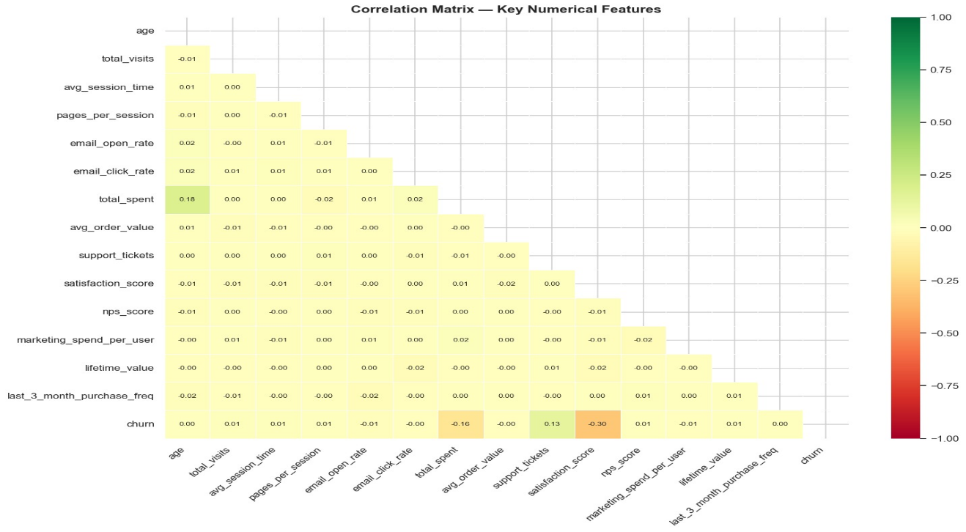
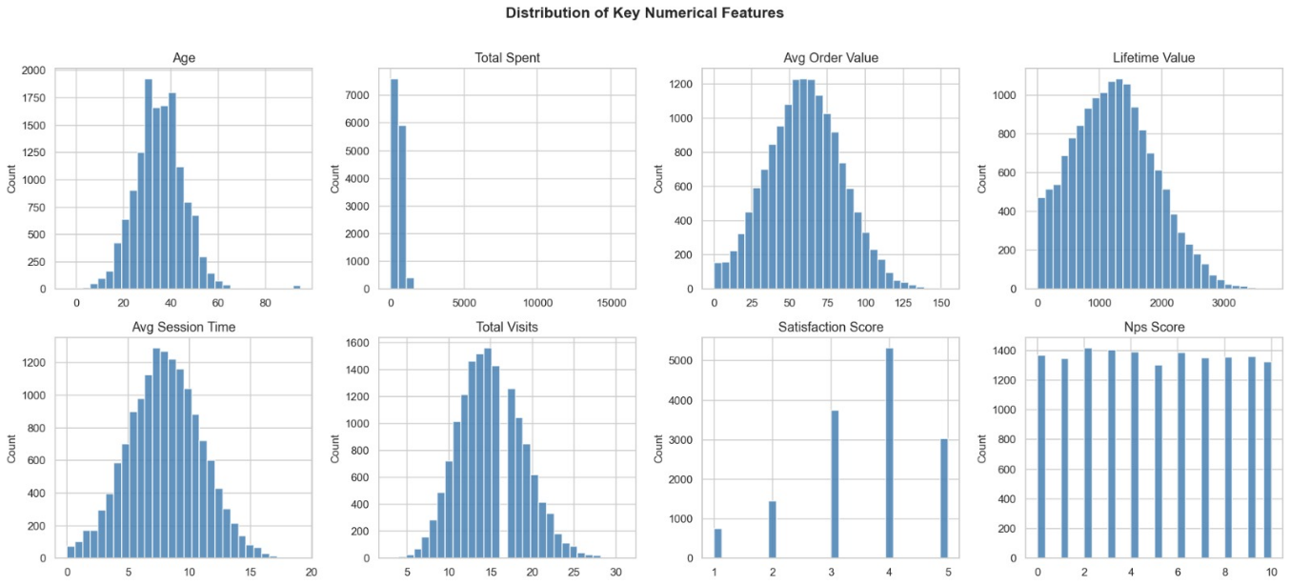
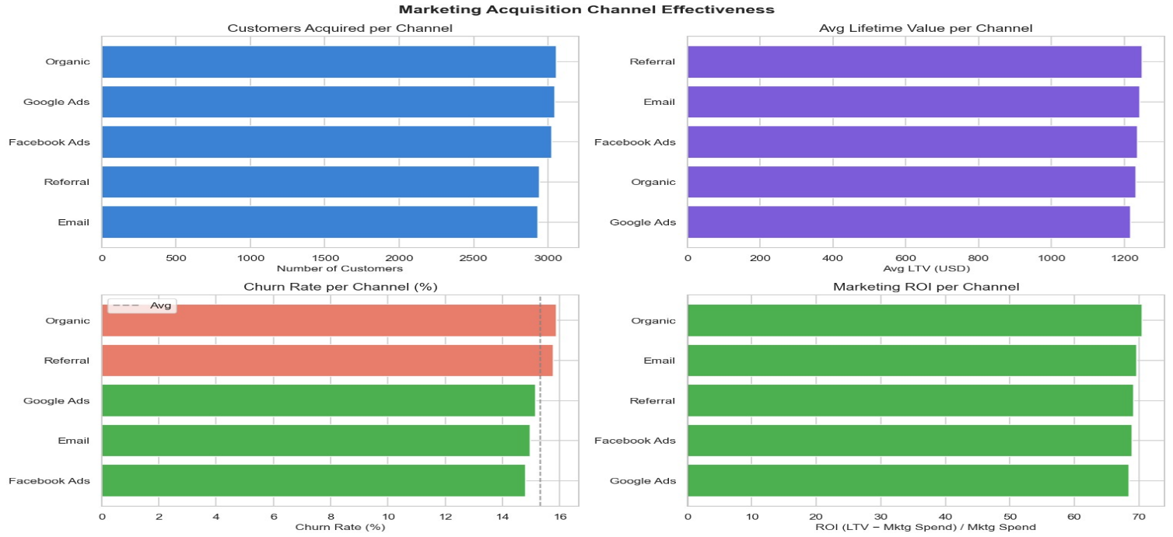
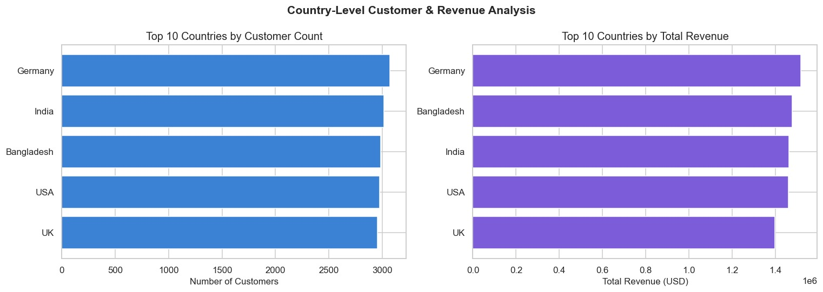
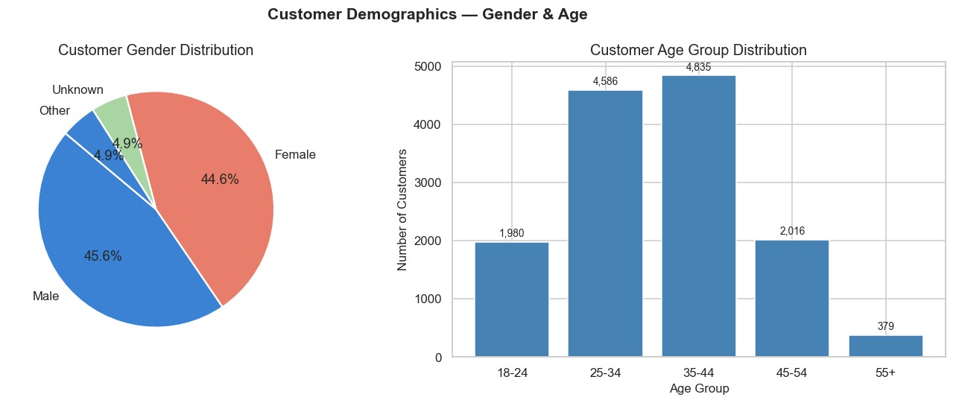
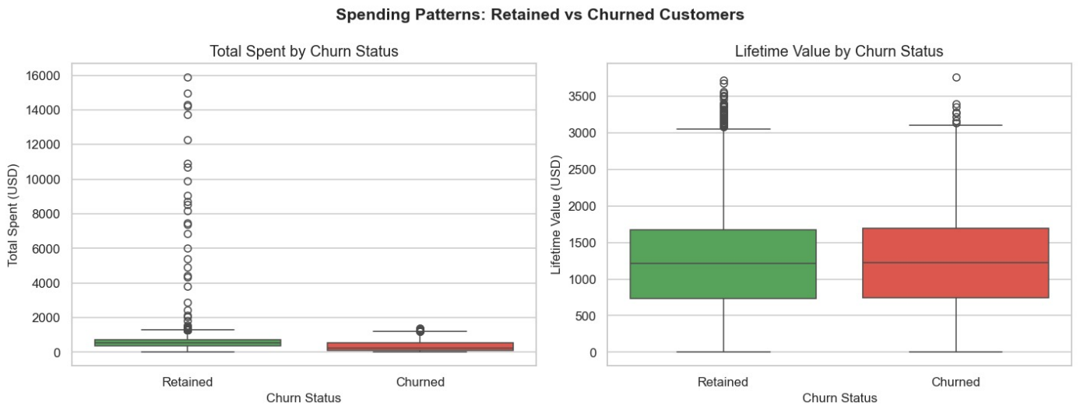
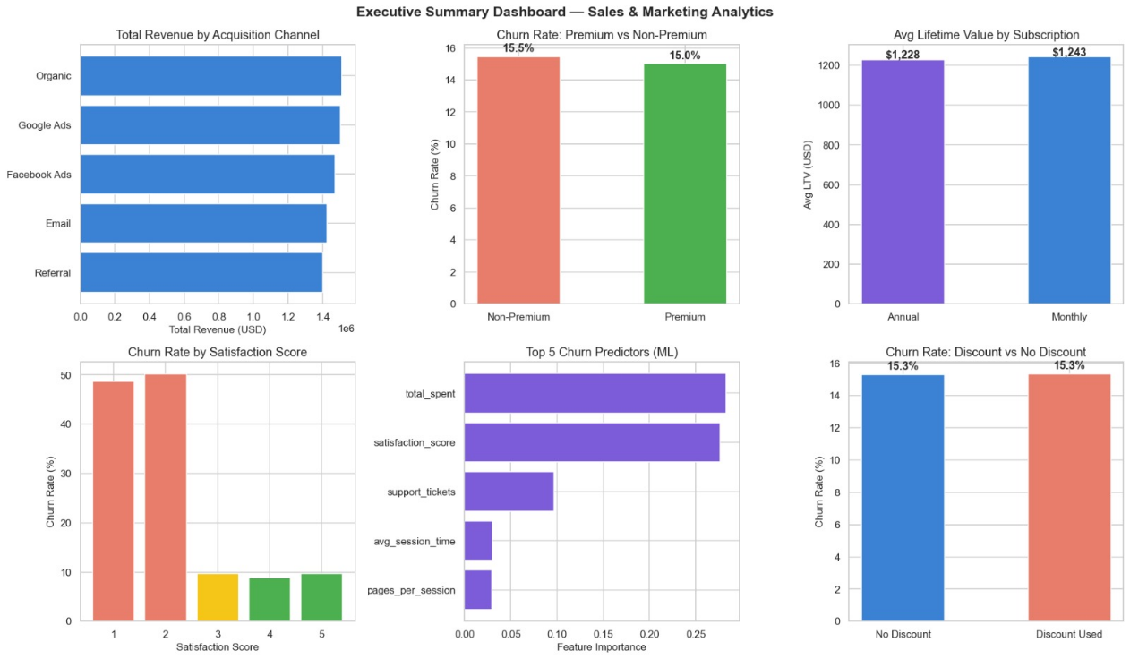
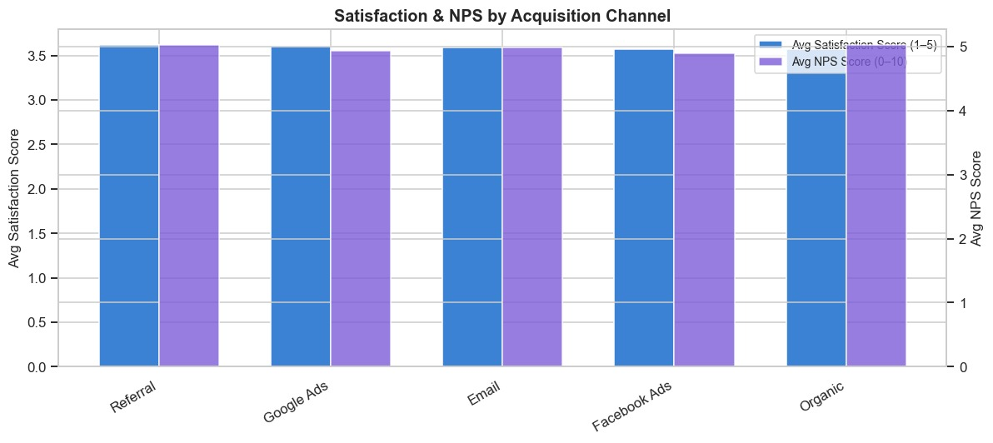
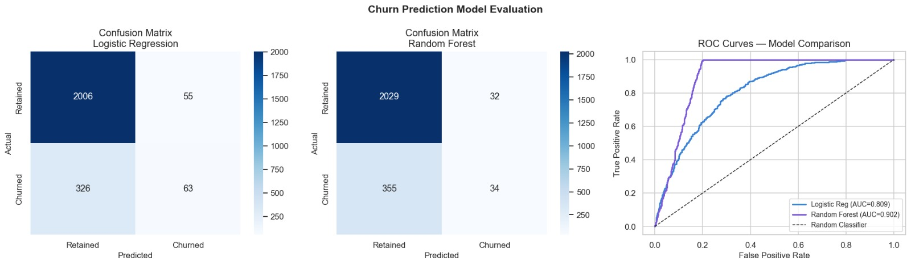

— END OF REPORT —
Submitted by: Prakash Maiti
IBM SkillsBuild — Data Analytics with AI Internship

