**Project Structure:**

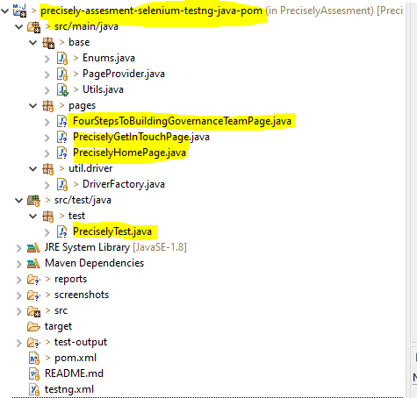

**Total 2 Test cases :** Both are passed. Please have a look below

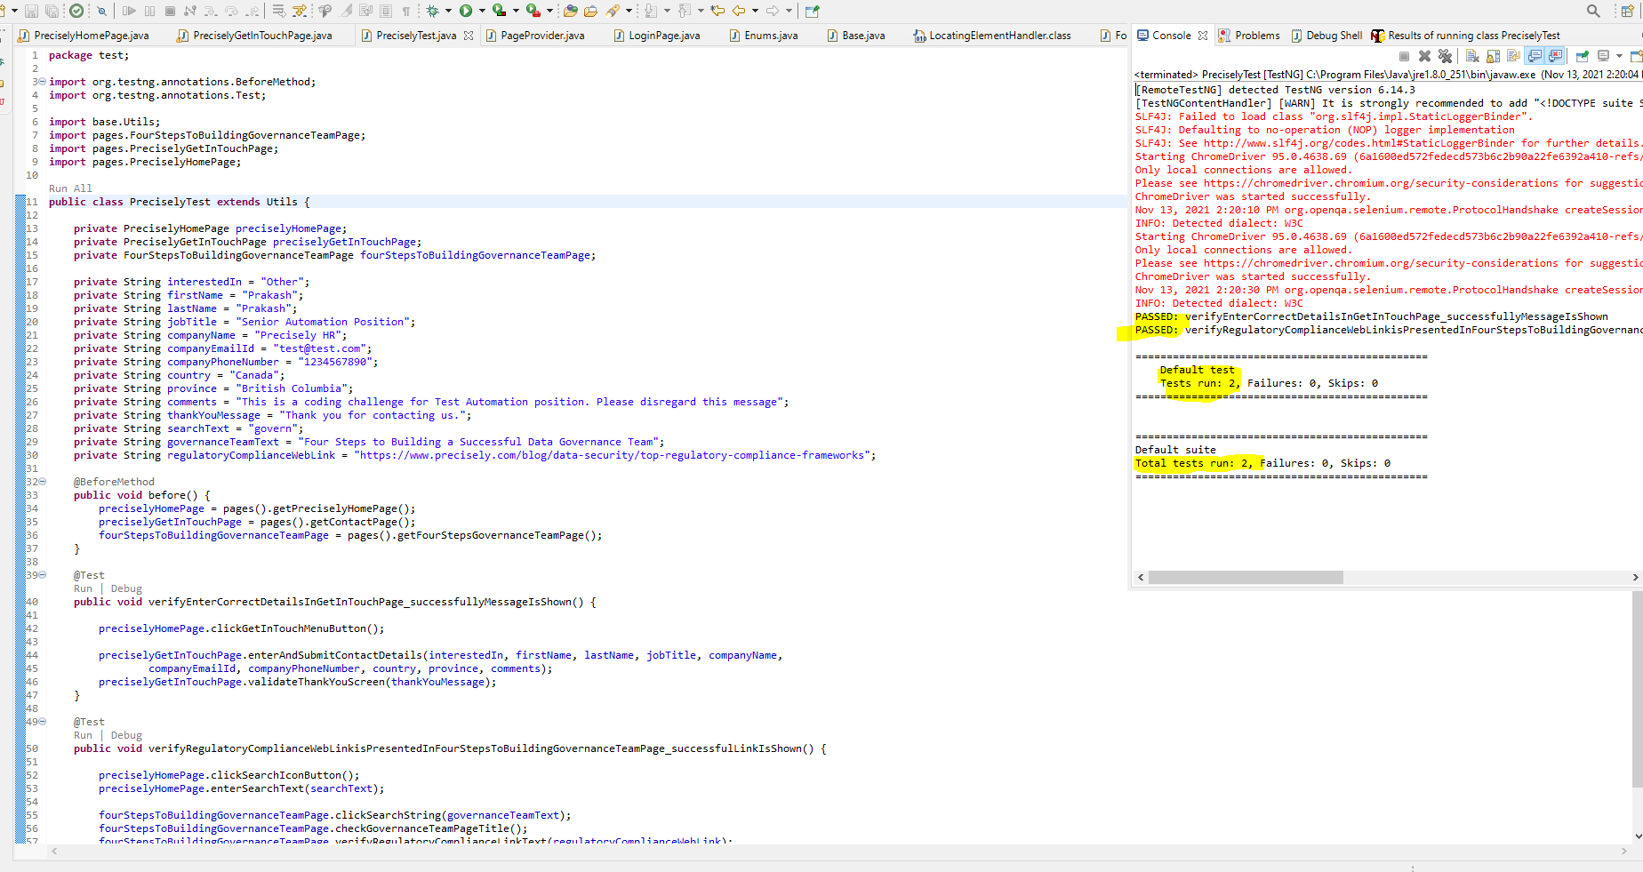

**Test Report:**

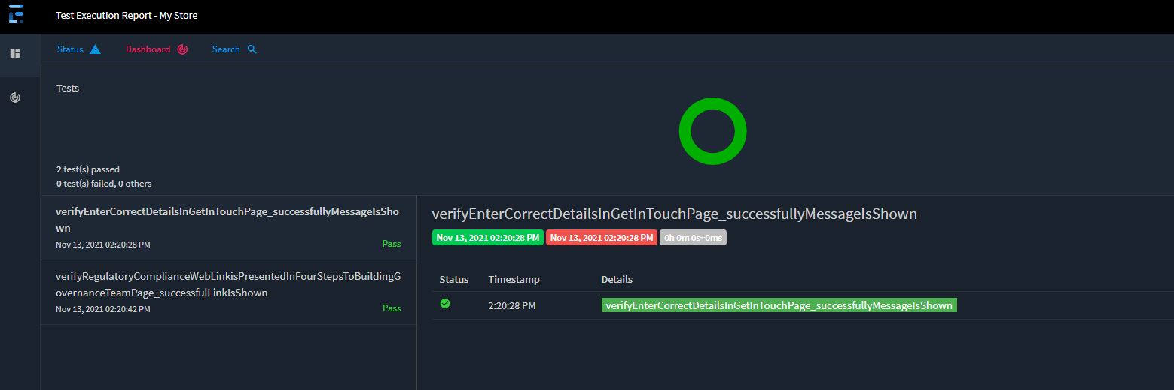

**Test case1:**

**Step1 &2:**

1. Go to the main page <https://www.infogix.com/> ( url redirects to [precisely.com](http://precisely.com/) website)

2. Click on "Get in Touch" in the menu at the top of the page

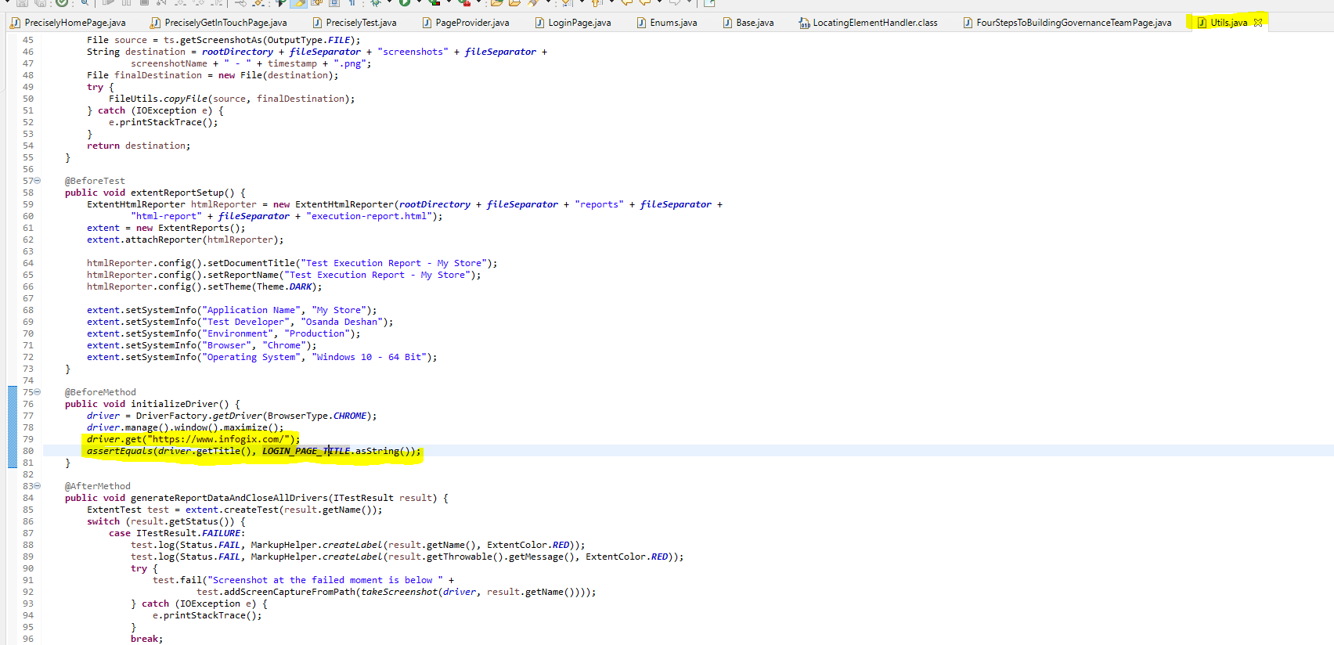

**Step3:**

Fill in the form, the following fields should

have these details, the other fields can be filled in

as you wish.

How can we help with: <General Enquires>

First Name: <your name>

Last Name: <lastname/repeat name>

Company name: "Precisely HR"

HQ Location Country: "Canada"

Comments:

"This is a coding challenge for Test Automation position. Please disregard this message"

**Step4:** Submit form

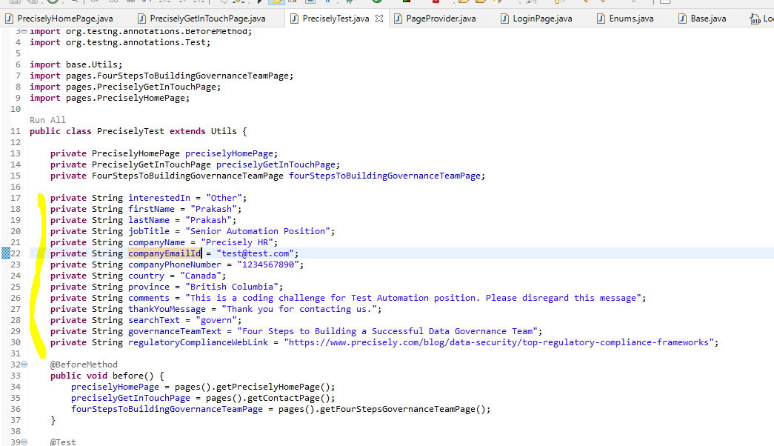

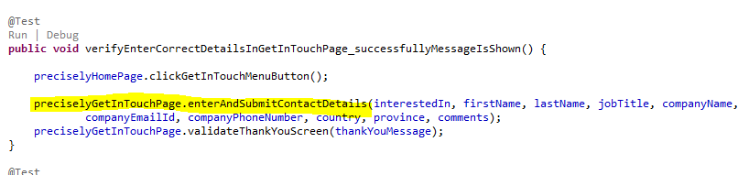

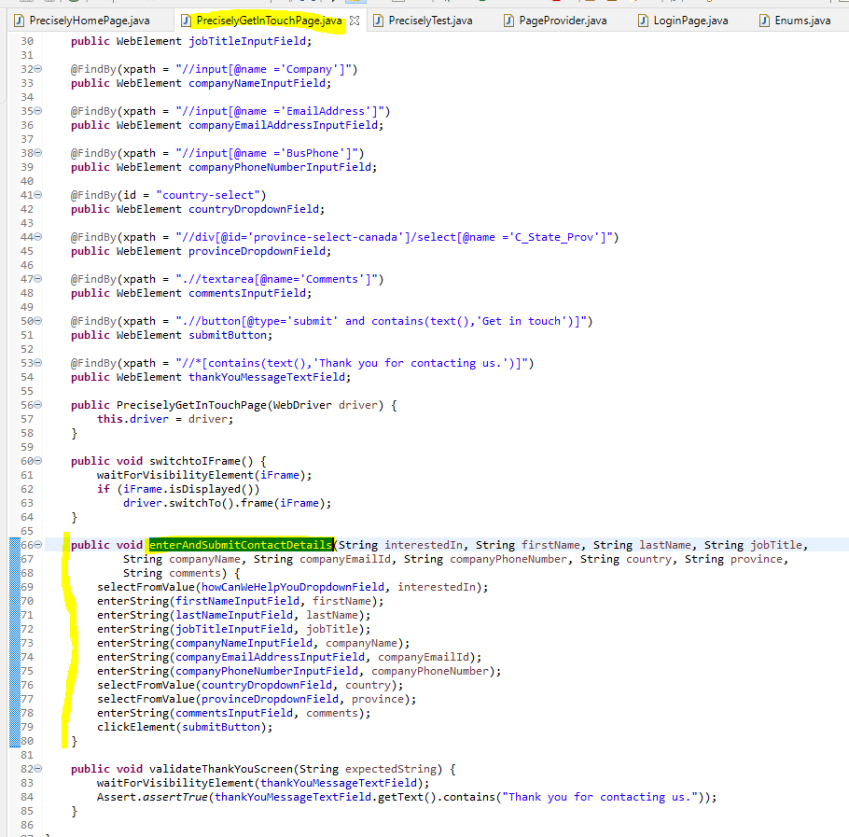

**Step5:** Check for "Thank you for contacting us" on page

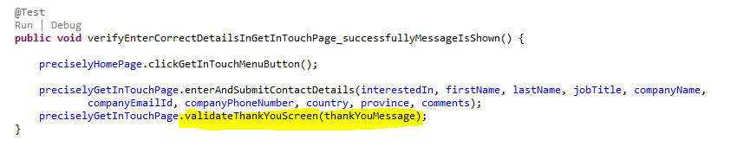

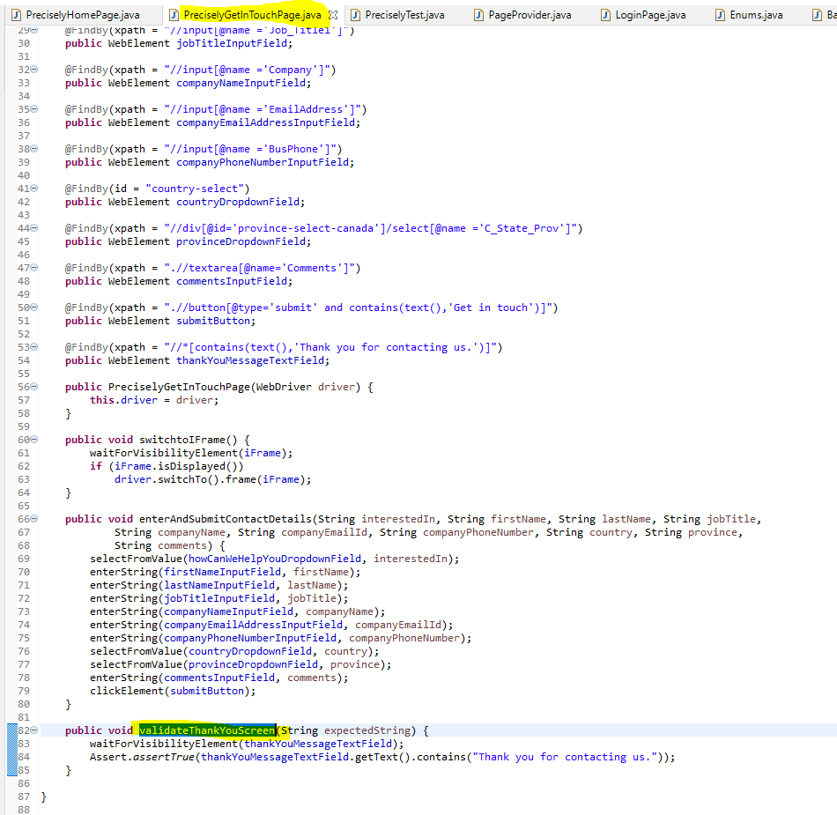

**Testcase2:**

**Step1 &2:**

1. Go to the main page <https://www.infogix.com/> ( url redirects to [precisely.com](http://precisely.com/) website)

2. Click on "Get in Touch" in the menu at the top of the page



**Step3:** In the search on the top right, search for the text "govern"

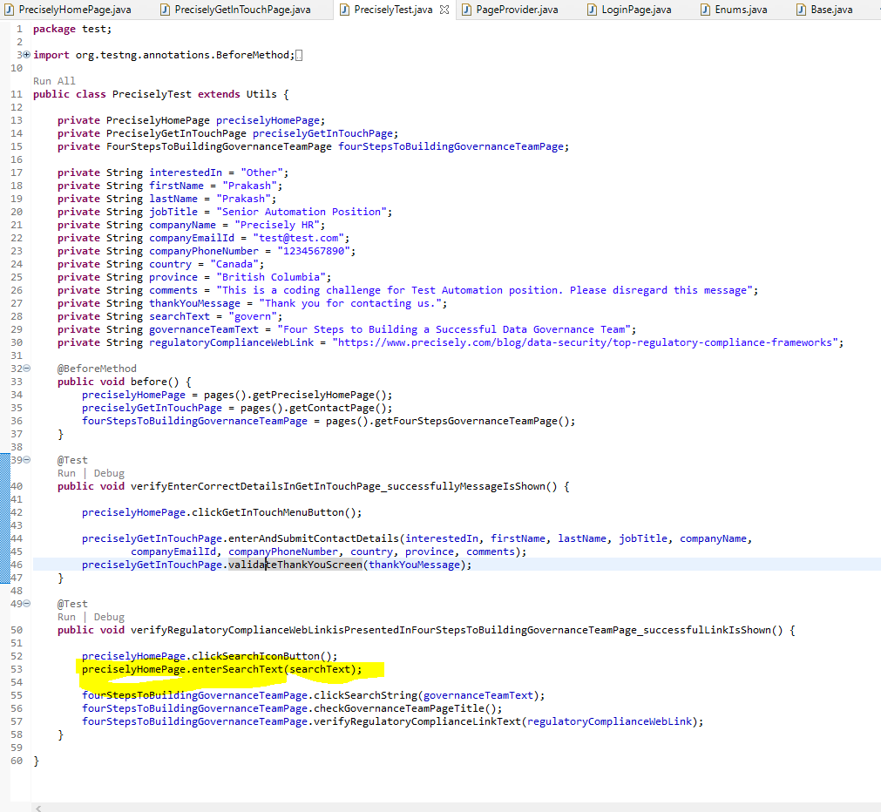

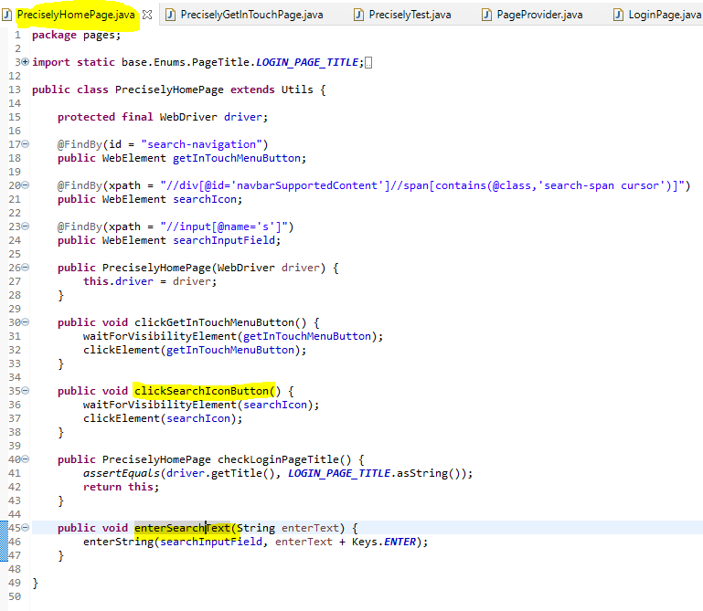

**Step4:**. In the search results, click on "Building Data Trust with Strategic Data Governance".

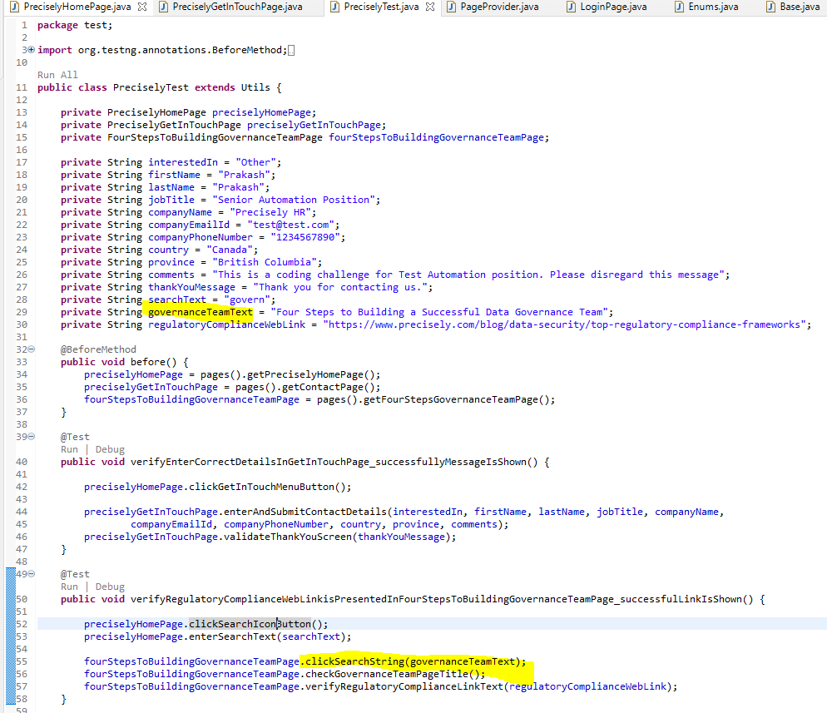

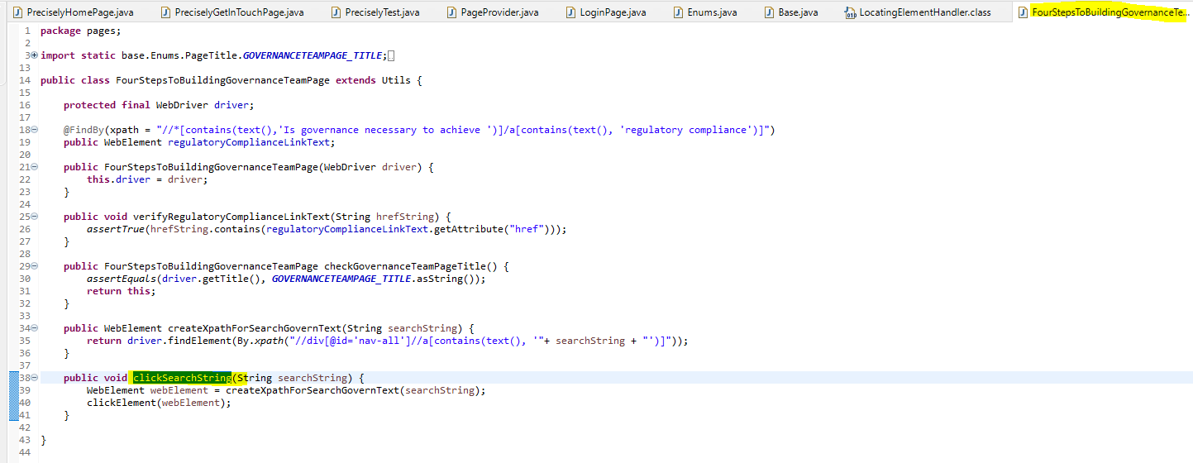

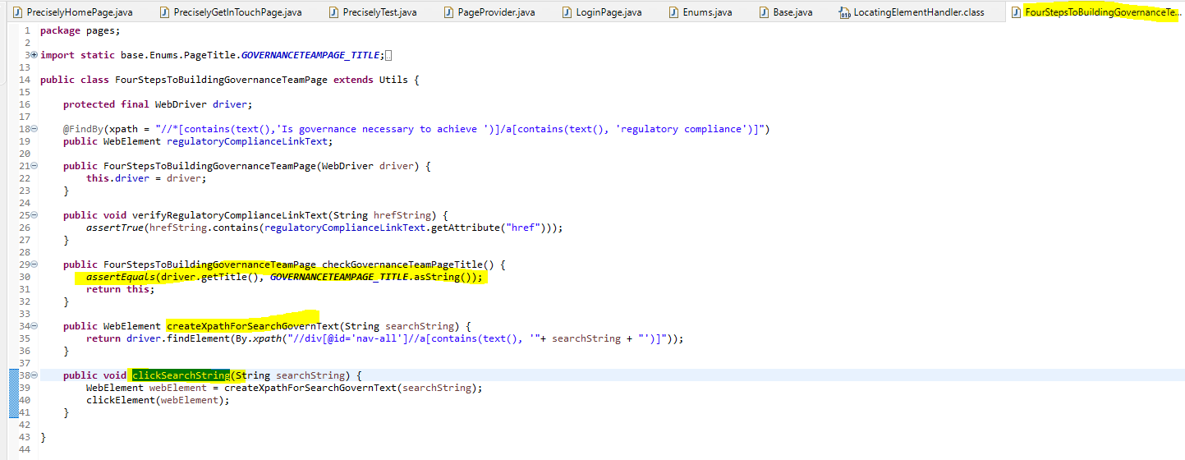

**Step5:**. Verify if the link "regulatory compliance" is targeting <https://www.infogix.com/solutions/regulatory-compliance/>

