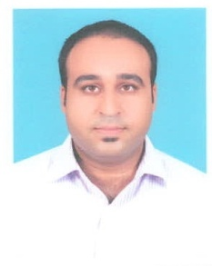
Ali Imam

Zubair House, 38-A 6/7 Altaf Town Multan

03007326002

ali.mirzabeyg75@gmail.com
Profile Summary | - Experienced professional with a career in banking, business development, audit and credit administration.  - Excel at interfacing with others at all levels to ensure organizational goals are attained.  - Possess excellent interpersonal, analytical, and organizational skills.  - Excel within highly competitive environments where leadership skills are the keys to success.
Personal Information | Father Name: Zubair Anwer Baig  Date of Birth: 25.10.1982
Banking Employment | Habib Bank Ltd, Multan

Assistant Manager Credit,HBL Multan,(2015-2017)
- Credit Loan Marketing
- Processing of Documents
- Site visit
- Redemption of Property
- Handling Insurance Policies

Asssistant Manager Credit .Administration.Department Corporate,HBL Multan(2009-2015)
- Co-ordination with Relation Ship Managers
- Co-ordination with Muccadam Companies
- Insurance Handling
- Documentation of Limit
- Pledge maintenance
- Stock inspection
- Pledge maintenance of Limit in a system

Asssistant Manager internal Audit, HBL Multan ( 2007 to 2009)
- Conducting audit of branches
- Investigation of Mishaps
- Conducting Exercises from Head Office.
- Branch inspection

Business Development Officer at HBL (2005 to 2007)
- Marketing of Liability Products
- Deposit mobilization

Audit and Account Officer at Khan Property Developers (2002-2005)
- Conductiong internal audit
Education | Masters Of Business Administration  Bahaudin Zakrya University, Multan |  | 2003-2005
Bsc Computers
Bahaudin Zakrya University, Multan 1999-2001

References Will be Provided on request.

