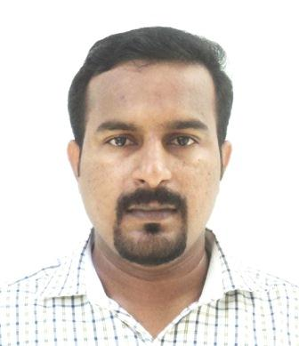
AJITH SASIKUMAR
S.K bhavanam, Erezha South,
Chettikulangara (P.O) Mavelikara,
Alappuzha (district) Kerala, INDIA, Pin-690 106
Phone: 00960-7858359 (Maldives)
E-mail: skajith84@gmail.com

Career Objective

- To be faithful in the utilization of my talents and services creating a distinctive identity in the firm and to enhance my personal and intellectual growth.

- To obtain a teaching position at the middle school or secondary level.

Summary of Qualifications

- Scored an overall score of 6.5 out of 9, in IELTS examination conducted by IDP AUSTRALIA.(2009)

- Doing MA Education [IGNOU, NewDelhi]

- B.Ed. (Natural Science) (2006) MAHATMA GANDHI UNIVERSITY, KOTTAYAM.

- B.Sc. (Botany and Environmental science) (2004) D.B Pampa College, Parumala, Mannar, MAHATMA GANDHI UNIVERSITY, KOTTAYAM.

- Computer Diploma in Information Technology (DIT) (2002)

Achievements and skills

- Very proficient in the use of computers and programs, Skill to work with Microsoft word, PowerPoint and excel and worked with other education support softwares.

- Implemented a positive discipline plan which promoted student responsibility, problem solving skills, and student accountability.

- Received 5 years intense training with National Cadets Corps (NCC) under the Ministry of Defence, Government of India during school and university levels and was awarded with prestigious ‘C’ Certificate with grade A.

Professional goals
- Seriously committed to be the best teacher for each group of students if provided with opportunity.
- To have positive influence in the lives of my students, their parents, and my fellow colleagues.

Professional Experience

2007-Present (10 years)
- Currently working with the Ministry of Education, Republic of Maldives, as a Teacher in Biology ( UNIVERSITY OF CAMBRIDGE, GCSE SYLLABUS)

2004-2005 (1 year)
- Worked as a Science Teacher in Sri Sai Public School, Secunderabad (Indian Council for Secondary Education(ICSE))

Areas of Interest

- Teaching of Science, incorporating values of nature and environment, motivating students of all levels.
- Curriculum development that fit every student and their background.
- Cooperative learning, language experience approach, hands-on/minds-on experiences, and interdisciplinary teaching.
- Innovative projects incorporating nature and science.
- To teach student in private or in an institutional level.

Personal details:

- Date of Birth : 11 – 02 – 1984
- Age : 32 years
- Sex : Male
- Martial Status : Married
- Nationally : Indian
- Linguistic Skills : English, Hindi and Malayalam
- Passport No : Z 3451682

References:
- Mr. Anish Kumar, Retired Vice Principal, D.B.Pampa College, Mannar, KERALA, INDIA
Mobile: 0091 9447455435

- Mr. Shyju George, Teacher coordinator, Baa Goidhoo School. Baa atoll, Republic of Maldives.
Mobile: 00960 9943797

