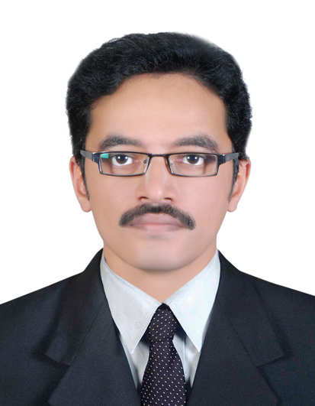
M. Linuraj,
Mobile :+96879368817(Oman), +919446434813, +917034018836, +919567847439
E mail : mlinuraj@gmail.com ; Skype : mlinuraj
Permanent Address
Raj Sadanam, Muttukudukka, Prakkanam P.O., Pathanamthitta- 689643, Kerala.

Summary
- I am a Graduate Mechanical Engineer with 8 years of gulf experience in Maintenance Management of critical assets. I am seeking opportunities as a Facilities Manager in Dubai that strongly emphasize my qualifications and experience in the field.

Organizational Experience
- Senior Mainenance Engineer
Al Mansoor Inernational, Al Dhahira Governorate (Oman), Full Time December 2017 to Present
- Managing MEP, Instrumentation, Civil department activities.
- Monitoring of municipal well field water production, RO plant production and consumption rates at Tanker filling stations
- Develop and maintain standard operating procedures, contingency plans, emergency response procedures, preventive maintenance programmes and all technical documentation
- Coordinating with third party contractors for inspection and certifications
- Monitoring inventory and coordinating with procurement for material stock.
- Junior Engineer
FARNEK Total Facilities Management LLC, Dubai (UAE), Full Time June 2015 to June 2017
- Carry out maintenance activities through CAFM.
- Develop and maintain standard operating procedures, contingency plans, emergency response procedures, preventive maintenance programmes and all technical documentation
- Perform CM, RM, DM, TR activities
- Maintain critical equipments in utmost condition
- Coordinating with other departments to carry out maintenance shutdowns.
- On time delivery of services and report submission.
- Coordinating with external sub-contractors for outsourced works.
- Preparing permits and enforcing it in day to day activities.
- Management & achievement of Service level Agreement (SLA), Key Performance Indicators (KPI), Point Rating System (PRS) & above all customer satisfaction.
- Assistant Facilities Engineer
Al Asmakh Facilities Management, Al Waab, Qatar April 2012 to April 2014
- Overall responsibility for all maintenance activities including annual maintenance contracts, breakdown maintenance of all equipment, and preventive maintenance systems
- Follow up of AMC, invoices, quotations, LPO.
- Coordinate renovation bidding, define the cost and scope of the project, and oversee the general contractor and subcontractors to ensure quality work is performed cost effectively
- Ensure monthly safety inspections take place and employees are trained accordingly
- Conversant with preopening activities, preparing snaglist and handover procedures to real estate development authorities.
- Managing parts & equipment inventory and petty cash (< QR 1500 (eq to Rs 24000) ).

- Assistant Piping Engineer
Larsen & Toubro Ltd, Ras Laffan, Qatar January 2009 to March 2010
- Fabrication of pipe supports as per standards and rectification works if required.
- Supervising sites and assuring compliance to project requirements, shop drawings and details.
- Preparing site progress reports, site surveys, schedules, etc.,
- Coordinating with warehouse for delivery, attending meetings with client, ensuring that project
schedules and planning are being followed up.
- Fabrication Engineer
Gama Industry Arabia Ltd, Rabigh, Saudi Arabia January 2007 to September 2008
- Fabrication of pipe spools as per SAUDI ARAMCO standards and material inspection
- Co-ordinating with Quality control for conducting NDT tests as PT,RT,MT,UT and thereafter performing necessary rectification of spools.
- Assuring follow up of project schedules and planning.
- Coordinating with site engineers for effective execution of scheduled work.
Academic Qualification
2011-12 : PG Diploma in Engineering Management from Indian Institute for Production Management (IIPM), Orissa, India with CGPA 3.92 / 5.0
2001-05 : B.Tech. in Mechanical Engineering from Cochin University, Kerala, India with 68.36%
Professional Courses
- Diploma in Elevator Technology from TUV Rheinland NIFE Academy Pvt. Ltd., Kerala
- Master Diploma Mechanical Design, Analysis and Management from CADD Centre Training Services, Habsiguda, Hyderabad, Andhra Pradesh, India
Short-term Trainings
- Managing Safely from IOSH - 3 days training at Burj Kalifa, Dubai
- Auditing Quality Management System – ISO 9001:2008 – 3 days training by Qatar Design Consortium at Regency Business Center, Doha, Qatar
- Auditing Occupational Health & Safety Management System – OHSAS 18001:2007 - 3 days training by Qatar Design Consortium at Regency Business Center, Doha, Qatar
Skills
FM services of High Rise tower, Residential properties (CHW system, S/pool, Domestic Water supply & Drainage system, Gas condensing Boilers, Solar Water Heating)
Occupational Health & Safety
Piping spool & supports fabrication
Interpretation of drawings & drafting (Autocad)
MS Excel, Word, Project
Personal Details
Age / Sex / Marital Status / Nationality 34 Years / Male / Married / Indian
Languages known English - Read, Write, Speak
Hindi - Read, Write, Speak
Malayalam - Read, Speak
Declaration
I hereby declare that all the information furnished above is true to my knowledge and I take complete responsibility for any false information.

M. Linuraj

