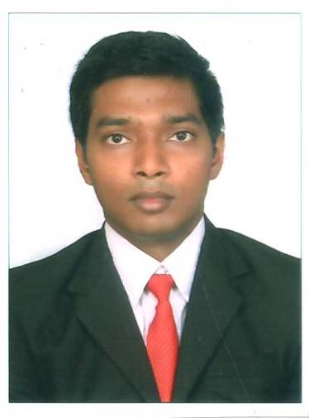
CURRICULUM VITAE
 | Position applied for FOOD & BEVERAGE SERVICE PERSONNEL
 | Course BACHELORS IN HOTEL MANAGEMENT & CATERING TECHNOLOGY
 | Session 2014-2018 |  |  |  |  |  | Reg. No. 1464076
PERSONAL  PROFILE |  |  |  |  |  |  |  | FIRST |  |  |  |  |  |  |  |  |  |  |  |  | MIDDLE |  |  |  |  |  |  |  |  | SURNAME
PERSONAL  PROFILE | Name |  |  |  |  |  |  | SHASHIKANT
 | Father’s Name |  |  |  |  |  |  | BABU JAN MAHTO
 | Address |  |  |  |  |  |  | AT+PO AMLABAD COLLIERY, DIST- BOKARO, JHARKHAND, 828302
 | Tel. No:8051208656 |  |  |  |  |  |  |  |  |  |  |  |  |  |  |  | E-mail |  |  |  |  |  | : Shashikantb68@gmail.com
 | Date of Birth |  |  |  |  |  |  |  |  |  |  |  |  |  | Sex |  |  |  |  | Nationality |  |  |  |  |  |  |  |  | Pass Port No. M5287540
 | D | D | M | M |  | Y |  |  | Y |  | Y |  | Y
 | 0 | 5 | 0 | 5 |  | 1 |  |  |  | 9 | 9 |  | 5 |  | MALE |  |  |  |  | INDIAN |  |  |  |  |  |  |  |  | Valid up to ; |  |  |  |  | 26.07.2027
EDUCATIONAL  DETAILS | School / College / Institutions  attended & Place |  |  |  |  |  |  |  |  |  | Duration |  |  |  |  |  |  |  |  |  |  | Board / Council / University |  |  |  |  |  | Qualification  attained |  |  |  |  |  |  | % age  / GPA
EDUCATIONAL  DETAILS |  |  |  |  |  |  |  |  |  |  | From |  |  |  |  | To
EDUCATIONAL  DETAILS | N.S.H.M KNOWLEDGE CAMPUS, DURGAPUR |  |  |  |  |  |  |  |  |  | 2014 |  |  |  |  | 2018 |  |  |  |  |  | M.A.K.A.U.T |  |  |  |  |  | B.H.M.C.T |  |  |  |  |  |  | PURSUEING
 | RASHTRIYA KISAN COLLEGE |  |  |  |  |  |  |  |  |  | 2012 |  |  |  |  | 2014 |  |  |  |  |  | B.S.E.B |  |  |  |  |  | HIGHER SECONDARY |  |  |  |  |  |  | 50.6%
 | K.M.ACADEMY |  |  |  |  |  |  |  |  |  | 1999 |  |  |  |  | 2011 |  |  |  |  |  | C.B.S.E |  |  |  |  |  | SECONDARY |  |  |  |  |  |  | 76%
OTHER  QUALIFICATIONS/  SKILL SETS | BASIC COMPUTING SKILLS
AREA OF SPECIALISATION
AREA OF SPECIALISATION | FOOD & BEVERAGE SERVICE
LANGUAGE  PROFICIENCY |  |  |  |  | ENGLISH |  |  |  |  |  |  |  |  |  |  | HINDI |  |  |  |  |  |  |  |  |  |  |  |  |  |  |  | BENGALI
 |  |  |  |  | READ |  |  |  |  | WRITE |  | SPEAK |  |  |  | READ |  |  | WRITE |  |  |  |  |  |  | SPEAK |  |  |  |  |  | READ |  |  | WRITE |  |  | SPEAK
 | EXCELLENT
 | GOOD
 | AVERAGE

EXPERIENCE  INDUSTRIAL /  VOCATIONAL | Name of the Organisation |  |  |  | Duration |  | Depts. |  | Remarks
EXPERIENCE  INDUSTRIAL /  VOCATIONAL | HILTON HOTEL, CHENNAI |  |  |  | 22 WEEKS |  | F & B SERVICE,  KITCHEN, HOUSEKEEPING |  | TRAINNING WAS COMPLETED SUCCESFULLY
PROJECTS  UNDERTAKEN | HOUSEKEEPING MODEL ON SUIT ROOM, THEME LUNCH ON ‘ THE GRAND TRUNK ROAD’
SEMINARS/  CONFERENCES  ATTENDED  (IF ANY) | IMPORTANCE OF ALCOHOL BY PERNOD RICARD IND. PVT, HATKON 2K15, COCKTAIL WORKSHOP BY KAPATRU ROY, SEMINAR ON “”NATIONAL TOURISM & HERITAGE””
PAPER  PRESENTATION  (IF ANY) | INDUSTRIAL TRAINNING REPORT ON HILTON CHENNAI, PRESENTATION ON CROSS CONTAMINATION
EXTRA CURRICULAR  ACTIVITIES /  HOBBIES /  AWARDS &  RECOGNITION | WAS PART OF BOY SCOUT DURING SCHOOL DAYS, ACTIVITY INCLUDES SKETCHING, HOBBY IS CRICKET(PLAYING & WATCHING)
FAMILY  RECORDS | Family  Members | Name | Qualification | Organisation  working for  with address |  | Contact  No. |  |  | Designation
 | Father | BABU JAN MAHTO | DIPLOMA | B.C.C.L, DHANBAD |  | 8002571443 |  |  | SNR.OVERMAN
 | Mother | KUMARI KIRAN LATA | B.ED | BIHAR GOVT.,  BHAGALPUR |  | 9939729422 |  |  | TEACHER
 | Date: |  |  |  |  | 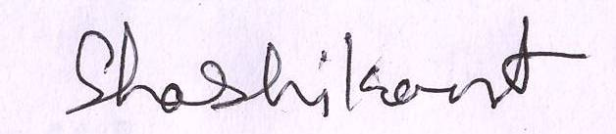
 | Place: |  |  |  |  |  |  | Signature

