CURRICULUM VITAE.

RESMI. S
Mobile no: 8075405689, 8129509323
Ernakulam, Kerala
E-mail: resmiskurup4@gmail.com

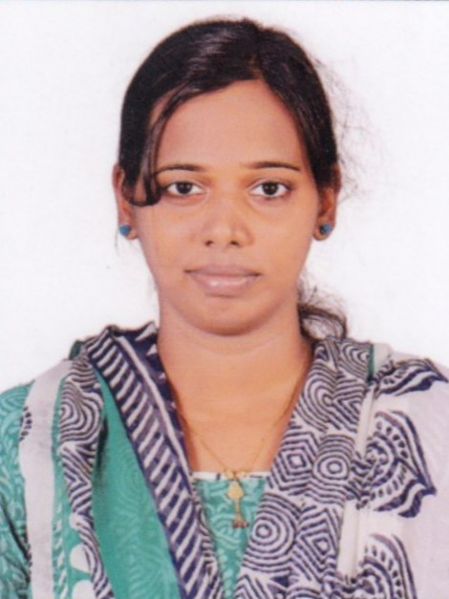

CAREER OBJECTIVE:

To establish myself as a highly skilled Nursing professional through continuous learning process. Looking for a challenging and motivating position in professionally managed organization that provide me with ample opportunity for personal growth and development and to improve my knowledge and ideas for generating outcomes that benefit mankind.

PERSONAL STRENGTHS:
- Highly motivated, confident, strong work ethics and ready for relocation.
- Ability to take decisions without being impulsive
- Ability to complete responsibilities on time
- Excellent communication and numerical skills and computer literate.
EDUCATIONAL QUALIFICATIONS:
Discipline | University/Board | Year | College/School | Percentage
S.S.L.C (10th) | Kerala State Board | 2004 | St Teresa’s C.G.H.S.S  Ernakulam | 83% Distinction.
Plus two (12th) | Board of Higher Secondary Exam., Kerala | 2006 | Sacred Heart C.G.H.S.S. Ernakulam | 63%  First class

PROFESSIONAL QUALIFICATIONS:
Discipline | University/Board | Year | College/School | Percentage
B.Sc. in Nursing | University of Calicut | 2006  To  2010 | Al- Shifa College Of Nursing,Perinthalmanna | 62%,  Second class
M.Sc Nursing pediatrics | KUHS | 2014  TO  2016 | Aswini College Of Nursing, Thrissur | 70%,  Grade A

PROFESSIONAL REGISRATION/ MEMBERSHIPS:
- The Kerala Nurses and Midwives Council :- Reg Nurse No: 53862

PROFESSIONAL EXPERIENCE:
Total years of experience: 3 years 7 months
Name of hospital | Designation | Period of experience | Department | Bed capacity
Al-Shifa College of Nursing, Perinthalmanna | Lecturer | 02-05-2017 to still working | Child Health Nursing | 450
Medical Trust Hospital, Ernakulam | Staff Nurse | 21-02-2012 to 24-02-2014 | PICU | 750
Al- Shifa Hospital, Perinthalmanna | Internship trainee | 09-05-2011 to  30-12-2011 | Pediatric Ward | 450

DISSERTATION:
“A study to evaluate the effect of computer facilitated guidance programme on knowledge and practices regarding safe administration of common pediatric drugs among staff nurses at a selected hospital, Thrissur, Kerala.”
CAREER DOMAINS ATTAINED:

- Attended workshop on "Class room management – An excellent learner reflects a sound teacher at Govt College of Nursing, Thrissur on Feb 2nd 2015
- Presented a paper on a study to assess the knowledge of mothers regarding breast feeding at PPG College of Nursing, Coimbatore.
- Attended state conference on “Advanced clinical assessment skills for nurses” at Pushpagiri College of Nursing, Tiruvalla on March 3 and 4 2015
- Attended workshop on Genetics at KVM College of Nursing, Cherthala on Jan 29th 2015.
- Organized state level workshop on “Accreditation – Enhancing Professionalism in Nursing” at Aswini College of Nursing on April 24th 2015.
- Organized state level workshop on “Nursing challenges in emerging technology- A warp speed ahead” at Aswini college of Nursing on June 16th 2016.
- Attended CNE organized by department of nursing at KIMS Al-shifa Hospital, Perinthalmanna on May 20th 2016.
- Published a study on knowledge regarding breast feeding among mothers on IOSR Journal of Nursing and Health Science Vol 5, Issue 1, Jan-Feb 2016.
- Attended continuing education programme on “Transformative education in Nursing- A challenge for complexities of learning and caring” at West fort College of Nursing on July 16th 2015.
- Attended National conference on Pediatric Onclogy on Father Muller Oncology Centre, Mangalore on Dec 12 and 13 2014.
- Attended state level workshop on “Update in research : An approach to relevant future” at Jubilee Mission College of Nursing on Jan 23rd 2015.
- Organized a state level workshop on “CRITICON : A journey through the updates in critical care” at Al Shifa College of Nursing on May 19 2017.
COMPUTER SKILLS:
- Proficient in using Microsoft word, power point, excel.
- Proficient in using Internet
PROFESSIONAL SKILLS:
- Excellent communication skills.
- Deep knowledge in care for paediatric and adult patients.
- Very efficient in handling the queries and problems.
- Proficient ability to plan and organize the coronary care unit.
- Ability to work independently.
- Profound ability to analyze, interpret and relate the medical data.
- Ability to provide direction and leadership to serve people.
- Skill to develop a relation with the patient and maintains the favourable public relation.
- Good Teaching and administrative skills
- Performing all kinds of nursing procedures and using all kinds of health care equipments and instruments
EQUIPMENTS HANDLED:

- Cardiac monitor&ECG
- Ventilator
- Defibrillators
- Syringe pump
- Ambubag
- Glucometer
- BP apparatus
- Nebulizer
- Blood Gas analyzer

JOB EXPERIENCE IN PICU:
- To give comprehensive care to pediatric patients
- Assessing child’s hemodynamic stability, level of comfort, coping ability, activity intolerance, dietary intake etc.
- Care of babies on ventilators, babies with ARDS, pneumonia, seizures, shock, burns, poisoning etc.
- Assessing the values of various laboratory tests & assessing ECG to detect any abnormalities.
- Assisting for various procedures like central venous catheter insertion, lumbar puncture, bone marrow aspiration etc
- Monitoring ECG, administration of drugs, injections, collection of blood for ABG & other investigations, monitoring intake & output, Assessing hemodynamic parameters, checking vital signs, feeding patients & keeping patient’ unit clean & tidy, syringe pump, infusion pump, pulse oxymeter, ventilator care and all other emergency life support procedures.

DUTIES AND RESPONSIBILITIES UNDERTAKEN:
DIRECT PATIENT CARE:
Admission and discharge of patients, maintaining personal hygiene and comfort of the patient, provide psychological support, attending to the nutritional needs of the patients and their activities of daily living. Maintaining clean and safe environment, carrying out doctor’s order, administration of medicines (in all routes), catheterization, NG tube insertion, suctioning, mobilization, oxygen administration, specimen collection, use of infusion pump, blood transfusion, recording vital signs, helping doctors in diagnosing and treatment. Observe change in patient condition, accurate recording and carrying out doctor’s order.
EMERGENCY MANAGEMENT:
Resuscitation, airway clearance, initiation of first aid measures in emergency situation. Preparing equipment while waiting for medical assistance that maybe required/ surgical management.

PERSONAL PROFILE
Name : Resmi. S
Date of birth : 04/11/1988
Age : 29 years
Gender : Female.
Blood group : O Positive
Marital status : Married
Nationality : Indian
Languages known : English, Hindi, Malayalam, Tamil
Correspondence address : Resmi S
Sreerangam, Thottumgathra Road
Kadavanthra P O, Ernakulam
Permanent address : Same as above.
Contact Number : (Mob.) 8075405689, 8129509323
Reference
- Dr. P Selvarani
Principal,
Al Shifa College of Nursing,
Lemon Valley, Angadippuram, Malappuram
9745106120
- Capt. Icy Joseph (Retd.)
Nursing Superintendent,
Medical Trust Hospital, Ernakulam
9349960864

DECLARATION
I hereby declare that the details furnished above are true to the best of my knowledge and belief.

Place: Ernakulam
Date : 11/7/18 Resmi . S

