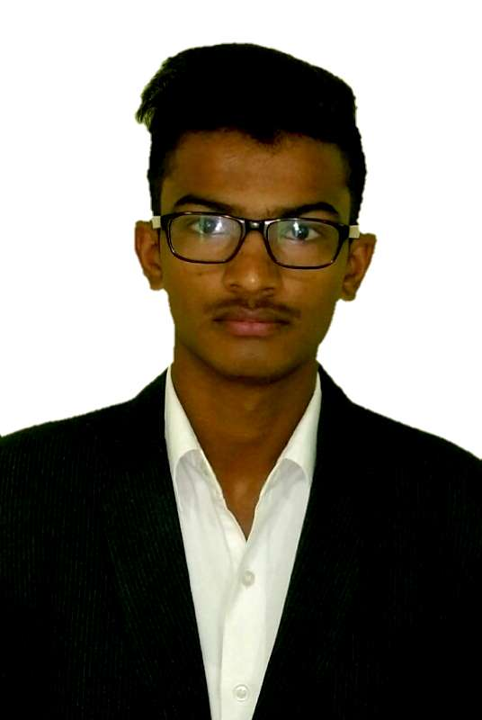

PERSONAL DETAILS

Name: Shabaj Salim Mulani
Date of Birth: 15/09/1996
Nationality: Indian

OBJECTIVES

- To gain professional competence in the field of Hotel Industry, either for an Hotel or in the Food Production department of a specialist Hotels.
- To extend my skills in working in a project.
-To get an insight into the Hotel labour procedures

Experience details

Company: The Regent
Department: Kitchen
Experience: 02/2017 To Till date

ACADEMIC ACHIEVEMENTS

Sr.No. | Qualification | Institute Name | University/Board | Percentage | Year Of Passing
1 | B.Sc.H.S | Iibm College of Hotel Management | Pune | Appeared | 2016-17
2 | 12th | Fattechand Jain Vidyalaya & Jr. College | HSC | 53.23 | 2014
3 | 10th | Fattechand Jain Vidyalaya & Jr. College | SSC | 62.40 | 2012

ADDITIONAL SKILLS, EXPERIENCE & AWARDS

- Training in Radisson Blu Hotel, Jaipur, India
- Played inter collage level football championship.
- Participated in Collage FOOD FESTIVAL to increase skill levels

COMPUTER & LANGUAGES

Languages: English, Marathi, Hindi

Computer Skills: MS Office, Ms word, Power Point

EXTRA CURRICULAR ACTIVITIES & HOBBIES

- Playing Cricket, Football
- Listening Songs
- Cooking, Baking

