**BIBIN CHERIYAN**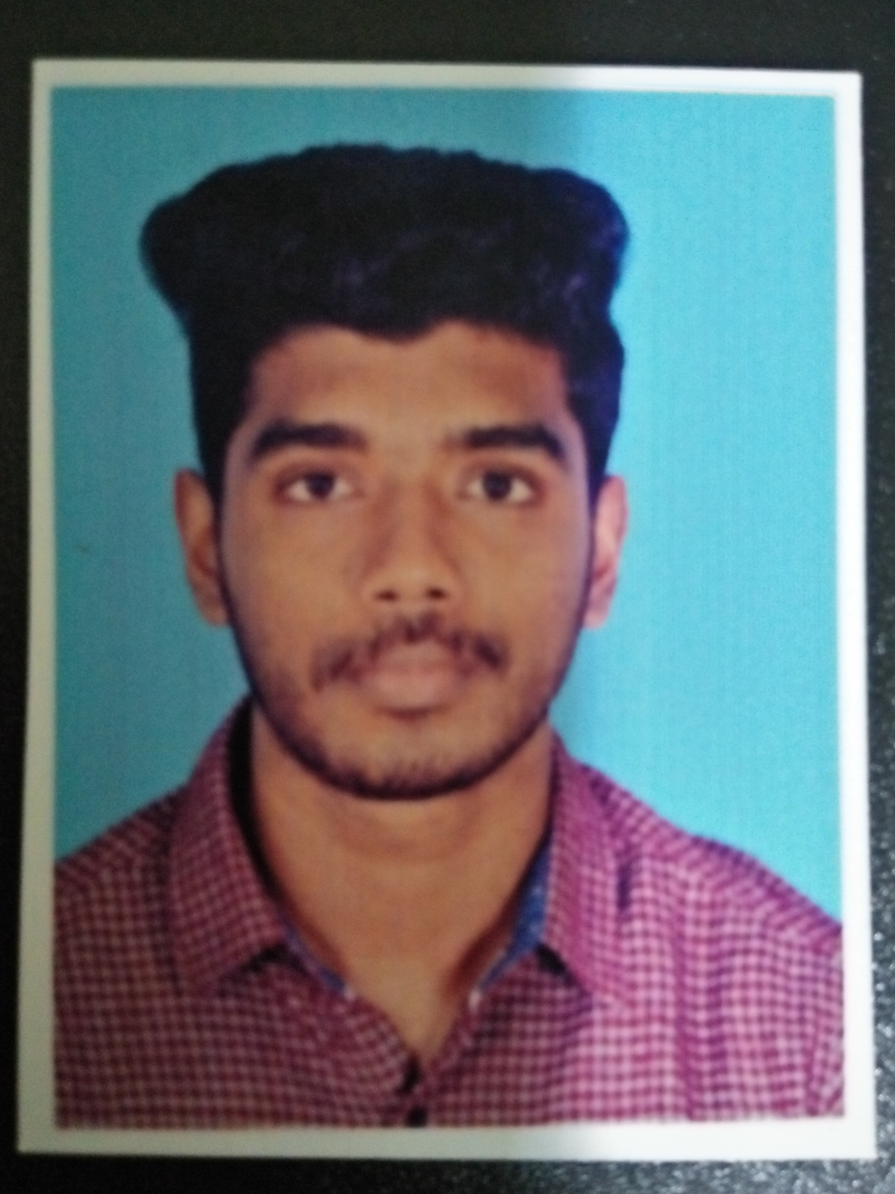

bibincherian14@gmail.com

8848805644

# CAREER OBJECTIVE

To have a growth oriented and challenging career where I can contribute my knowledge and skills to the organisation and enhance my experience through continuous learning and teamwork.

# SKILLS

•Team player with good leadership qualities

•Quick learner

•Good communication skills

•Problem solving ability

**DIGITAL COMPETENCE**

Java, MySQL, AutoCAD,Microsoft office tools,

# EDUCATION

|  |  |  |  |  |
| --- | --- | --- | --- | --- |
| Degree/Course | Institute/ College | University/ Board | Percentage/ CGPA | Year of Passing |
| BE-Mechanical and automation engineering | P.S.N  ENGINEERING COLLEGE | ANNA  UNIVERSITY | 6.4% | 2018 |
| CLASS 12 | Govt.HSS Thevanoor,Ayoor | KERALA STATE HIGHER SECONDARY BOARD | 82% | 2014 |
| CLASS 10 | SKVHSS Thrikanamangal,kottarakara | KERALA STATE BOARD | 84% | 2012 |

# ACHIEVEMENT

* Won prizes in school scholarships and in drawing competitions.
* Youth committee President in Church

# STRENGTHS

•Ability to do hardwork

•Handle multiple tasks

•Dedication and Responsibility

**AREAS OF INTERESTS**

* Automobile work
* Machinery customization
* Tools handling

# HOBBIES

|  |  |
| --- | --- |
| •Chess  •Soccer  •Swimming  •Socialising  **PERSONAL DETAIL** |  |
| Address | Mappilaveettil (H)  Malaeram (po),thalachira  Pathanamthitta.  Pin-689664 |
| Date of Birth | 23-03-1996 |
| Gender | Male |
| Marital Status | Single |
| Languages Known  **DECLARATION** | English, Hindi, Malayalam, Tamil |

*I hereby declare that the above-mentioned information is correct up to my knowledge and I bear the responsibility for the correctness of the above-mentioned particulars.*

## BIBIN CHERIYAN