**Career Objective**

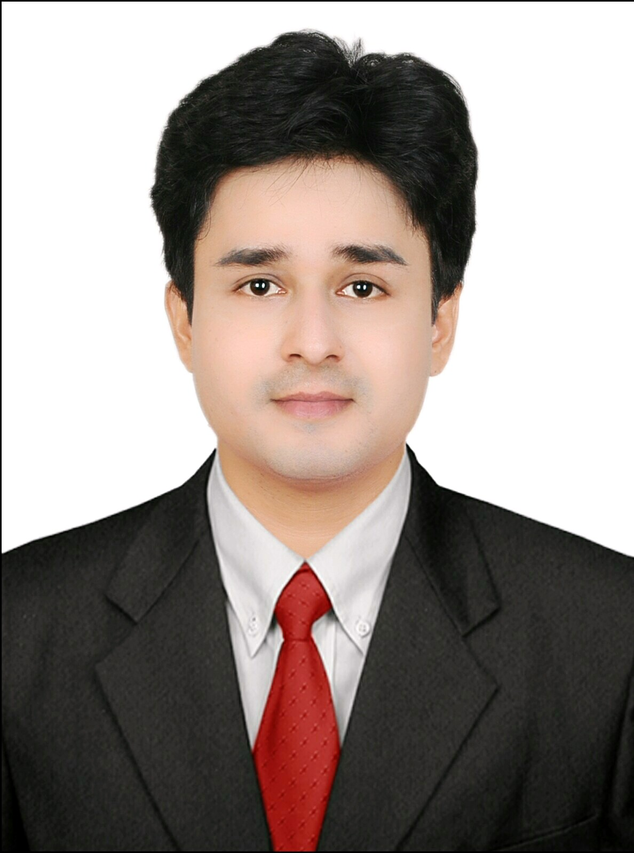

**PERSONAL DATA**

**Name Biswajit Mukherjee**

**Date Of Birth February 5, 1993**

**Address Tapas Printers Lane, Old Manbazar Road, Purulia, West Bengal,India**

**E-mail Id** [**biswajit1touch@gmail.com**](mailto:biswajit1touch@gmail.com)

**ContactNumber +91 8972180058**

Seeking a challenging career with a progressive organization that provides an opportunity to capitalize my skills and acquired knowledge and thereby contributing towards organization’s growth.

**Educational Qualifications**

* BCOM(H) – Accounting and Finance
* BHM- Hospitality Management
* Diploma in Aviation and Customer Service
* PGDM- Front Office

**PERSONAL SKILLS**

* Microsoft Office-MS word,excel,powerpoint,internet.
* Excellent written and verbal communication skills.
* Highly organised and efficient
* Leadership quality and ability to motivate.
* Ability to work independently and also with a team.

**Responsibilities/Achievements**

* Assisstant Cultural Secretary of JK College(2013-2014)
* Purulia representative in Yoga District Championship.

**Pre-Professional Experience**

* Industrial Training Intern(2015-2016), The RESORT MUMBAI, INDIA.

**EXPERIENCE**

* THE WESTIN-MARRIOTT GROUP (2016-2017)