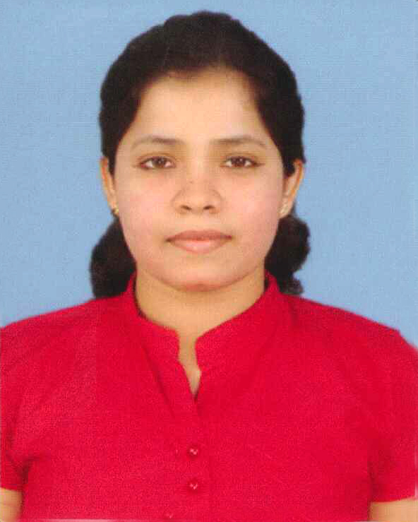Sanjeewani N. Ranathunga

Address : 326/A, Sisila Sewana, Kelimune, Mahakeliya, Kurunegala.

Phone : +94-37-2239989

Mobile : +94-77-1031852

E-Mail : nisansalaranatunga@yahoo.com

OBJECTIVE

Enthusiastic and interested to work in a challenging and growth oriented environment with a scope for learning, innovation and career development and looking for a prospect where my functional and technical competence is valued and where I can make substantial contribution to the growth of the company.

PERSONAL ATTITUDES

* Self-motivated and dynamic character with leadership qualities
* Ability to work with minimum resources
* Critical thinking in problem solving
* Achieve goals within the time frame

PERSONAL INFORMATION

Full Name : Jevendra Gamladdalage Sanjeewani Nisansala Ranathunga

Name with initials : Ranathunga J.G.S.N

Date of birth : 9th March 1987

Gender : Female

Civil status : Married

Nationality : Sri Lankan

N.I.C No : 875691422V

School attended : Vijayaba National School, Maho. (1993-2003)

Maliyadewa Adarsha Maha Vidyalaya, Kurunegala. (2003-2006)

EDUCATIONAL QUALIFICATIONS

1. B.A. Special degree in Sociology with a Second Class (Upper Division) Honors in Kelaniya University.

2. G.C.E. Advanced Level August, 2007 (Index No - 5238048)

Subject Grade

History A

Sinhala A

Economics C

3. G.C.E Ordinary Level December, 2003 (Index No - 32192339)

Subject Grade Subject Grade

English A Music C

Health and Physical education A Sinhala C

Social Studies B Commerce S

Buddhism B Science S

Mathematics C English Literature S

PROFESSIONAL QUALIFICATIONS

1. The auxiliary subjects and the Elective subjects imploded to the degree.

* **Auxiliary Subjects.**

Human Resources Management (One Semester)

English for Communication (One Year)

* **Elective Subjects.**

Psychology of leadership

Child Psychology

1. Research Project completed in Sociology
2. Completed a computer diploma course in ESOFT Metro campus
3. Completed a one year Tamil course in Ministry of cultural affairs

EXTRA CURRICULAR ACTIVITIES (SCHOOL)

1. Member of the Western Band (1999-2003).
2. Participated Sinhala and English Day competition conducted by the Ministry of Education (1998-2003)

REFEREES

N.A Aruna Wijesiri

Senior Assistant Director

Regional Development Department

Central Bank

Colombo 01.

Mobile: 071-4432980

J.G.N Thilakarathne

Provincial Director of Education

Provincial Education Office

Kurunegala.

Mobile: 071-4971266

I hereby declare that the particulars indicated by me in the curriculum vitae are true and accurate to the best of my knowledge.

Sanjeewani N. Ranathunga Date:......................................