CV

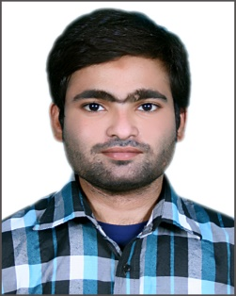

Muhammad Basit Ahmed

Mobile # 03007044604

E-mail: basit7593@yahoo.com

# **OBJECT:**

To work with a team of professional in a reputable organization that allows me to enhance current expertise and acquire new professional & technical skills.

# **ACADEMIC QUALIFICATION:**

* Inter (Pre-Engineering) Karachi Board
* Matric (science) Karachi Board

# **WORKING EXPERIENCE**:

* **TMT LOGISTICS (15 Jan 2014 to 28 March 2015)**

Working as Sales & Marketing Executive

* **CRESCENT LOGISTICS PAKISTAN Pvt. Ltd. (05 April 2015 to 10 Dec 2015)**

Working in Documentation Department.



* **PEARL CONTINENTAL KARACHI (10 Jan 2017 till Date)**

Working as Communication Officer at H2H Department

RESPOSIBILITIES

* Handling internal and external calls
* Handling guest request and complaints with problem Resolution
* Order Taking from guest for In-Room Dinning
* Handling Fire Alarm System
* Supervising the shift
* Preparing Monthly Reports of guest complaint and Request
* Training New Associates

# **COMPUTER SKILLS & OTHER COURSES:**

* MS office
* Internet
* English Language Course

# **PERSONAL INFORMATION:**

* Father Name : Muhammad Mehmood Ahmed
* Domicile/PRC : Sindh (Karachi)
* Date of Birth : 07th May, 1993
* Marital Status : Single
* Nationality : Pakistani
* N.I.C : 42201-7917959-1

# **REFERENCE:**

* **Will be furnished on request**