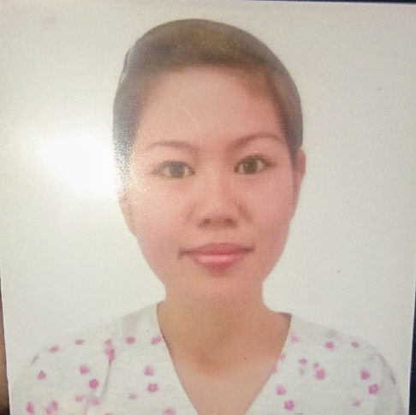

**CANDACE FRANCES CALINA, RN**

Tamalagon Tangalan, Aklan

Philippines 5612

Mobile Number: +639198476257

Email Address: leksi08@yahoo.com

**PROFILE**

A passionate Registered Nurse with almost 10 years of experience in healthcare for the people. Equipped with interpersonal communication skills while working in private and public hospitals. Applied honesty, discipline, and commitment in a competitive environment that ensured prompt, efficient, and quality services are delivered. A compassionate and effective team player who can accomplish multiple objectives even under pressure.

**OBJECTIVE**

Highly motivated, organized and attentive to details who seeks for an opportunity with interest in healthcare.

**ELIGIBILITY**

**REGISTERED NURSE**

BOARD OF NURSING

PROFESSIONAL REGULATION COMMISION

PHILIPPINES

DECEMBER 2007

**EDUCATION**

**Bachelor of Science in Nursing**

Years Attended: 2003 -2007

Iloilo Doctors College

Iloilo City, Iloilo, Philippines

**KEY QUALITIES**

 Highly motivated graduate with interest in healthcare

 Highly organized and attentive to details

 Highly determined and hardworking with open attitude and can accept criticisms who can work individually and with a team

 Able to work under pressure and accomplish multiple objectives

**WORK EXPERIENCES**

**ER/ICU Staff Nurse**

Al Adwani General Hospital

October 2013 to March 2018

* Acted as patient advocate
* Ables to draw ABG sample and interpret report correctly. Had enough knowledge about GCS and evaluation of patient condition. Assess patients' pain levels and sedation requirements.
* Prioritize nursing care for assigned patients based on assessment data and identified needs. Responds to life saving situations.
* Assist physician in delivering proper treatment and with different procedures. Consults and coordinates with health care team about patients' care plan. Administers medications. Documents patients' vital signs, treatment plans, interventions and outcomes. Monitor and record changes in patients' conditions and informs physician.

**Dental Staff Nurse**

Nahj Al Takwa Dental Clinic

2010 - 2012

* Assist dentist in preparing the appropriate materials and instruments for each treatment and ensures the availability. Ensures materials are properly cleaned and sterilized after use. Ensures patient comfort in their visit.
* Helps the dentist in recording patients' oral health condition, make appointments and in processing radiographs.

**TRAININGS AND SEMINARS**

* **Pharmacy CBAHI Standards Process of Handling Medication Errors System for Safety of LASA Medications**

Conference Hall, Al Adwani General Hospital, Taif, Kingdom of Saudi Arabia

December 15, 2016

* **Pharmacy CBAHI Standards Safe Handling of High Alert Medications**

Conference Hall, Al Adwani General Hospital, Taif, Kingdom of Saudi Arabia

June 8, 2016

* **Pharmacy CBAHI Standards**

Conference Hall, Al Adwani General Hospital, Taif, Kingdom of Saudi Arabia

May 12, 2015

* **CBAHI Standards on Medication System (Preparation, Stability and Shelf Life)**

Conference Hall, Al Adwani General Hospital, Taif, Kingdom of Saudi Arabia

April 14, 2015

* **Antimicrobial Guidelines and Restrictions**

Conference Hall, Al Adwani General Hospital, Taif, Kingdom of Saudi Arabia

January 13, 2015

* **Unit Dose System of Drug Distribution**

Conference Hall Al Adwani General Hospital, Taif, Kingdom of Saudi Arabia

December 16, 2104

**ACTIVITIES/INVOLVEMENT**

* **MEMBER**

Saudi Heart Association

National CPR Committee

August 8, 2016

**CHARACTER REFERENCE**

* **Ms. LALAINE B. MALULUYON**

Nursing Supervisor

Al Adwani General Hospital

P.O. Box 519 Taif, KSA

Email: lalaine_adwani@gmail.com

Contact Number: +966509529643

* **Ms. GENEL L. LIMOS**

In Patient Department, HEAD NURSE

Al Adwani General Hospital

P.O. Box 519 Taif, KSA

Contact Number: +966509159413

* **Ms. Aileen Sanchez**

ER Head Nurse

Al Adwani General Hospital

P.O. Box 519 Taif, KSA

Contact Number: +966581305481

* **Ms. RODEL J. LLAVE**

Total Quality Management Director

Al Adwani General Hospital

P.O. Box 519 Taif, KSA

Email: rodel@aladwanihospital.com

Contact Number: +966593368813

* **Dr. ASAAD SHETA**

ICU Resident Doctor

Al Adwani General Hospital

P.O. Box 519 Taif, KSA

Contact Number: +966543149071

* **Dr. MOHAMMAD HAMOUDA**

Consultant Cardiologist

Al Adwani General Hospital

P.O. Box 519 Taif, KSA

Contact Number: +966538690467

* **Dr. KAMIL ABBAS**

Medical Director

Al Adwani General Hospital

P.O. Box 519 Taif, KSA

Contact Number: +966503719570

* **Dr.MOHAMMED BELAL**

ICU Resident Doctor

Al Adwani General Hospital

P.O. Box 519 Taif, KSA

002010 30699882

* **Dr. MALEK ASSAFIN**

Medical Director

Al Adwani General Hospital

P.O. Box 519 Taif, KSA

* **Dr. OMAR AL OTEBI**

Marketing Manager

Al Adwani General Hospital

P.O