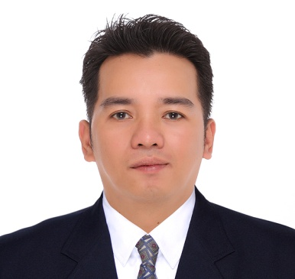**RODERICK VITERBO MIRANDA**  *Blk 4 lot 26 alora homes nova romania deparo caloocan city 09293382300*

**OBJECTIVES:**

To develop my skills, ability and knowledge that will add merits to my career. To work with a company that provides avenues to career growth.

**WORKING EXPERIENCE:**

KING JIRD SERVICES INC. Coordinator 1997-1999

SIR EDWARD MANAGEMENT INC. Coordinator January 1999-2002

SKI FIRST BALFOUR Encoder 2003-2004

YUJIN ELECTRONICS Machine Operator 2007-2011

MIJIN CHEMICAL IND. CO. LTD. MACHINE OPERATOR 2013-2014

DEASUNG ELECTRONICS Machine Operator 2014-2016

**PERSONAL BACKGROUND:**

Nickname: Eric Birthday: May 08 1977 Birth Place: San Miguel bulacan Age: 41 Sex: Male Height: 5’6” Weight: 175 lbs. Religion: Roman Catholic Citizenship: Filipino Civil Status: Married

**SKILLS:**

* Can work with minimum supervision Can work beyond schedule task Stocks montoring & ensure implementation

**EDUCATIONAL BACKGROUND**

COLLEGE: ST. john Technological college Computer Technology Novaliches Quezon city

SECONDARY: Claveria school of Arts and trade Clavria cagayan 1991-1995

PRIMARY: Union Elementary school Brgy. Union Claveria Cagayan 1985-1991

**CHARACTER REFERENCES:**

REEZHAKNIEL RUIZ Key Accounts Specialist

DARWIN TIANGCO KEY Accounts Mngr.

LITA DELA PAZ Sales Supervisor

I hereby certify that the information above mentioned are true and correct to the best of my knowledge and beliefs.

*Applicant Signature*