**SHAHRUKH SHAIKH**

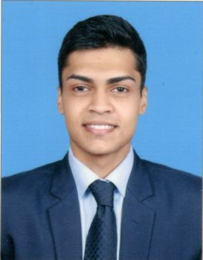**PERSONAL PROFILE**

**Gender: Male**

**Nationality: Indian**

**Date of Birth: 04/07/1997**

**Phone #: +91 7387779022**

**E-mail: sshahrukh896@gmail.com**

**Current Location: Mumbai, India**

**PROFESSIONAL ASPIRATION**

**To secure a position where by hard work, dedication and the ability to acquire new skills will advantage any company I work for. My friendly nature will enable me to fit in and complement your existing team.**

**EDUCATION AND COURSES**

|  |  |  |  |  |
| --- | --- | --- | --- | --- |
| **Course** | **Institute** | **Board/ University** | **Year** | **%** |
| **BBA(Bachelor of Business Administration)** | **Institute of Business Studies & Research**  **Belapur (W)** | **Tilak Maharashtra University** | **2018** | **70.1%** |
| **H.S.C.** | **New English Jr. college**  **Vasai(W)** | **Maharashtra State Board.** | **2015** | **68.62%** |
| **S.S.C.** | **St. John Bosco High School**  **Vasai(W)** | **Maharashtra State Board.** | **2013** | **62.20%** |

**SHAHRUKH SHAIKH**

**SKILLS AND COMPETENCIES**

**Languages: Hindi (native), English (fluent), Marathi (basic)**

**Other skills and competencies: excellent interpersonal and communication skills.**

**PERSONAL QUALITIES**

**Team Player**

**Skilled team player who adapts quickly to different team dynamics and excels at building trusting relationships with colleagues at all levels.**

**Friendly and Positive Attitude.**

**A Friendly and Positive attitude in the workplace which helps me to accomplish tasks faster and in a better manner.**

**Strong Interpersonal Skills**

**Unsurpassed interpersonal skills with a proven ability to quickly develop and maintain relationships with customers and colleagues.**

**Communication skills**

**Exhibits exceptional written and verbal communication skills, and is adept at communicating effectively with people at all levels, and in a manner appropriate to the audience.**

**Flexible to any environment**

**Able to work in any environment and will be willing to work flexible hours.**