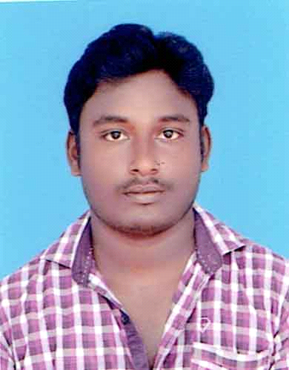

**CHINNASAMY MANIKANDAN.S**

E-mail : chinna64viru@gmail.com

Mobile : +91 – 8608191914

I would like to be the best wherever I go and in whatever I do, because “*STRIVING FOR EXCELLENCE MOTIVATES ME*”. Moreover I would like to be involved in challenging tasks where my work would lead to the development of both self as well as the Organization I work for.

* 1 year and 6 month **(2011-2012)** Experience as a “**Site Supervisor at GK CONSTRUCTION ”, Ramanathapuram – India.**
* 1 year and 7 months **(2015-2017)** Experience as a “**Site supervisor at GK CONSTRUCTION, Ramanathapuram – India.**
* Currently working and Experience as a “**Quality control engineer(contract staff, RMC Department) at INDIA CEMENTS PRIVATE LTD”, Chennai – Chennai.(from 2017)**
* My skill set includes Planning, Execution, supervision and co-ordination and further I am versed with the usage of software packages of **Auto Cad**.
* Expertise in construction projects in scheduling of Sub activities and monitoring the same, material procurement and quantity estimating.

**Organization : GK CONSTRUCTION.**

**Designation : Site Supervisor (from May 2011 to May 2012)**

* **Project** : G+2 Apartment’s,

: Ramanathapuram, Tamilnadu, India.

* **Project** : G+2 Commercial buildings,

: Ramanathapuram, Tamilnadu, India.

**Organization : GK CONSTRUCTION.**

**Designation : Site Engineeer (from May 2015)**

* **Project** : G+2 Mosque Project, **(2015)**

: Ramanathapuram, Tamilnadu, India.

* Trough study of the contract scope - BOQ, Specification and drawings.
* Preparation of Execution Plan for the project.
* Review drawings and marking at site.
* Organizing the Labors.
* Responsible for the above projects in execution of all types of civil works, including planning and scheduling of Sub activities for monitoring the same.
* Day to day activities record
* Active Co-Ordination with key consultants Liaoning agents to get the approval of the final design.
* Material procurement quantity estimating co-ordination.
* Co-ordination with design dept., quality control department and sub-contractor.
* Direct supervision of mass concrete work.
* Preparing technical submittal for approval and subcontractor finalization, quantity surveying, billing of sub-contractors and client.
* Interaction and constant follow up of materials with suppliers for receiving and getting the Status to ensure that minimum delivery time is maintained.
* Arranging client for inspection of deliverables.
* Follow all the safety guide lines

|  |  |  |
| --- | --- | --- |
| **Packages** | **Level** | **Certification** |
| Auto cad | Expert | Yes |
| Stadd pro. | Intermediate | Yes |
| Ms Office. | Expert | Yes |
| Revit. | Advanced | yes |
| Primavera | Intermediate | yes |

|  |  |  |  |  |
| --- | --- | --- | --- | --- |
| **Course** | **Institution** | **Board/ University** | **Year of Passing** | **Percentage** |
| **BE**  **(Civil Engg.)** | **Ganapathychettiar college of engineering and technology,**  **Paramakudi.** | Anna  university | Apr 2015 | **70.9 %** |
| **Diploma in Civil Engg.** | **Udhayam Polytechnic**  **College, Ariyankundu**  **Post,Rameshwaram.** | Directorate of Technical Education | Apr 2011 | **61.12 %** |
| **Higher secondary** | **Syed ammal Higher secondary school,**  **Ramanathapuram.** | Tamil Nadu Board of high. Sec. Education | Mar 2009 | **63.09 %** |

`

* **Construction Planning, Execution & management.**
* **Estimation and Quantity.**
* **Design and Technical support.**
* **Concrete technology.**
* **Bar Bending Scheduling.**
* Good Leadership Qualities & problem solving abilities.
* Excellent verbal and written communication skills.
* Ability to deal with people diplomatically.

Engineering : **1**. **PLANNING & DESIGN OF PANCHAYAT BUILDING*.***

**2. PRTIAL REPLACEMENT OF GRANITE AND BRICK FINES IN CONCRETE.**

Diploma : **PLANNING AND DESIGN OF PRIMARY HELTH CENTER.**

Name : ChinnasamyManikandan.S

Father’s Name : Selvaraj.C

Date of Birth : 06.01.1992

Gender : Male

Marital Status : Single

Permanent Address : 17A Thaimanavarkovilnorth street, vellipattinam,

Ramanathapuram ,Tamil Nadu, India. Pin - 623 504.

Nationality : Indian

Languages known : English, Tamil- (Read, write).

Passport Availability : Yes

Driving License : Yes (India)

I hereby declare that the above particulars furnished by me are true to the best of my knowledge and belief.

**Place**: RAMANATHAPURAM**Signature**

**Date: __/__/2016 (CHINNASAMY MANIKANDAN)**