**Curriculum-Vitae**

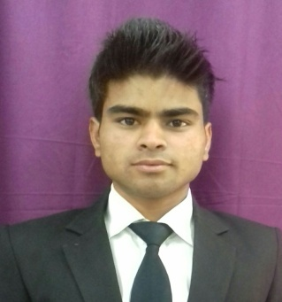**Address-**

Vill-Inder P.O-Kandikhal (Tehri Garhwal)

Pin-249131

Email-dmmahar1996@gmail.com

Contact No.-7042382114 (7579148995)

**Deepak Mahar**r

**Carrier Aim -** To harness my potential as a professional by becoming the part of fast growing organization & move up.

**Working Experience** - 6th months working (as a contract base) in vivanta by Taj surjkund delhi NCR.

**Training Experience -**6thmonths Industrial Training ALOFT Bengluru Cessna Business Park Hotel.*6thmonths job training vivantaby taj surajkund delhi NCR.

**Academic Details-**

* Highschool [2011] with aggregate of 60% from G.I.C KandikhalTehrigarhwal.
* Intermediate [2013] with aggregate of 49% from G.I.C KandikhalTehrigarhwal.
* Bachelor of Hotel Management with aggregate of 60% from Centre H.N.B Garhwal (Central) University, Srinagar Garhwal, Uttarakhand(Pursing)

**Area ofinterested-**Food production (county hot section)

**Personal information**

Date of birth - 1 june 1996

Father’s Name - Mr. DaleepMahar

Religion - Hindu

Hobbies - Cooking,Cricket

**Skill**

Hard working

Good communication

Ability to work under pressure

Quick learner, keep to learn and improve to skill