**CURRICULUM VITAE** 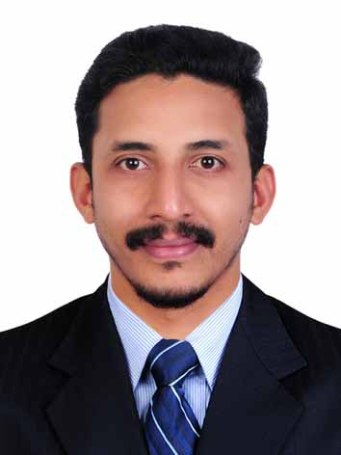

**HSE OFFICER cum Banking professional**

|  |
| --- |
| **PERSONAL PROFILE** |

**Name Mithun Das**

Age 32

Sex Male

Marital status Married

Nationality Indian

Passport No: S5269636

Languages known: English, Hindi, Malayalam, Tamil

**Current location India**

Contact No: +919562705044

Driving license India

Email mithunhsep[@gmail.com](mailto:meetmithi@gmail.com)

|  |
| --- |
| **CAREER SUMMARY** |

Industry - Manufacturing/Banking

**Overall experience - 8 years**

|  |
| --- |
| **PROFESSIONAL EXPERIENCE** |

* As Assistant Managerfor ICICI Bank (October 2014 – Till Date ).
* As Safety Engineer for EICL Ltd,(December 2010– October 2014)

|  |
| --- |
| **DUTIES AND RESPONSIBILITIES PERFORMED** |

* Develop HSE Training Plan and schedule Training for all staff and frontline employees.
* Manage cost code of employees for training hours
* Present training programs using recognized training techniques and tools
* Apply and monitor assessment tools to measure training effectiveness
* Establish and maintain relationships with external training providers
* Manage and maintain in-house training facilities and equipment
* Identify internal and external training programs to address competency gaps
* Provide advice to employees about training options
* Conduct Train the Trainer program for contractor trainers
* Develop new training programs based on client needs
* Schedule training programs based on requirement
* Evaluate the need of new/refresher training based on incident statistics
* Evaluate training of temporarily hired Contractor Trainers.
* Promoting and developing a positive and proactive safety culture.
* Providing training, assistance and mentoring to team members.
* Take over other duties assigned by hierarchal supervisors

**Conduct Training programs for:**

* Isolation/Lock out Tag out (LOTO)
* Abrasive wheels
* Confined Space Entry
* H2S Familiarization
* Manual Handling
* Hazard Identification & Risk Assessment (HIRA)
* Simultaneous Operations (SIMOPS)
* Permit to Work & Job Safety Analysis
* Working At Height
* Hot weather working
* Hot work
* Integrated Safety Induction
* Work Area Management

|  |
| --- |
| **BASIC QUALIFICATION** |

* Bachelor of Technology**-** Mechanical Engineering, Kerala University
* Higher Secondary Board

|  |
| --- |
| **HSE QUALIFICATION** |

* NEBOSH IGC**,** Level 3
* Certified Trainer, PTLLS- (Level 3). CIEH, UK
* Lead Auditor OHSAS 18001:2007
* Medic First Aid from Indian Navy
* IOSH Managing Safely
* NEBOSH Environmental Diploma (Ongoing)

|  |
| --- |
| **TRAININGS AND CERTIFICATIONS** |

* Hazard identification and Risk Assessment
* Behavior Based Safety Training
* Work Management System
* H2S Familiarization
* Dealing with Difficult People
* First Aid/ BLS
* Positive Thinking
* Time And Stress Management
* IELTS- 7

|  |
| --- |
| **SKILLS** |

* Industrial Safety Training
* JSA Review
* Risk Assessment
* Report Writing
* HAZARD IDENTIFICATION
* MS Office
* Supervisory Skills

|  |
| --- |
| **EXTRA CARRICULAR ACIVITIES** |

* Reading
* Yoga/Meditation
* Karate