**CURRICULUM VITAE**

*MERUGU VENKATESH RAMALINGAM*

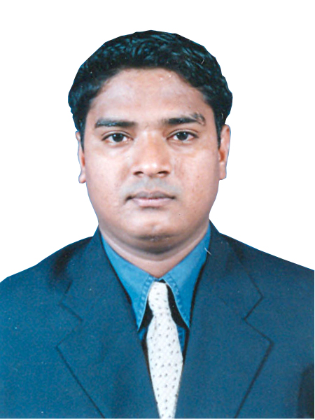

***Personal Information***

**Postal Address** : 1ST Floor, Room No. 10, Bldg. No. 30  
 10th Lane, S. P. Road, Nagpada,  
 Mumbai Central, Mumbai—400 008.

**Mobile No** : 9987805565

**E-mail ID** :venkatesh7hills@gmail.com

**Date of Birth**  : 27th March 1981

**NATIONALITY**  : Indian

**RELIGION** :HINDU

**MARITAL STATUS** : Married

**LANGUAGES**  : English, Marathi, Hindi & Telugu

**EDUCATIONAL** : **12th Discontinue   
QUALIFICATION**

**WORK EXPERIENCE:**

* I have 10 years experience in Mobile Software Field to Support of Service Centre Level
* **Current Employment – Mobile Info Telecom**

Banking Services – Sr. Operations

From 2018 to till date

I hereby certify that above information is true to the best of my knowledge and I bear the responsibility for the correctness of the above mentioned particulars.

**Merugu Venkatesh R.**