BACKEND IMPLEMENTATION DOCUMENT
Fleet Management and GPS Vehicle Tracking System
Continuous Internal Assessment - 1 (CIA-1)

Name: ______________________________
Roll No: ____________________________
Date: ______________________________
Batch / Section: ____________________

1. Project Folder Structure
The backend follows a clean layered architecture (Controller -> Service -> Repository) with separate packages for configuration, JPA entities, DTOs, exceptions and the main application entry point. This separation keeps the code modular, testable and easy to extend.
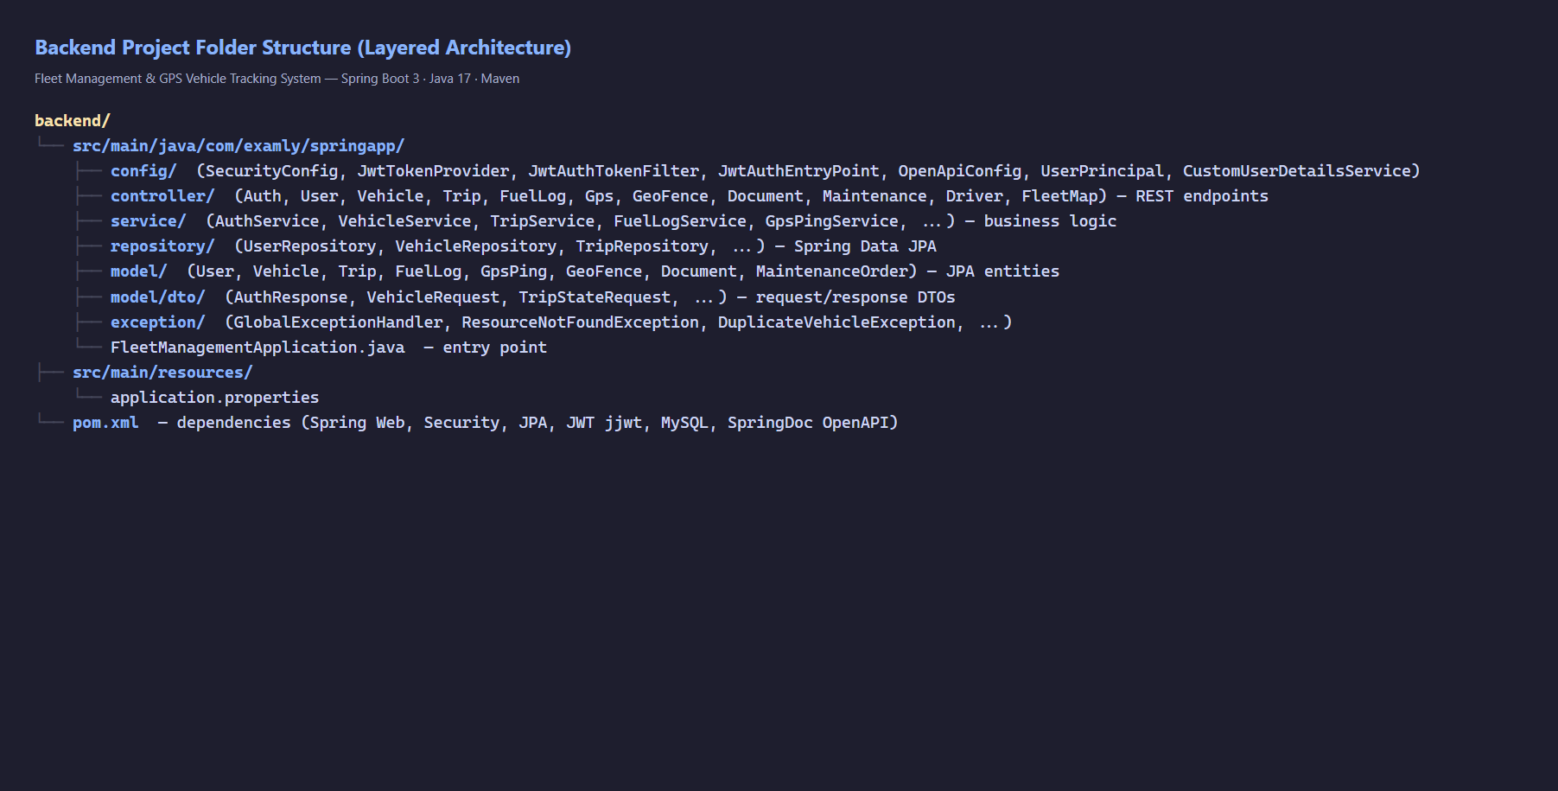

2. application.properties Configuration
The application is configured entirely through application.properties: MySQL datasource, JPA/Hibernate auto-DDL, JWT signing secret with role-specific token expiry times, and fleet business rules (maintenance interval, speeding threshold, GPS staleness) taken from the SRS.
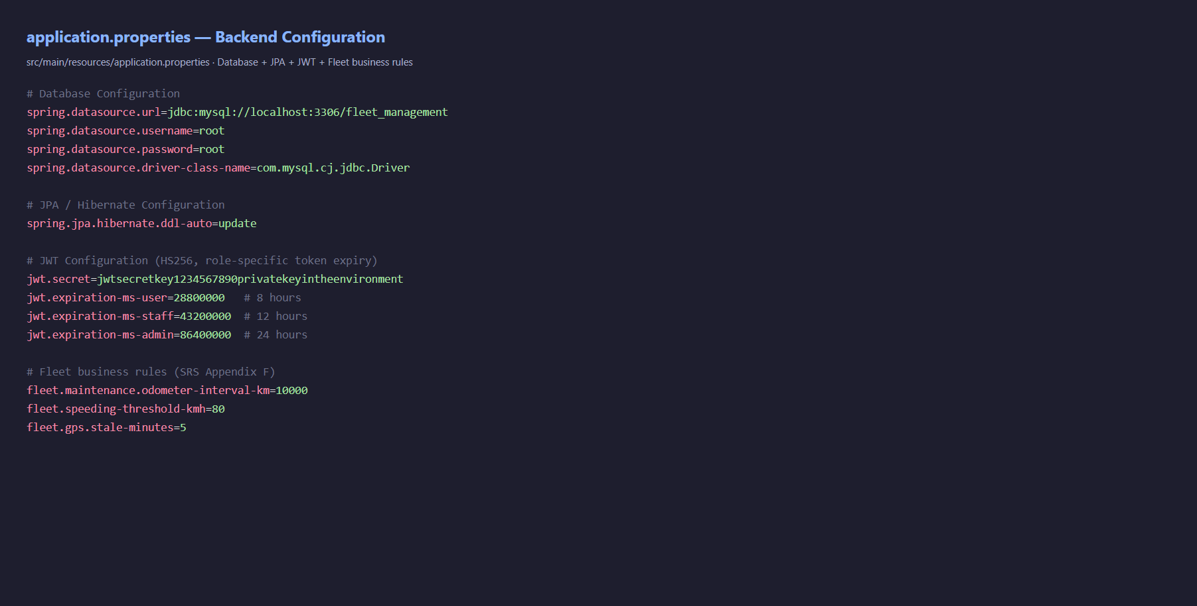

3. Complete CRUD Operations (Vehicle Module)
CRUD was demonstrated end-to-end on the Vehicle resource using Swagger UI. A new vehicle (MH01CD5678) was created, read back by id, updated (model changed to Nexon EV, odometer to 7200 km), and finally deleted. The list operation confirms the vehicle no longer exists after deletion.

3.1 Create (POST /api/vehicles) - HTTP 201
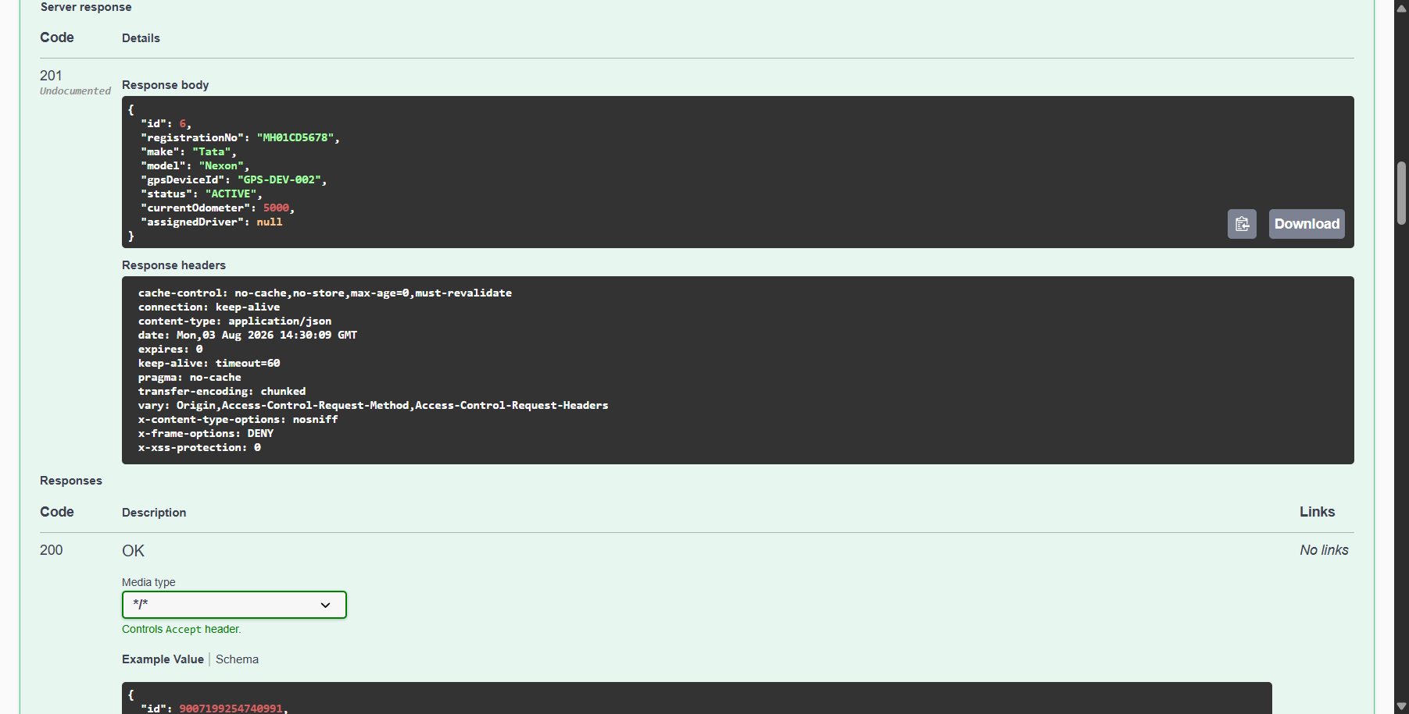

3.2 Read (GET /api/vehicles/{id}) - HTTP 200
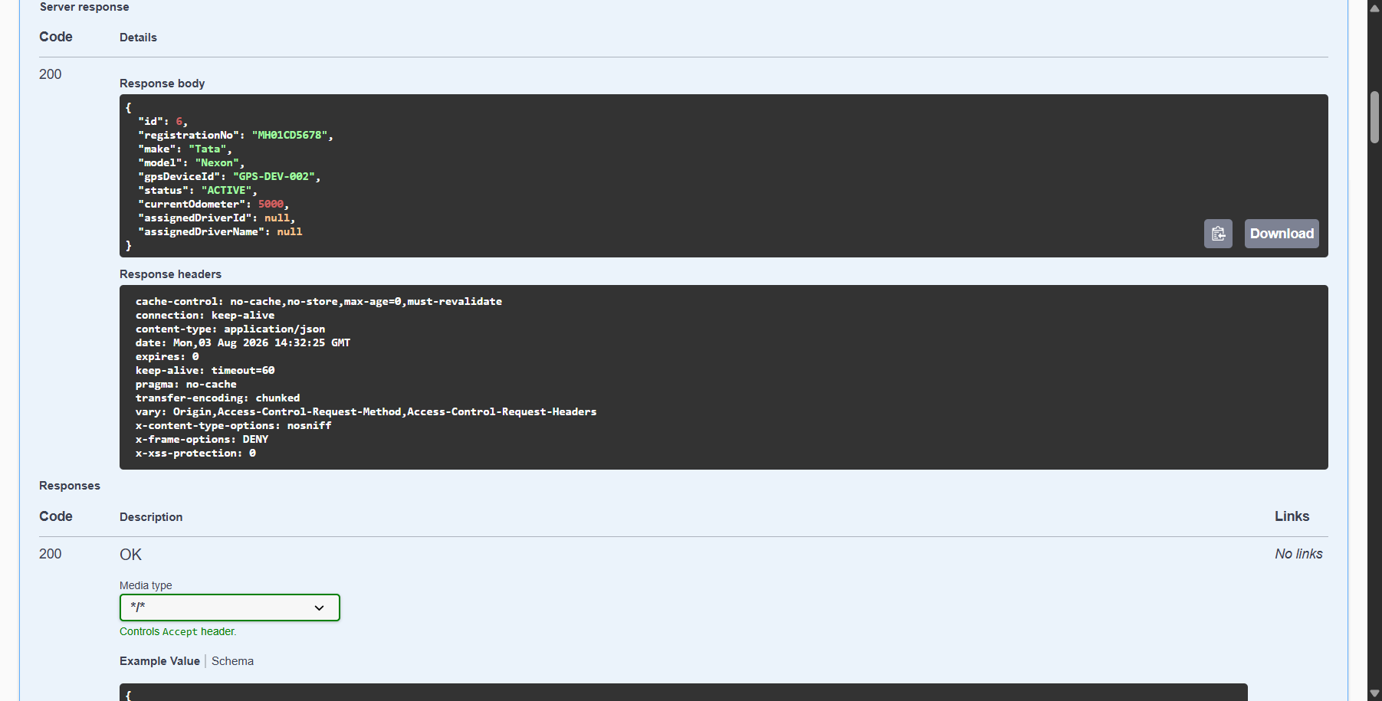

3.3 Update (PUT /api/vehicles/{id}) - HTTP 200
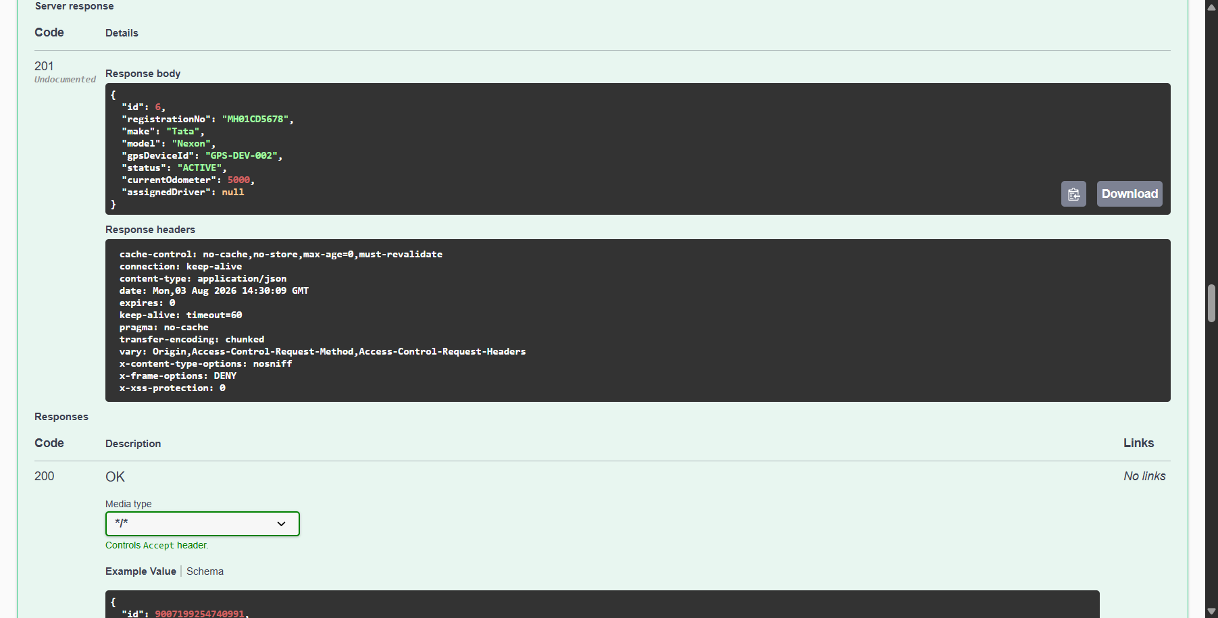

3.4 Delete (DELETE /api/vehicles/{id}) - HTTP 204
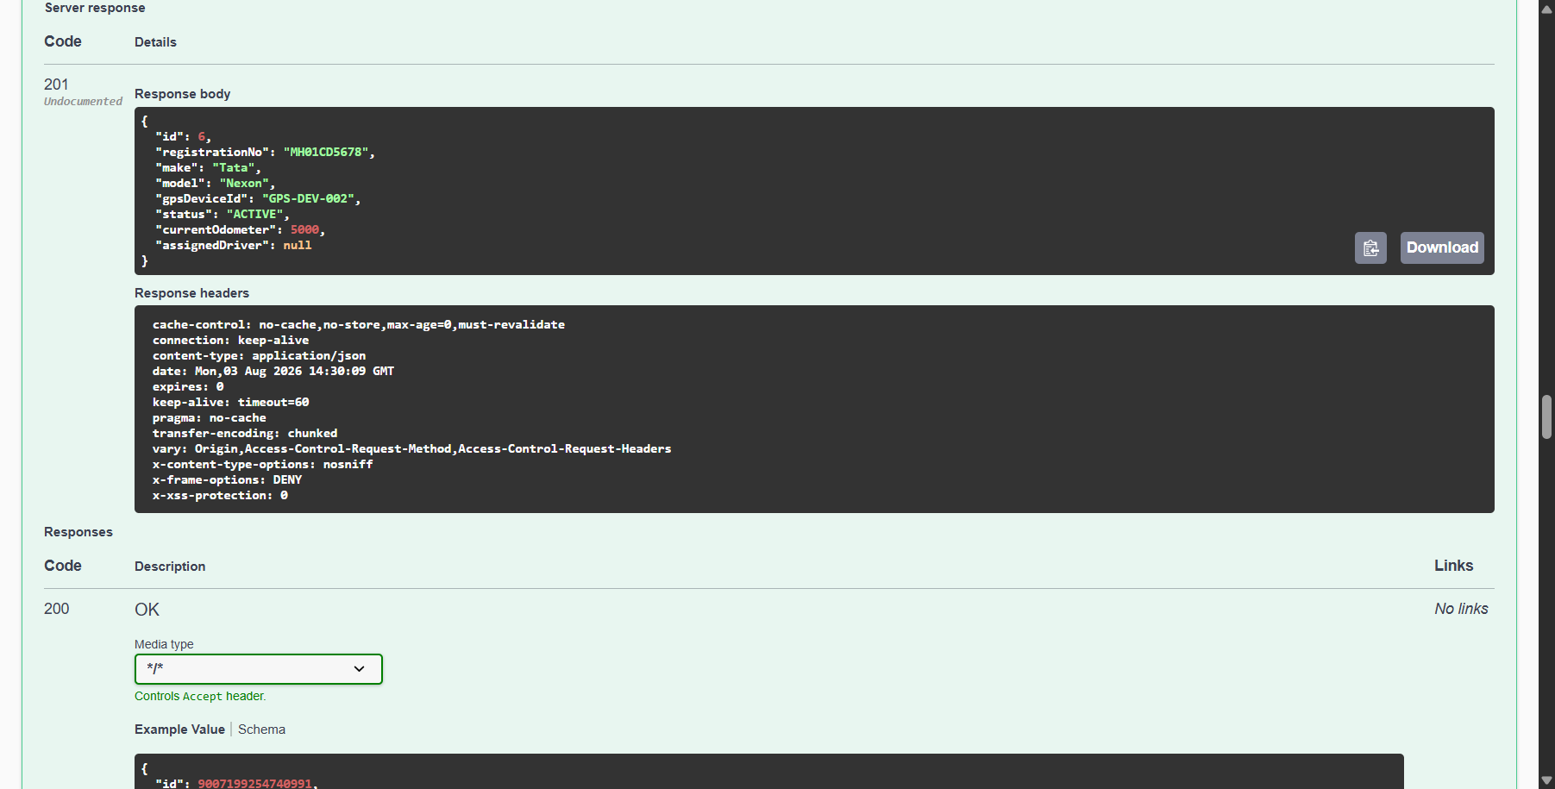

3.5 Read All (GET /api/vehicles) - HTTP 200
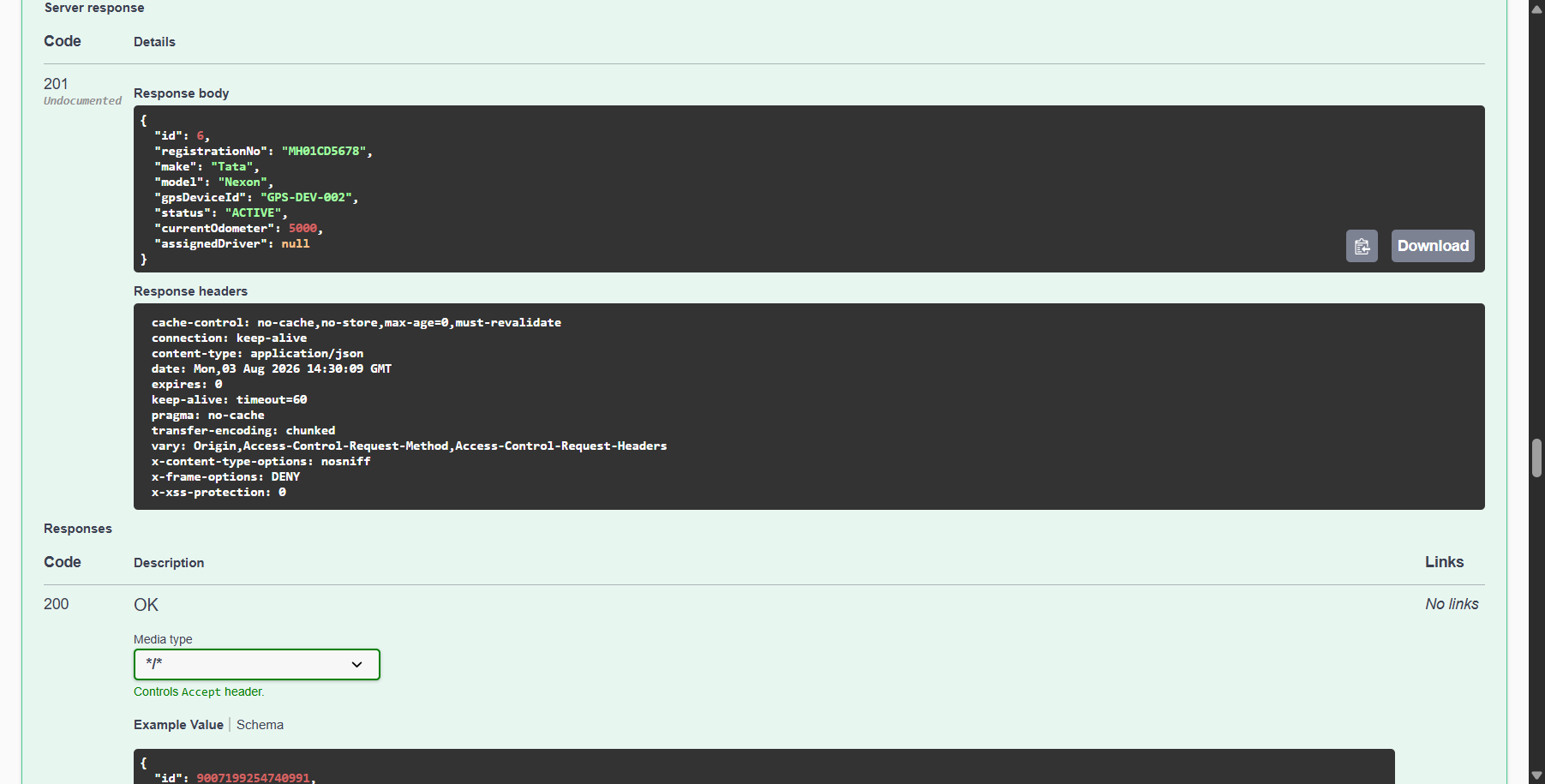

4. Global Exception Handling
A @ControllerAdvice (GlobalExceptionHandler) converts every exception into a uniform JSON error body {timestamp, message, details}. Business exceptions map to proper HTTP status codes: 400 (validation), 404 (not found), 409 (conflict/duplicate), 401 (bad credentials), 403 (access denied), and a catch-all 500 for unexpected errors.

4.1 Exception handler code
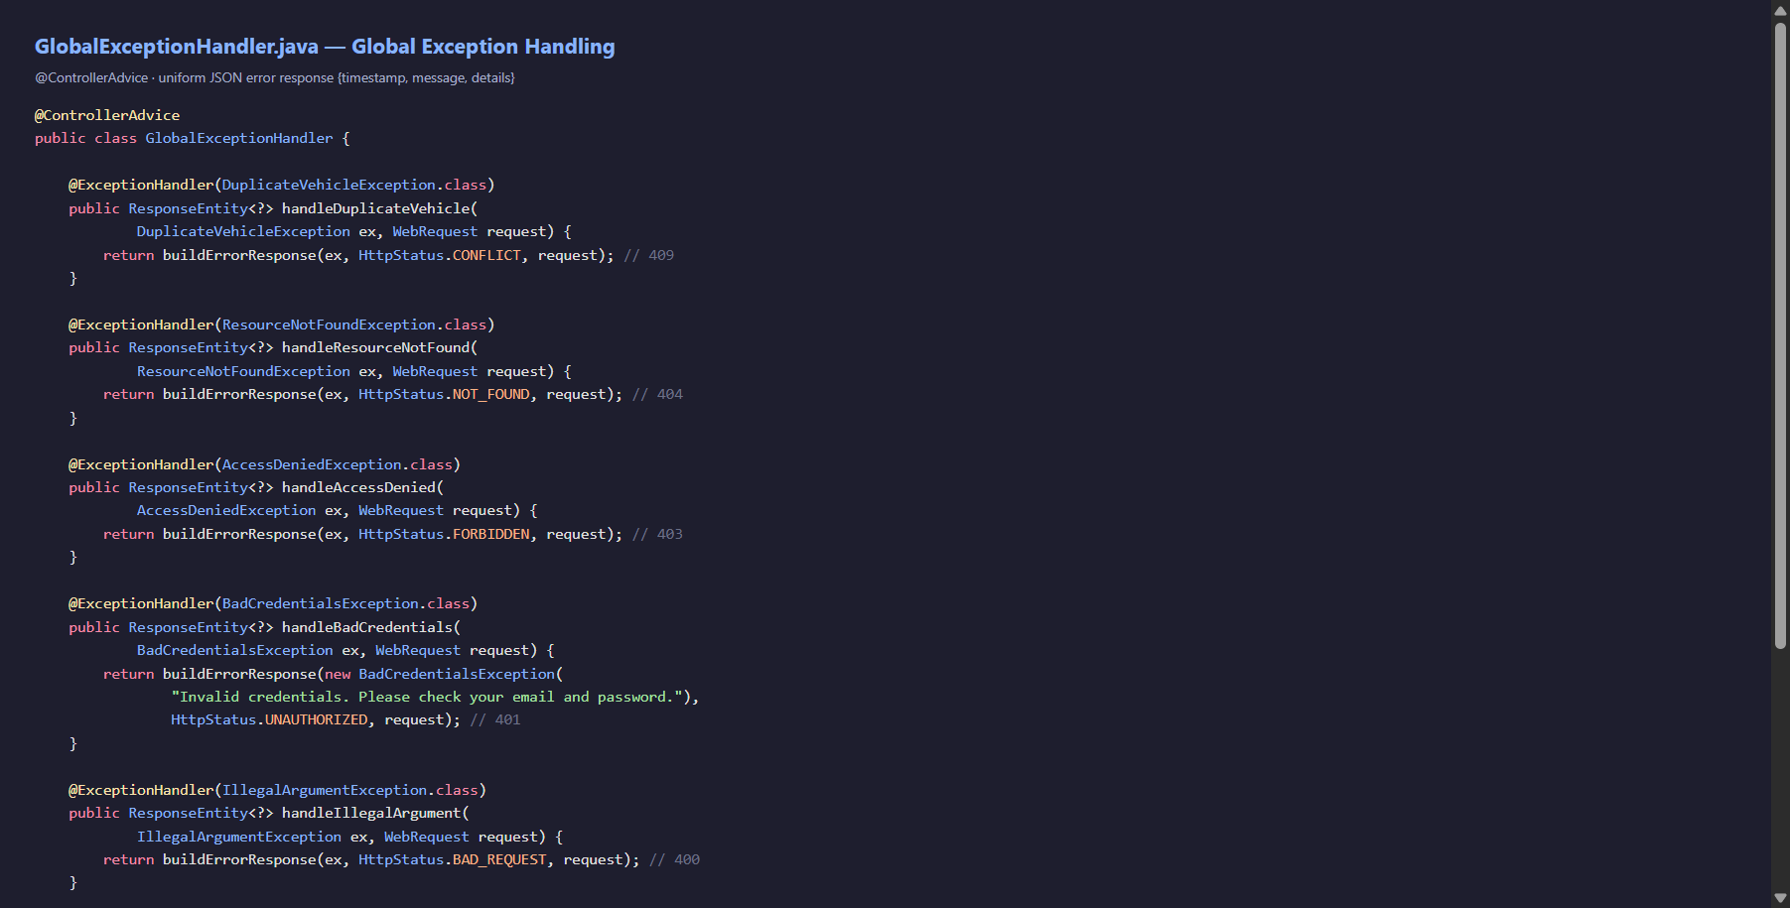

4.2 404 Resource Not Found
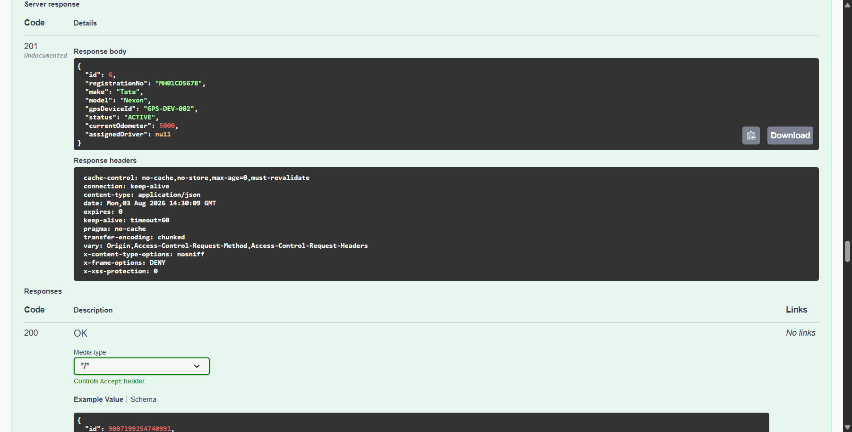

4.3 400 Bad Request (validation)
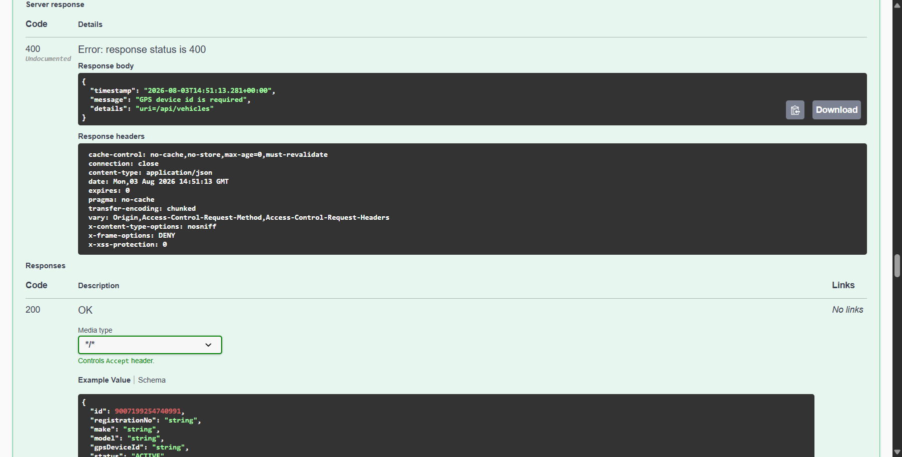

4.4 409 Conflict (duplicate)
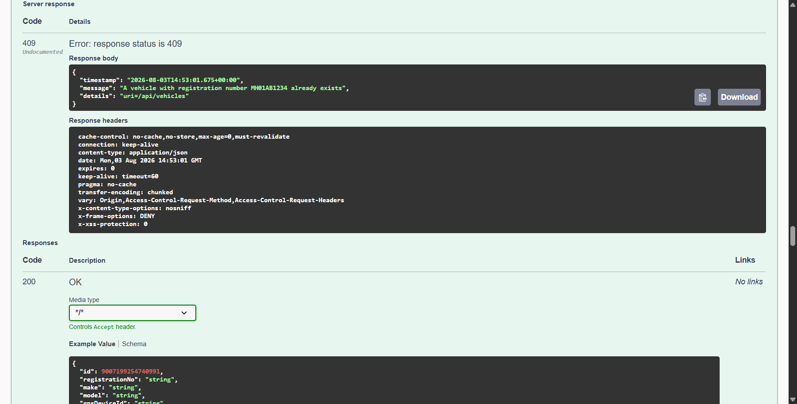

5. Security Implementation (Authentication, Authorization, Role-based Access)
Security is implemented with Spring Security + JWT: BCrypt hashes passwords at registration, login issues an HS256-signed JWT carrying the role claim, and every endpoint is protected with @PreAuthorize role checks. Unauthenticated calls get 401, authenticated users without the required role get 403.

5.1 Security configuration code
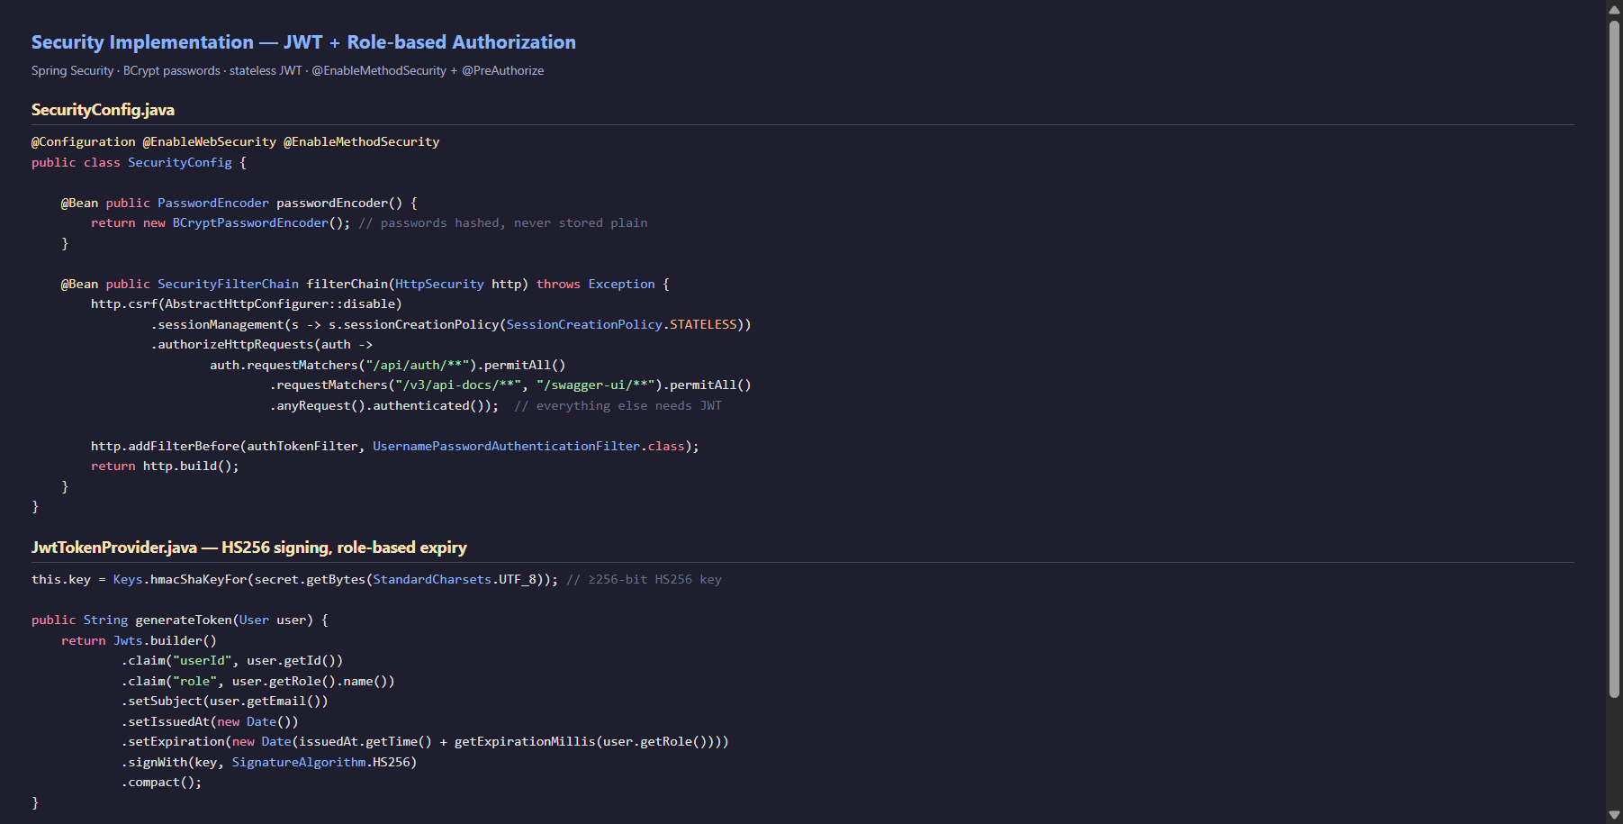

5.2 Authentication - User registration
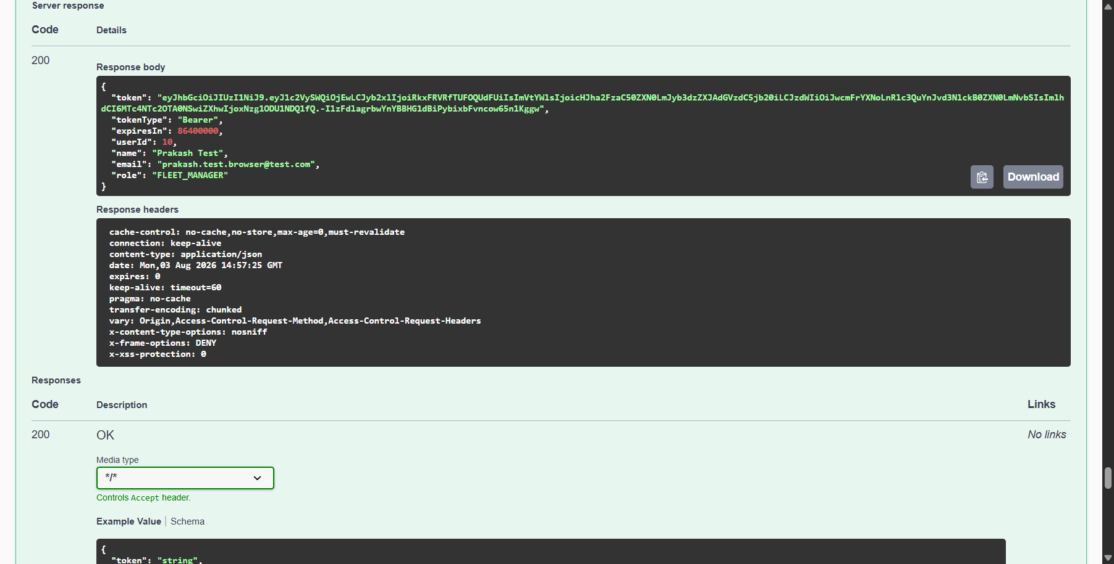

5.3 Authentication - Login returns JWT
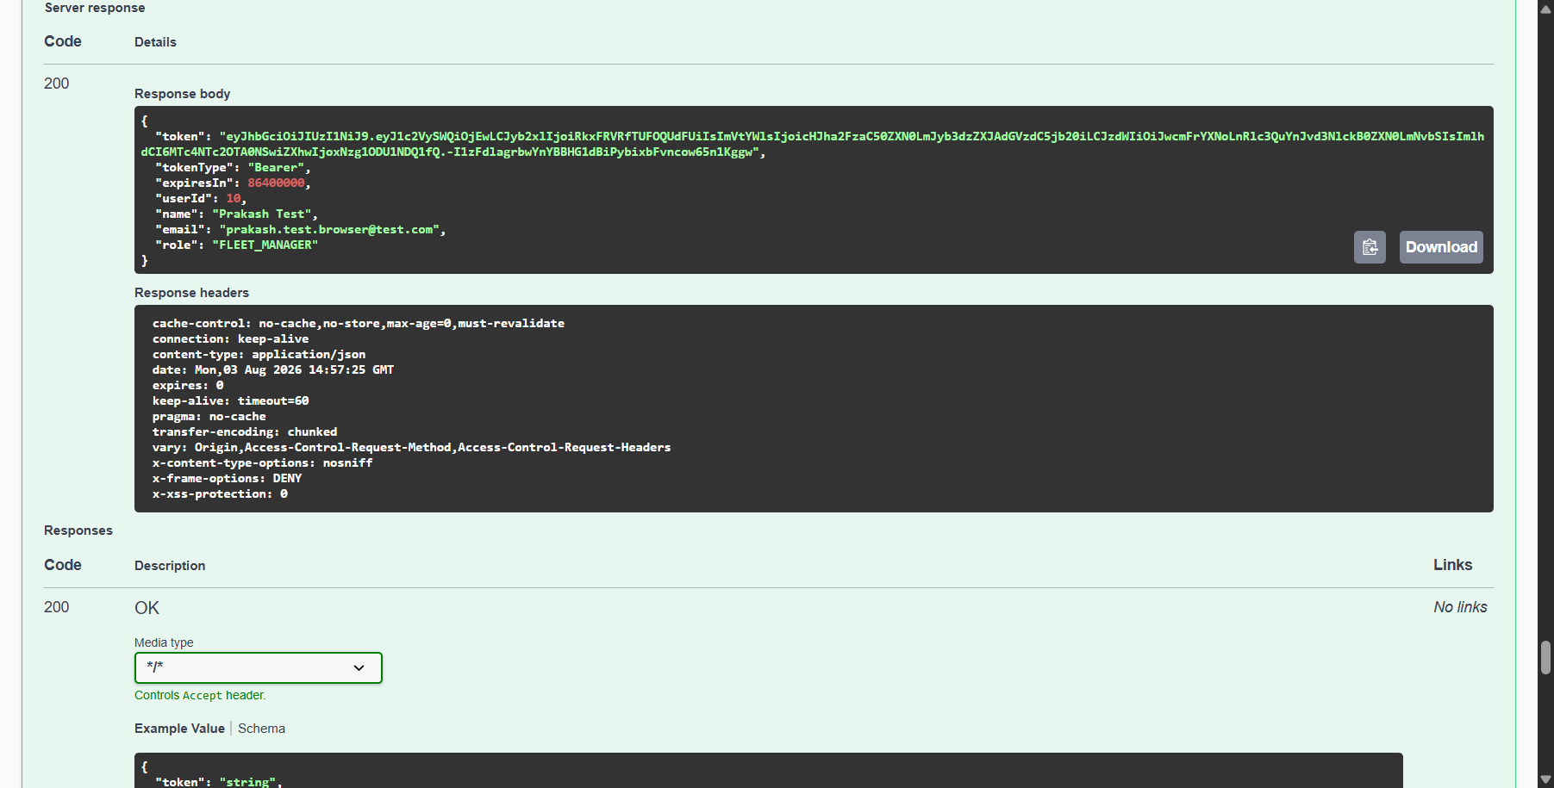

5.4 Authorization - 401 without token
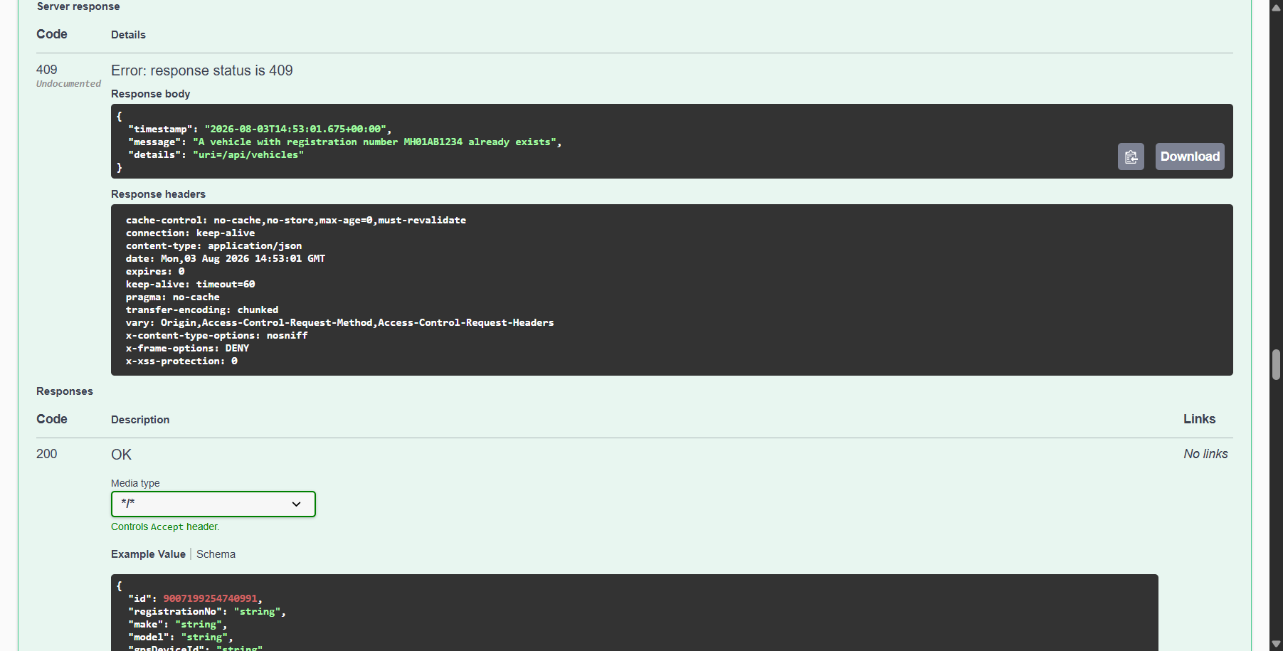

5.5 Role-based access - 403 forbidden


6. Swagger UI Testing and Setup
Springdoc OpenAPI auto-generates the interactive Swagger UI (http://localhost:8080/swagger-ui/index.html). It lists every controller, endpoint, request/response schema, and lets us execute calls with the Authorization bearer token directly from the browser - which is how all CRUD, exception and security tests in this document were executed.
