1. Install anaconda in your windows.
https://www.anaconda.com/products/individual

2. Make sure you add anaconda to path environment variable while installing anaconda.
And reboot pc.
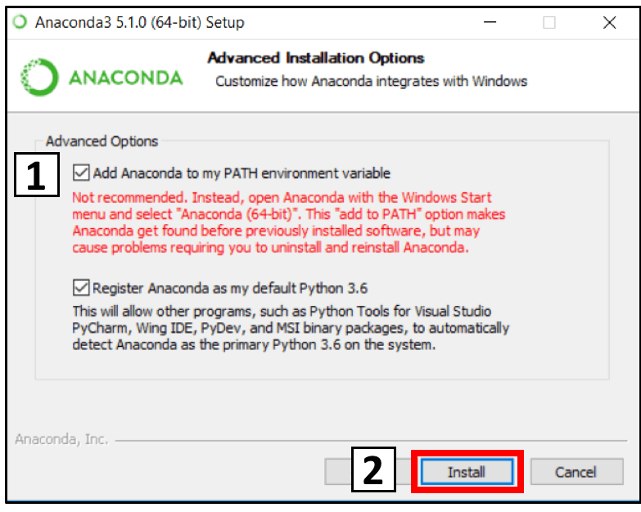
3. Check if python is installed in your pc, by opening command prompt and run.
> python --version or python3 --version

output should be like this:
Python 3.8.5
4. Install pip. Pip is required to install any modules required for python scripts.
> conda install pip

5. Extract amazon_scraper and make sure requirements.txt is present inside this folder.

6. Open command prompt and change directory to amazon_scraper.
> cd amazon_scraper

7. Install all the modules required for script.
> python -m pip install -r requirements.txt
or > python3 -m pip install -r requirements.txt
or > pip install -r requirements.txt
or > pip3 install -r requirements.txt
(one command should work)

8. Install selenium packages (I forgot to include this packages in requirements.txt)
>python -m pip install selenium
or > python3 -m pip install selenium
or > pip install selenium
or > pip3 install selenium

9. Run the script
> python main.py
or > python3 main.py

