**Hive Assignment**

Step 1 : Get data files in Master node

wget <https://e-commerce-events-ml.s3.amazonaws.com/2019-Oct.csv>

wget <https://e-commerce-events-ml.s3.amazonaws.com/2019-Nov.csv>

Step 2 : remove UTC from the timestamp column before loading the data

sed -i -e 's/ UTC//g' 2019-Oct.csv

sed -i -e 's/ UTC//g' 2019-Nov.csv

Step 3 : Import csv files in HDFS by running following steps

hdfs dfs -mkdir /user/hive_assignment

hdfs dfs -put 2019-Nov.csv /user/hive_assignment/

hdfs dfs -put 2019-Oct.csv /user/hive_assignment/

Step 4 : Verify if the files are imported in HDFS succesfully.

hdfs dfs -ls /user/hive_assignment/

hdfs dfs -cat /user/hive_assignment/2019-Nov.csv | head

hdfs dfs -cat /user/hive_assignment/2019-Oct.csv | head

Step 5 : Enter into Hive console by typing ‘hive’

Step 6 : Create database and required tables using following commands

create database if not exists ECom comment "Created to store events done on website" with dbproperties('creator'='Prakash','date'='30-01-2021');

show databases;

use ecom;

create external table if not exists event_nov (event_time timestamp,event_type string,product_id string,category_id string,category_code string,brand string,price float,user_id bigint,user_session string) row format delimited fields terminated by ',' lines terminated by '\n' stored as textfile tblproperties("skip.header.line.count"="1") ;

create external table if not exists event_oct (event_time timestamp,event_type string,product_id string,category_id string,category_code string,brand string,price float,user_id bigint,user_session string) row format delimited fields terminated by ',' lines terminated by '\n' stored as textfile tblproperties("skip.header.line.count"="1") ;

show tables;

Step 7 : Load data to both tables created for October and November

load data inpath '/user/hive_assignment/2019-Nov.csv' into table event_nov;

load data inpath '/user/hive_assignment/2019-Oct.csv' into table event_oct;

set hive.cli.print.header=true;

select * from event_nov limit 10;

select * from event_nov limit 10;

Step 8 : Consolidate the data of October and November in a single table

create table events

as

(

select 'Nov' as Month,* from event_nov

union all

select 'Oct' as Month,* from event_oct

)

Step 9 : Create partitioning(Static partitioning was used) and bucketing. (I have chosen month and event_type for partitioning and product_id for bucketing. I chose this because most of the queries were based on event type and month. Both columns were having low cardinality)

create table if not exists part_events (event_time timestamp,product_id string,category_id string,category_code string,brand string,price float,user_id bigint,user_session string) partitioned by (month string,event_type string) clustered by (product_id) into 5 buckets row format delimited fields terminated by ',' lines terminated by '\n';

insert into part_events partition( month='Oct', event_type='cart') select event_time,product_id,category_id,category_code,brand,price,user_id, user_session from events where month='Oct' and event_type='cart';

insert into part_events partition( month='Oct', event_type='remove_from_cart') select event_time,product_id,category_id,category_code,brand,price,user_id, user_session from events where month='Oct' and event_type='remove_from_cart';

insert into part_events partition( month='Oct' ,event_type='view') select event_time,product_id,category_id,category_code,brand,price,user_id, user_session from events where month='Oct' and event_type='view';

insert into part_events partition( month='Oct' ,event_type='purchase') select event_time,product_id,category_id,category_code,brand,price,user_id, user_session from events where month='Oct' and event_type='purchase';

insert into part_events partition( month='Nov', event_type='cart') select event_time,product_id,category_id,category_code,brand,price,user_id, user_session from events where month='Nov' and event_type='cart';

insert into part_events partition(month='Nov',event_type='remove_from_cart') select event_time,product_id,category_id,category_code,brand,price,user_id, user_session from events where month='Nov' and event_type='remove_from_cart';

insert into part_events partition(month='Nov',event_type='view') select event_time,product_id,category_id,category_code,brand,price,user_id, user_session from events where month='Nov' and event_type='view';

insert into part_events partition(month='Nov',event_type='purchase') select event_time,product_id,category_id,category_code,brand,price,user_id, user_session from events where month='Nov' and event_type='purchase';

Step 10 : Verify if partitioning and bucketing is done

hdfs dfs -ls /user/hive/warehouse/ecom.db/part_events

Step 11 : Run a test if the query will be optimized after partitioning.(I have checked the performance for question #1 )

I have queried the events table directly which is not partitioned and it is taking 21 seconds. However when I used the partitioned table it is giving result in 12 seconds. There is a improvement of 43 percent. Please find the screenshot below.

select sum(price) as Total_Revenue_from_purchases from events where month='Oct' and event_type='purchase';

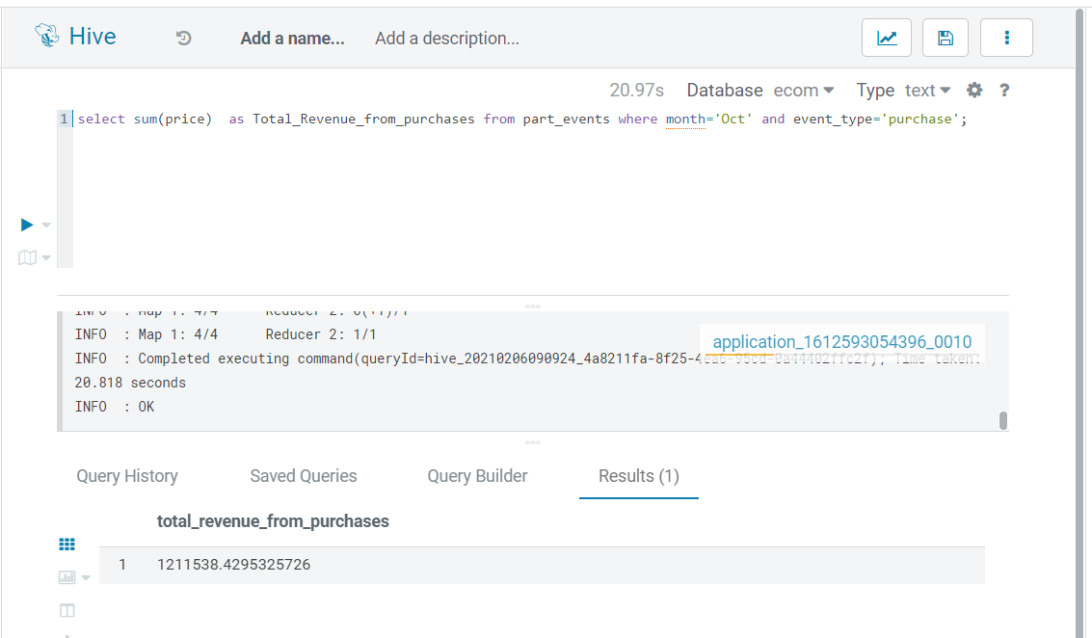

select sum(price) as Total_Revenue_from_purchases from part_events where month='Oct' and event_type='purchase';

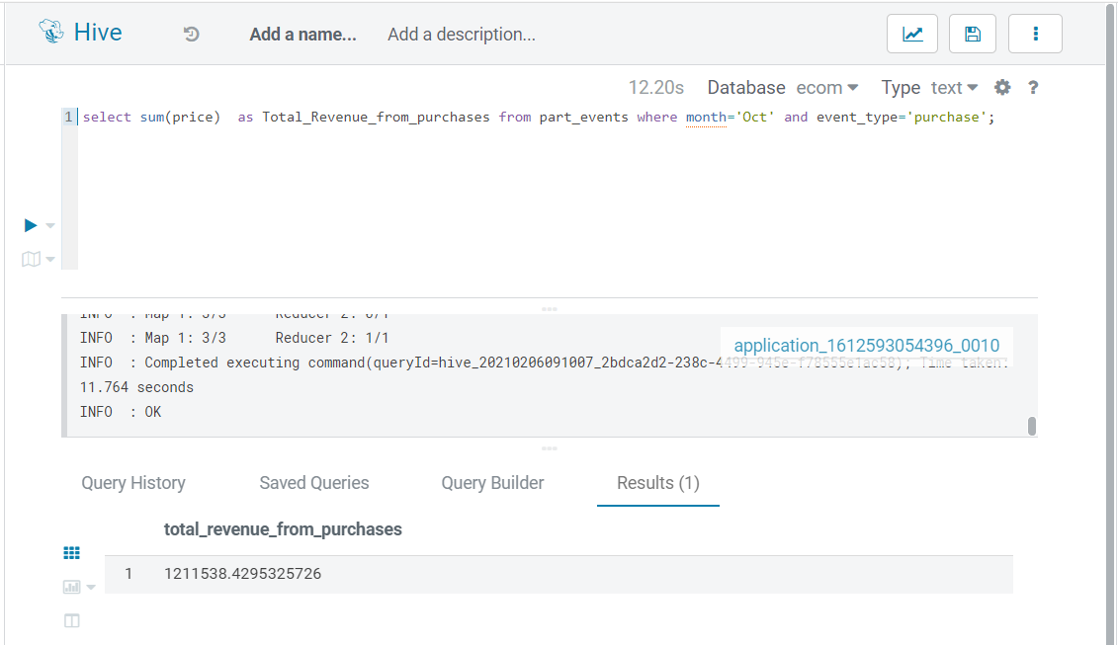

Step 12 : Answer the Questions asked. Please find below the Answers of all queries/questions.

1. Find the total revenue generated due to the purchases made in October.

select sum(price) as Total_Revenue_from_purchases from part_events where month='Oct' and event_type='purchase';



1. Write a query to yield the total sum of purchases per month in a single output.

select month, sum(price) as Sum_of_purchases from part_events where event_type='purchase' group by month ;

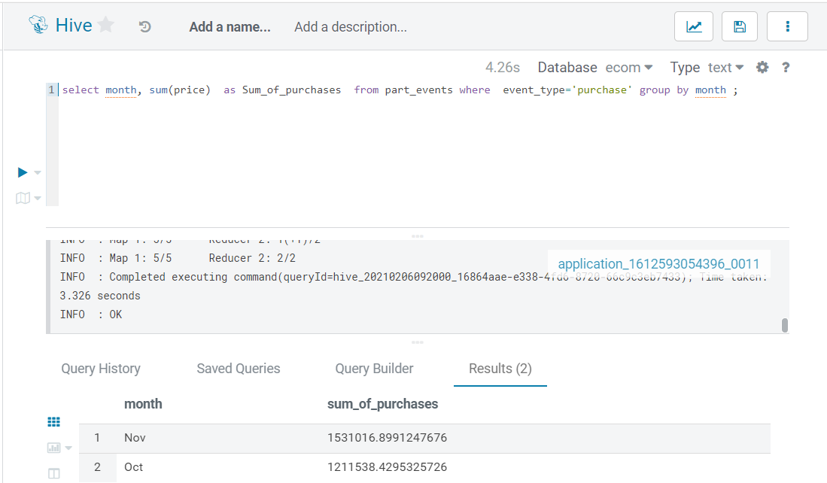

1. Write a query to find the change in the revenue generated due to purchases made from October to November.

with MonthlyRevenue as

(select month, sum(price) as Revenue_purchases

from part_events

where event_type='purchase'

group by month)

select (nov.Revenue_purchases-oct.Revenue_purchases) as change_in_revenue

from MonthlyRevenue nov cross join MonthlyRevenue oct

where nov.month<>oct.month and nov.month='Nov' and oct.month='Oct';

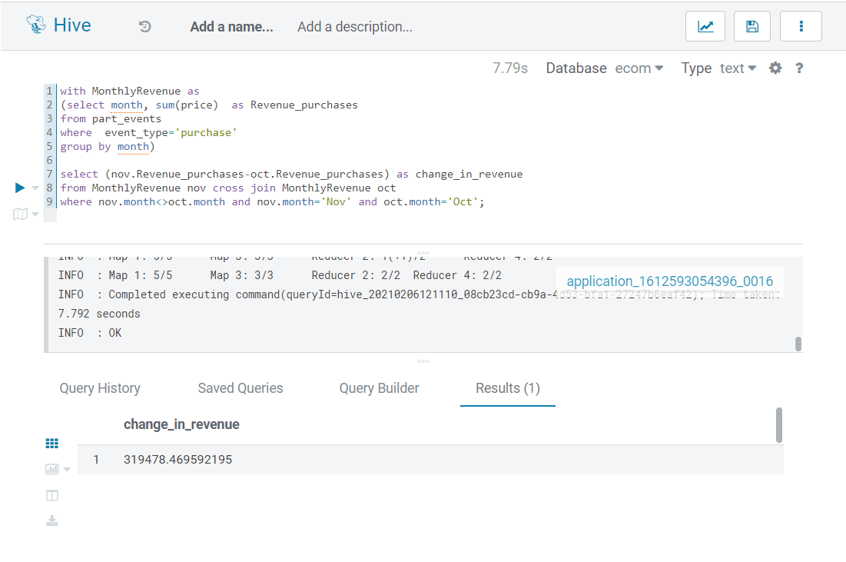

Note: use set hive.strict.checks.cartesian.product = False for cross product.

1. Find distinct categories of products.

select distinct category_id from part_events;

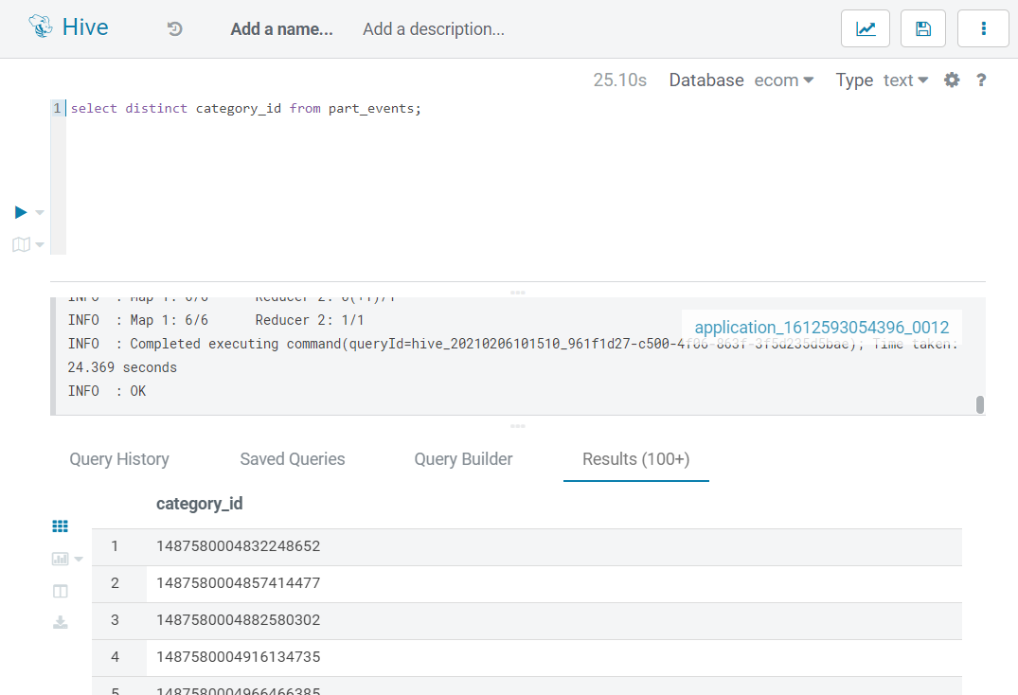

1. Find the total number of products available under each category.

with categories as (select distinct category_id, product_id from part_events)

select category_id, count(category_id) from categories group by category_id;

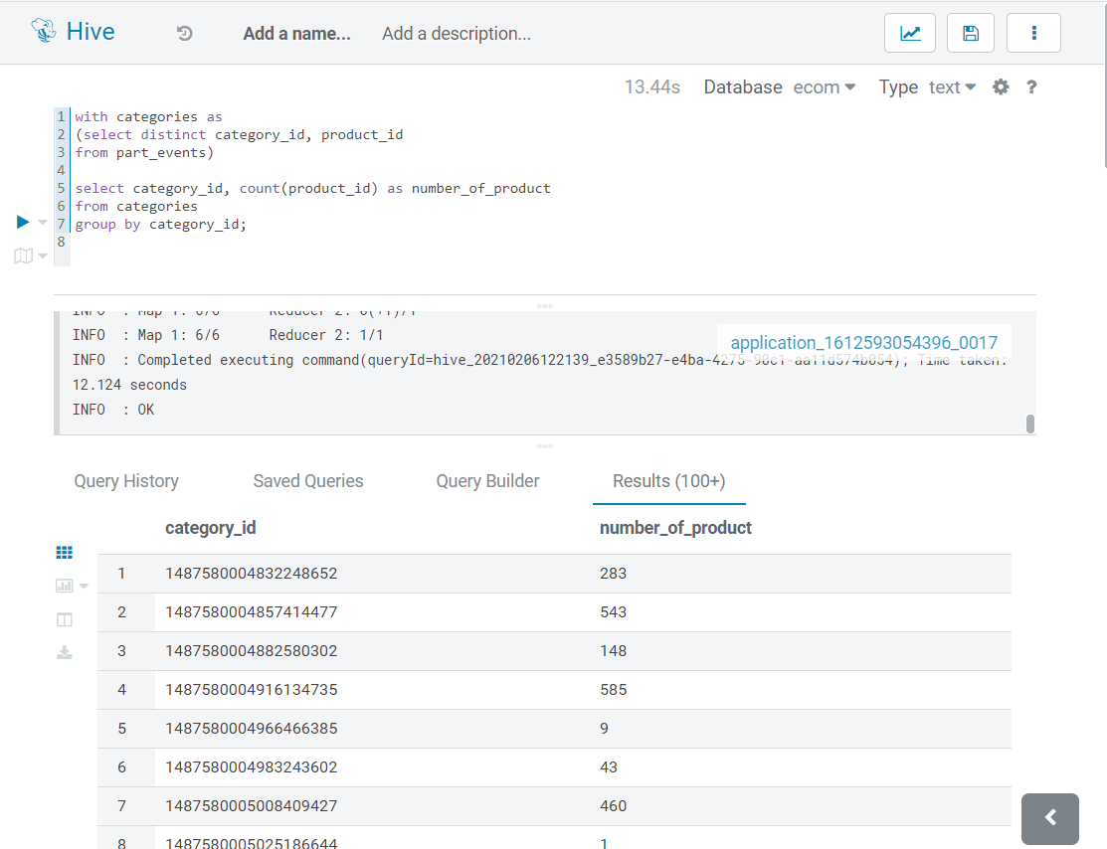

1. Which brand had the maximum sales in October and November combined?

select brand, sum(price) as revenue from part_events where event_type='purchase' and brand <> ""

group by brand order by revenue desc limit 1;

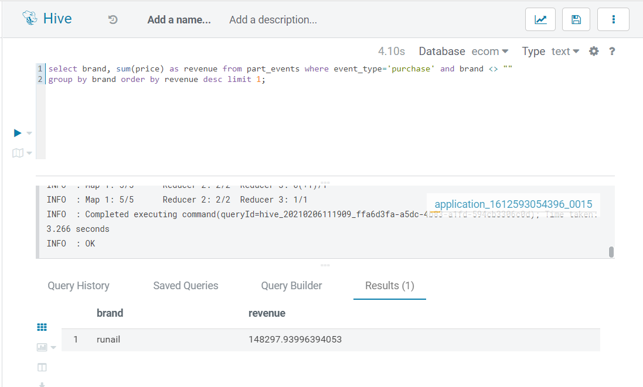

1. Which brands increased their sales from October to November?

with BrandRevenue as

(select month, brand ,sum(price) as sales_per_brand

from part_events

where event_type='purchase'

and brand <> ""

group by month,brand)

select nov.brand

from BrandRevenue nov

inner join BrandRevenue oct

on nov.brand =oct.brand and nov.month <> oct.month

where nov.sales_per_brand >oct.sales_per_brand

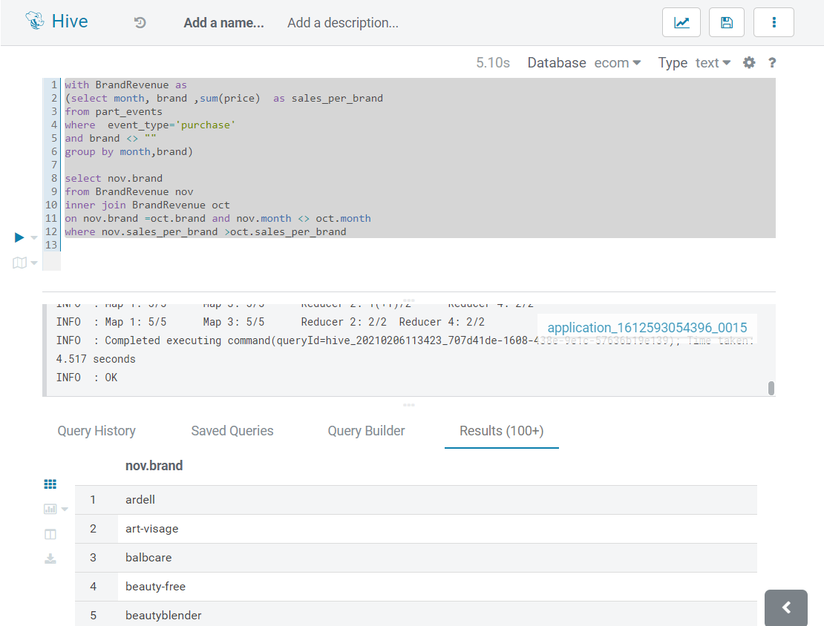

1. Your company wants to reward the top 10 users of its website with a Golden Customer plan. Write a query to generate a list of top 10 users who spend the most on purchases.

select user_id,sum(price) as purchase_Amount from part_events where event_type = 'purchase'

group by user_id order by purchase_Amount desc limit 10;

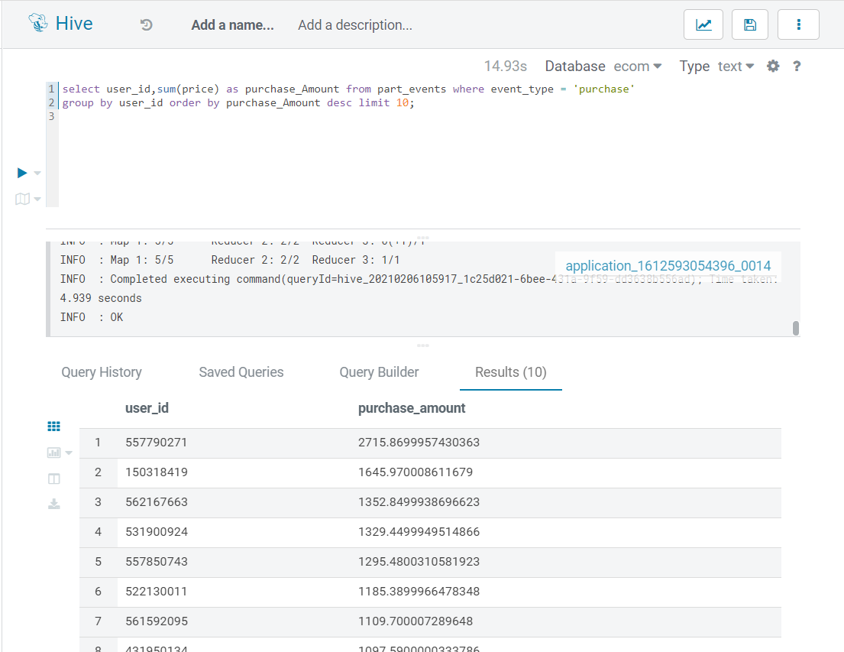

Step 13 : Dropped all tables and database and Terminated the cluster. I have tried to do all this in one go so as to prevent heavy costing due to extended use.