FALCON RCA PLATFORM
Market Data Service
Requirements Specification
Prepared for the MDP Team

Document | Falcon ↔ MDP Market Data Service — Requirements
Version | 1.0 (Draft for Review)
Status | For MDP review & SLA response
Date | 14 June 2026
Author | Prakash — Falcon Platform Engineering
Audience | MDP architecture & engineering; Falcon team

Table of Contents

1. Purpose & Audience
This document specifies what the Falcon RCA platform requires from the MDP team in the form of a synchronous, agent-callable market data service. It states the domain-level data, the field-level data, the interaction model, and — most importantly — the Service-Level Agreement (SLA) that the service must meet because it is invoked on the critical path of automated agent reasoning.
What this document is: a requirements and SLA contract. It defines the external behaviour Falcon depends on, so that the MDP team can design and operate the service internally however it sees fit.
What this document is not: it is not a design of MDP’s internals. Data sourcing (e.g. Bloomberg), storage, internal caching, and any internal asynchronous processing are entirely MDP’s concern and are explicitly out of scope for Falcon, provided the external contract and SLA in Sections 5–7 are met.

2. Background & Design Reset
Falcon is an alert-processing and root-cause-analysis (RCA) automation platform. It ingests alerts from upstream systems, runs an agent ecosystem that investigates each alert, and hands the resulting analysis to a human for action. Several of Falcon’s investigation tools require market data — pricing, security reference data, and corporate actions.

2.1 Previous direction (now descoped)
The earlier design had Falcon building an internal “golden-copy” market data layer (the MDF). That design included data aggregation, a market-data cache and aggregation store on DynamoDB, queueing, feed-state / freshness gating, and feed-completion notifications driven from the upstream pricing feed.

2.2 The reset decision
Falcon will no longer build any market data aggregation, queueing, notification, or feed-state management. The market data domain is owned end-to-end by the MDP team. Falcon’s responsibility is reduced to two things:
- Calling the MDP service synchronously from agent tools when market data is needed during an investigation.
- Optionally caching responses for reference / metadata domains with a time-to-live (TTL), falling back to a synchronous MDP call on a cache miss.
Net ask to MDP: design and operate the market data service internally as you choose, and expose a synchronous request/response API to Falcon that meets the domain, field, and SLA requirements in this document. Nothing else is built on the Falcon side for market data.

3. Scope

3.1 In scope for MDP
- A synchronous, low-latency, agent-callable market data API.
- Three data domains: Pricing, Security Master (reference data), and Corporate Actions — plus identifier resolution.
- A committed SLA covering latency, availability, throughput, freshness, and error behaviour (Section 7).
- Authentication, rate limits, error semantics, observability, and non-production environments for integration and agent testing.

3.2 Out of scope (Falcon owns these)
- The alert ingestion pipeline, normalization, the RCA agent ecosystem, and the Neptune Knowledge Graph.
- Falcon’s thin read-through metadata cache and its TTL policy.
- Orchestration of which tools are called and when — the MDP service simply answers requests it receives.

3.3 Explicitly not required from MDP
To remove ambiguity from the reset: Falcon does not require any push or streaming feed, feed-completion events, batch file drops, or notifications. The MDP service is request/response only.

4. Falcon Architecture Overview
This section gives MDP the context of who calls the service and why latency is on the critical path. It is descriptive, not a request — the only request to MDP is the service described in Sections 5–7.
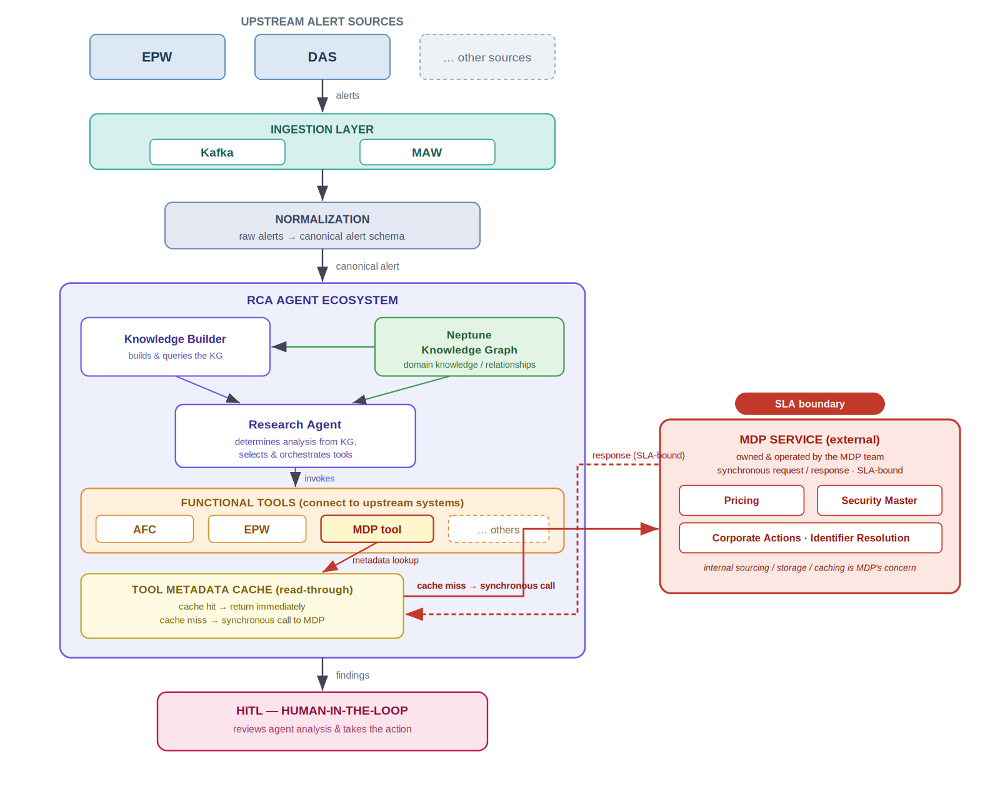
Figure 1 — Falcon high-level data flow: ingestion → normalization → RCA agent ecosystem → HITL, with the MDP service as a synchronous, SLA-bound dependency behind the tool metadata cache.

4.1 Ingestion layer
Upstream alert sources (e.g. EPW, DAS, and others) deliver alerts into Falcon through Kafka and MAW, which together form the ingestion layer.

4.2 Normalization
Raw alerts from heterogeneous sources are normalized into a single canonical alert schema before they reach the agents.

4.3 RCA agent ecosystem
Each normalized alert is handed to the RCA agent ecosystem, which consists of:
- Knowledge Builder — builds and queries the Neptune Knowledge Graph (KG), which holds domain knowledge and the relationships used to reason about an alert.
- Research Agent — uses the KG to determine the required analysis, then selects and orchestrates the appropriate tools.
- Functional tools — connect to upstream systems (e.g. AFC, EPW, MDP, and others). The MDP tool is the entry point for all market data.
- Tool metadata cache — a read-through cache for reference/metadata. On a cache hit the value is returned immediately; on a cache miss the service is called synchronously.

4.4 Human-in-the-loop (HITL)
When the analysis is complete, the agent hands its findings to a human, who reviews them and takes the action.

4.5 Where MDP fits — and why the SLA matters
The MDP service sits behind the MDP tool and the metadata cache. It is invoked synchronously inside the Research Agent’s reasoning loop, often several times per alert and across many alerts processed in parallel. Every millisecond of MDP latency adds directly to agent turnaround and therefore to how quickly a case reaches the human. This is the reason the SLA in Section 7 is strict and is expressed for the agent path.

5. Interaction & Integration Model
The following describe the shape of the contract. The concrete protocol (REST/JSON or gRPC) is MDP’s choice, provided it is a low-latency synchronous call.
Requirement | Description
Synchronous request/response | A single call returns the answer. Agents cannot poll — a submit→poll→fetch pattern is not acceptable on the agent path. If MDP uses such a pattern internally, it must be hidden behind a synchronous facade that meets the SLA.
Stateless | Each request is self-contained; no session state is required on the Falcon side.
Batch / bulk reads | A single call must accept many securities and/or fields to minimize round-trips (e.g. resolve and price a list of instruments in one request). See max batch size in Open Questions.
Idempotent reads | All operations are reads and must be safely retryable.
Versioned API | An explicit version (e.g. /v1) with additive, backward-compatible evolution and a published deprecation policy.
Service-to-service auth | Machine authentication (mTLS or OAuth2 client-credentials). Falcon will not handle or pass any end-user credentials.

6. Functional & Domain Requirements
The service must serve the three domains below plus identifier resolution. “Req” = required in every response for that record; “Opt” = provide where available. Field names are indicative — MDP may use its own naming in the API spec as long as the semantics are preserved.

6.1 Pricing
Current and historical prices for a security, on a stated basis and currency, with an explicit as-of date and a freshness indicator.
Field | Type | Req/Opt | Description
instrument_id | string | Req | Security the price applies to; echoed back.
price_value | decimal | Req | The price.
price_basis | enum | Req | e.g. CLOSE / BID / ASK / MID / LAST / NAV.
currency | ISO 4217 | Req | Currency of price_value.
as_of_date | date | Req | Pricing date the value applies to.
as_of_timestamp | datetime (UTC) | Req | When the price was captured / last updated at source.
price_type | enum | Opt | INTRADAY / EOD / INDICATIVE.
source | string | Opt | Originating vendor / feed tag.
freshness_status | enum | Req | FRESH / STALE / UNAVAILABLE — lets the agent reason about confidence.
precision | int | Opt | Decimal scale for display / rounding.
Historical: a price-history query must return a series for a given instrument, date range, and basis (used by trend / regression analysis).

6.2 Security Master (reference data)
Reference attributes and a cross-reference of identifiers. Supports Falcon’s demand-driven discovery: a security first seen in an alert must be resolvable on first request.
Field | Type | Req/Opt | Description
internal_id | string | Req | Firm/Falcon internal security identifier (canonical).
isin / cusip / sedol | string | Opt | Standard identifiers; return all that are known.
ticker / bbg_id | string | Opt | Exchange ticker and vendor identifier.
security_name | string | Req | Human-readable name / description.
asset_class | enum | Req | EQUITY / BOND / FX / DERIVATIVE / FUND / etc.
instrument_type | string | Opt | Finer sub-type within the asset class.
issuer_name / issuer_id | string | Opt | Issuing entity.
currency | ISO 4217 | Req | Trading / denomination currency.
country_of_risk | ISO 3166 | Opt | Domicile / country of risk.
exchange | string | Opt | Primary listing venue.
classification | string | Opt | Sector / industry (e.g. GICS).
maturity_date / coupon | date / decimal | Opt | Fixed-income terms where applicable.
status | enum | Req | ACTIVE / MATURED / DELISTED / SUSPENDED.
last_updated | datetime (UTC) | Req | Last change to this record at source (drives Falcon cache TTL).

6.3 Corporate Actions
Corporate-action events for a security, with the key dates and terms, so the agent can adjust or explain price / position movements.
Field | Type | Req/Opt | Description
event_id | string | Req | Unique event identifier.
instrument_id | string | Req | Affected security.
event_type | enum | Req | DIVIDEND / SPLIT / MERGER / SPINOFF / RIGHTS / NAME_CHANGE / etc.
announcement_date | date | Opt | When the event was announced.
ex_date / record_date / pay_date | date | Req/Opt | Key event dates (ex-date required where applicable).
ratio_factor | decimal | Opt | e.g. split ratio.
amount / amount_ccy | decimal / ISO 4217 | Opt | e.g. dividend amount and currency.
status | enum | Req | ANNOUNCED / CONFIRMED / EFFECTIVE / CANCELLED.
terms | string | Opt | Free-text terms / description.
last_updated | datetime (UTC) | Req | Last change at source.

6.4 Identifier resolution
Agents may hold any supported identifier. The service must resolve any of them to the canonical internal_id and return the full cross-reference set.
Field | Type | Req/Opt | Description
input_identifier | string | Req | Identifier supplied by the caller; echoed back.
input_type | enum | Req | ISIN / CUSIP / SEDOL / TICKER / INTERNAL / BBG / etc.
resolved_internal_id | string | Req | Canonical internal identifier.
all_identifiers | map | Req | All known identifiers for the resolved security.
match_status | enum | Req | EXACT / AMBIGUOUS / NOT_FOUND — ambiguity must be signalled, not silently guessed.

7. Service-Level Agreement (SLA)
The MDP service is on the critical path of automated agent reasoning. The targets below are Falcon’s requirements for the agent path. MDP is asked to confirm each one, or to counter-propose with a committed figure, in its SLA response. Bracketed values are deployment-specific and need MDP’s committed numbers.
Dimension | Falcon requirement (target) | Measurement / notes
Interaction pattern | Synchronous request/response | The agent thread blocks on the call; no polling.
Single-key read latency | p50 ≤ 100 ms · p95 ≤ 300 ms · p99 ≤ 500 ms | Server-side at the MDP edge (network measured separately).
Batch read latency (≤ ~250 keys) | p95 ≤ 800 ms · p99 ≤ 1.5 s | Batching is preferred to many single calls.
Availability | ≥ 99.9% monthly | Of the synchronous read API (≈ 43 min/month budget).
Throughput (sustained) | ≥ [N] req/s at ≥ [C] concurrent | Many alerts processed in parallel; agents fan out tool calls.
Burst tolerance | Absorb [B]× sustained for ≥ 60 s | Alert storms create correlated bursts.
Error rate | ≤ 0.1% (5xx / timeouts) | Counts against availability budget.
Server timeout | Hard timeout ≤ 2 s with structured error | Falcon sets its client timeout just above this.
Pricing freshness | EOD available by [time]; intraday ≤ [x] min lag if offered | Per basis; document what is actually available.
Reference freshness | New/unknown security resolvable on first request within [x] | Supports demand-driven discovery.
Corp-action freshness | Reflected no later than (ex-date − 1 BD) where source allows | So adjustments are not missed.
Maintenance | Announced ≥ [x] BD ahead; zero-downtime preferred | With a documented degradation mode.
Note: if MDP caches internally, the cold path (internal cache miss) must still meet the p99 target — Falcon has no visibility of MDP’s internal cache state and cannot compensate for it.

8. Falcon-Side Caching & What MDP Must Expose
Falcon keeps a thin read-through cache, mainly for low-volatility reference/metadata, to reduce load and latency. Live pricing is generally passed through (or cached only very briefly). For Falcon to cache safely and correctly, MDP must expose enough metadata to set sane TTLs and to revalidate cheaply.
- Per-record freshness: every record carries an as_of / last_updated timestamp (already required in Section 6).
- Volatility guidance: documented refresh cadence / volatility per field, so Falcon can choose TTLs (e.g. long for static reference data, short or none for prices).
- Optional record version / ETag: a stable version or entity tag enables cheap change detection.
- Optional conditional requests: support for If-None-Match / If-Modified-Since so Falcon can revalidate without transferring the full payload.
- Cache miss behaviour: on a miss Falcon issues a synchronous MDP call — i.e. the SLA path in Section 7.

9. Non-Functional Requirements
Area | Requirement
Security | Service-to-service auth (mTLS or OAuth2 client-credentials); TLS in transit. Falcon handles no end-user credentials. No sensitive data in URL/query parameters.
Observability | Accept and echo a Falcon correlation / request ID; expose per-request latency and status; provide a health / readiness endpoint.
Rate limiting | Published per-client quotas; deterministic 429 with Retry-After; limits sized to Falcon’s committed throughput.
Error semantics | Distinct, structured codes: INVALID_REQUEST · NOT_FOUND · UNAUTHORIZED · RATE_LIMITED · UPSTREAM_UNAVAILABLE. Batch requests return per-item status (partial success allowed).
Environments | Dev/sandbox + UAT + Prod, with representative (non-prod-safe) data in lower environments for end-to-end agent testing.
API governance | Versioned endpoints, additive backward-compatible changes, and a published deprecation notice period.

10. Explicitly Out of Scope for MDP
- Falcon will not send alerts, agent state, or Knowledge Graph data to MDP. MDP needs no awareness of Falcon’s pipeline.
- No push, streaming, feed-completion events, or batch file drops are required by Falcon.
- MDP’s internal sourcing (e.g. Bloomberg), storage, internal caching, and any internal async (submit-poll-fetch) are MDP’s own design choices and are invisible to Falcon — provided the synchronous external contract and the SLA in Section 7 are met.

11. Requested Deliverables & Timelines
Falcon requests the following from the MDP team. Items 1–5 are required to start integration.
- API specification (OpenAPI 3 or protobuf) covering all domains and fields in Section 6.
- SLA commitment — confirm or counter the targets in Section 7 with committed numbers, including the bracketed throughput/burst/freshness values.
- Auth & onboarding guide — client registration and credential issuance.
- Environment access — sandbox + UAT endpoints with representative test data.
- Rate-limit & quota documentation.
- Support model — on-call / incident contacts and escalation path.
- (Optional) internal design overview — not required, but welcomed for confidence.

Indicative timeline (to be agreed; T0 = requirements sign-off):
Milestone | Owner | Target
Requirements review & sign-off | MDP + Falcon | T0
Draft API spec + SLA proposal | MDP | T0 + 3 wks
Sandbox available | MDP | T0 + 5 wks
Falcon integration (MDP tool + cache) | Falcon | T0 + 7 wks
UAT — end-to-end agent path | MDP + Falcon | T0 + 9 wks
Prod readiness + SLA validation | MDP + Falcon | T0 + 11 wks

12. Open Questions for MDP
- Which pricing bases and intraday availability can you provide, and at what lag?
- Which identifier types are supported, and how is an AMBIGUOUS match represented?
- What is the maximum batch size, and is a batch served as a single server-side round-trip?
- Can you support conditional requests (ETag / If-Modified-Since) for cheap cache revalidation?
- What committed throughput / concurrency ceiling and rate-limit policy can you offer?
- What historical depth is available for prices and corporate actions?
- Which auth standard will you use — mTLS or OAuth2 client-credentials?
- At what point is the SLA measured — the MDP edge, or end-to-end including the network path?

13. Glossary
Expansions marked “(confirm)” are inferred and should be verified or replaced before this document is circulated.
Term | Meaning
Falcon | Alert-processing & RCA automation platform (owner of this document).
RCA | Root Cause Analysis.
MDP | Market Data Platform / Provider — the team and service this specification addresses.
MDF | (Prior) internal market-data foundation layer in Falcon — now descoped.
HITL | Human-in-the-Loop.
KG | Knowledge Graph (AWS Neptune).
SLA / TTL | Service-Level Agreement / Time-To-Live (cache).
EPW · DAS | Upstream alert sources (confirm).
MAW | Ingestion-layer component alongside Kafka (confirm).
AFC | Upstream system queried by functional tools (confirm).
ETag / BD | Entity tag for cache validation / Business Day.

End of document — Falcon ↔ MDP Market Data Service Requirements v1.0

