Document Ingestion Pipeline
System Design Document & Technical Specifications

Version: 1.0
Date: August 29, 2025
Document Type: Comprehensive System Design
Classification: Internal

Table of Contents
- 1. Executive Summary
- 2. System Diagrams
- 2.1 Entity Relationship Diagram
- 2.2 Functional Flow Diagram
- 2.3 System Architecture Diagram
- 3. Functional Specification
- 3.1 System Overview
- 3.2 Module Specifications
- 3.3 User Roles and Permissions
- 4. Technical Specification
- 4.1 System Architecture
- 4.2 Technology Stack
- 4.3 Integration Specifications
- 5. Data Model & Architecture
- 5.1 Entity Relationship Model
- 5.2 Data Storage Strategy
- 5.3 Data Security and Compliance
- 6. System Flows
- 6.1 Onboarding Flow
- 6.2 Extraction Flow
- 6.3 Evaluation Flow
- 7. Non-Functional Requirements
- 7.1 Performance Requirements
- 7.2 Reliability Requirements
- 7.3 Security Requirements
- 7.4 Usability Requirements
- 8. Implementation Roadmap
- 8.1 Phase 1: Foundation
- 8.2 Phase 2: Core Functionality
- 8.3 Phase 3: Advanced Features
- 8.4 Phase 4: Production Readiness
- 9. Risk Assessment
- 9.1 Technical Risks
- 9.2 Business Risks
- 9.3 Operational Risks
- 10. Appendices

1. Executive Summary

1.1 Purpose
The Document Ingestion Pipeline is an enterprise-grade system designed to automate the extraction, processing, and evaluation of structured data from unstructured PDF documents using Agentic AI technologies. The system provides a comprehensive framework for iterative prompt engineering and accuracy measurement against ground truth datasets.

1.2 Scope
This system encompasses three core modules:
- Onboarding Module: Namespace management, use-case configuration, and template setup
- Extraction Module: AI-driven document processing and structured data extraction
- Evaluation Module: Accuracy assessment and iterative improvement workflows

1.3 Key Benefits
- Automated Document Processing: Reduces manual data entry by 90%
- Iterative Improvement: Continuous prompt optimization based on accuracy metrics
- Scalable Architecture: Supports enterprise-level document volumes
- Audit Trail: Complete versioning and tracking of all operations

2. System Diagrams
This section presents the key architectural diagrams that illustrate the system's structure, data relationships, and operational flows. These diagrams provide a visual foundation for understanding the system's design and implementation approach.

2.1 Entity Relationship Diagram
The Entity Relationship Diagram illustrates the core data entities and their relationships within the Document Ingestion Pipeline. This diagram shows the hierarchical structure from Namespaces down to individual Evaluation Runs, demonstrating how data flows through the system.
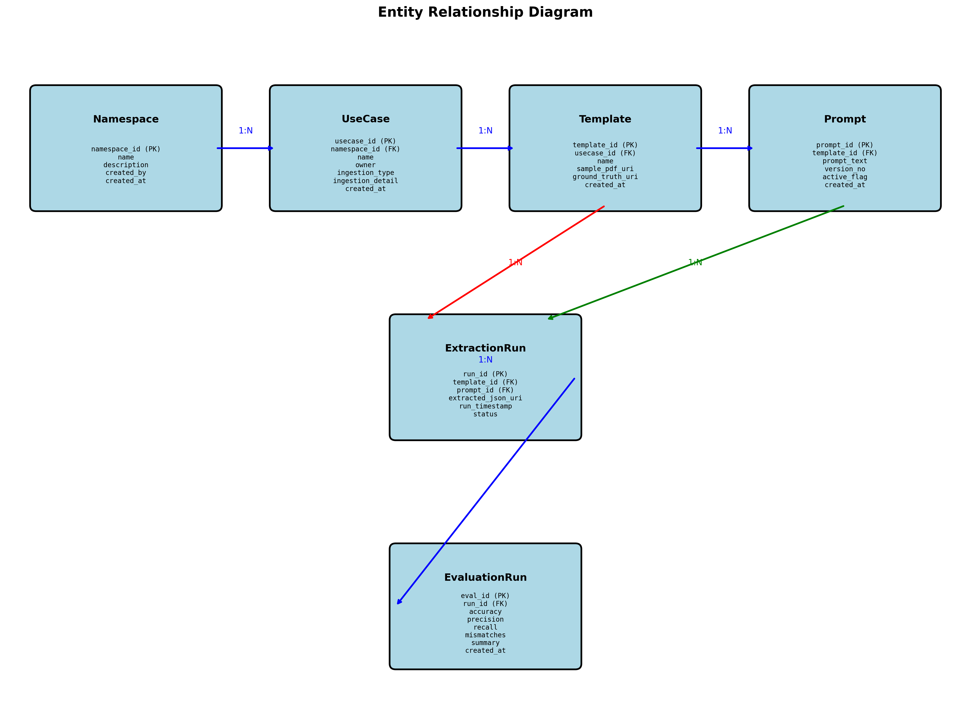

Key relationships shown in the diagram:
- Namespace (1:N) UseCase: Each namespace can contain multiple use-cases
- UseCase (1:N) Template: Each use-case can have multiple document templates
- Template (1:N) Prompt: Each template can have multiple extraction prompts
- Template & Prompt (N:N) ExtractionRun: Extraction runs link templates with specific prompts
- ExtractionRun (1:N) EvaluationRun: Each extraction can have multiple evaluation iterations

2.2 Functional Flow Diagram
The Functional Flow Diagram depicts the complete operational workflow of the Document Ingestion Pipeline, showing the four main phases: Onboarding, Extraction, Evaluation, and Iteration. This diagram illustrates the decision points and feedback loops that enable continuous improvement of extraction accuracy.
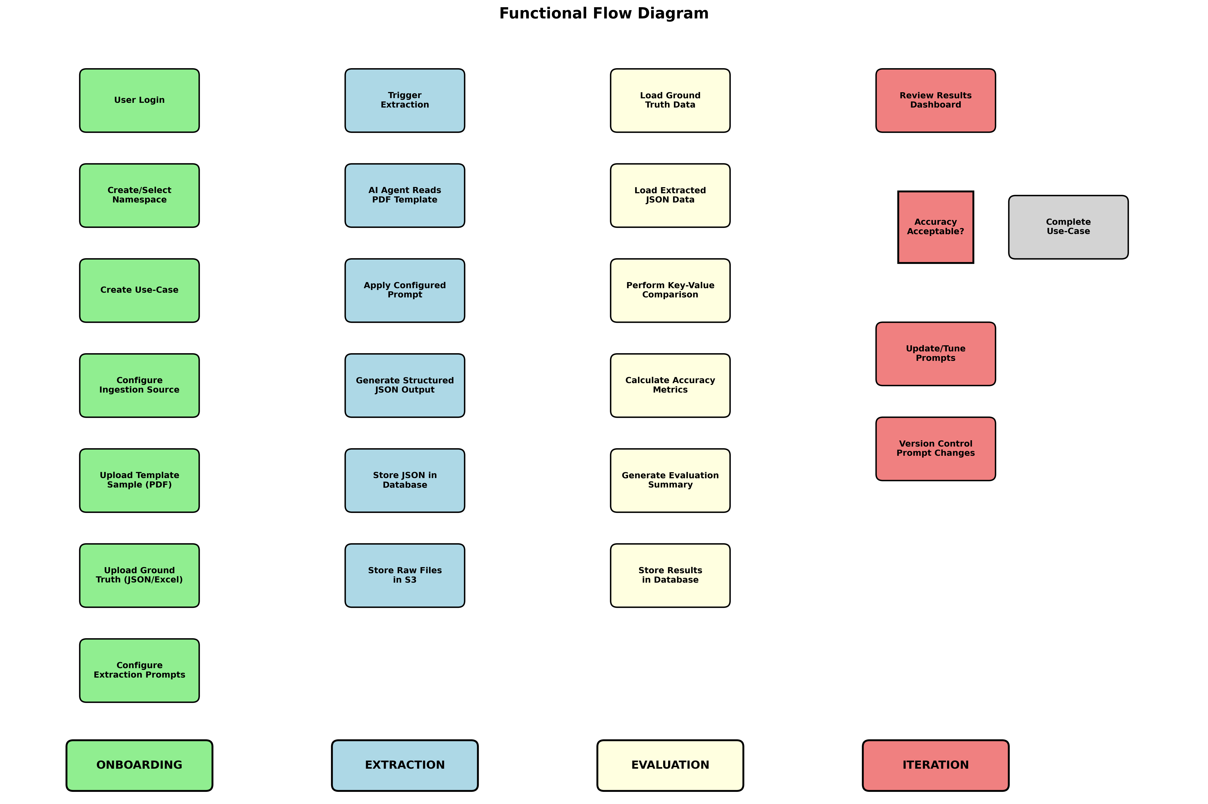

The workflow consists of four distinct phases:
- Onboarding (Green): User setup, namespace creation, template upload, and prompt configuration
- Extraction (Blue): AI-driven document processing and structured data extraction
- Evaluation (Yellow): Accuracy assessment through comparison with ground truth data
- Iteration (Red): Results review, prompt tuning, and workflow repetition until desired accuracy

2.3 System Architecture Diagram
The System Architecture Diagram presents the technical infrastructure and component organization of the Document Ingestion Pipeline. This layered architecture ensures scalability, maintainability, and clear separation of concerns across the entire system.
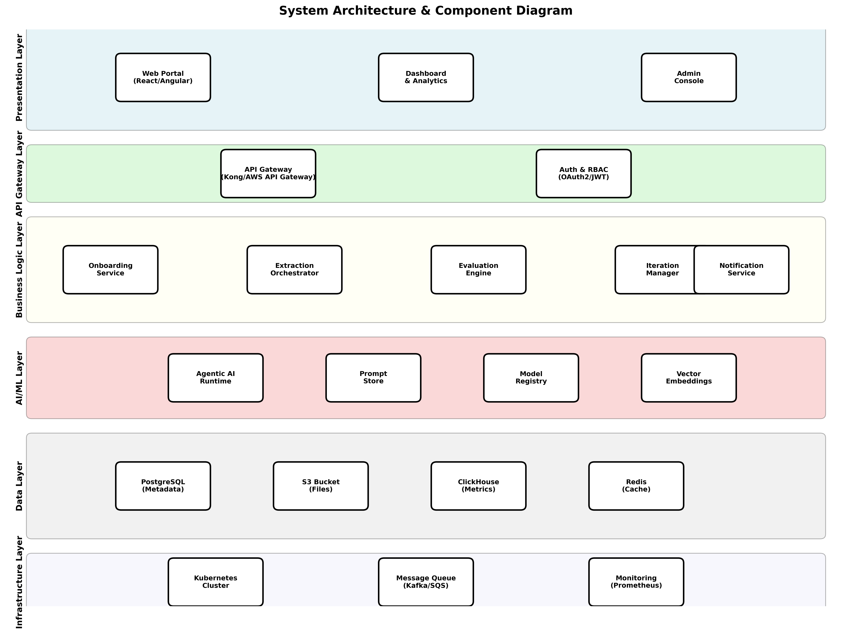

The architecture consists of six distinct layers:
- Presentation Layer: User interfaces including web portal, dashboards, and admin console
- API Gateway Layer: Centralized API management, authentication, and authorization
- Business Logic Layer: Core services for onboarding, extraction, evaluation, and iteration management
- AI/ML Layer: Agentic AI runtime, prompt store, model registry, and vector embeddings
- Data Layer: PostgreSQL for metadata, S3 for files, ClickHouse for metrics, Redis for caching
- Infrastructure Layer: Kubernetes orchestration, message queues, and monitoring systems

3. Functional Specification

3.1 System Overview
The Document Ingestion Pipeline operates as a multi-tenant system supporting multiple namespaces, each containing various use-cases with specific document templates and extraction requirements. The system is designed to handle enterprise-scale document processing with high accuracy and reliability.

3.2 Module Specifications

3.2.1 Onboarding Module
Purpose: Establish the foundational configuration for document processing workflows.

Core Functions:
- Namespace Management: Create, update, delete, and manage namespaces with access controls
- Use-Case Configuration: Define use-cases with ingestion sources (Email, SFTP, HTTP API)
- Template Management: Upload PDF templates and associate ground truth files
- Prompt Configuration: Define extraction prompts with versioning capabilities

3.2.2 Extraction Module
Purpose: Execute AI-driven extraction of structured data from PDF documents.
- Document Ingestion: Monitor sources and queue documents for processing
- AI-Powered Extraction: Execute LLM inference with configured prompts
- Output Management: Generate and validate structured JSON output
- Processing Pipeline: Support batch and real-time processing modes

3.2.3 Evaluation Module
Purpose: Assess extraction accuracy and enable iterative improvement of prompts.
- Accuracy Assessment: Compare extracted JSON against ground truth data
- Metrics Calculation: Generate precision, recall, and F1-score metrics
- Iterative Improvement: Enable prompt modification based on results
- Reporting and Analytics: Generate detailed evaluation dashboards

4. Technical Specification

4.1 System Architecture
The system follows a microservices architecture pattern with clear separation of concerns and scalable component design. The architecture is built on modern cloud-native principles ensuring high availability, scalability, and maintainability.

4.2 Technology Stack
Component | Technology
Frontend Framework | React 18+ with TypeScript
Backend Runtime | Node.js 18+ or Python 3.11+
API Framework | Express.js/FastAPI
Primary Database | PostgreSQL 15+
Object Storage | Amazon S3 or MinIO
Analytics Database | ClickHouse or Apache Druid
Cache | Redis 7+
Container Orchestration | Kubernetes
Message Queue | Apache Kafka or AWS SQS
AI/ML Integration | OpenAI GPT-4, Anthropic Claude
Monitoring | Prometheus, Grafana, Jaeger
Security | HashiCorp Vault, AWS KMS

5. Data Model & Architecture

5.1 Entity Relationship Model
The system's data model is designed to support multi-tenancy, versioning, and audit trails while maintaining referential integrity and performance. The model consists of six core entities that represent the complete lifecycle of document processing.

5.1.1 Core Entities

Namespace Entity
CREATE TABLE namespaces (
namespace_id UUID PRIMARY KEY DEFAULT gen_random_uuid(),
name VARCHAR(255) NOT NULL UNIQUE,
description TEXT,
created_by UUID NOT NULL,
created_at TIMESTAMP DEFAULT CURRENT_TIMESTAMP,
updated_at TIMESTAMP DEFAULT CURRENT_TIMESTAMP,
is_active BOOLEAN DEFAULT TRUE,
settings JSONB DEFAULT '{}'
);

UseCase Entity
CREATE TABLE use_cases (
usecase_id UUID PRIMARY KEY DEFAULT gen_random_uuid(),
namespace_id UUID NOT NULL REFERENCES namespaces(namespace_id),
name VARCHAR(255) NOT NULL,
description TEXT,
owner UUID NOT NULL,
ingestion_type VARCHAR(50) NOT NULL CHECK (ingestion_type IN ('email', 'sftp', 'api', 'manual')),
ingestion_config JSONB NOT NULL DEFAULT '{}',
created_at TIMESTAMP DEFAULT CURRENT_TIMESTAMP,
updated_at TIMESTAMP DEFAULT CURRENT_TIMESTAMP,
is_active BOOLEAN DEFAULT TRUE,
UNIQUE(namespace_id, name)
);

Template Entity
CREATE TABLE templates (
template_id UUID PRIMARY KEY DEFAULT gen_random_uuid(),
usecase_id UUID NOT NULL REFERENCES use_cases(usecase_id),
name VARCHAR(255) NOT NULL,
description TEXT,
sample_pdf_uri VARCHAR(1000) NOT NULL,
ground_truth_uri VARCHAR(1000) NOT NULL,
schema_definition JSONB,
created_at TIMESTAMP DEFAULT CURRENT_TIMESTAMP,
updated_at TIMESTAMP DEFAULT CURRENT_TIMESTAMP,
is_active BOOLEAN DEFAULT TRUE,
UNIQUE(usecase_id, name)
);

6. System Flows

6.1 Onboarding Flow
The onboarding flow establishes the foundational configuration required for document processing. This flow ensures proper setup of namespaces, use-cases, templates, and prompts before any extraction activities can begin.
- 1. User Authentication: Verify user credentials and permissions
- 2. Namespace Creation: Initialize namespace with proper access controls
- 3. Use-Case Configuration: Define ingestion sources and processing parameters
- 4. Template Upload: Store PDF samples and ground truth files in S3
- 5. Prompt Configuration: Define and version extraction prompts
- 6. Validation: Ensure all configurations are complete and valid

6.2 Extraction Flow
The extraction flow represents the core AI-driven processing of documents. This automated workflow transforms unstructured PDF content into structured JSON data using configured prompts.
- 1. Document Detection: Monitor ingestion sources for new documents
- 2. Template Matching: Identify appropriate template and prompts
- 3. Queue Processing: Add documents to processing queue with priority
- 4. AI Processing: Execute LLM inference with configured prompts
- 5. Output Generation: Create structured JSON from AI response
- 6. Validation: Verify output against predefined schemas
- 7. Storage: Persist results in database and object storage

6.3 Evaluation Flow
The evaluation flow assesses the accuracy of extracted data by comparing it against ground truth. This process enables continuous improvement through iterative prompt refinement.
- 1. Data Retrieval: Load extracted JSON and corresponding ground truth
- 2. Field Mapping: Align extracted fields with ground truth structure
- 3. Comparison Logic: Execute detailed field-by-field comparison
- 4. Metrics Calculation: Compute accuracy, precision, and recall scores
- 5. Analysis: Identify patterns in mismatches and errors
- 6. Reporting: Generate comprehensive evaluation reports
- 7. Iteration Decision: Determine if prompt refinement is needed

7. Non-Functional Requirements

7.1 Performance Requirements
Metric | Target | Measurement
API Response Time | < 200ms | 95th percentile
Document Processing | < 30 seconds | Average per document
Dashboard Loading | < 3 seconds | Initial page load
Concurrent Users | 1,000+ | Simultaneous active users
Document Throughput | 10,000+ | Documents per hour
System Availability | 99.9% | Annual uptime target

7.2 Security Requirements
- Multi-Factor Authentication: Required for administrative access
- Role-Based Access Control: Granular permissions by namespace
- Data Encryption: AES-256 at rest, TLS 1.3 in transit
- Audit Logging: Complete audit trail for compliance
- API Security: OAuth 2.0/JWT token-based authentication
- Key Management: Centralized key management system

8. Implementation Roadmap

8.1 Phase 1: Foundation (Months 1-3)
- Infrastructure Setup: Cloud provisioning and Kubernetes configuration
- Database Setup: PostgreSQL installation and schema creation
- Authentication Service: OAuth2/JWT implementation
- Basic UI Framework: React application foundation
- CI/CD Pipeline: Automated deployment setup

8.2 Phase 2: Core Functionality (Months 4-6)
- Onboarding Module: Complete namespace and use-case management
- Extraction Module: AI integration and document processing
- Evaluation Module: Comparison algorithms and metrics calculation
- Basic Dashboard: Results visualization and reporting

8.3 Phase 3: Advanced Features (Months 7-9)
- Batch Processing: High-volume document processing
- Advanced Analytics: Machine learning insights
- External Integrations: Email, SFTP, and API connectors
- Mobile Application: Responsive mobile interface

8.4 Phase 4: Production Readiness (Months 10-12)
- Security Audit: Comprehensive security testing
- Performance Optimization: Load testing and tuning
- Compliance Certification: SOC 2, GDPR preparation
- Production Deployment: Go-live support and monitoring

9. Risk Assessment

9.1 Technical Risks
Risk | Probability | Impact | Mitigation Strategy
AI Model Performance | Medium | High | Extensive testing, multiple model options, fallback mechanisms
Scalability Challenges | Medium | Medium | Load testing, auto-scaling, performance monitoring
Integration Complexity | Low | Medium | Proof of concepts, standardized APIs, comprehensive testing
Data Security Breach | Low | Very High | Multi-layered security, regular audits, incident response plan
User Adoption Issues | Medium | High | User-centered design, training programs, phased rollout

10. Appendices

10.1 Glossary
- Agentic AI: Autonomous AI systems capable of making decisions and taking actions
- Ground Truth: Verified, accurate data used as a reference for evaluation
- Namespace: Logical grouping mechanism for organizing use-cases and resources
- Prompt Engineering: Process of designing and optimizing AI prompts for better results
- Use-Case: Specific business scenario or application within a namespace

10.2 Document History
Version | Date | Changes
1.0 | 2025-08-29 | Initial comprehensive system design document with diagrams

Document Classification: Internal
Next Review Date: 2025-11-29
Approval Required: Architecture Review Board

