**University of Petroleum and Energy Studies**

School of Computer Science

Department of Cybernetics



**Graphics and Animation Tools**

**(Lab File)**

Course: B.Tech Branch: CSE (OSOS)

Batch: 2017-2021 Semester: 7th

**Submitted By:**

**Prakash Tiwari**

**Roll No.: R100217049**

**Sap ID: 500062116**

**(Batch 2)**

**INDEX**

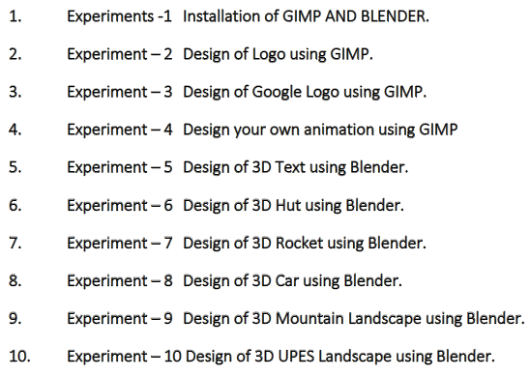

**EXPERIMENT 8: Designing 3D Car Using Blender**

**Aim:** Creating a 3D Car using Blender.

Steps taken to create 3D Car:

1. Add Cubes and Cylinders by clicking on: Add > Mesh > Cubes or Add > Mesh > Cylinders.
2. Use cubes (for car body) and cylinder meshes (for tyres) to create a model of car.

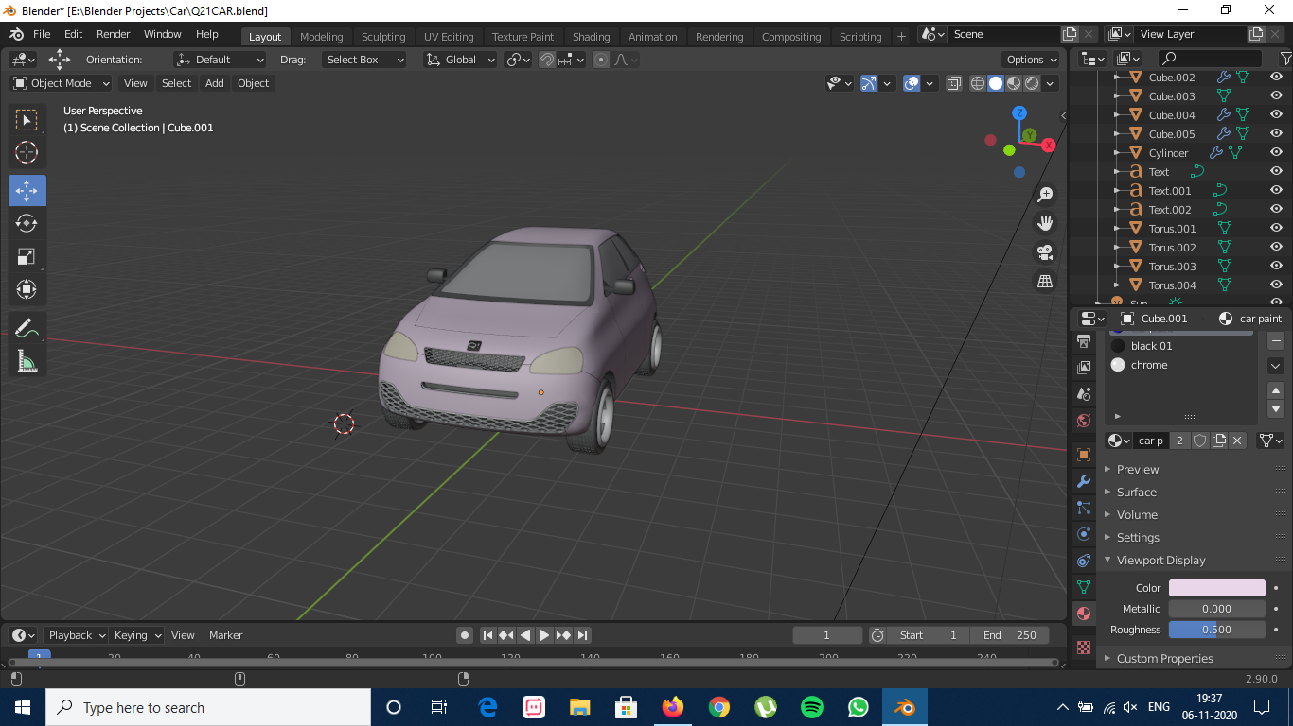

1. Add a viewport colour for car’s cube to distinct car body from other parts of car.

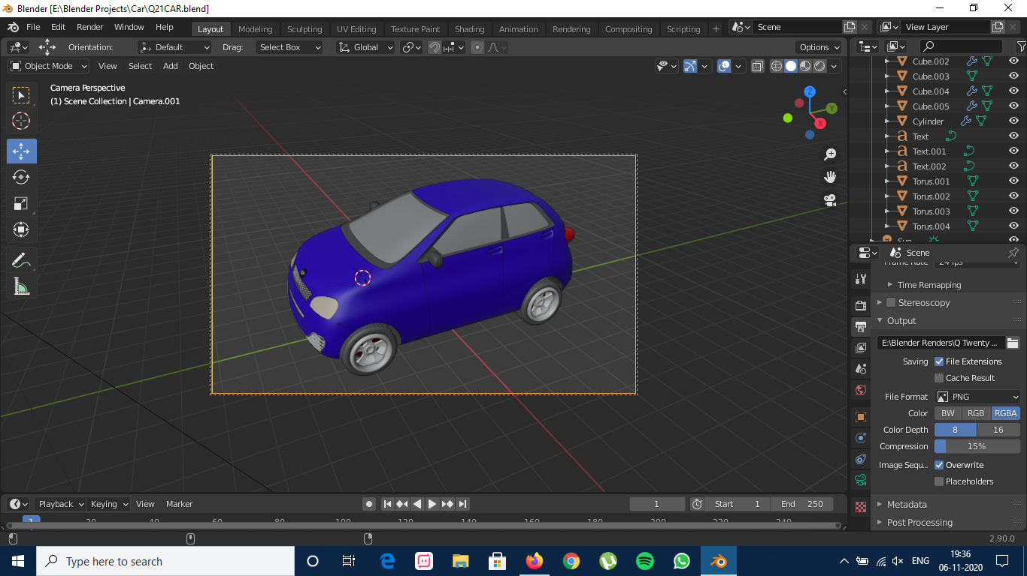

1. In Shading tab, add different materials to the car (Including glass material for windshield and windows and Metallic material for Car’s Body).

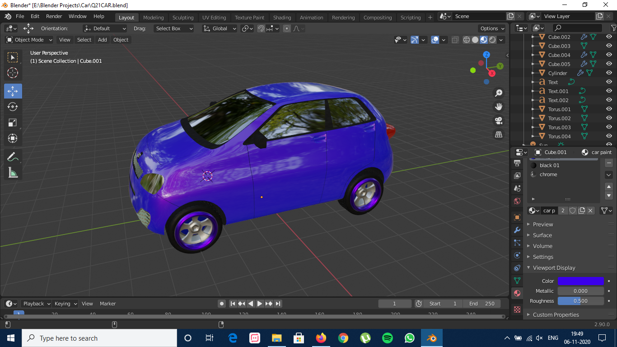

1. Add a name and Icon for your car by clicking on: Add > Text.

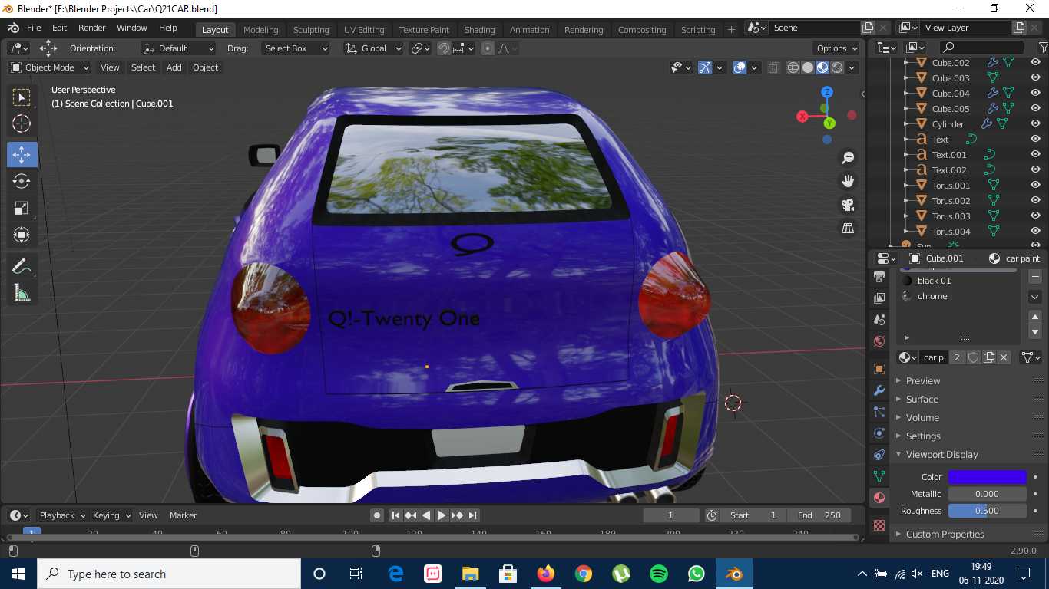

1. Finally, add a camera and render the final image of 3D car after adding an HDRI (Sunset here) to show the materials’ reflection.

