**University of Petroleum and Energy Studies**

School of Computer Science

Department of Cybernetics

**Graphics & Animation Tools**

**VIVA FILE**

**(Session: 2020-2021)**

Course: B.Tech with Specialization in Open Source and Open Standards

Submitted To- Submitted By-

Dr. Durgansh Sharma Prakash Tiwari

Assistant Professor 500062116

Department of Cybernetics R100217049

**Graphics and Animation VIVA File**

**1. Create a Mobile using GIMP.**

Steps:

1. OPEM GIMP
2. CREATE A NEW DOCUMENT/IMAGE

## DESIGN YOUR BACKGROUND (USING THE MAZE FILTER)

## BLEND YOUR BACKGROUND USING THE BLEND TOOl

## ADD YOUR TEXT

## STYLE YOUR TEXT (BUCKET FILL TOOL AND CUBISM FILTER)

## ADD A DROP SHADOW TO YOUR TEXT

## SAVE AND/OR EXPORT YOUR COMPOSITION

**FINAL OUTPUT:**

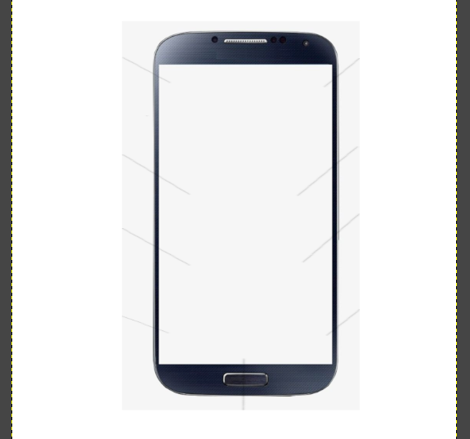

**2. Create a basket with fruits using blender**

**Final Output:**

