University of Petroleum and Energy Studies

School of Computer Science

Department of Cybernetics


Graphics and Animation Tools

(Lab File)

Course: B.Tech Branch: CSE (OSOS)

Batch: 2017-2021 Semester: 7th

Submitted By:

Prakash Tiwari

Roll No.: R100217049

Sap ID: 500062116

(Batch 2)

INDEX
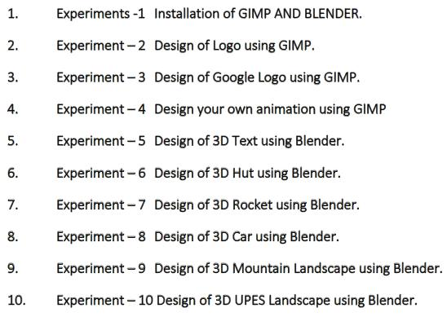

EXPERIMENT 7: Designing 3D Rocket Using Blender

Aim: Creating a 3D Rocket using Blender.

Steps taken to create the 3D Rocket animation:

- Click on Add>Mesh and add a cylinder.

- Click on object and then Shade Smooth to make the cylinder smooth.

- In the Edit Mode give the cylinder a rocket shape.

- Add more cylinders that look like thrusts around the central cylinder.
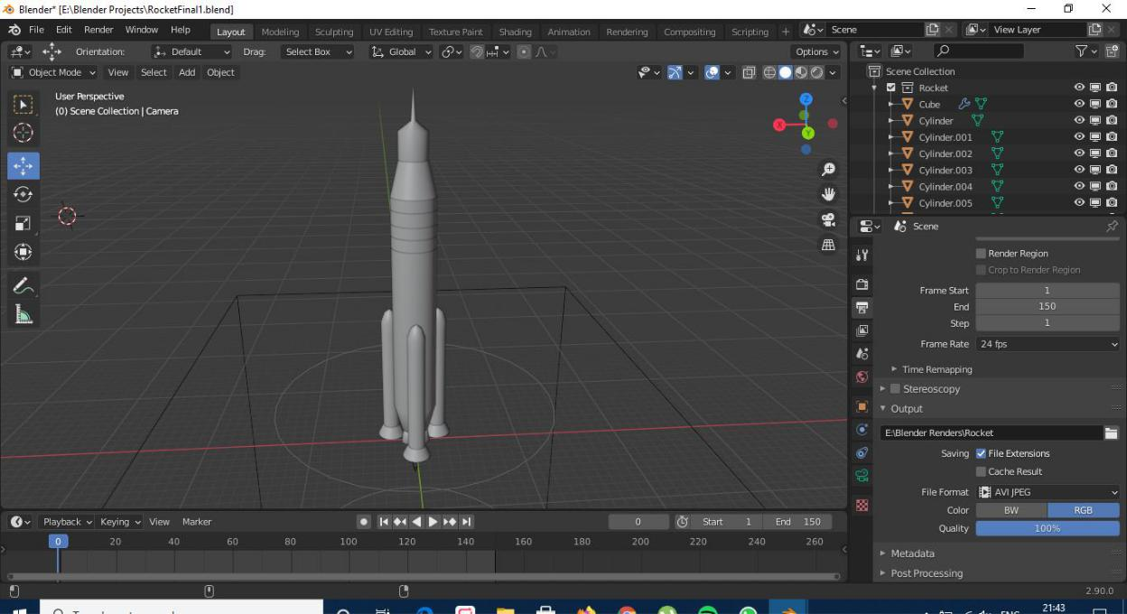
5. Add text ISRO at the front of rocket.
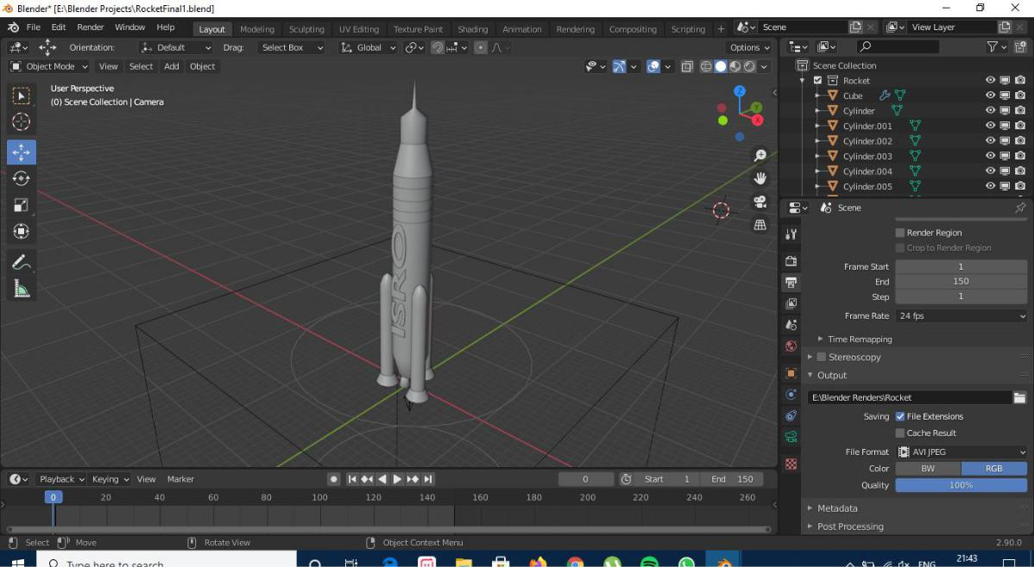

6. Give different shades in the shading tab to the rocket.
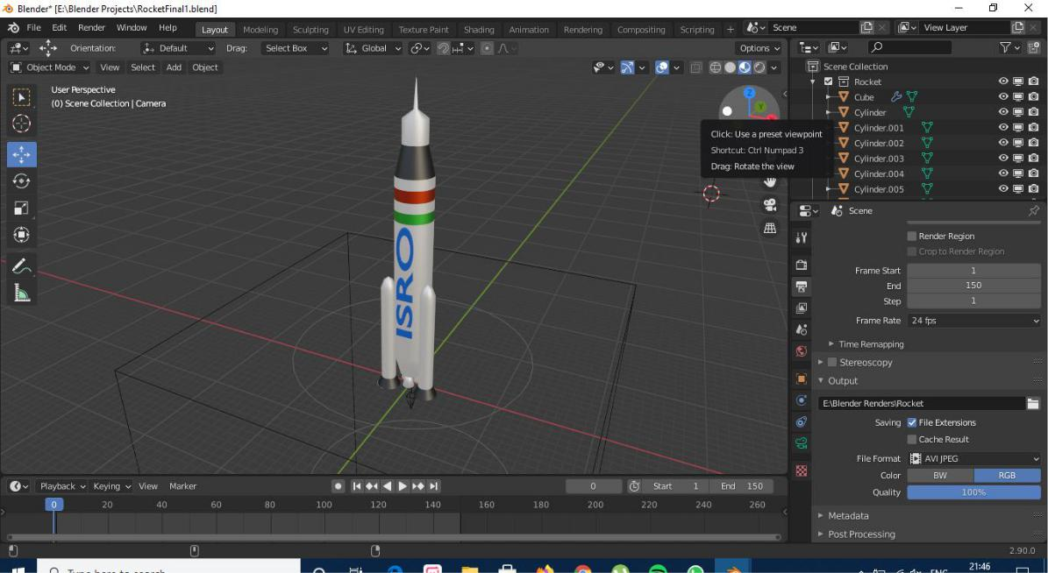

- Finally add smoke and fire animation after adding a FIRE and SMOKE Domain at the bottom of rocket with the help of an ICOSPHERE Emitter.
