# ASSIGNMENT-3

**Q1- Part B, Decision Trees**

1. **Decision Tree:**



**I am getting very poor accuracies for this data.**

1. **Decision tree grid search**

* **The best parameters:**

**max_depth=10**

**min_samples_leaf=3**

**min_samples_split= 3**

* **The train and test accuracy:**

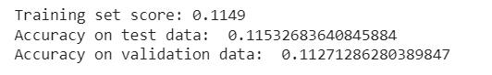

1. **Decision tree post pruning**

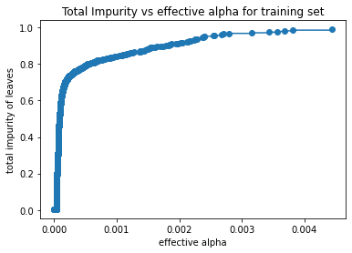

1. **Random forest:**

**The random forest classifier with n_estimator: 100 gives better results and accuracy:**



**Random forest grid search:**

1. **Gradient boosted trees:**