**PYTHON CAPSTONE PROJECT**

1. **Project Title:**

CRM (Customer Relationship Management)

1. **Problem Statement:**

The project endeavors to address the challenges confronted by the customer service center of a company in efficiently managing the entire life cycle of customer complaints. The primary objectives involve enhancing the process of registering, monitoring, modifying, and closing complaints as they progress through the resolution pipeline.

1. **Project Description:**

Goals:

The project aims to design and implement a Customer Relationship Management system tailored to meet the specific needs of a business or organization. The system should serve as a centralized tool for managing customer data,communication, and interactions throughout the entire customer lifecycle.

Main Features:

**Key Feature: Date of complaint registration, is used for the generation of unique Complaint IDs.**

1. Dashboard :

* Offering a comprehensive overview of all complaints registered within the company’s database, the dashboard is meticulously designed to display a detailed breakdown of both open and closed complaints. The user-friendly interface not only presents a consolidated view of all complaints but also facilitates seamless interaction by providing users with one-click options to add new complaints, modify existing ones, and efficiently close them.

1. New Complaint Registration:

* Introducing an intuitive and user-friendly complaint registration page designed to streamline the process of registering new complaints. This user-centric interface ensures a quick and efficient registration experience, reducing the time required for both employees and customers, optimizing overall interaction efficiency.

1. Modify Complaint:

* The platform provides a dedicated interface for the modification of existing complaint records, allowing users to update names, phone numbers, addresses, and even reopen complaints. This functionality ensures the correction of any errors made during the initial complaint registration, thereby maintaining precision and accuracy in the complaint data. This capability contributes to the overall reliability and integrity of the system.

1. **Source code:**

Github Repository link : <https://github.com/praket02/CRM>

1. **Result & Discussion:**

The system has been effectively designed to manage complaints, incorporating a robust mechanism for generating unique complaint identifiers. The primary challenge encountered during the development process was devising a method to generate distinct complaint IDs for each registered complaint. After careful consideration, we came up with an idea of associating the complaint IDs with the date of registration. This approach ensures the generation of unique and date stamped identifiers, adding to efficient management of complaints.

1. **Snapshots:**

* Dashboard

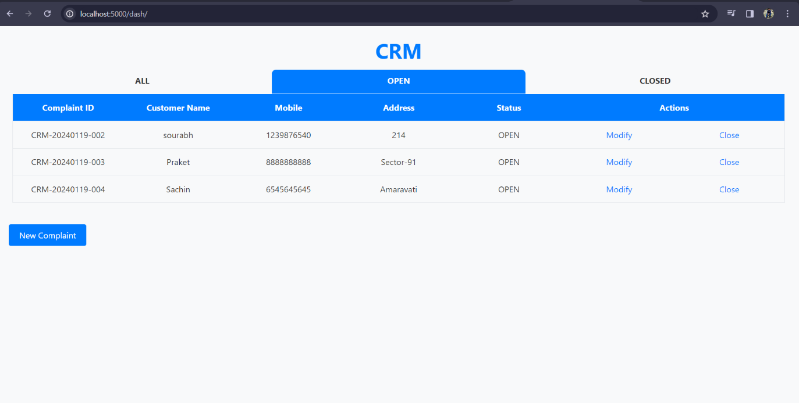

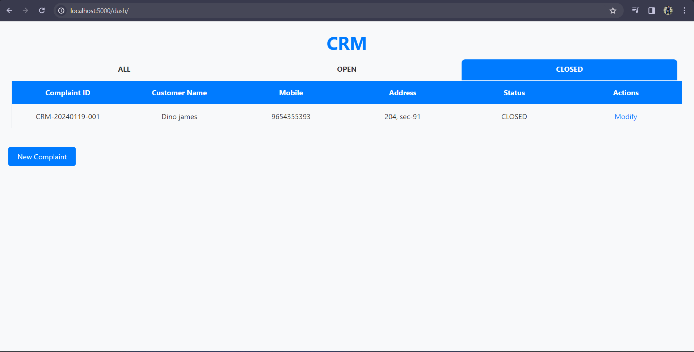

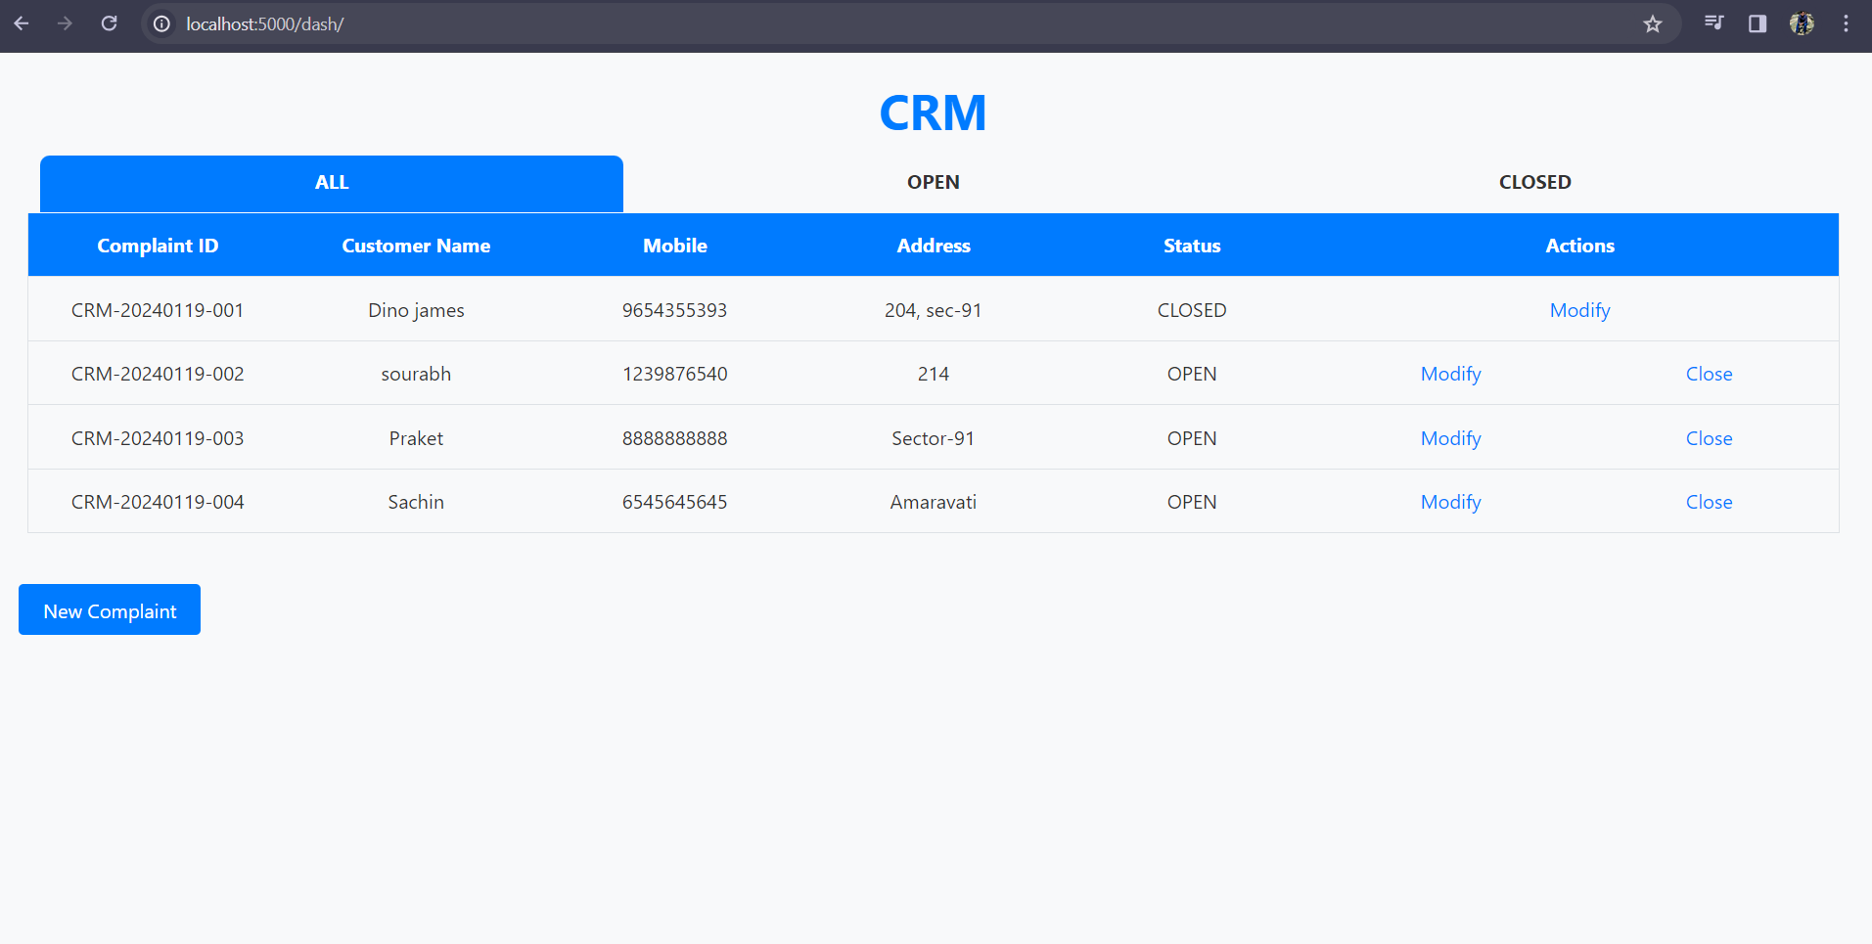

* New Complaint

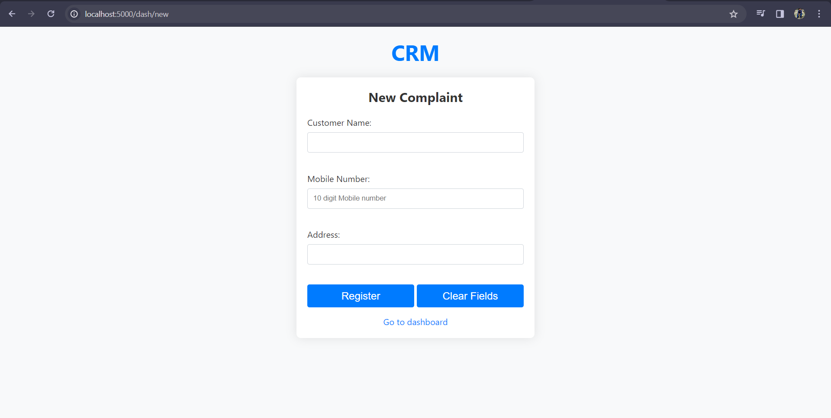

* Modify Complaint

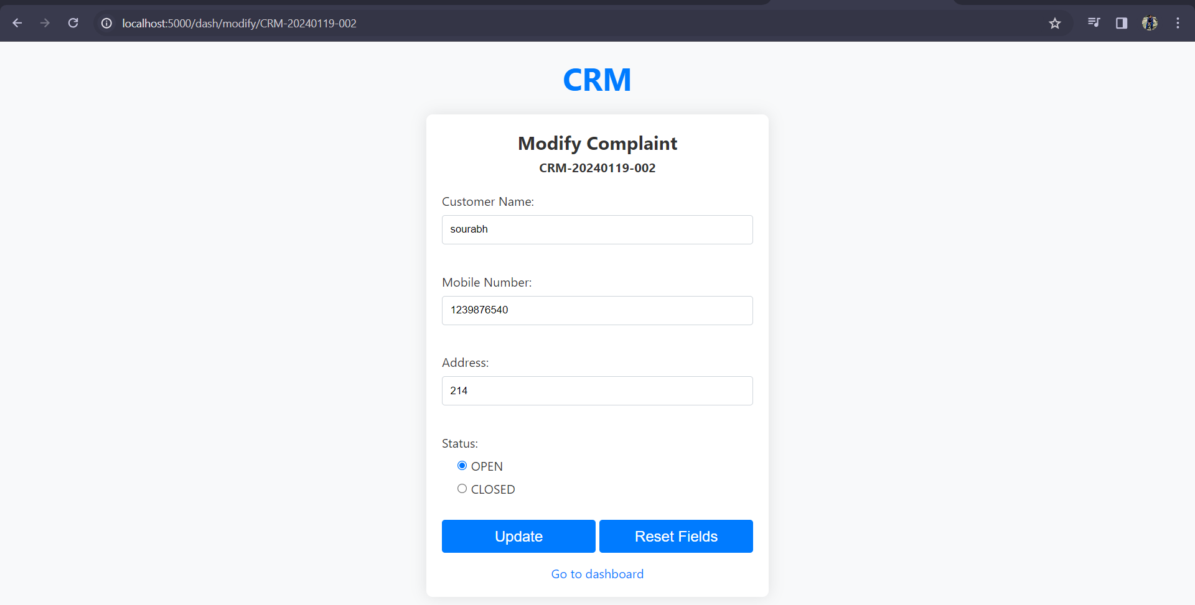

1. **Conclusion:**

Through this project, we tried to manage the entire lifecycle of customer complaints and address the challenges faced by the customer service center.

We tried to focus on the process of registering, monitoring, modifying, and closing complaints and achieved these objectives by designing a tailored CRM system.

1. **Future Direction:**

Our project enhancement goals include the implementation of a secure login method to grant users access to complaint data, with a designated super admin overseeing user privileges. Additionally, we aspire to introduce real-time complaint tracking, allowing for location monitoring of technicians and seamless communication through the portal. The further incorporation of Google Maps will streamline the process, by linking addresses to Gmaps, making it easier for technicians to navigate to customer’s location.