**IDA DBMS**

**ER Diagram -**

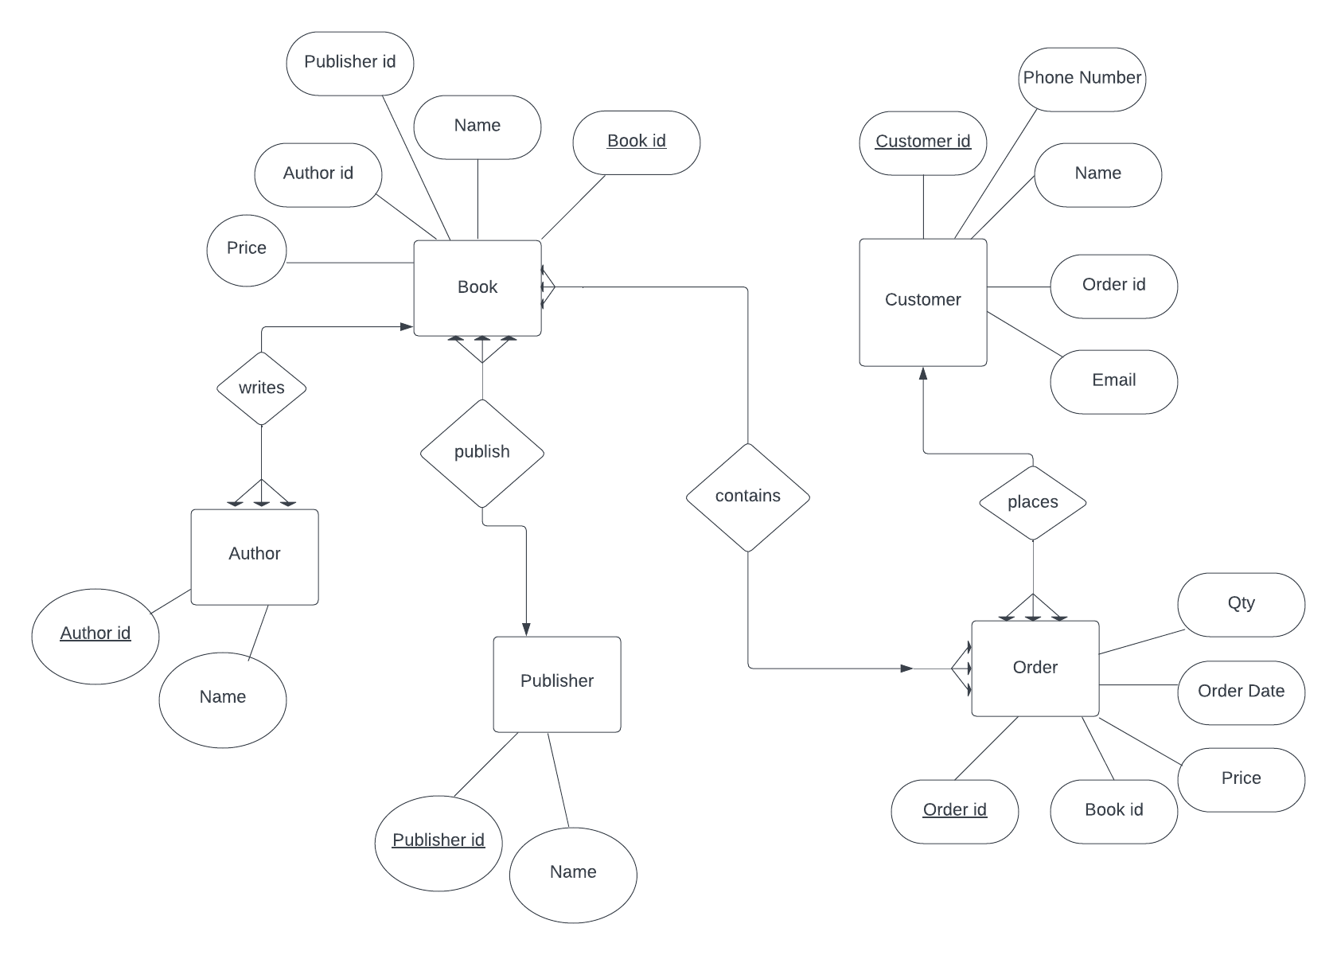

**Normalised Tables –**

Book –

|  |  |  |  |  |
| --- | --- | --- | --- | --- |
| **Book Id** | **Name** | **Author id** | **Publisher id** | **Price** |
| 1 | ABC | 10 | 20 | 999 |
| 2 | DEF | 11 | 21 | 499 |

Customer –

|  |  |  |  |  |
| --- | --- | --- | --- | --- |
| **Customer Id** | **Name** | **Order Id** | **Phone no.** | **Email** |
| 100 | qwerty | 50101 | 8737288827 | uoa@gmail.com |
| 101 | asdfgh | 50102 | 7482971737 | aouf@gmail.com |

Order –

|  |  |  |  |  |
| --- | --- | --- | --- | --- |
| **Order id** | **Book id** | **Order date** | **Qty** | **Price** |
| 50101 | 1 | 25/08/2023 | 1 | 999 |
| 50102 | 2 | 26/08/2023 | 1 | 499 |

Publisher –

|  |  |
| --- | --- |
| **Publisher id** | **Name** |
| 20 | Blue Publishers |
| 21 | Red Publishers |

Author –

|  |  |
| --- | --- |
| **Author Id** | **Name** |
| 10 | Praket |
| 11 | Sid |