Survival Extrapolation Analysis of First-Line
Immunotherapy versus Chemotherapy in Advanced NSCLC
A reconstructed individual-patient-data (IPD) approach for health economics and outcomes research
Prepared by Prakhar Gupta
M.Sc. Statistics
July 2026
Based on: Reck M, et al. Pembrolizumab versus Chemotherapy for PD-L1–Positive
Non–Small-Cell Lung Cancer. N Engl J Med. 2016;375:1823-1833. (KEYNOTE-024)

Executive summary
This report presents a health economics and outcomes research (HEOR) style survival extrapolation analysis based on the pivotal KEYNOTE-024 trial, which established pembrolizumab as a first-line standard of care for advanced non–small-cell lung cancer (NSCLC) in patients with high PD-L1 expression. Using only the published Kaplan-Meier overall survival curve and its accompanying number-at-risk table, individual patient-level survival records were reconstructed and used to fit and compare a standard set of parametric survival distributions, producing extrapolated survival projections and restricted mean survival time (RMST) estimates suitable for downstream cost-effectiveness modeling.
The reconstructed data reproduced the trial's headline result closely — a hazard ratio of 0.61 (95% CI, 0.41–0.90) against the published 0.60 (95% CI, 0.41–0.89) — supporting the validity of the reconstruction. Pembrolizumab was projected to provide a meaningful and growing survival advantage over platinum-based chemotherapy across all modeled time horizons. An interactive R Shiny dashboard was developed alongside this report to make the full pipeline, from digitized curve to extrapolated projection, explorable in real time.

Background
Published clinical trial reports typically present survival outcomes only as Kaplan-Meier curves and summary statistics such as median survival and hazard ratios, without releasing the underlying individual patient data (IPD). Health economic evaluations and health technology assessments, however, generally require patient-level time-to-event data — both to validate modeling assumptions and to extrapolate survival beyond a trial's observed follow-up window. Analysts routinely address this gap by reconstructing approximate IPD directly from published figures, a well-established technique in the HEOR literature. This report demonstrates that workflow end-to-end using a real, publicly available oncology trial.

Data source
Reck M, Rodríguez-Abreu D, Robinson AG, et al. Pembrolizumab versus Chemotherapy for PD-L1–Positive Non–Small-Cell Lung Cancer. New England Journal of Medicine. 2016;375(18):1823–1833.
KEYNOTE-024 was an open-label, phase 3 randomized controlled trial enrolling 305 patients with previously untreated advanced NSCLC and a PD-L1 tumor proportion score of 50% or higher. Patients were randomized 1:1 to pembrolizumab monotherapy or investigator's choice of platinum-based chemotherapy. The endpoint used for this analysis is Overall Survival, as reported in Figure 2 of the original publication.

Methodology

Curve digitization
The published overall survival Kaplan-Meier curve was digitized using WebPlotDigitizer, extracting time and survival-probability coordinates for both treatment arms directly from the source figure, together with the accompanying number-at-risk table.

Pseudo individual patient data reconstruction
Individual patient-level time-to-event records were reconstructed from the digitized curve using the algorithm of Guyot et al. (2012), implemented directly in R. The method anchors reconstruction to the published number-at-risk table: within each risk-table interval, the ratio of successive survival estimates is used to infer the number of events, and any residual discrepancy against the next reported risk count is attributed to censoring and distributed across the interval. This produces a reconstructed dataset of patient-level time and event/censoring status for each treatment arm, reconciled exactly to the published risk table at every checkpoint.

Validation
Reconstruction quality was assessed by refitting a Kaplan-Meier curve and a Cox proportional hazards model to the reconstructed data, and comparing the resulting hazard ratio, confidence interval, and median survival estimates against the values reported in the original publication.

Parametric survival modeling
Six standard parametric survival distributions — exponential, Weibull, gamma, log-normal, log-logistic, and Gompertz — were fit to the reconstructed data by maximum likelihood estimation for right-censored survival data. This distribution set follows the standard candidate list recommended by the NICE Decision Support Unit (Technical Support Document 14) for survival extrapolation in cost-effectiveness modeling. Model fit was compared using the Akaike Information Criterion (AIC) and Bayesian Information Criterion (BIC), with the lowest-AIC model selected as the primary extrapolation model for each arm.

Extrapolation and restricted mean survival time
The best-fitting distribution for each arm was used to project survival beyond the trial's observed follow-up period. Restricted mean survival time (RMST) — the area under the survival curve up to a defined time horizon, and a standard summary measure in economic evaluation — was calculated at 24-month and 60-month horizons via numerical integration.

Interactive dashboard
An interactive R Shiny application was developed to allow real-time exploration of the full analytic pipeline: reconstructed Kaplan-Meier curves, side-by-side parametric model comparison with live AIC/BIC ranking, and extrapolation under any user-selected distribution and time horizon.

Results

Reconstruction validation
The reconstructed dataset contained 305 patients (154 pembrolizumab, 151 chemotherapy), matching the trial's enrollment exactly. Reconstructed events totaled 43 of 154 (27.9%) in the pembrolizumab arm and 63 of 151 (41.7%) in the chemotherapy arm.
Metric | Reconstructed | Published (Reck et al., 2016)
Hazard ratio (pembrolizumab vs. chemotherapy) | 0.61 | 0.60
95% confidence interval | 0.41–0.90 | 0.41–0.89
P-value | 0.013 | 0.005
Median OS — chemotherapy | 12.6 months | consistent with published curve
Median OS — pembrolizumab | Not reached | Not reached
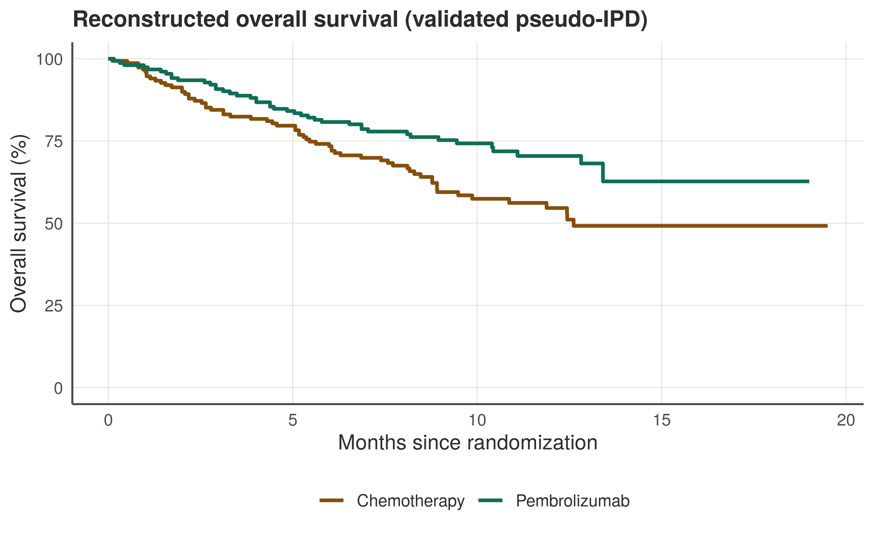
Figure 1. Reconstructed overall survival curves, both treatment arms.

Parametric model selection
Model fit statistics for both arms are summarized below, ranked by AIC. Differences between the top-ranked models are small in both arms, and the Weibull and gamma shape parameters are close to 1.0 in both cases — consistent with an approximately constant hazard over the trial's observed follow-up window, which favors the exponential model on parsimony grounds (AIC and BIC both penalize its two competitors' additional parameter).
Pembrolizumab arm
Distribution | AIC | BIC
Exponential (selected) | 386.89 | 389.92
Log-logistic | 388.37 | 394.44
Log-normal | 388.43 | 394.50
Gompertz | 388.57 | 394.65
Weibull | 388.87 | 394.94
Gamma | 388.88 | 394.95

Chemotherapy arm
Distribution | AIC | BIC
Exponential (selected) | 503.21 | 506.23
Log-normal | 503.66 | 509.69
Log-logistic | 503.85 | 509.88
Gamma | 505.02 | 511.05
Gompertz | 505.06 | 511.10
Weibull | 505.12 | 511.16
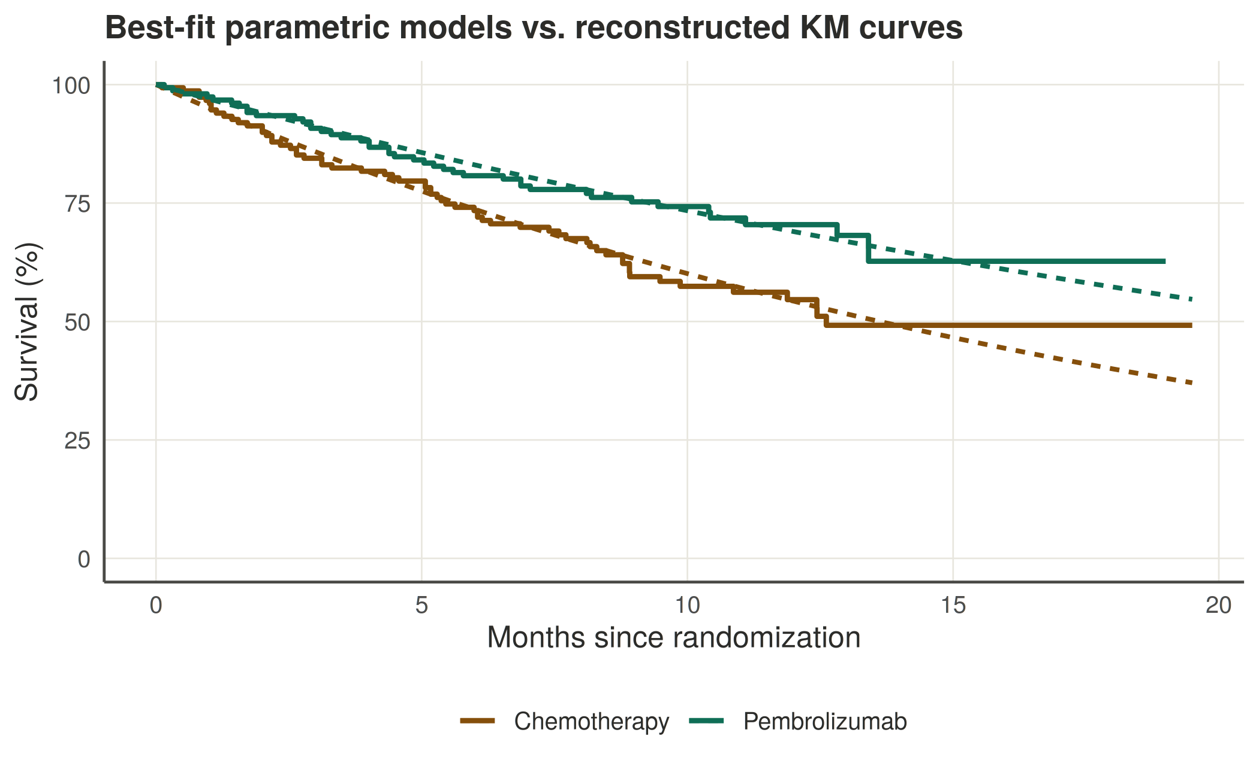
Figure 2. Best-fit parametric models (exponential, both arms) overlaid on the reconstructed Kaplan-Meier curves.

Extrapolated survival and restricted mean survival time
Applying each arm's selected exponential model, projected survival and restricted mean survival time (RMST) were computed at 24- and 60-month horizons:
Horizon | Pembrolizumab RMST | Chemotherapy RMST | Difference
24 months | 16.94 months | 13.86 months | +3.08 months
60 months | 27.27 months | 18.72 months | +8.55 months
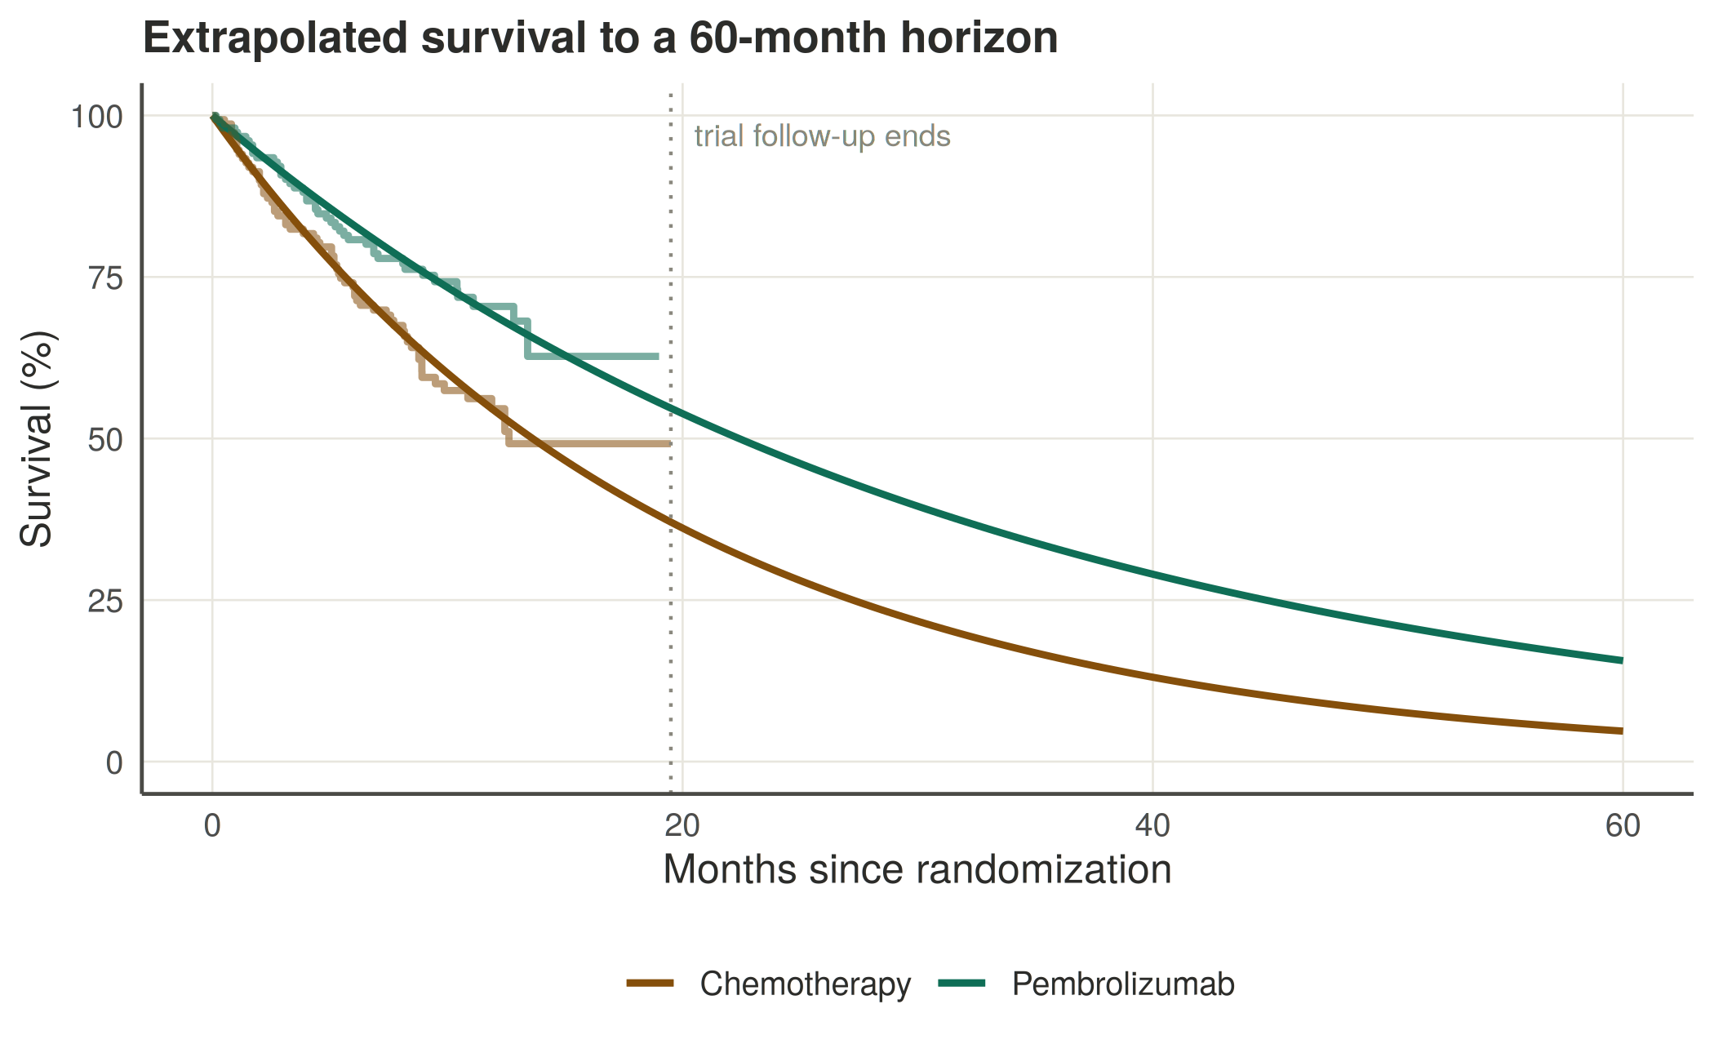
Figure 3. Extrapolated survival to a 60-month horizon, both arms.

Discussion
The close agreement between the reconstructed and published hazard ratios (0.61 vs. 0.60) supports the reliability of the underlying pseudo-IPD reconstruction, and by extension, the downstream parametric modeling and extrapolation built on it. The projected RMST advantage for pembrolizumab widens substantially between the 24-month and 60-month horizons (+3.08 months to +8.55 months), reflecting the compounding effect of a consistently lower hazard rate over a longer projection window.
The exponential model's selection in both arms reflects a genuinely close fit rather than a modeling artifact — the fitted shape parameters for the more flexible Weibull and gamma distributions were both close to 1.0, the value at which each of those distributions collapses to the exponential case. That said, immunotherapy survival curves are well documented in the oncology and HEOR literature to plateau over longer horizons than most trials directly observe, as a subset of patients become durable long-term responders. Because this analysis is anchored to the trial's own observed follow-up window, extrapolations well beyond that window should be treated cautiously; in practice, HEOR analyses of immuno-oncology data often supplement standard parametric models with more flexible alternatives — spline-based models or mixture cure models — specifically to capture this long-term plateau behavior.

Limitations
- The reconstructed IPD is an approximation derived from a published figure, not the trial's actual patient-level data; small deviations from ground truth are expected and are reflected in the modest gap between reconstructed and published confidence intervals.
- Digitization and reconstruction introduce a degree of measurement error inherent to any curve-reading exercise.
- Parametric extrapolation beyond the observed follow-up window carries structural uncertainty that AIC and BIC alone do not fully capture, particularly for immunotherapy data with potential long-term plateau effects.
- This analysis is intended for educational and methodological demonstration purposes and does not constitute a clinical, regulatory, or reimbursement-submission-grade analysis.

Conclusion
This project demonstrates a complete, reproducible pipeline for turning a published clinical trial figure into decision-analytic-ready survival data — spanning curve digitization, pseudo-IPD reconstruction, parametric model selection, and interactive extrapolation. Applied to KEYNOTE-024, the reconstruction closely reproduced the trial's published treatment effect, and the resulting extrapolation supports a substantial and widening long-term survival benefit for pembrolizumab over platinum-based chemotherapy in this population. The accompanying interactive dashboard makes this workflow directly reusable for additional trials, positioning it as a reusable template for early-stage HEOR survival analysis work.

References
1. Reck M, Rodríguez-Abreu D, Robinson AG, et al. Pembrolizumab versus Chemotherapy for PD-L1–Positive Non–Small-Cell Lung Cancer. N Engl J Med. 2016;375(18):1823–1833.
2. Guyot P, Ades AE, Ouwens MJ, Welton NJ. Enhancing secondary analysis of survival data: reconstructing the data from published Kaplan-Meier survival curves. BMC Med Res Methodol. 2012;12:9.
3. National Institute for Health and Care Excellence (NICE) Decision Support Unit. TSD 14: Survival Analysis for Economic Evaluations Alongside Clinical Trials.

