STATISTICAL ANALYSIS REPORT

Efficacy of Drug X versus Placebo on Fasting Glucose in Type 2 Diabetes
An end-to-end SDTM → ADaM → TLF analysis in SAS using the two-sample t-test and ANCOVA
Item | Detail
Prepared by | Prakhar Gupta
Primary endpoint | Change from baseline in fasting glucose (mg/dL) at Week 12
Design | Two-arm, parallel-group, 1:1 allocation; Drug X 10 mg vs placebo; N = 80
Methods | PROC TTEST, PROC GLM (ANCOVA), PROC MEANS, PROC FREQ, PROC SGPLOT
Software | SAS 9.4 (SAS OnDemand for Academics)
Date | October 2026
Contents
1. Executive Summary
2. Background and Objectives
3. Study Design and Data
4. Methods
5. Results
6. Discussion
7. Conclusion
Appendix A. Output Inventory

1. Executive Summary
This report documents the programming workflow and statistical analysis of a two-arm, parallel-group mock study comparing Drug X (10 mg) with placebo in 80 adults with Type 2 Diabetes. Raw demographic, exposure and laboratory data were converted to CDISC SDTM, derived into ADaM analysis datasets (ADSL and ADLB), and analysed in SAS 9.4 to produce summary tables, a subject listing and a figure. The primary endpoint is the change from baseline in fasting glucose (mg/dL) at Week 12.
Key findings
- Mean glucose fell by 31.2 mg/dL (SD 9.7) on Drug X versus 7.9 mg/dL (SD 11.4) on placebo at Week 12.
- The treatment difference was −23.3 mg/dL (95% CI −28.2 to −18.4; t = −9.41, df = 72, p < 0.0001).
- The ANCOVA, adjusting for baseline glucose, gave an adjusted difference of −23.27 mg/dL (95% CI −28.23 to −18.30; p < 0.0001). Baseline glucose was not a significant covariate (p = 0.69).
- The standardised effect size was large (Cohen's d = 2.19). In an exploratory responder analysis, 88.6% of Drug X patients achieved a reduction of at least 20 mg/dL, compared with 15.4% on placebo.
- Model assumptions were satisfied (residual normality: Shapiro–Wilk p = 0.23; equal variances: folded-F p = 0.33).
- 74 of 80 patients (92.5%) had a Week 12 measurement; 5 Drug X and 1 placebo patient discontinued before Week 12.
Table 1. Summary of the primary efficacy result (Week 12 analysis set)
Measure | Drug X (n = 35) | Placebo (n = 39) | Difference (95% CI) | p-value
Baseline glucose, mean (SD) | 166.4 (19.3) | 165.2 (18.0) | — | —
Week 12 glucose, mean (SD) | 135.2 (21.5) | 157.4 (20.5) | — | —
Change from baseline, mean (SD) | −31.2 (9.7) | −7.9 (11.4) | −23.3 (−28.2, −18.4) | <0.0001
ANCOVA adjusted mean change (SE) | −31.15 (1.81) | −7.88 (1.71) | −23.27 (−28.23, −18.30) | <0.0001
SD = standard deviation; SE = standard error; CI = confidence interval. Differences are Drug X minus placebo; negative values favour Drug X.

2. Background and Objectives
Type 2 Diabetes is characterised by chronically elevated blood glucose, and fasting glucose is a standard efficacy marker in early-phase glucose-lowering trials. Because patients begin a study at different glucose levels, efficacy is judged on the change from baseline rather than on the raw post-treatment value. Clinical programmers and biostatisticians turn collected trial data into regulatory-standard datasets and outputs; this project reproduces that workflow end to end.
Objectives. (1) Convert raw DM, EX and LB data to SDTM-compliant datasets. (2) Derive the ADaM datasets ADSL and ADLB, including baseline and change-from-baseline variables. (3) Estimate and test the effect of Drug X versus placebo on Week 12 glucose change using a two-sample t-test and an analysis of covariance (ANCOVA). (4) Produce a demographics table, an efficacy table, a subject listing and a figure.
Hypotheses. Let μ(X) and μ(P) denote the true mean change from baseline at Week 12 on Drug X and placebo. The null hypothesis is H₀: μ(X) − μ(P) = 0 against the two-sided alternative H₁: μ(X) − μ(P) ≠ 0, tested at the 5% significance level.

3. Study Design and Data

3.1 Design
The study is a randomised, parallel-group comparison with 1:1 allocation: 40 patients received Drug X (10 mg) and 40 received placebo, recruited across four sites (SITE01–SITE04). Treatment lasted 12 weeks (84 days). Fasting glucose was measured at five visits (Table 2). The data were simulated to reproduce the structure and variability of a two-arm diabetes trial and contain no real patient information.
Table 2. Visit schedule and glucose assessments
Visit | Study day | Purpose | Records (n)
Screening | Day −14 (±) | Eligibility measurement | 80
Baseline | Day 1 (first dose) | Reference value for change | 80
Week 4 | Day 29 (±2) | Early response | 80
Week 8 | Day 57 (±2) | Intermediate response | 80
Week 12 | Day 85 (±2) | Primary endpoint | 74
Total of 394 glucose records. Six patients (5 Drug X, 1 placebo) discontinued after Week 8 and have no Week 12 value.

3.2 Source datasets
Table 3. Raw datasets and key variables
Dataset | Rows | Content | Key variables
DM | 80 | Demographics, one row per patient | STUDYID, SITEID, SUBJID, AGE, SEX, RACE, ARM, RFSTDTC
EX | 80 | Exposure (dosing period) | EXTRT, EXDOSE, EXDOSU, EXSTDTC, EXENDTC
LB | 394 | Laboratory results, glucose only | LBTESTCD, LBTEST, LBORRES, LBORRESU, VISIT, LBDTC

4. Methods

4.1 Data pipeline
The analysis followed the standard clinical programming flow shown in Figure 1. Each layer is stored as a permanent SAS library (SDTM, ADAM) so that every table can be traced back to the source record.
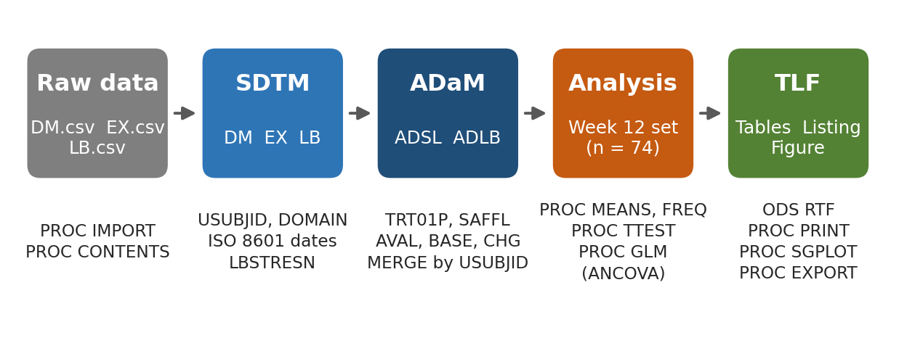
Figure 1. Programming workflow from raw data to Tables, Listings and Figures (TLF).

4.2 SDTM creation
Raw CSV files were read with PROC IMPORT and checked with PROC CONTENTS. SDTM datasets were created in DATA steps: the unique subject identifier was derived as USUBJID = STUDYID–SUBJID; the two-letter DOMAIN variable was added; dates were stored as ISO 8601 character strings (variables ending in DTC); and the laboratory result was kept as the original character value (LBORRES) alongside a standardised numeric value (LBSTRESN) used for analysis.

4.3 ADaM derivations
ADSL (80 rows) was built by merging DM and EX by USUBJID. It carries the planned and actual treatment (TRT01P, TRT01A), numeric treatment dates (TRTSDT, TRTEDT), treatment duration, and the population flag SAFFL. ADLB (394 rows) was built from LB for the glucose parameter and merged with each patient's baseline value and treatment. The analysis value, baseline value and change from baseline were derived as:
CHG(i, v) = AVAL(i, v) − BASE(i), PCHG(i, v) = 100 × CHG(i, v) / BASE(i)
where i indexes the patient and v the post-baseline visit. BASE is the value at the Baseline visit (flagged ABLFL = “Y”). Change values were derived only for post-baseline visits with both values present.

4.4 Statistical methods
Descriptive statistics. Continuous variables were summarised by n, mean, SD, median, minimum and maximum (PROC MEANS); categorical variables by counts and column percentages (PROC FREQ).
Two-sample t-test. Week 12 change was compared between arms with the pooled-variance Student t-test (PROC TTEST). With group means M₁ and M₂, SDs s₁ and s₂ and sample sizes n₁ and n₂:
t = (M₁ − M₂) / ( s_p · √(1/n₁ + 1/n₂) ), s_p² = [ (n₁−1)s₁² + (n₂−1)s₂² ] / (n₁ + n₂ − 2)
with n₁ + n₂ − 2 degrees of freedom. The folded-F test assessed equality of variances, and the Satterthwaite t-test was reported as a sensitivity check.
Analysis of covariance (ANCOVA). The primary model regressed Week 12 change on treatment and baseline glucose (PROC GLM):
CHG(i) = β₀ + β₁ · TRT(i) + β₂ · BASE(i) + ε(i), ε(i) ~ N(0, σ²)
β₁ is the treatment effect adjusted for baseline. Adjusted means (least-squares means) were evaluated at the average baseline glucose of 165.8 mg/dL, with 95% confidence limits for each mean and for their difference. Adjusting for baseline accounts for chance imbalance between arms and typically improves precision, which is why ANCOVA is the standard primary analysis for change-from-baseline endpoints.
Assumption checks and effect size. Normality of residuals was examined with a normal Q–Q plot and the Shapiro–Wilk test; homogeneity of variance with the folded-F test and Levene's test; and parallel slopes with a treatment × baseline interaction term. The standardised effect size was Cohen's d = (M₁ − M₂) / s_p.
Analysis set and missing data. The Week 12 analysis used all patients with an observed Week 12 value (n = 74). No imputation was applied; the implications are discussed in Section 6.

4.5 Software
Table 4. SAS procedures used
Task | SAS procedure / statement | Output
Import and inspect | PROC IMPORT, PROC CONTENTS, PROC PRINT | Work datasets, metadata
Dataset construction | DATA step, PROC SORT, MERGE, SELECT | SDTM and ADaM datasets
Descriptive tables | PROC MEANS, PROC FREQ | Tables 5–6
Hypothesis testing | PROC TTEST, PROC GLM (LSMEANS) | Tables 8–11
Reporting | ODS RTF, PROC PRINT, PROC EXPORT | RTF table, CSV listing
Graphics | PROC SGPLOT | Mean change by visit figure
Programs were run in SAS 9.4 (SAS OnDemand for Academics). Additional report graphics were drawn from the ADLB data.

5. Results

5.1 Disposition and baseline characteristics
All 80 patients were treated (40 per arm). Seventy-four (92.5%) provided a Week 12 glucose value: 35 of 40 on Drug X (87.5%) and 39 of 40 on placebo (97.5%). The arms were well balanced on age, sex and race (Table 5), and baseline glucose was almost identical (166.4 versus 165.2 mg/dL), so any difference in outcome is unlikely to reflect baseline imbalance.
Table 5. Demographics and baseline characteristics
Characteristic | Drug X (n = 40) | Placebo (n = 40) | Total (n = 80)
Age (years), mean (SD) | 55.7 (9.3) | 53.5 (11.3) | 54.6
Age range (years) | 33 – 75 | 32 – 75 | 32 – 75
Female, n (%) | 19 (47.5) | 18 (45.0) | 37 (46.3)
Male, n (%) | 21 (52.5) | 22 (55.0) | 43 (53.8)
Asian, n (%) | 18 (45.0) | 18 (45.0) | 36 (45.0)
Black or African American, n (%) | 7 (17.5) | 6 (15.0) | 13 (16.3)
White, n (%) | 15 (37.5) | 16 (40.0) | 31 (38.8)
Completed Week 12, n (%) | 35 (87.5) | 39 (97.5) | 74 (92.5)

5.2 Week 12 descriptive results
Table 6 shows glucose at baseline and Week 12 with the derived change. Drug X patients fell from a mean of 166.4 to 135.2 mg/dL, while placebo patients moved only from 165.2 to 157.4 mg/dL. Every Drug X patient had a lower glucose at Week 12 than at baseline (maximum change −12.5 mg/dL), whereas placebo changes ranged from −33.8 to +8.9 mg/dL.
Table 6. Fasting glucose (mg/dL) at baseline and Week 12
Treatment | Variable | n | Mean | SD | Median | Min | Max
Drug X | Baseline | 35 | 166.4 | 19.3 | 167.0 | 123.3 | 202.0
 | Week 12 | 35 | 135.2 | 21.5 | 135.4 | 99.0 | 177.1
 | Change | 35 | −31.2 | 9.7 | −30.9 | −51.3 | −12.5
Placebo | Baseline | 39 | 165.2 | 18.0 | 169.5 | 130.5 | 198.2
 | Week 12 | 39 | 157.4 | 20.5 | 158.3 | 106.3 | 200.1
 | Change | 39 | −7.9 | 11.4 | −6.5 | −33.8 | 8.9

5.3 Response over time
The separation between arms emerged by Week 4 and widened at each visit (Figure 2, Table 7). At Week 4 the mean change was −14.2 mg/dL on Drug X versus −2.7 mg/dL on placebo; by Week 12 it was −31.2 versus −7.9 mg/dL. The error bars (±1 SE) do not overlap at any visit. Individual patient profiles (Figure 3) show a consistent downward trend on Drug X and a flat, noisy pattern on placebo.
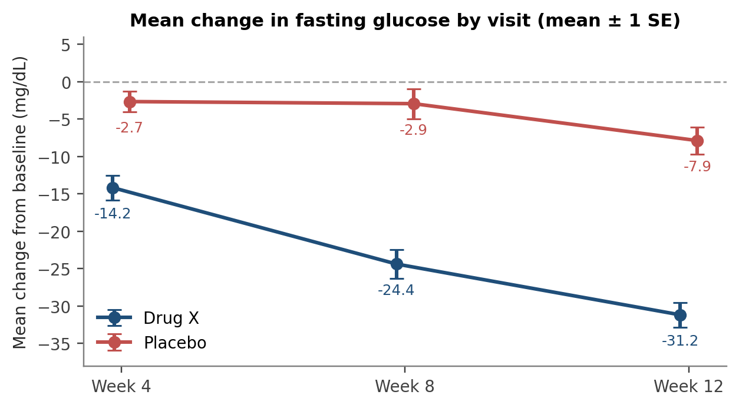
Figure 2. Mean change from baseline in fasting glucose by visit (mean ± 1 SE).
Table 7. Change from baseline by visit (mg/dL)
Visit | Drug X n | Drug X mean (SD) | Drug X SE | Placebo n | Placebo mean (SD) | Placebo SE
Week 4 | 40 | −14.2 (10.4) | 1.64 | 40 | −2.7 (8.8) | 1.39
Week 8 | 40 | −24.4 (12.1) | 1.91 | 40 | −2.9 (12.7) | 2.00
Week 12 | 35 | −31.2 (9.7) | 1.64 | 39 | −7.9 (11.4) | 1.83

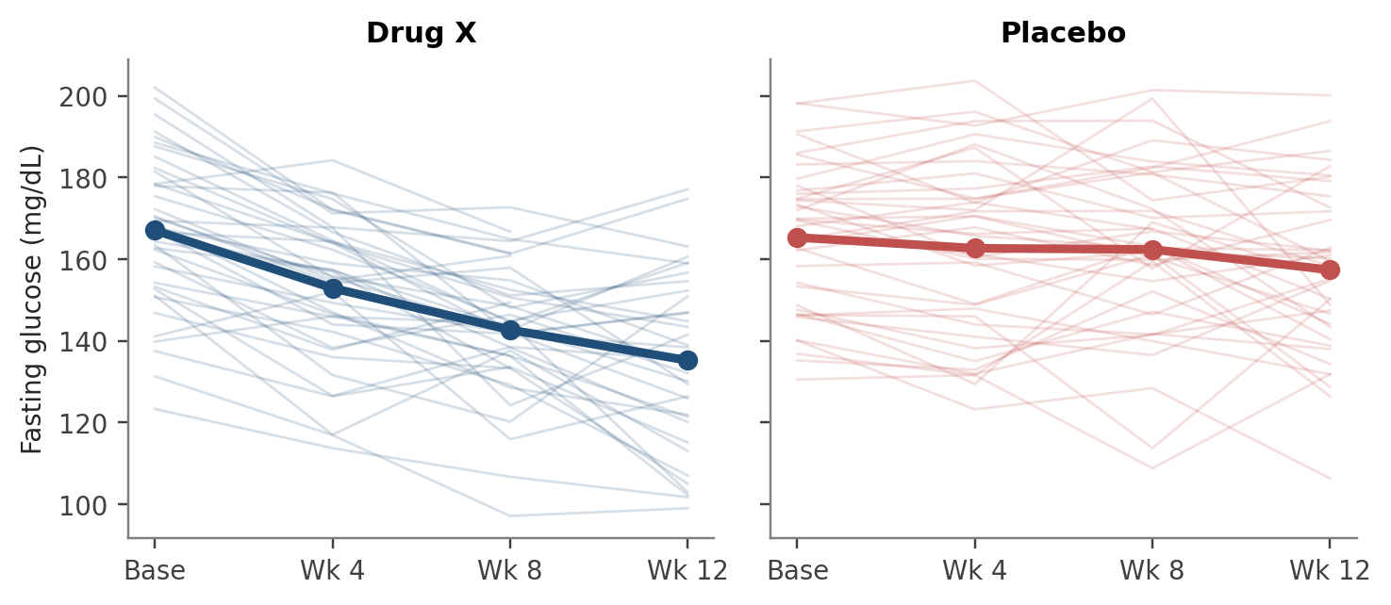
Figure 3. Individual fasting glucose profiles (thin lines) and arm means (bold lines).

5.4 Two-sample t-test
The pooled t-test showed a highly significant difference in mean change between arms (Table 8). The estimated difference was −23.30 mg/dL (SE 2.48; 95% CI −28.23 to −18.36), t(72) = −9.41, p < 0.0001. The Satterthwaite test, which does not assume equal variances, agreed (t = −9.49, df = 71.8, p < 0.0001), and the folded-F test gave no evidence of unequal variances (F(38, 34) = 1.39, p = 0.33). Cohen's d was 2.19, a very large effect.
Table 8. Two-sample t-test on Week 12 change from baseline
Group / contrast | n | Mean | SD | SE | 95% CI for mean
Drug X | 35 | −31.17 | 9.68 | 1.64 | (−34.49, −27.84)
Placebo | 39 | −7.87 | 11.42 | 1.83 | (−11.57, −4.17)
Difference (pooled) | — | −23.30 | 10.64 | 2.48 | (−28.23, −18.36)
Difference (Satterthwaite) | — | −23.30 | — | 2.45 | (−28.19, −18.40)
Pooled: t = −9.41, df = 72, p < 0.0001. Satterthwaite: t = −9.49, df = 71.8, p < 0.0001. Folded F: F(38, 34) = 1.39, p = 0.33.
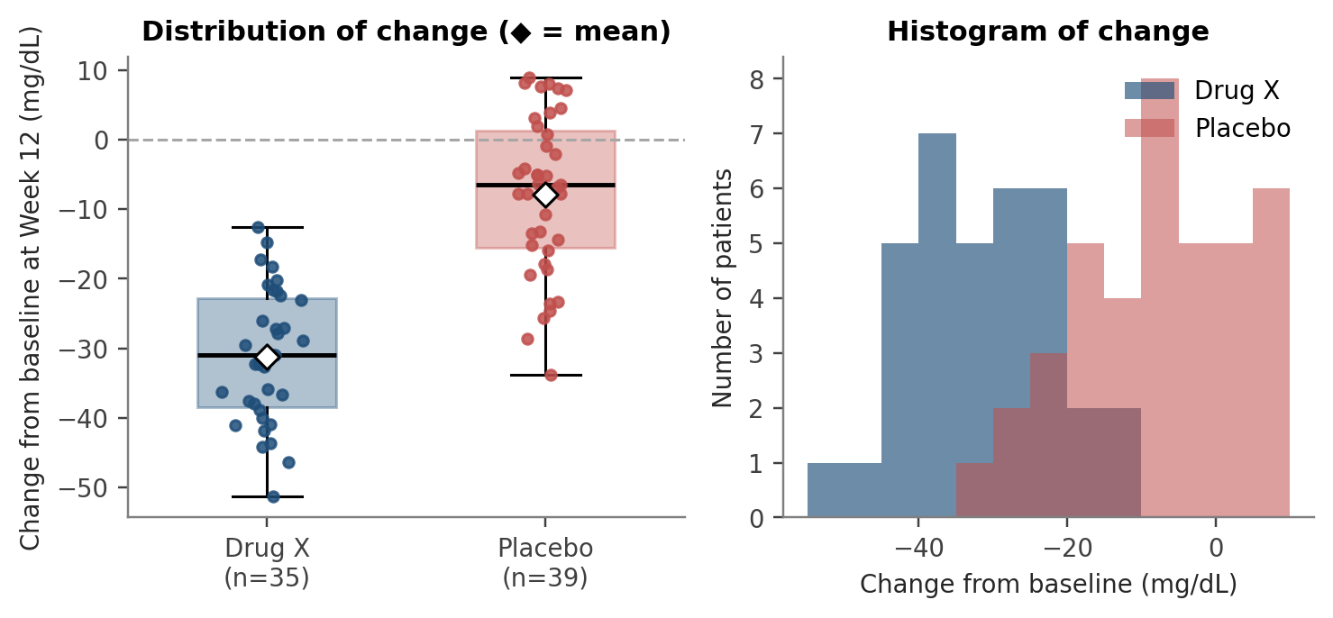
Figure 4. Distribution of Week 12 change from baseline by treatment arm.

5.5 ANCOVA adjusted for baseline glucose
The ANCOVA model was highly significant overall (F(2, 71) = 43.82, p < 0.0001; R² = 0.552; root MSE = 10.70 mg/dL; Table 9). Treatment explained most of the variation in change (Type III F = 87.15, p < 0.0001), while baseline glucose did not contribute (F = 0.17, p = 0.69; Table 10). The adjusted treatment effect was −23.27 mg/dL (SE 2.49; t = −9.34; 95% CI −28.23 to −18.30; Table 11), virtually identical to the unadjusted t-test. This agreement is expected: randomisation produced near-identical baselines, and baseline glucose was essentially unrelated to change, so adjustment altered the estimate by only 0.03 mg/dL. The fitted lines in Figure 5 are almost flat, consistent with a baseline slope of −0.028 mg/dL per mg/dL.
Table 9. ANCOVA analysis of variance
Source | DF | Sum of squares | Mean square | F value | Pr > F
Model | 2 | 10,030.03 | 5,015.02 | 43.82 | <0.0001
Error | 71 | 8,126.27 | 114.45 | — | —
Corrected total | 73 | 18,156.30 | — | — | —
R² = 0.552; root MSE = 10.70; mean change = −18.89 mg/dL.
Table 10. Model effects and parameter estimates
Effect / parameter | Type III F | Estimate | SE | t value | p-value
Treatment (Drug X vs placebo) | 87.15 | −23.27 | 2.49 | −9.34 | <0.0001
Baseline glucose (slope) | 0.17 | −0.028 | 0.068 | −0.41 | 0.685
Intercept | — | −3.32 | 11.33 | −0.29 | 0.771
Table 11. Least-squares means for Week 12 change (mg/dL)
Treatment | Adjusted mean | SE | 95% CI | p (vs 0)
Drug X | −31.15 | 1.81 | (−34.76, −27.54) | <0.0001
Placebo | −7.88 | 1.71 | (−11.30, −4.47) | <0.0001
Difference (Drug X − Placebo) | −23.27 | 2.49 | (−28.23, −18.30) | <0.0001

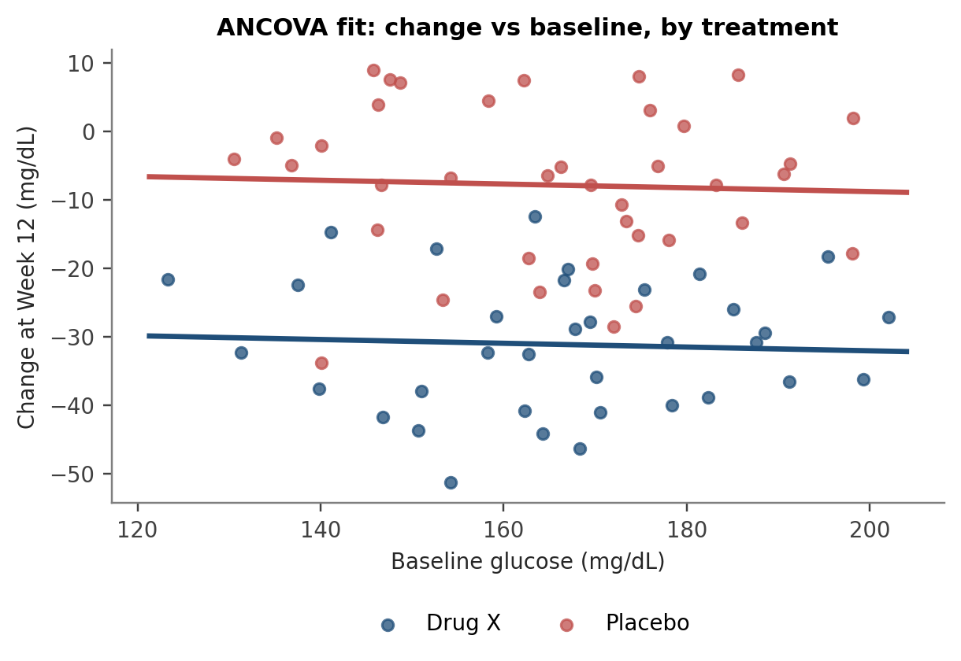
Figure 5. Week 12 change versus baseline glucose with ANCOVA fitted lines.
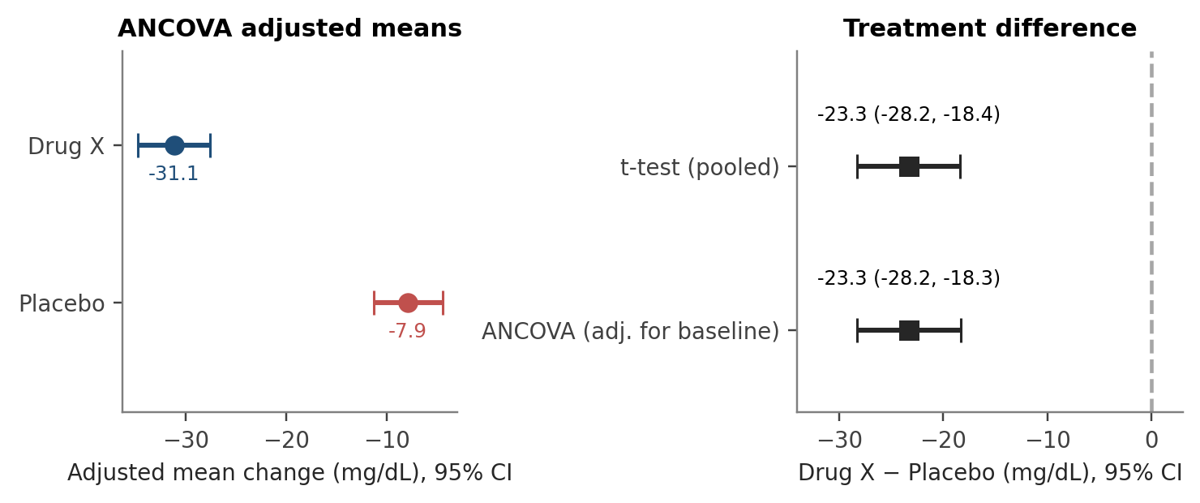
Figure 6. Adjusted means and treatment difference with 95% confidence intervals.

5.6 Model diagnostics
The residuals were symmetrically scattered around zero with similar spread in both arms, and the Q–Q plot followed the reference line closely (Figure 7). Formal tests supported the visual checks (Table 12). The treatment × baseline interaction was not significant (p = 0.70), supporting the parallel-slopes assumption of the ANCOVA.
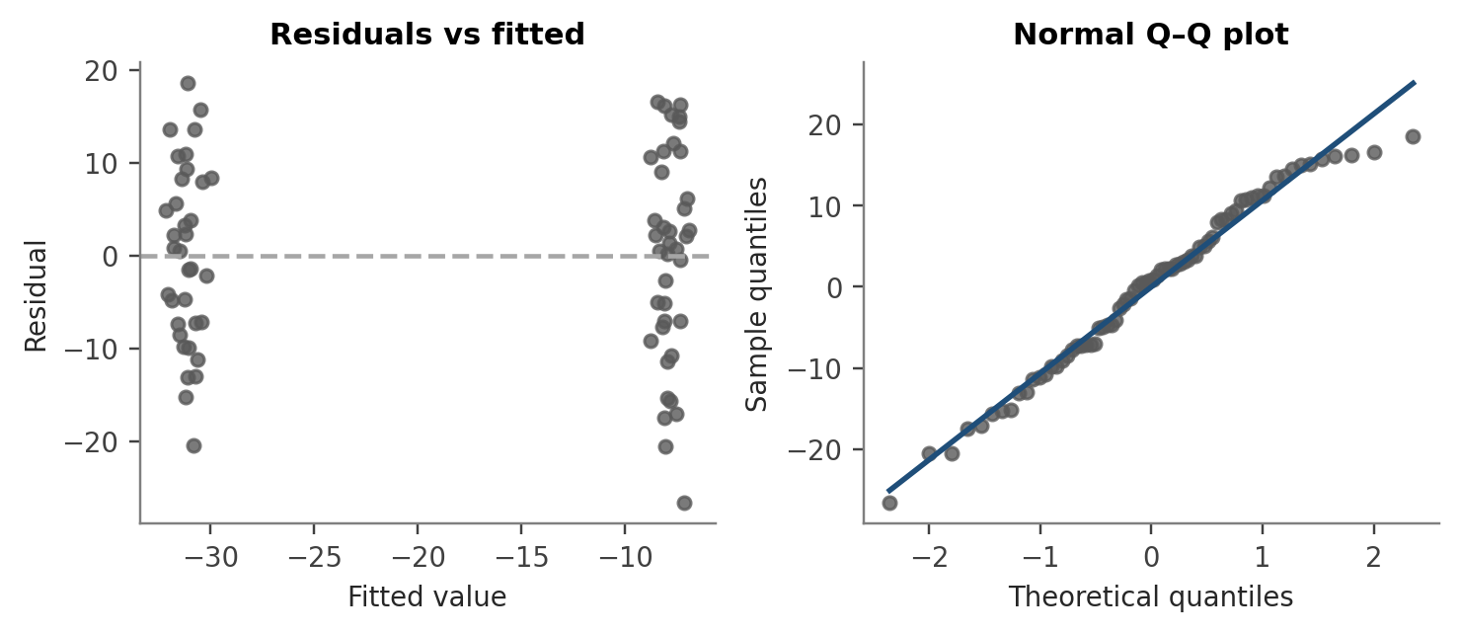
Figure 7. Residuals versus fitted values and normal Q–Q plot for the ANCOVA model.
Table 12. Assumption checks
Assumption | Method | Result | Conclusion
Normal residuals | Shapiro–Wilk | W = 0.978, p = 0.225 | Satisfied
Equal variances | Folded F / Levene | F = 1.39, p = 0.33 / p = 0.43 | Satisfied
Parallel slopes | Treatment × baseline term | p = 0.70 | Satisfied

5.7 Exploratory responder analysis
Using a descriptive threshold of a reduction of at least 20 mg/dL at Week 12, 31 of 35 Drug X patients (88.6%) were responders compared with 6 of 39 placebo patients (15.4%), a difference of 73.2 percentage points. This analysis is exploratory and was not pre-specified.

6. Discussion
Drug X produced a mean reduction in fasting glucose that was about 23 mg/dL greater than placebo at Week 12, with a confidence interval that excludes zero by a wide margin. The effect built progressively across visits, which is the pattern expected of a drug with a cumulative pharmacological effect. The t-test and ANCOVA gave the same answer to within 0.03 mg/dL, showing that the conclusion does not depend on the choice of method.
Limitations. (1) *Missing data:* the Week 12 analysis used observed values only. Five Drug X patients and one placebo patient discontinued, an imbalance that could bias a completers analysis in a real trial; a mixed model for repeated measures (MMRM) or multiple imputation would be the preferred sensitivity analysis. (2) *Analysis population:* the efficacy analysis was run on patients with a Week 12 value; a full analysis set based on all randomised patients is the regulatory standard. (3) *Single endpoint:* no adjustment for multiplicity was needed, but secondary endpoints would require it. (4) *Covariates:* only baseline glucose was modelled; site, age and sex could be added. (5) *Data source:* the data were simulated for demonstration, so the numerical results illustrate the workflow and should not be read as evidence about a real compound.
Possible extensions. MMRM with PROC MIXED using all visits; validation of ADaM datasets with PROC COMPARE against an independent program; addition of a safety (adverse event) domain; and generation of define.xml metadata.

7. Conclusion
The project delivered a complete, traceable pipeline from raw data to SDTM, ADaM and TLF outputs in SAS. In the analysis, Drug X lowered fasting glucose by 31.2 mg/dL compared with 7.9 mg/dL on placebo at Week 12, an adjusted difference of −23.27 mg/dL (95% CI −28.23 to −18.30; p < 0.0001), robust to the choice of t-test or ANCOVA and supported by satisfied model assumptions.

Appendix A. Output Inventory
Table 13. Files produced by the SAS program
Layer | File | Description
SDTM | dm, ex, lb (.sas7bdat) | Standardised demographics, exposure and laboratory domains
ADaM | adsl.sas7bdat | Subject-level dataset, 80 rows
ADaM | adlb.sas7bdat | Glucose analysis dataset, 394 rows
Table | Table_Glucose_Wk12.rtf | Week 12 efficacy table (baseline, Week 12, change)
Table | SUMMARY_TABLE.csv | Change-from-baseline summary by treatment
Listing | LISTING.csv | Subject-level glucose by visit
Figure | Fig_Glucose_Change.png | Mean change from baseline by visit

