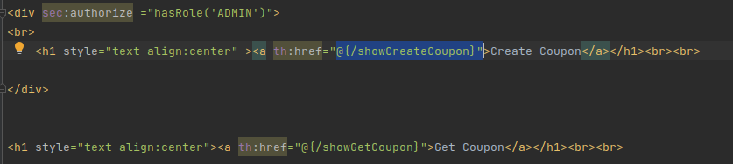
Earlier

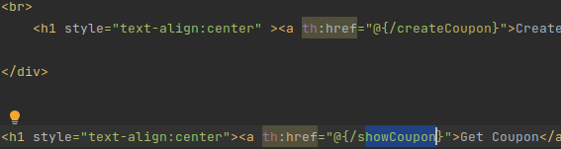
After:

Before:

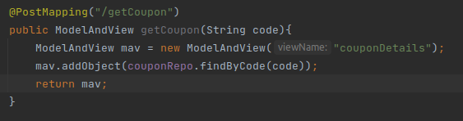

Before:

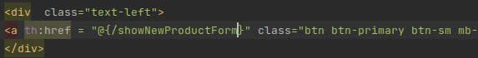

After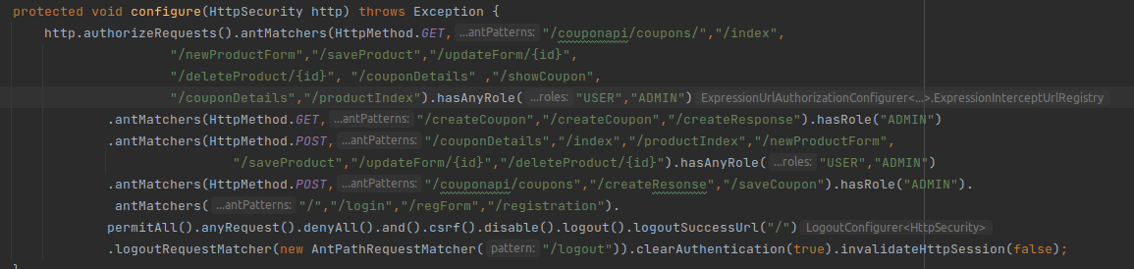

Mapping Changed Form One to Many – One Coupon can Have Many Product

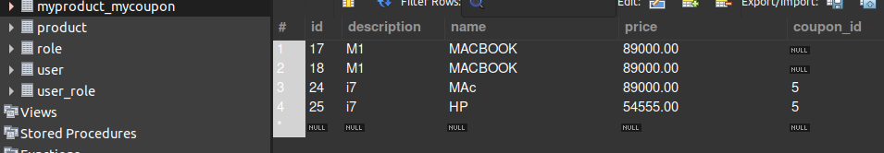

Id 17 and id 18 are from Many To Many mapping which I showed you.
ID 24 and ID 25 is one to many, One coupon Id has many Product Id

