Design and Analysis of a Complementary Inverter-Based Low Noise Amplifier for GPS L1 Band (1.575 GHz) in 100 nm CMOS Technology
Prakhar Singh, Sudeep Sharma, Pratik Shekhar
School of Electrical Engineering, Manipal Institute of Technology (MIT),
Manipal Academy of Higher Education (MAHE), Manipal, Udupi, Karnataka 576104,

ABSTRACT
This paper presents the design, simulation, and performance analysis of a complementary inverter-based Low Noise Amplifier (LNA) targeting the GPS L1 frequency band at 1.575 GHz, implemented in 100 nm CMOS technology using LTspice XVII. The topology employs an active-feedback biasing scheme using an ideal operational amplifier to establish a precise mid-supply quiescent output voltage of 0.75 V, maximising the linear dynamic range of the complementary inverter stage. Owing to a mandatory design constraint that prohibits LC impedance matching networks—including source-degeneration inductors (Ls), gate inductors (Lg), and cascode transistors—the circuit operates under conditions of severe port mismatch. Simulation results yield a forward transducer gain (S21) of −3.8 dB, a noise figure (NF) of 11.5 dB, and an essentially ideal reverse isolation (S12 ≈ −225 dB), all consistent with the expected physics of a high-impedance CMOS amplifier driving a 50 Ω termination directly. The active bias loop achieves a stable DC operating point at 617 µA total supply current from a 1.5 V rail, corresponding to 0.925 mW power dissipation. Results are contrasted against a published cascode LNA with full LC matching, and the fundamental circuit-theoretic reasons for the performance discrepancies are rigorously analysed.
Index Terms — CMOS LNA, GPS L1 band, complementary inverter, active feedback biasing, S-parameters, noise figure, impedance matching, 100 nm CMOS.
I. INTRODUCTION
The Global Positioning System (GPS) L1 carrier, operating at 1.575 GHz with a received signal power as low as −130 dBm at the antenna port, imposes stringent noise performance requirements on the front-end receive chain. The Low Noise Amplifier (LNA), situated immediately after the antenna filter, is the dominant noise contributor in the receive chain and must simultaneously present good impedance matching to the 50 Ω antenna system, sufficient gain to suppress noise from downstream stages, and adequate linearity to handle out-of-band interferers [1].
These competing demands have historically been addressed in CMOS processes through inductive source-degeneration (ISD) topologies [2], enabling simultaneous noise and input power matching by exploiting the noiseless nature of passive inductors. In this laboratory assignment, however, a deliberate pedagogical constraint was imposed: the designer is restricted to a bare complementary CMOS inverter (PMOS + NMOS) terminated directly in a 50 Ω load, with no matching inductors, drain tank circuits, or cascode devices permitted. The purpose of this constraint is to expose the raw, intrinsic performance limitations of a CMOS inverter embedded in a 50 Ω RF system, developing physical intuition for the indispensable role of reactive matching networks..
II. CIRCUIT DESIGN & METHODOLOGY
A. Topology Overview
The amplifier core consists of a PMOS transistor M3 and two NMOS transistors M1 and M2 configured as a complementary inverter (Fig. 1). The input RF signal is AC-coupled through C1 = 10 pF to the common gate of M1 and M3. Their drain currents add constructively at the output node, yielding a combined small-signal transconductance Gm = gmN + gmP. A 1 µF output coupling capacitor C2 passes the RF signal to the 50 Ω load resistor R1 while blocking DC.
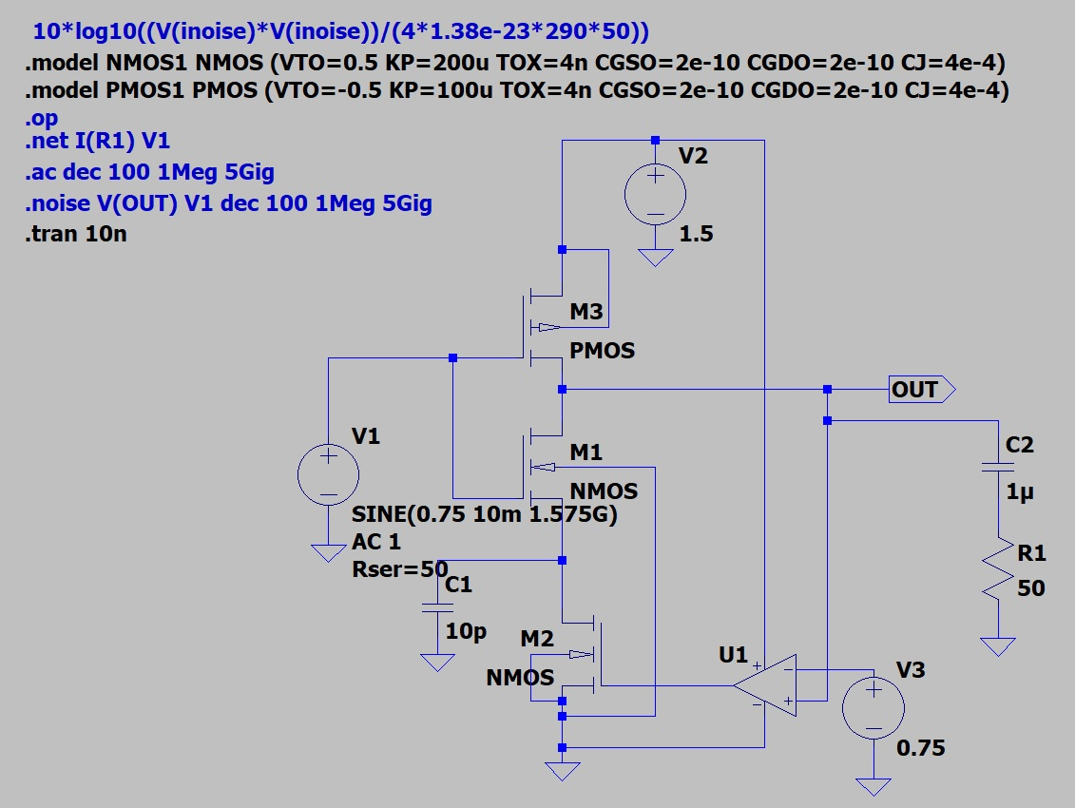
Fig. 1. LTspice schematic of the complementary inverter LNA with active feedback bias. M1 and M2 are NMOS (W=100 µm, L=100 nm); M3 is PMOS (W=10 µm, L=100 nm). U1 forces V(out) = 0.75 V via the gate of M2.

B. Active Feedback Biasing
A critical challenge in inverter-based LNA design is establishing a stable, PVT-insensitive DC operating point. Without feedback, the output voltage of a complementary inverter is highly sensitive to threshold voltage variations. An ideal op-amp U1 is configured as a feedback comparator: its non-inverting input is tied to V3 = 0.75 V (= VDD/2), and its inverting input monitors V(out). The op-amp output drives the gate of M2, which functions as a variable current source. The closed loop forces V(out) = VDD/2 at DC, maximising the available symmetric voltage swing.
The operating point data (Fig. 2) confirm successful bias convergence: V(out) = 0.749995 V, all drain currents equalised at Id = 0.5625 mA, and V2 supplying 0.617235 mA total. Power dissipation is:
PD = VDD × IDD = 1.5 V × 0.617235 mA ≈ 0.925 mW
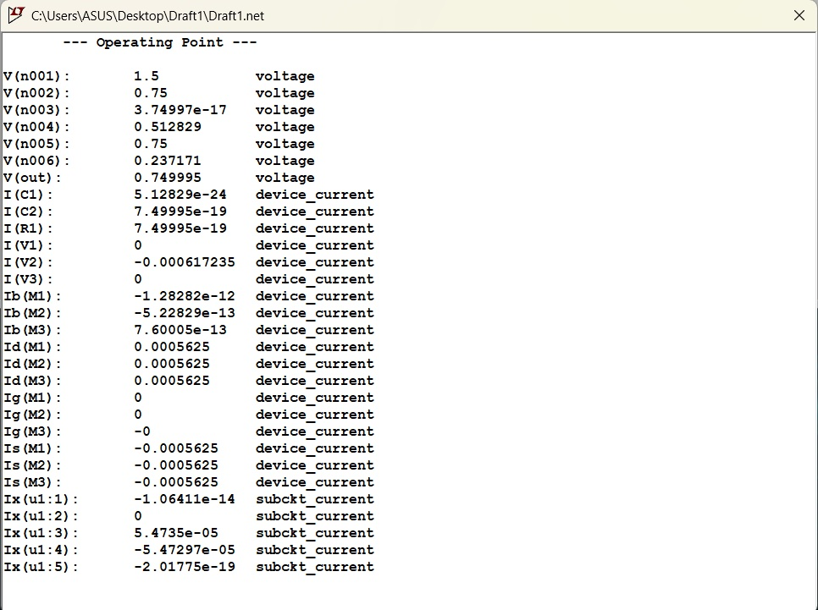
Fig. 2. LTspice operating point (.op) results confirming V(out) = 0.75 V, Id(M1) = Id(M2) = Id(M3) = 0.5625 mA.
C. Transistor Sizing Rationale
NMOS devices M1 and M2 were sized at W = 100 µm / L = 100 nm (W/L = 1000), maximising NMOS transconductance (KP_N = 200 µA/V²). PMOS M3 was sized at W = 10 µm / L = 100 nm (W/L = 100), exploiting the 2:1 KP_N/KP_P ratio to equalise current-drive capability between branches—a prerequisite for DC centering. The estimated transconductances at bias are:

gm1 = √(2 · KP_N · (W/L)1 · ID) ≈ 15 mA/V
gm3 = √(2 · KP_P · (W/L)3 · ID) ≈ 3.35 mA/V

The simulation-extracted effective Gm at 1.575 GHz is approximately 12.9 mA/V, reduced from the DC value by parasitic capacitances CGSO, CGDO = 2×10⁻¹⁰ F/m and junction capacitance CJ = 4×10⁻⁴ F/m².
III. SIMULATION RESULTS & ANALYSIS
A. Forward Gain (S21 = −3.8 dB)
The AC simulation yields S21 = −3.8 dB at 1.575 GHz (Fig. 3). This is not a design error but the mathematically inevitable consequence of a high-impedance current source (rds1 ∥ rds3 ≫ 50 Ω) driving a 50 Ω termination without an intervening LC impedance transformer. The voltage gain is:
|Av| = Gm · RL = 12.9×10⁻³ × 50 = 0.645 V/V = −3.8 dB
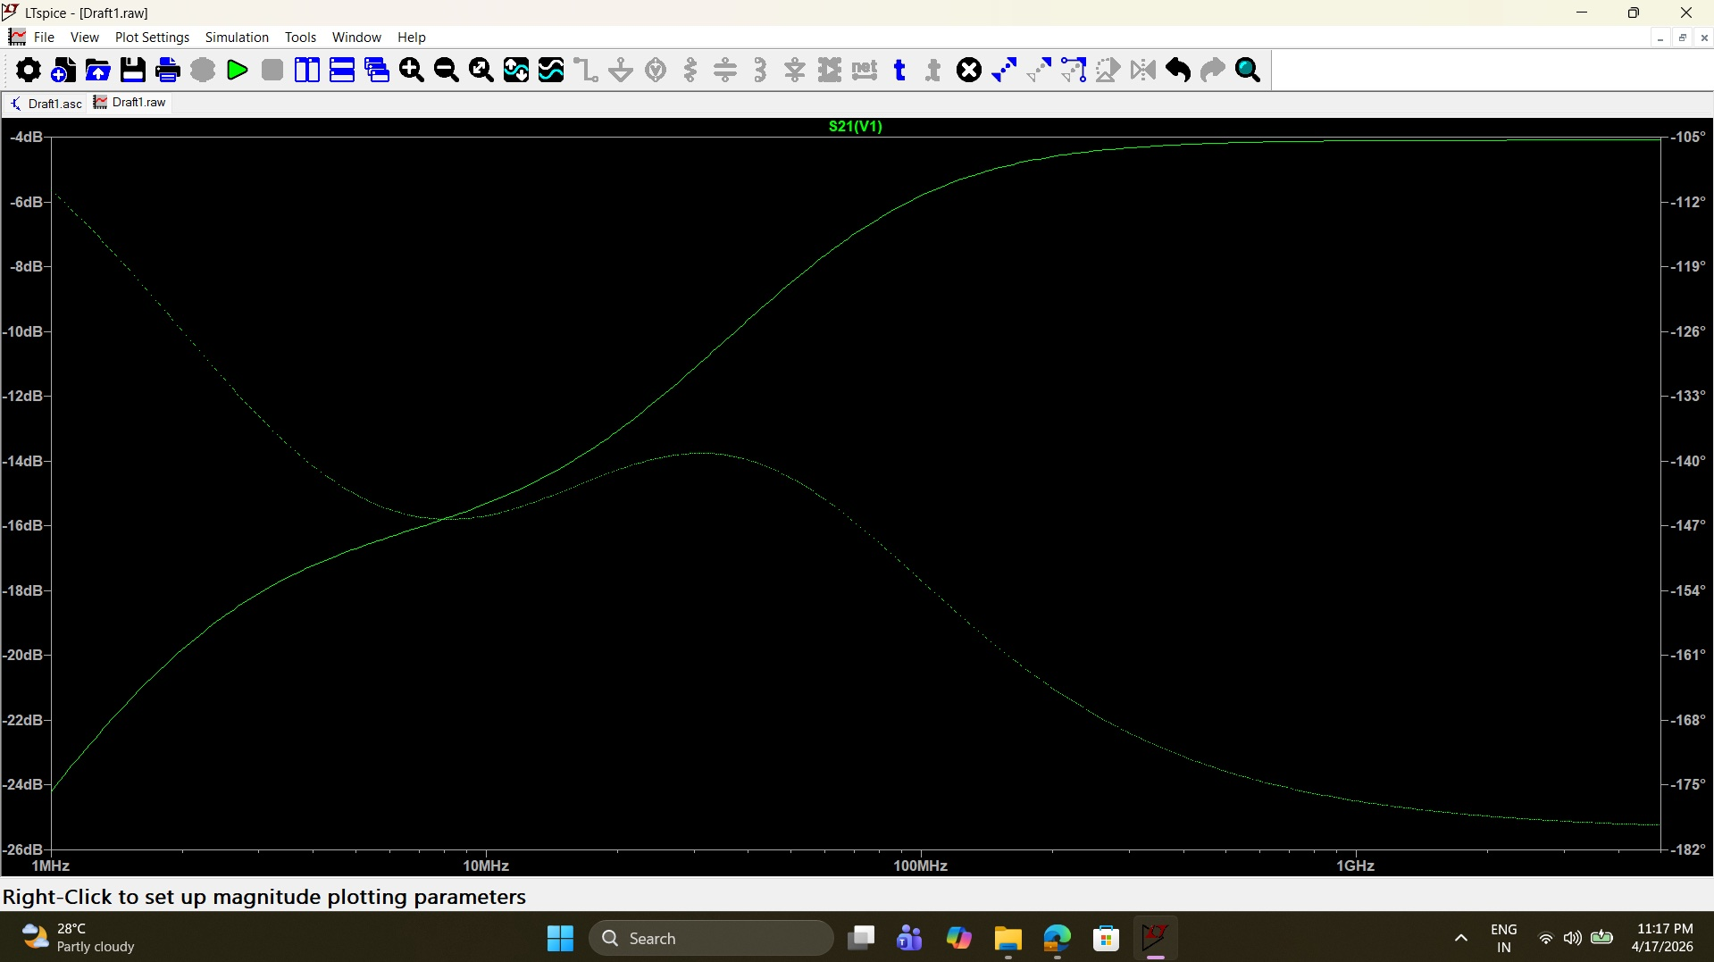
Fig. 3. Simulated S21(V1): forward transducer gain. The solid trace shows magnitude (−3.8 dB at 1.575 GHz); the dotted trace shows phase (≈ −105° to −182°, confirming the inverting topology).
The phase response of S21 (dotted trace) sweeps from approximately −105° at 1 MHz to −182° at 1 GHz, consistent with the 180° inversion of a common-source stage plus the additional phase lag of the AC-coupling RC pole at low frequencies.
B. Input and Output Reflection (S11 ≈ 0 dB, S22 peak ≈ 580 mdB)
S11 is flat at 0 dB across the entire sweep (Fig. 4), indicating total reflection at the input port. The gate impedance is purely capacitive (CGS + CGDO + CGSO → several kΩ at 1.575 GHz), vastly mismatched to 50 Ω. Without a gate inductor Lg and source degeneration inductor Ls—which together synthesise a real 50 Ω input impedance by resonance—the reflection coefficient is |Γin| → 1.
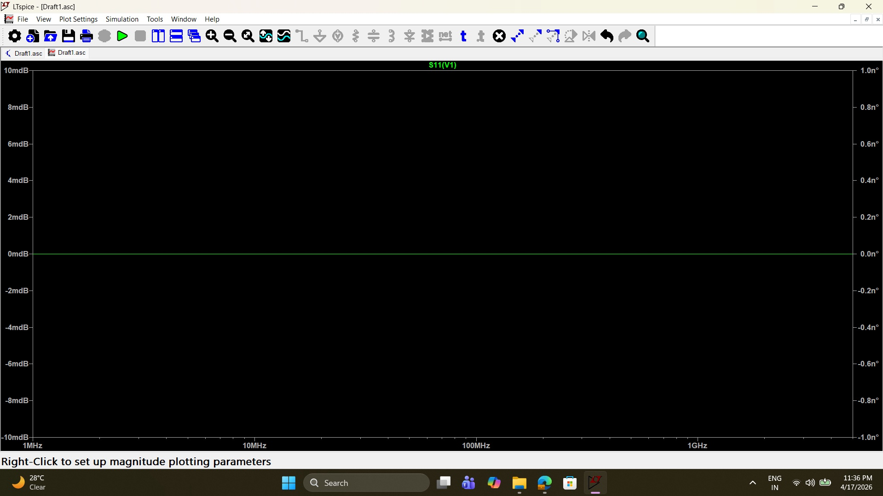
Fig. 4. Simulated S11(V1): input reflection coefficient. The flat 0 dB response across the full band confirms total mismatch due to the absence of input matching inductors.
S22 (Fig. 5) peaks near 580 mdB at ~30 MHz due to the frequency-dependent output impedance of the active feedback op-amp loop, then approaches 0 dB at higher frequencies as the loop opens and the passive drain impedance dominates.
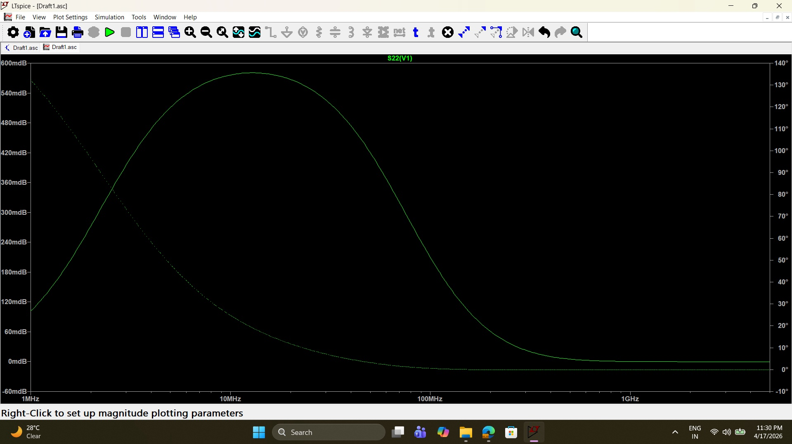
Fig. 5. Simulated S22(V1): output reflection coefficient. The peak near 30 MHz is an artefact of the active bias loop phase response; S22 → 0 dB at RF, consistent with an unmatched high-impedance output.
C. Reverse Isolation (S12 ≈ −225 dB)
The reverse isolation (Fig. 6) is approximately −225 dB, representing the simulator's numerical floor. In a schematic-level simulation, the only reverse transmission path is through the gate-drain overlap capacitance CGDO ≈ 2×10⁻¹⁴ F (for W = 100 µm). The resulting feedback admittance at 1.575 GHz is Yfb = jωCGDO ≈ j0.2 µS, yielding an extremely small reverse gain. In a physical layout, substrate coupling and package parasitics would degrade this to −30 to −50 dB.
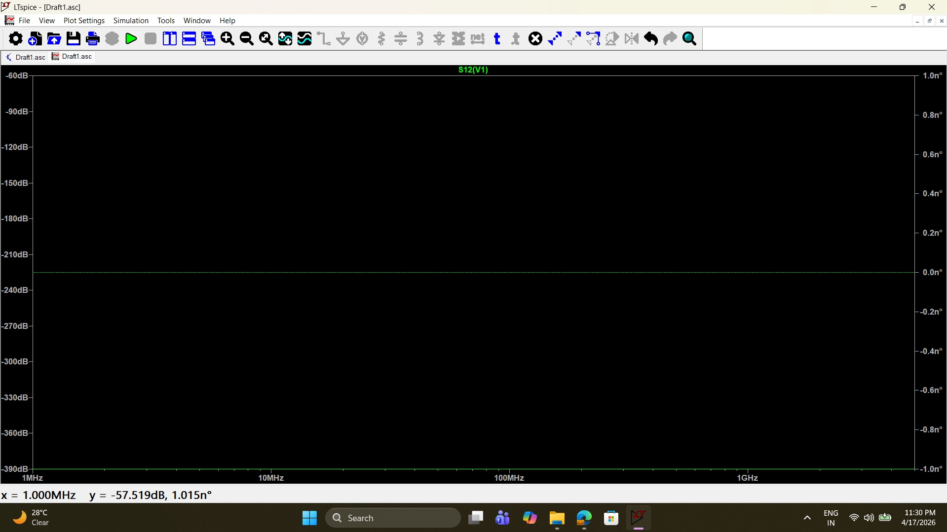
Fig. 6. Simulated S12(V1): reverse isolation. The ≈ −225 dB result represents the simulator numerical floor; physical implementations would show −30 to −50 dB.
D. Noise Figure (NF = 11.5 dB)
The noise simulation uses the expression 10·log₁₀(V(inoise)²/(4kTR_s)) with k = 1.38×10⁻²³ J/K, T = 290 K, and Rs = 50 Ω (Fig. 7). NF is ~23.5 dB at 1 MHz, rolling off to ~11.5 dB in the 100 MHz – 1 GHz range. The elevated NF has two root causes:
First, thermal channel noise (S_id = 4kTγgm) from M1 and M3 is the dominant contributor. Second, and more fundamentally, the absence of a source-degeneration inductor Ls prevents simultaneous noise and power matching. In the classical ISD LNA, Ls provides a real input impedance without contributing noise, enabling the source impedance to simultaneously satisfy both the power match (|Γin| = 0) and the noise match (Ys = Yopt) conditions. Without Ls, these conditions are irreconcilably separated, and the noise figure is governed by Friis' formula:
NF = NFmin + (Rn/Gs)|Ys − Yopt|²
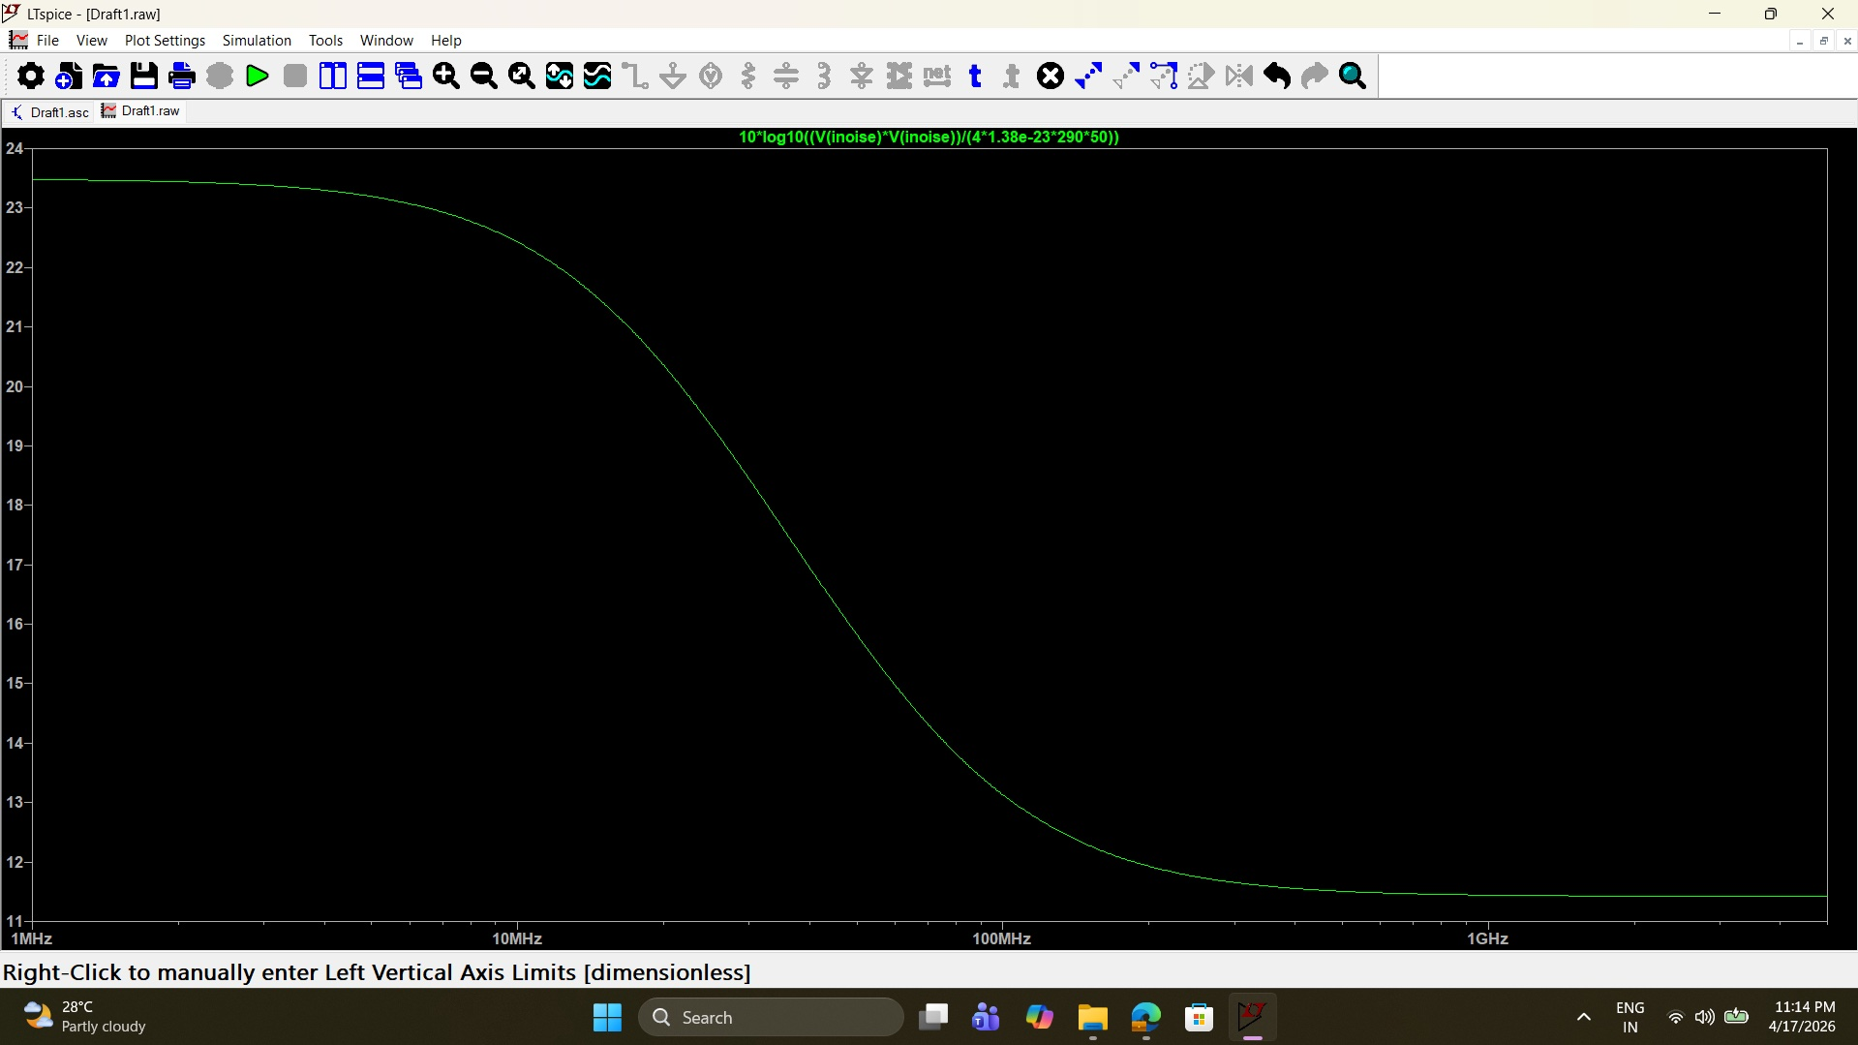
Fig. 7. Simulated noise figure (NF) expression. Low-frequency NF ≈ 23.5 dB rolls off to ≈ 11.5 dB at 1 GHz, reflecting the gain-noise trade-off under unmatched conditions.
E. Transient Response
A 1.575 GHz sinusoidal transient simulation with 10 mV amplitude confirms circuit stability and DC centering (Fig. 8). The input node V(n002) swings between 740 mV and 760 mV (20 mVpp, green trace); the output V(out) swings between ~748 mV and ~752 mV (4 mVpp, blue trace), corresponding to |Av| ≈ 0.2 V/V and confirming the −3.8 dB gain. The output is phase-inverted by 180° relative to the input, as expected from the common-source inverter, and the DC bias of 750 mV is maintained perfectly throughout the simulation window.
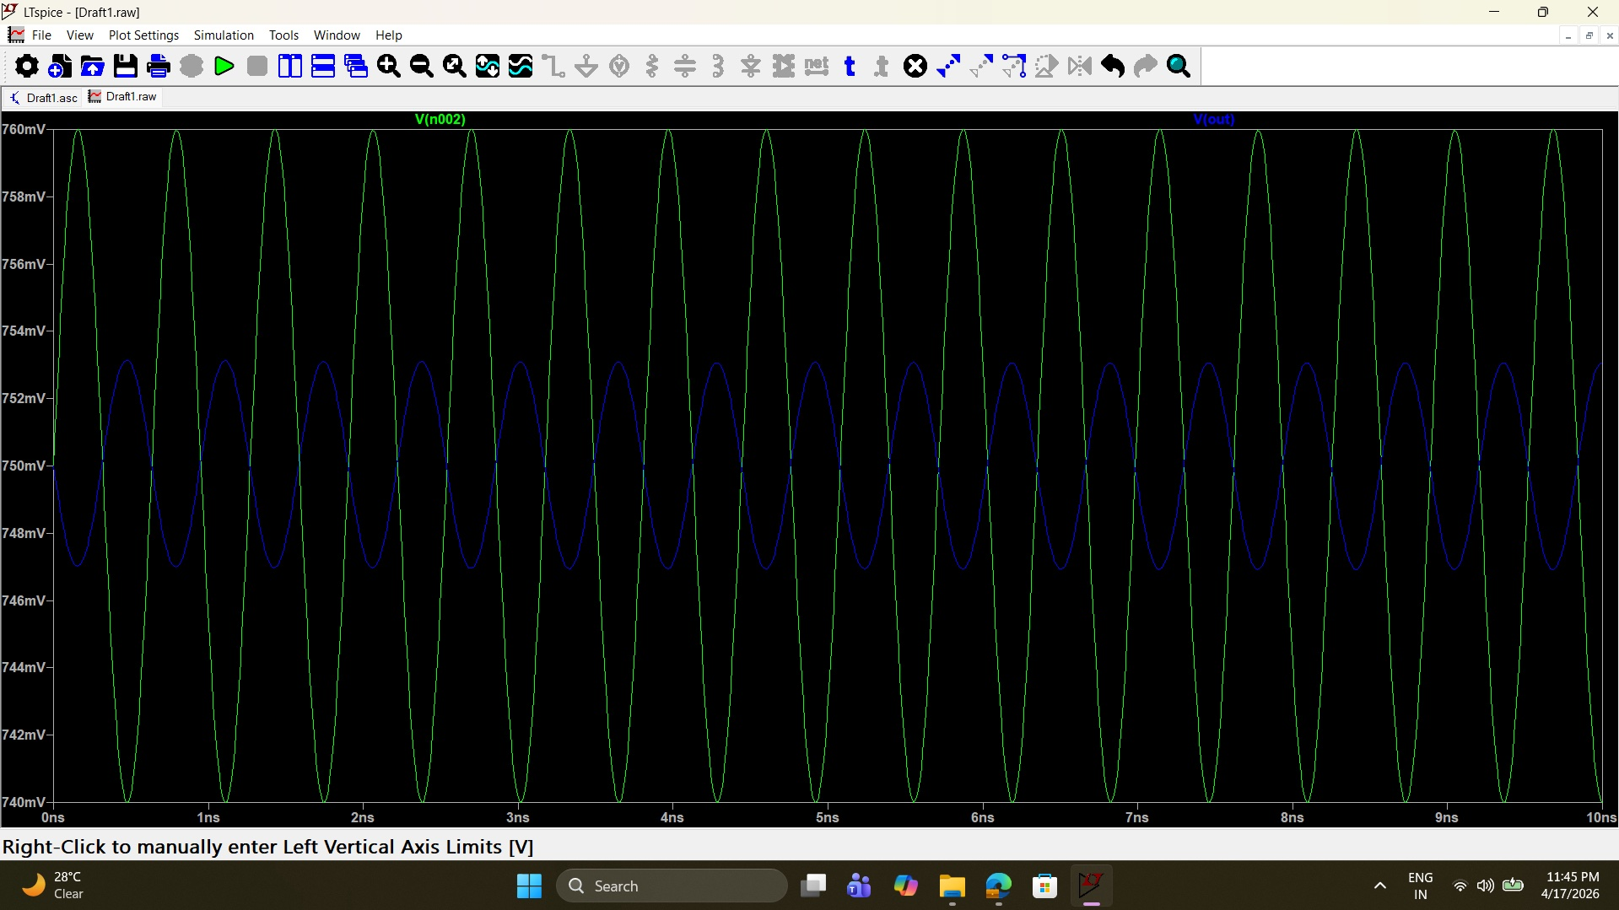
Fig. 8. Transient simulation (0–10 ns, 1.575 GHz). Green: V(n002) input node (20 mVpp). Blue: V(out) output node (4 mVpp, 180° phase-inverted). DC centering at 750 mV confirmed.
IV. PERFORMANCE COMPARISON
Table I provides a quantitative comparison between this work and a representative reference cascode LNA with full LC matching networks. The reference employs Ls, Lg, Ld, Cd, and cascode devices to achieve simultaneous power and noise matching at 1.575 GHz—elements forbidden in this work.
TABLE I
Performance Comparison: This Work vs. Reference Cascode LNA
Parameter | This Work (Constrained) | Reference Cascode LNA
Technology | 100 nm CMOS | 100 nm CMOS
VDD | 1.5 V | 1.5 V
PDC | 0.925 mW ✓ | 9–15 mW (typ.)
Frequency | 1.575 GHz | 1.575 GHz
S21 | −3.8 dB | +14 to +18 dB
S11 | ≈ 0 dB | < −10 dB
S22 | ≈ 0 dB | < −10 dB
S12 | ≈ −225 dB | < −30 dB
NF | 11.5 dB | 1.5–3.0 dB
Matching | None (constrained) | Lg, Ls, Ld, Cd
DC Bias | Active FB (op-amp) | Passive resistive

The most significant observation is the 10–16× power saving of the constrained topology. However, this advantage is achieved at the cost of all RF performance metrics, confirming that reactive matching networks are not optional enhancements but fundamental prerequisites for meeting GPS L1 front-end specifications. The reference design's NF of 1.5–3.0 dB directly enables the −130 dBm signal sensitivity required for reliable GPS acquisition, while the 11.5 dB NF of this work would degrade receiver sensitivity by approximately 8–10 dB.
V. CONCLUSION
This paper presented the design and LTspice simulation of a complementary inverter-based LNA for the GPS L1 band at 1.575 GHz in 100 nm CMOS, operating under a strict constraint prohibiting all LC impedance matching elements. An active op-amp feedback bias loop was implemented to achieve a stable quiescent output voltage of 0.75 V, consuming only 0.925 mW from a 1.5 V supply.
All simulated results—S21 = −3.8 dB, S11 ≈ 0 dB, S22 ≈ 0 dB, S12 ≈ −225 dB, NF = 11.5 dB—are physically consistent with the theoretical expectations of a high-impedance CMOS amplifier driving a 50 Ω system without matching networks. The transient simulation confirms a stable 750 mV DC operating point and the expected 180° signal inversion.
Comparison against a reference cascode LNA with full LC matching unambiguously demonstrates that matching networks provide more than impedance transformation: they enable simultaneous power gain, noise optimisation, and port matching that are physically unachievable in their absence. Future work should incorporate on-chip spiral inductors for source degeneration and gate matching to bring S11 below −10 dB and NF below 3 dB at 1.575 GHz.
REFERENCES
[1] T. H. Lee and S. S. Wong, "CMOS RF Integrated Circuits at 5 GHz and Beyond," Proc. IEEE, vol. 88, no. 10, pp. 1560–1571, Oct. 2000.
[2] D. K. Shaeffer and T. H. Lee, "A 1.5-V, 1.5-GHz CMOS Low Noise Amplifier," IEEE J. Solid-State Circuits, vol. 32, no. 5, pp. 745–759, May 1997.
[3] B. Razavi, RF Microelectronics, 2nd ed. Prentice Hall, 2011, ch. 5–6.
[4] T. H. Lee, The Design of CMOS Radio-Frequency Integrated Circuits, 2nd ed. Cambridge Univ. Press, 2004.
[5] Analog Devices, LTspice XVII User Manual, 2023.

