Assignment 1-

Part 1)

**SET** ***ThousandSep***=',';  
**SET** ***DecimalSep***='.';  
**SET** ***MoneyThousandSep***=',';  
**SET** ***MoneyDecimalSep***='.';  
**SET** ***MoneyFormat***='$#,##0.00;($#,##0.00)';  
**SET** ***TimeFormat***='h:mm:ss TT';  
**SET** ***DateFormat***='M/D/YYYY';  
**SET** ***TimestampFormat***='M/D/YYYY h:mm:ss[.fff] TT';  
**SET** ***MonthNames***='Jan;Feb;Mar;Apr;May;Jun;Jul;Aug;Sep;Oct;Nov;Dec';  
**SET** ***DayNames***='Mon;Tue;Wed;Thu;Fri;Sat;Sun';  
**SET** ***LongMonthNames***='January;February;March;April;May;June;July;August;September;October;November;December';  
**SET** ***LongDayNames***='Monday;Tuesday;Wednesday;Thursday;Friday;Saturday;Sunday';  
**SET** ***FirstWeekDay***=6;  
**SET** ***BrokenWeeks***=1;  
**SET** ***ReferenceDay***=0;  
**SET** ***FirstMonthOfYear***=1;  
**SET** ***CollationLocale***='en-US';  
  
OLEDB **CONNECT32** TO [Provider=SQLOLEDB.1;Integrated Security=SSPI;Persist Security Info=False;Initial Catalog=Airbnb database;Data Source=DESKTOP-64367PF;Use Procedure for Prepare=1;Auto Translate=True;Packet Size=4096;Workstation ID=DESKTOP-64367PF;Use Encryption for Data=False;Tag with column collation when possible=False];  
**QUALIFY**\*;  
**UNQUALIFY** Host_ID;  
**UNQUALIFY** User_ID;  
**UNQUALIFY** Property_ID;  
**UNQUALIFY** Guest_ID;  
  
**LOAD** "Property_ID",  
 NoOfGuests,  
 "Host_ID" as "HOST_ID",  
 ZipCode,  
 PricePerDay;  
**SQL** SELECT *  
FROM "Airbnb database".dbo.Property;  
  
**LOAD** "Property_ID",  
 "Guest_ID" as "User_ID",  
 PropertyReview,  
 HostReview;  
**SQL** SELECT *  
FROM "Airbnb database".dbo.Reviews;  
  
**LOAD** "Property_Address",  
 "Property_Zip",  
 AptSuiteNo,  
 "Property_ID";  
**SQL** SELECT *  
FROM "Airbnb database".dbo.PropLocation;  
  
**LOAD** Wifi,  
 "Heater_AC",  
 Workspace,  
 WasherDryer,  
 Parking,  
 Pool,  
 Gym,  
 "Property_ID";  
**SQL** SELECT *  
FROM "Airbnb database".dbo.PropAmenities;  
  
**LOAD** "User_ID",  
 "User_Type",  
 "User_FName",  
 "User_LName",  
 "User_Phone",  
 "User_Address",  
 "User_Email",  
 "User_SSN",  
 "User_DrivingL",  
 "User_DOB";  
**SQL** SELECT *  
FROM "Airbnb database".dbo."User";  
  
**LOAD** "Property_ID",  
 "Space_Details",  
 "Guest_Bedrooms",  
 "Guest_Bathrooms";  
**SQL** SELECT *  
FROM "Airbnb database".dbo.PropSpace;  
  
**LOAD** Description,  
 NoOfPhotos,  
 "Property_ID",  
 HouseRules;  
**SQL** SELECT *  
FROM "Airbnb database".dbo.PropDesc;  
  
**LOAD** "Host_FName",  
 "Host_LName",  
 "Host_ID",  
 "Host_LoginID",  
 "Host_Password";  
**SQL** SELECT *  
FROM "Airbnb database".dbo.Host;  
  
**LOAD** "Host_SSN",  
 Status,  
 "Host_DrivingL",  
 "Host_ID";  
**SQL** SELECT *  
FROM "Airbnb database".dbo.BackgroundCheck;  
  
**LOAD** "Booking_ID",  
 "Host_ID",  
 CheckIn,  
 CheckOut,  
 "Property_ID",  
 "Total_Price",  
 "Guest_ID";  
**SQL** SELECT *  
FROM "Airbnb database".dbo.BookingDetails;  
  
**LOAD** "Guest_ID",  
 "Guest_FName",  
 "Guest_LName",  
 "Guest_Login",  
 "Guest_Password";  
**SQL** SELECT *  
FROM "Airbnb database".dbo.Guest;  
  
**LOAD** "Guest_ID",  
 NoOfGuests,  
 CheckIn,  
 CheckOut,  
 "Property_Zip",  
 MinPriceRange,  
 MaxPriceRange,  
 PropertyType,  
 "Req_ID";  
**SQL** SELECT *  
FROM "Airbnb database".dbo.GuestRequirements;

Table 1)

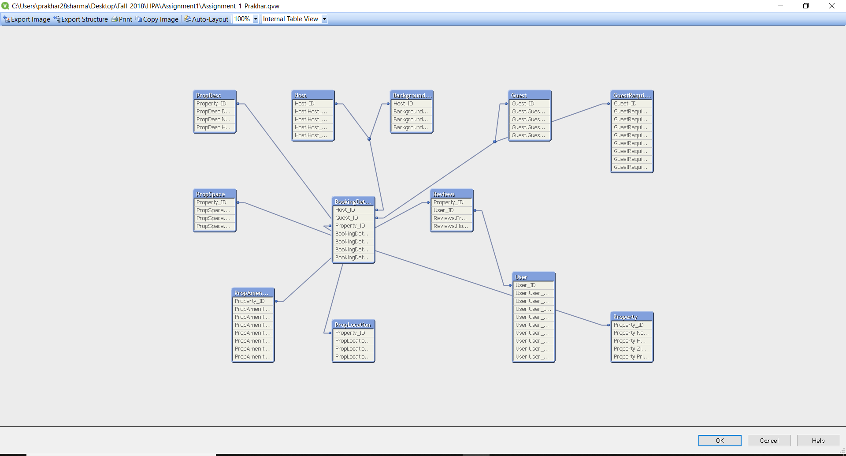

Part 2)

**SET** ***ThousandSep***=',';  
**SET** ***DecimalSep***='.';  
**SET** ***MoneyThousandSep***=',';  
**SET** ***MoneyDecimalSep***='.';  
**SET** ***MoneyFormat***='$#,##0.00;($#,##0.00)';  
**SET** ***TimeFormat***='h:mm:ss TT';  
**SET** ***DateFormat***='M/D/YYYY';  
**SET** ***TimestampFormat***='M/D/YYYY h:mm:ss[.fff] TT';  
**SET** ***MonthNames***='Jan;Feb;Mar;Apr;May;Jun;Jul;Aug;Sep;Oct;Nov;Dec';  
**SET** ***DayNames***='Mon;Tue;Wed;Thu;Fri;Sat;Sun';  
**SET** ***LongMonthNames***='January;February;March;April;May;June;July;August;September;October;November;December';  
**SET** ***LongDayNames***='Monday;Tuesday;Wednesday;Thursday;Friday;Saturday;Sunday';  
**SET** ***FirstWeekDay***=6;  
**SET** ***BrokenWeeks***=1;  
**SET** ***ReferenceDay***=0;  
**SET** ***FirstMonthOfYear***=1;  
**SET** ***CollationLocale***='en-US';  
  
  
OLEDB **CONNECT32** TO [Provider=SQLOLEDB.1;Integrated Security=SSPI;Persist Security Info=False;Initial Catalog=Airbnb database;Data Source=DESKTOP-64367PF;Use Procedure for Prepare=1;Auto Translate=True;Packet Size=4096;Workstation ID=DESKTOP-64367PF;Use Encryption for Data=False;Tag with column collation when possible=False];  
  
  
**QUALIFY**\*;  
**UNQUALIFY** Property_SK;  
**LOAD** "Property_SK",  
 "Property_Name",  
 "Property_No",  
 "Property_Address",  
 "Property_City",  
 "Property_State",  
 "Property_Zip",  
 AvailabilityStartDate,  
 PerDayCost,  
 "Property_Type",  
 NoofBedrooms,  
 NoofBathrooms,  
 "AC_Heater",  
 Workspace,  
 "Pool_Gym",  
 Parking,  
 AvailabilityEndDate;  
**SQL** SELECT *  
FROM "Airbnb database".dbo."Dim_Property";  
  
**QUALIFY** *;  
**UNQUALIFY** CheckInDate_SK;  
**UNQUALIFY** CheckOutDate_SK;  
**UNQUALIFY** Review_Date_SK;  
  
  
  
Dim_ReviewTable:  
**LOAD** "Date_SK" as Review_Date_SK,  
 "Calender_Date",  
 "Day_of_Week",  
 WeekoftheYear,  
 WeekoftheMonth,  
 DayoftheMonth,  
 CalenderYear,  
 CalenderMonth,  
 CalenderQuarter,  
 FiscalYear,  
 FiscalQuarter,  
 FiscalMonth;  
**SQL** SELECT *  
FROM "Airbnb database".dbo."Dim_Time";  
  
Dim_CheckingIn:  
**Load** "Date_SK" as CheckInDate_SK,  
 "Calender_Date",  
 "Day_of_Week",  
 WeekoftheYear,  
 WeekoftheMonth,  
 DayoftheMonth,  
 CalenderYear,  
 CalenderMonth,  
 CalenderQuarter,  
 FiscalYear,  
 FiscalQuarter,  
 FiscalMonth;  
**SQL** SELECT *  
FROM "Airbnb database".dbo."Dim_Time";  
  
Dim_CheckingOut:  
**LOAD** "Date_SK" as CheckOutDate_SK,  
 "Calender_Date",  
 "Day_of_Week",  
 WeekoftheYear,  
 WeekoftheMonth,  
 DayoftheMonth,  
 CalenderYear,  
 CalenderMonth,  
 CalenderQuarter,  
 FiscalYear,  
 FiscalQuarter,  
 FiscalMonth;  
**SQL** SELECT *  
FROM "Airbnb database".dbo."Dim_Time";  
  
**QUALIFY** *;  
**UNQUALIFY** User_SK_Host;  
**UNQUALIFY** User_SK_Guest;  
  
**LOAD** "User_SK" as User_SK_Host,  
 "User_FName",  
 "User_LName",  
 "User_Type",  
 "User_Address",  
 "User_City",  
 "User_Zip",  
 CurrRecInd,  
 "User_Email",  
 "User_Phone",  
 "User_DL",  
 "User_DOB";  
**SQL** SELECT *  
FROM "Airbnb database".dbo."Dim_User";  
  
Dim_GuestUser:  
**LOAD** "User_SK" as User_SK_Guest,  
 "User_FName",  
 "User_LName",  
 "User_Type",  
 "User_Address",  
 "User_City",  
 "User_Zip",  
 CurrRecInd,  
 "User_Email",  
 "User_Phone",  
 "User_DL",  
 "User_DOB";  
**SQL** SELECT *  
FROM "Airbnb database".dbo."Dim_User";  
  
  
**QUALIFY** *;  
**UNQUALIFY** Property_SK;  
**UNQUALIFY** CheckInDate_SK;  
**UNQUALIFY** User_SK_Guest;  
**UNQUALIFY** User_SK_Host;  
**UNQUALIFY** CheckOutDate_SK;  
**UNQUALIFY** Review_Date_SK;  
  
  
**LOAD** "Property_Type",  
 "User_SK_Host",  
 "Property_SK",  
 "Count";  
**SQL** SELECT *  
FROM "Airbnb database".dbo."Fact_Property";  
  
Outer Join (Fact_Property)  
  
**LOAD** "Property_SK",  
 TotalNoOfDays,  
 PerDayCost,  
 TotalCost,  
 "Guest_FName",  
 "Guest_LName",  
 "Host_FName",  
 "Host_LName",  
 CurrRecInd,  
 "User_SK_Guest",  
 "User_SK_Host",  
 "CheckInDate_SK",  
 "CheckOutDate_SK";  
**SQL** SELECT *  
FROM "Airbnb database".dbo."Fact_Transaction";  
  
Outer Join (Fact_Property)  
   
**LOAD** "Property_SK",  
 HostReview,  
 PropertyReview,  
 "Count",  
 "User_SK_Guest",  
 "Review_Date_SK",  
 "User_SK_Host";  
**SQL** SELECT *  
FROM "Airbnb database".dbo."Fact_Review";

Table 2)

