Major Assignment-1

SQL and GIT

Prakhar Singh

Milestone-1

Create Database Schema to support the above-mentioned use case and create the tables as shown above

I don’t have POSTgreSQL on my laptop. so I am doing online and Schema’s section is not available.

So I am just attaching the Tables created.

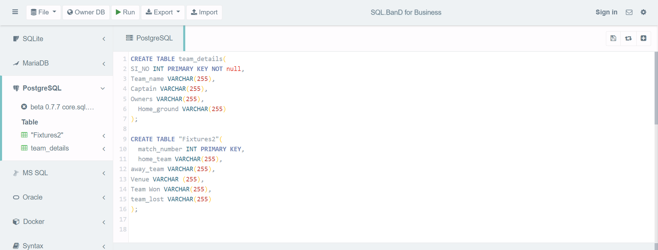

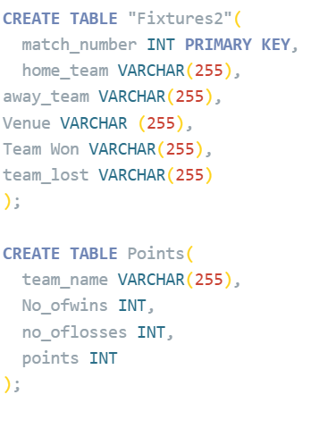

Milestone-2

Write a query to load all the data in Team Details table from team-details.csv.

Write a query to display all team details.

Write a query to get the total number to teams playing

* Cannot write query to export Data on online compiler.

Copy teamdetails from ‘ C:\Users\prakharsingh5\Desktop\Mainagg1teamdetails.csv’ DELIMITER ‘,’ CSV HEADER.

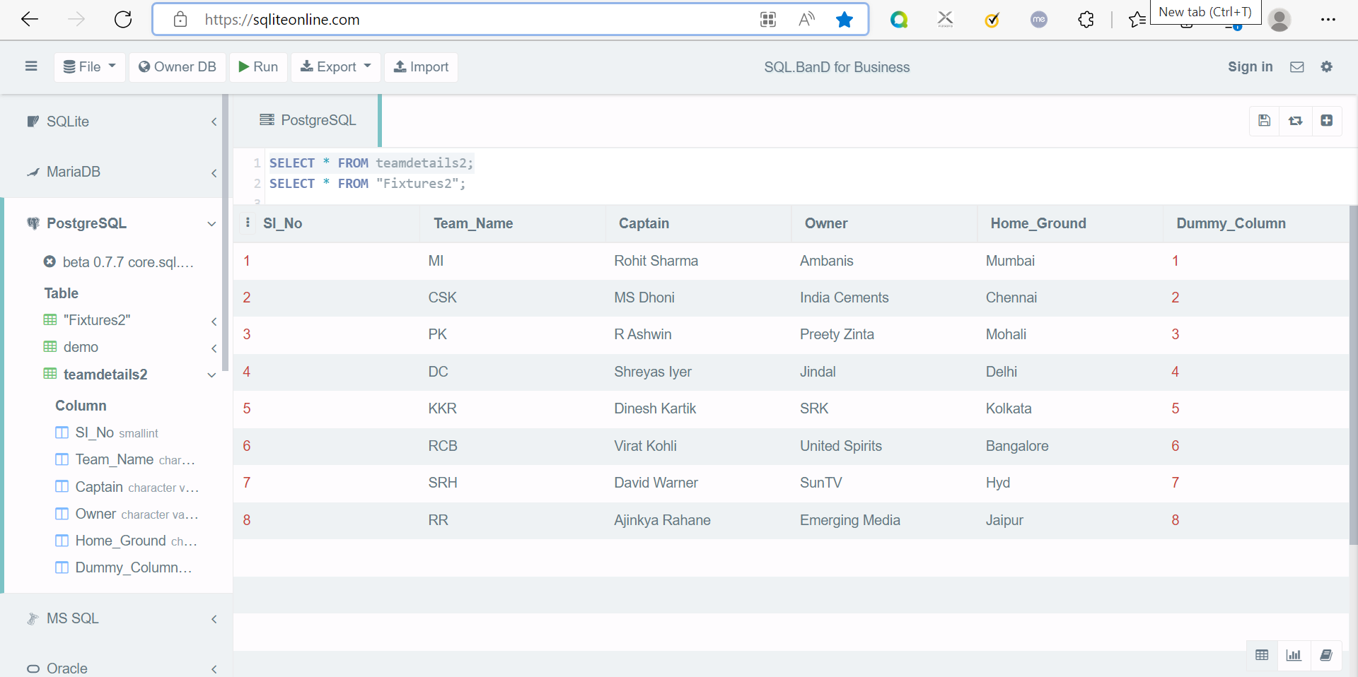

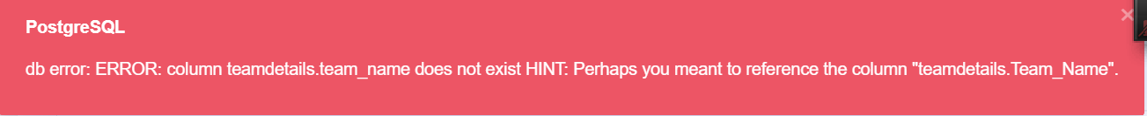

Even thought the coloumns are created I am not able to select the coloumn.

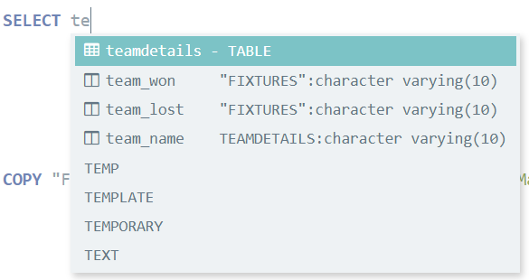



MileStone-3

Write a query to load all the data in *Fixtures* table from fixtures.csv .



Mile stone-4

Write a query to fetch all the matches played by RCB on it’s home ground

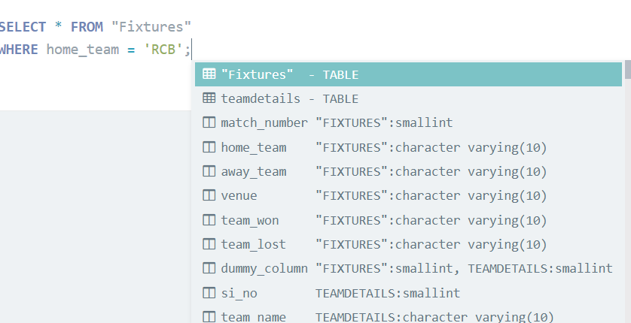

Milestone – 5

Write a query to find the team names who lost matches in Kolkata



Milestone -6

Write query to Insert data to Points table from Team Details and Fixtures tables, and order the data based on points scored in descending order-

* Add teams to Points table, who won more than 8 matches
* Add team(s) to Points table, who lost highest number of matches
* Get the teams whose scored are between 11 and 15, and insert these into Points table
* Fetch number of matches lost by PK
* Fetch the teams who scored more points than RR

