A Job Simulation Report
Of
Project Manager — Siemens Mobility

Submitted
To
School of Computer Science and Engineering
IILM University, Greater Noida, U.P.


In partial fulfilment of the requirement of degree of
B.Tech (CSE)

By
Roll Number of Student:- 25SCS1003004134
Name of Student: PRAKHAR SINGH
Batch: 2026-27

CANDIDATE'S DECLARATION
I, PRAKHAR SINGH, do hereby declare that this report titled “Project Manager — Siemens Mobility Job Simulation” has been completed by me to fulfil the requirement for the award of the degree of Bachelor of Technology in Computer Science and Engineering. All the references have been quoted and I have not taken as such any material from any other source. I affirm that this report is my own and has not been submitted to any other institute for any degree/diploma requirement, and further I shall be solely responsible for any kind of copyright violation in this regard.
Signature:-
Student Name: PRAKHAR SINGH
Enrollment No.: 25SCS1003004134

ACKNOWLEDGEMENT
I am using this opportunity to express my gratitude to everyone who supported me throughout this job simulation. I am thankful for their guidance and the resources made available to help me learn and apply project management concepts in a practical, real-world-style context.
I would like to thank Siemens Mobility and the Forage virtual experience platform for designing and providing this Project Manager Job Simulation, which gave me the opportunity to practise developing key performance indicators (KPIs) and managing project dashboards for a simulated rail infrastructure project. I am also thankful to my institute, IILM University, Greater Noida, and the faculty of the School of Computer Science and Engineering for their continuous support and encouragement.
I express my gratitude to my parents for their blessings.
Signature:
Student Name: PRAKHAR SINGH
Enrollment No.: 25SCS1003004134

TABLE OF CONTENTS
1. Candidate's Declaration i
2. Acknowledgement ii
3. Job Simulation Completion Certificate –
4. Project Description 1
4.1 Introduction 1
4.2 Organization Profile 2
4.3 Problem Statement 3
4.4 Simulation Objectives 3
4.5 Scope of the Simulation 4
4.6 Skills & Competencies Applied 4
4.7 Task Workflow / Methodology 5
4.8 Expected Outcomes 6
4.9 Certificate of Completion 6
5. Bibliography/References 7

3. JOB SIMULATION COMPLETION CERTIFICATE
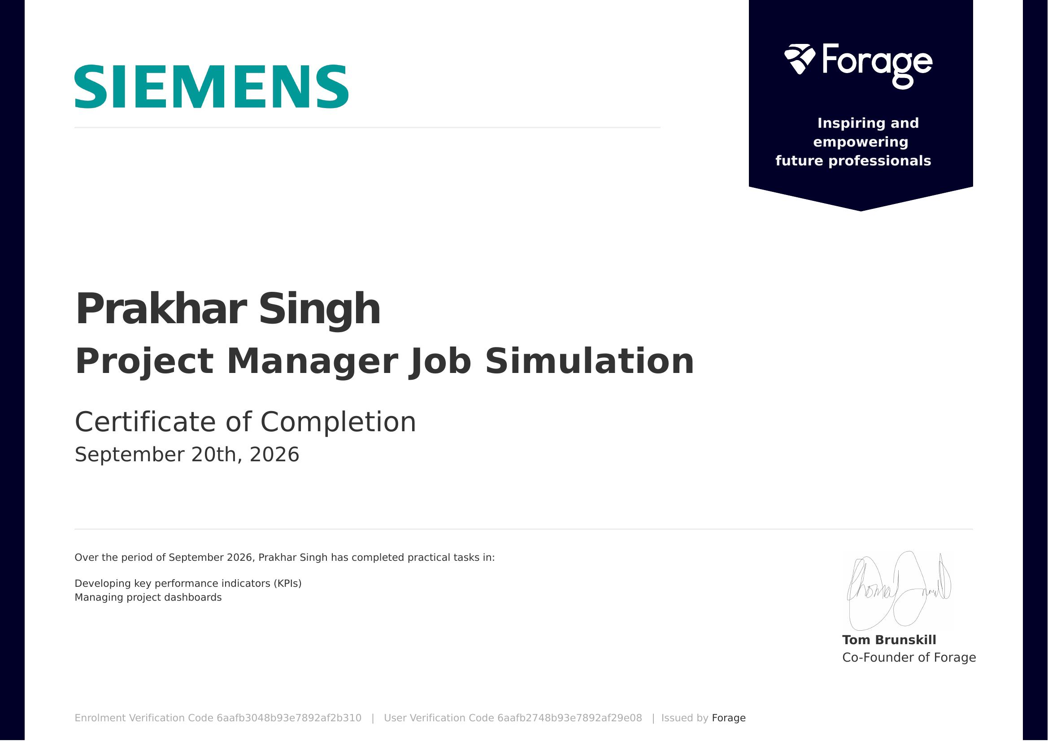
Certificate of Completion issued by Forage, on behalf of Siemens Mobility, dated September 20, 2026.

4. PROJECT DESCRIPTION

4.1 Introduction
This report presents an account of the Siemens Mobility — Project Manager Job Simulation, completed through the Forage virtual experience platform, in the domain of project management for rail infrastructure. The simulation was completed in September 2026 as part of a skill-enhancement activity undertaken alongside the Bachelor of Technology (Computer Science and Engineering) programme at IILM University, Greater Noida. The simulation is self-paced and designed to take approximately 1–2 hours, and it allows learners to step into the role of a project team member working on a rail expansion programme run by Siemens Mobility.
The simulation is structured around two applied task modules — developing key performance indicators (KPIs) and managing a project dashboard — that mirror the real, day-to-day responsibilities of a Siemens Mobility project management team member. On successful completion of both tasks, a Certificate of Completion was issued by Forage and co-signed by Tom Brunskill, Co-Founder of Forage.

4.2 Organization Profile
Siemens Mobility is a leading provider of transport solutions, focused on sustainable and efficient mobility across the entire ecosystem of rail and road transportation. Its offerings span infrastructure, rolling stock, rail electrification, signaling and control systems, and intelligent traffic systems, and the organization positions itself as a partner in shaping the future of transportation through innovation, technology, and collaboration with stakeholders worldwide.
This job simulation was delivered through Forage, a virtual experience platform that partners with global employers — including Siemens Mobility — to give students a risk-free way to practise realistic workplace tasks, build job-relevant skills, and explore potential career paths before entering the workforce.

4.3 Problem Statement
Rail infrastructure programmes typically involve numerous stakeholders and moving parts across safety, engineering, and operations. Without clear, measurable indicators, it becomes difficult for a project team to track progress against objectives such as safety, efficiency, and sustainability — or to communicate that progress convincingly to decision-makers and other stakeholders. The problem addressed by this simulation was to design a meaningful KPI framework for a rail expansion project, and to translate ongoing project updates into a dashboard that could be understood at a glance by non-technical stakeholders.

4.4 Simulation Objectives
- To understand the background, context, and team structure behind a simulated Siemens Mobility rail expansion project.
- To develop key performance indicators (KPIs) aligned with project objectives in safety, efficiency, and sustainability.
- To set measurable targets for each KPI and outline a strategy for ongoing monitoring.
- To analyze provided project data and identify the most relevant progress signals.
- To summarize project progress and challenges clearly and concisely.
- To visually present project updates on a dashboard for effective stakeholder communication.

4.5 Scope of the Simulation
The scope of this job simulation was limited to the two-module virtual environment provided by Forage, based on a fictional rail expansion project in “Metroville.” It did not involve access to, or deployment on, any live Siemens Mobility organizational system. Within this simulated environment, the scope covered the full task cycle of defining a KPI framework from a project brief and then using that framework to structure a stakeholder-facing project dashboard.

4.6 Skills & Competencies Applied
- Analytical Thinking
- Strategic Planning
- KPI Design
- Written Communication
- Data Integration
- Dashboard Operations
- Critical Thinking

4.7 Task Workflow / Methodology
The simulation followed a structured, task-wise workflow, summarized in the table below.
Stage | Module | Description
1 | Intro & Scenario | Background context on the rail expansion project and introduction to the project team at Siemens Mobility.
2 | Developing KPIs | Defined KPIs aligned to the project's safety, efficiency, and sustainability objectives; set measurable targets; and outlined a strategy for ongoing monitoring.
3 | Managing Project Dashboards | Analyzed provided project data, summarized key progress and challenges, and visually presented updates for clear stakeholder communication.
4 | Finish Line | Reviewed the completed task submissions against the simulation brief to finalize the deliverables.

Both task modules were self-paced and ungraded, with no formal assessments; the emphasis throughout was on applying realistic project-management thinking to a scenario-based brief.

4.8 Expected Outcomes
- Ability to design a measurable KPI framework aligned with strategic project objectives.
- Practical understanding of dashboard management and data-driven progress reporting.
- First-hand exposure to the kind of tasks handled by Siemens Mobility's project management team.
- Strengthened written communication for translating technical progress into stakeholder-ready updates.
- Enhanced strategic and critical thinking applied to an infrastructure-scale project scenario.

4.9 Certificate of Completion
The Certificate of Completion issued by Forage, confirming successful completion of the Siemens Mobility — Project Manager Job Simulation, is attached in Chapter 3 of this report.

5. BIBLIOGRAPHY/REFERENCES
1. Forage, “Siemens Mobility — Project Manager Job Simulation,” Certificate of Completion, Enrolment Verification Code 6aafb3048b93e7892af2b310, User Verification Code 6aafb2748b93e7892af29e08, issued September 20, 2026.
2. Forage, “Project Manager — Siemens Mobility Job Simulation,” https://www.theforage.com/simulations/siemens-mobility/project-management-qydx
3. Siemens Mobility, Official Company Overview, https://www.mobility.siemens.com/
4. Forage Virtual Experience Platform, https://www.theforage.com/

