REPORT

RACHAMALLA HINDUSREE-2103128

A1. The probability distribution of the random numbers as a function of

the value of the random number.

X – direction

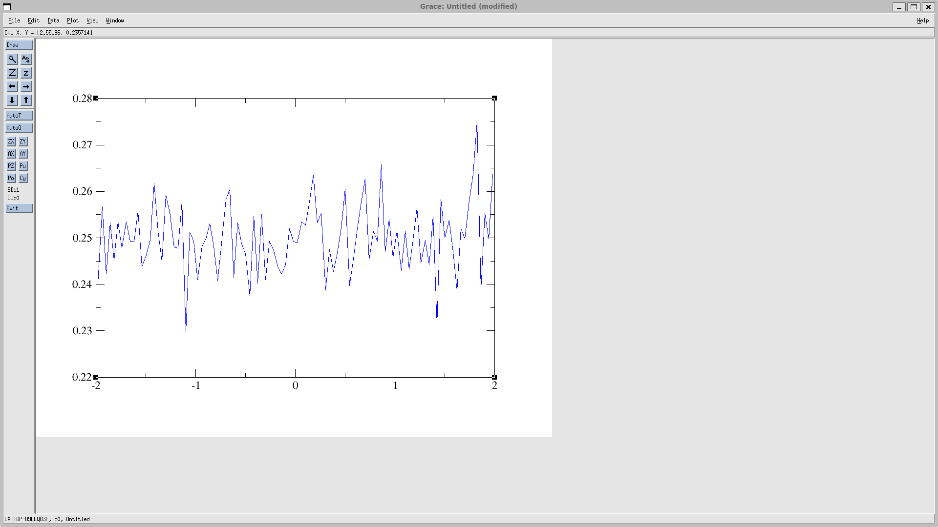

Y - direction

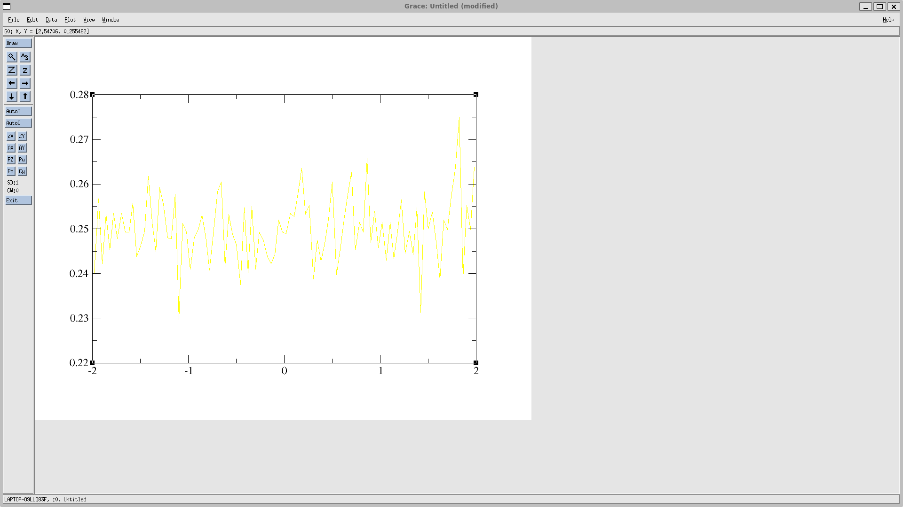

Z-direction

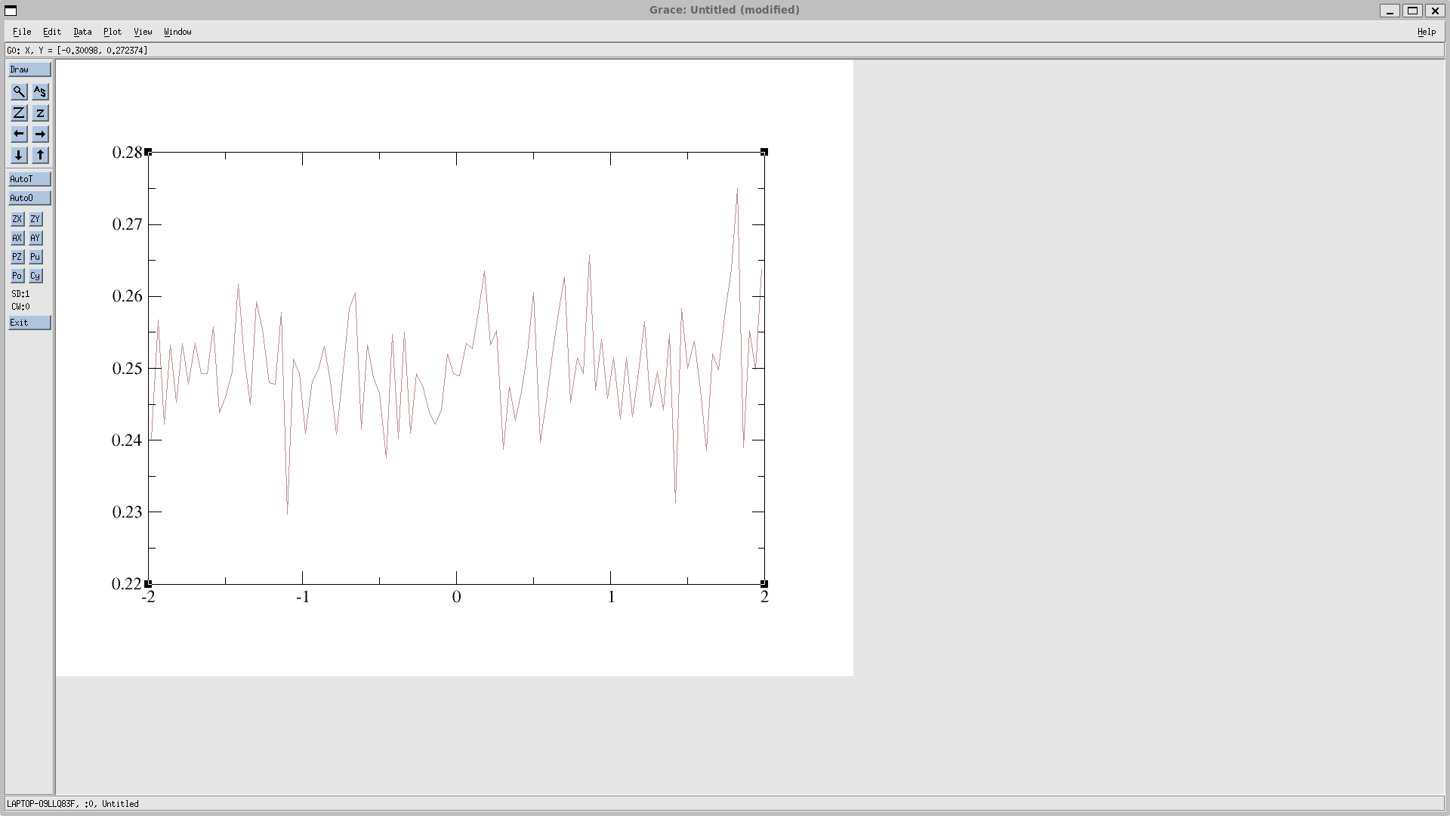

B.

Numerical probability distribution

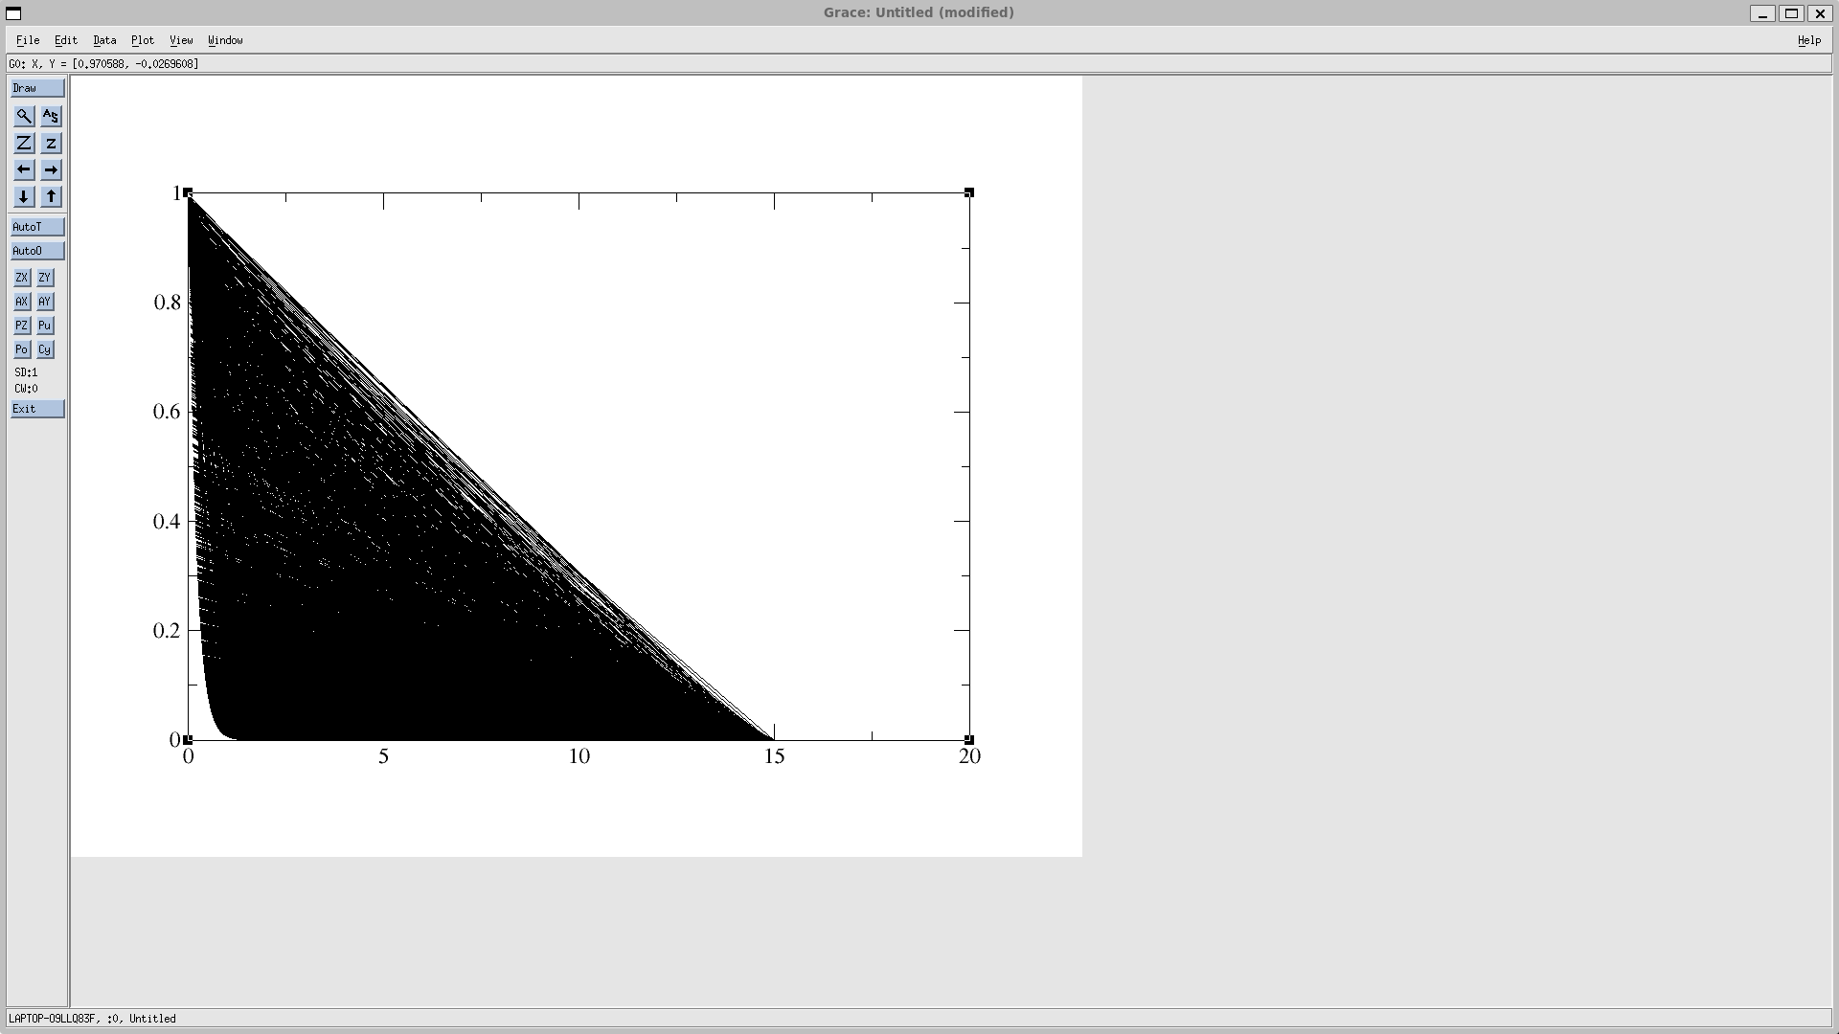

Analytical probability distribution

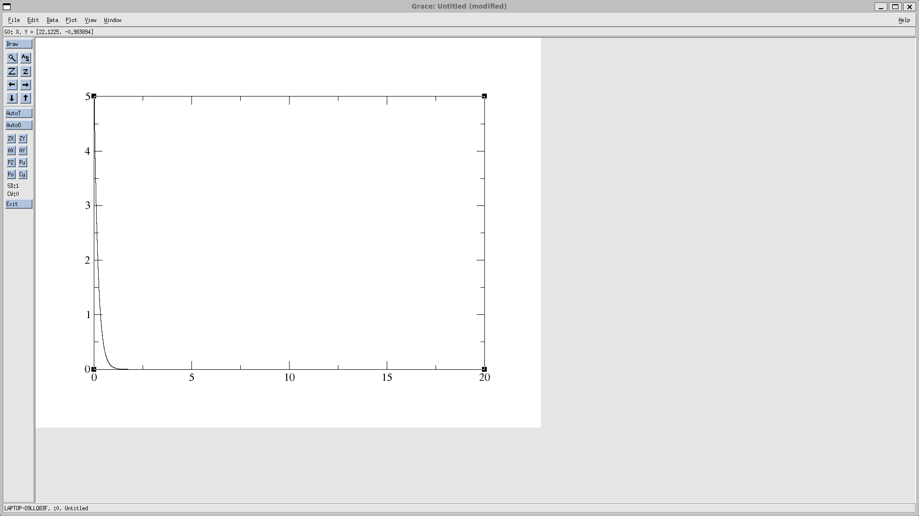

Both numerical and analytical plots are identical

A2.

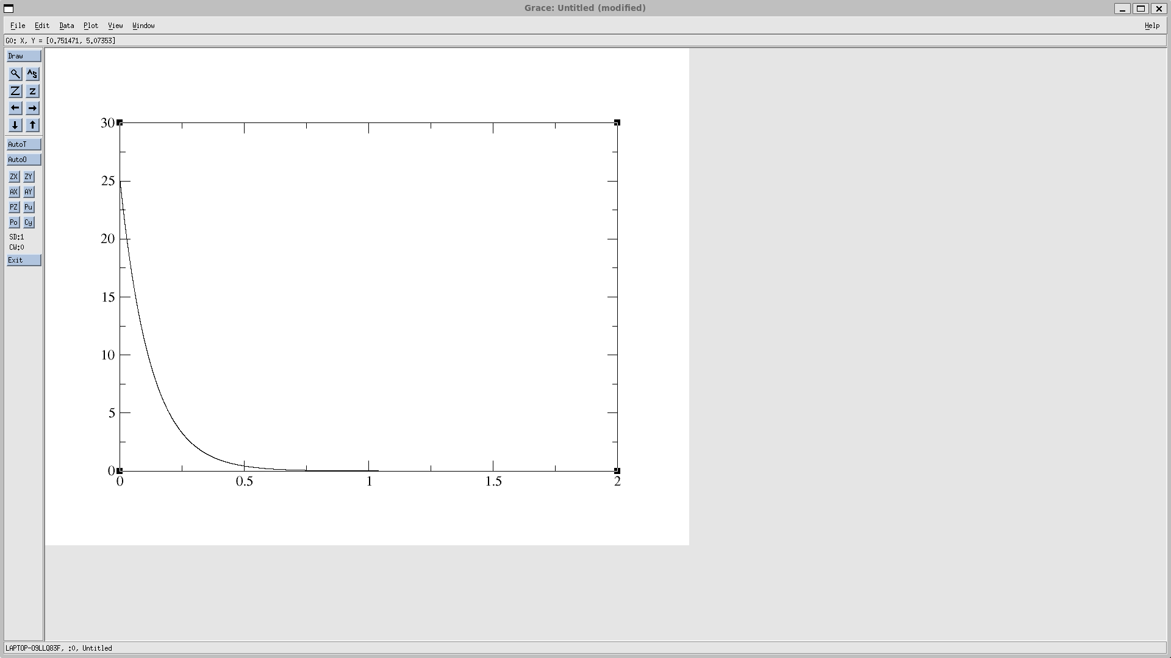Vx vs time plot Vz vs time plot

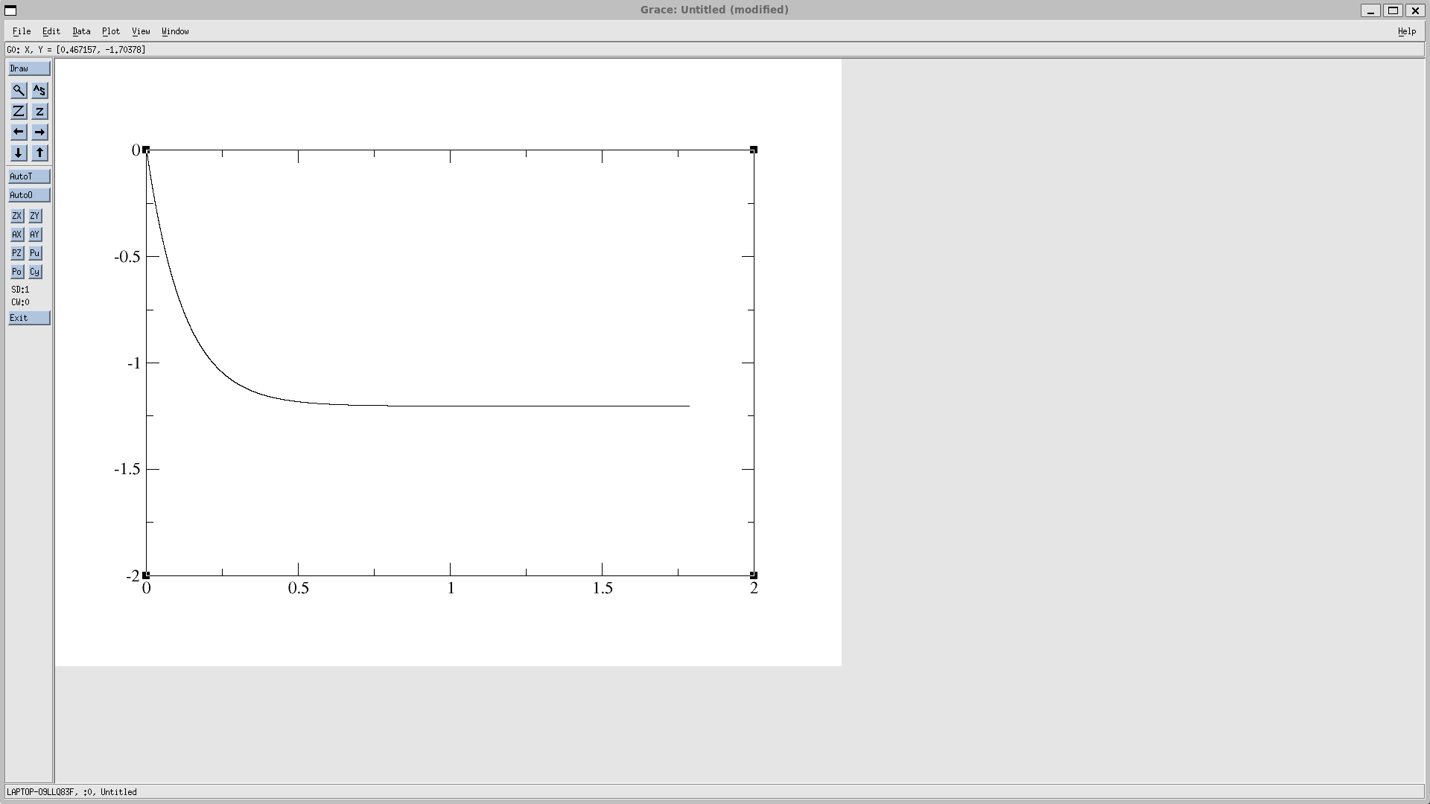

X vs time z vs time

