Lab 4

Operating System

Name: Prakhar Gupta
Roll No: 2103126
Department: CS
Instructor: Dr. Shitala Prasad

Part B:
Output:
Matrix A (10*10); Matrix B (10*10); Matrix C (10*10)

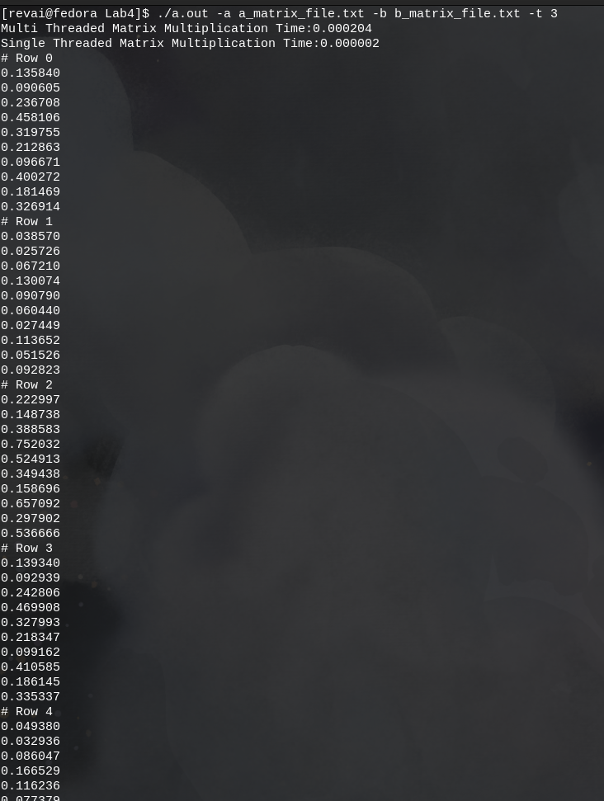

Matrix A(100*100); Matrix B(100*100); Matrix C(100*100)
No of Threads: 3
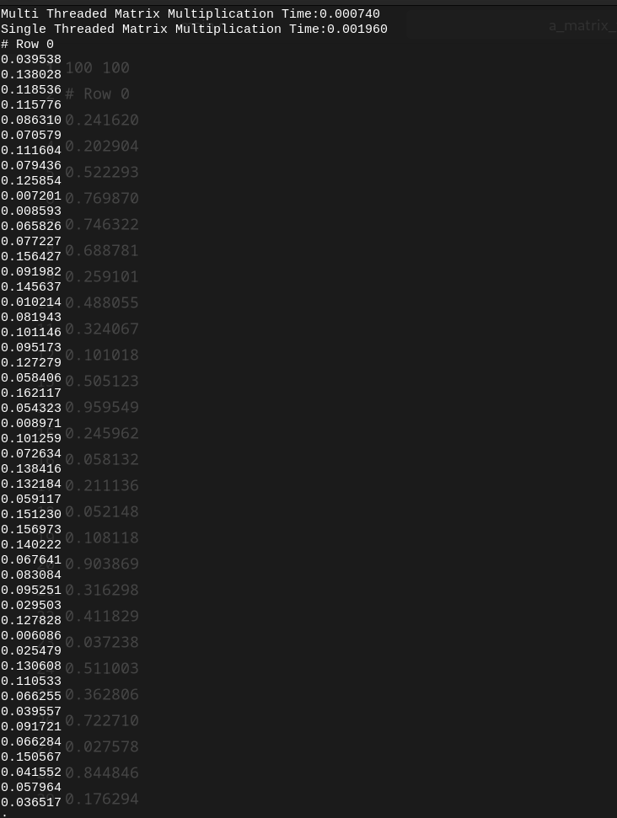
When the matrix to be multiplied are small creating threads to solve multiplication actually takes more time as OS has to create and manage threads. But on scaling the problem 10 times we can see that multithreading has much better advantage.

