Product Design
Team | Team 45 : Prakhar Pandey , Veerendra Mandava , Ayush Joshi

Design Model :

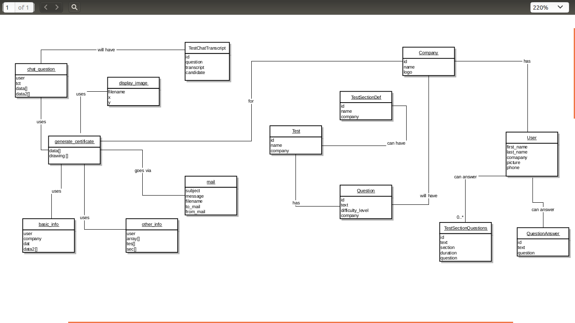
Class Diagram can viewed properly here : http://s27.postimg.org/kyi05cgw3/image.png
Company | This class holds data for company. There are many companies listed that conduct different tests on candidates. This class holds the data associated with a company.  Data Members :  id  logo  name
User | Holds data for user . A candidate can take tests for several companies.  Data Members :  first_name  last_name  company  phone  photo.
TestSectionQuestion | Holds test question data. This is used in generation of actual PDF  Data Members :  id  text  section  duration  difficulty
Test | Holds companies test data. There are different types of tests .  Each test is associated with a company.  Data Members :  id  company  test
generate_certificate | Generates the main pdf documents  Data Members :  data[]  drawing[]  Member functions :  first_page()  other_page()
mail | This class emails the generated pdf to the Hiring Manager  Data Member :  filename,  sender_email  receiver_email  subject  message  Member Functions :  send()
display_image | This class displays images in the pdf  Data Members :  name  x  y
basic_info | Contains info of the candidates  Data Members : name  ,company  dat[]  data2[]
.

Sequence Diagram(s) :

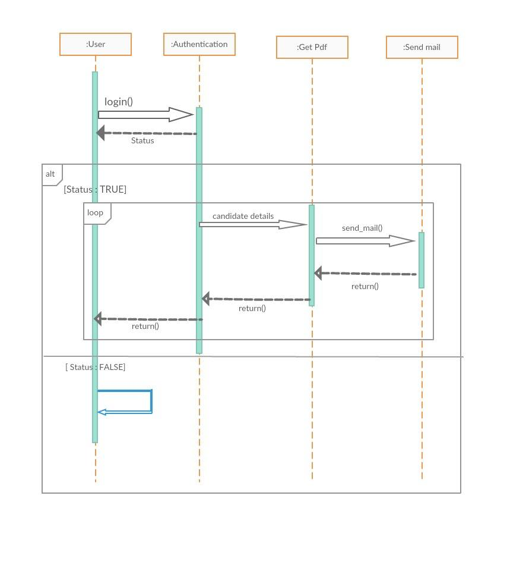
Uploaded : http://s23.postimg.org/4jc6a612z/12211104_718179991649743_1590558217_o.jpg

Design Rationale

