**Problem Statement 1:**



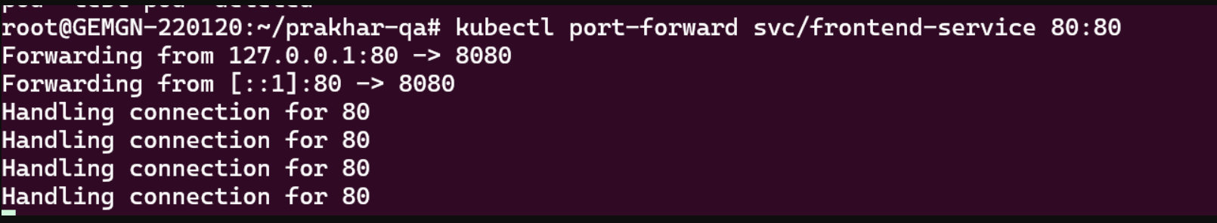

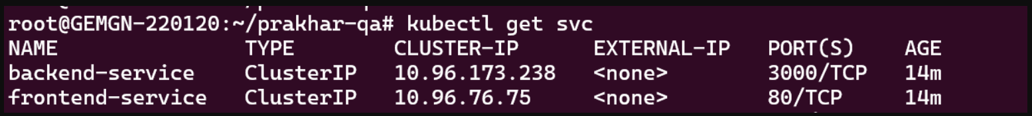

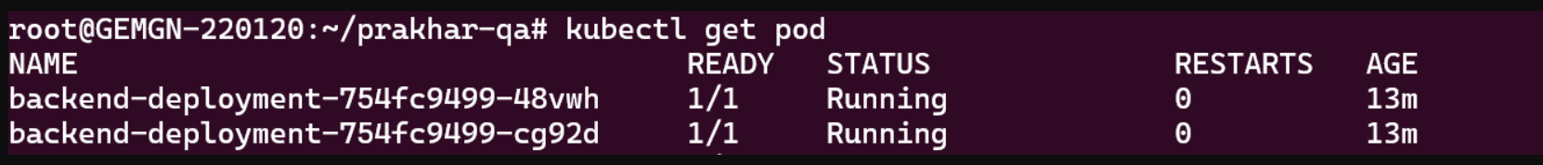

**Problem Statement 2:**

1. **System Health Monitoring Script:**

Develop a script that monitors the health of a Linux system. It should check

CPU usage, memory usage, disk space, and running processes. If any of

these metrics exceed predefined thresholds (e.g., CPU usage > 80%), the

script should send an alert to the console or a log file.

**Bash Script –**

#!/bin/bash

# Thresholds

CPU_THRESHOLD=80

MEM_THRESHOLD=80

DISK_THRESHOLD=90

# Log file location

LOG_FILE="/var/log/system_health.log"

# Function to log alerts

log_alert() {

local message=$1

echo "$(date) : $message" | tee -a $LOG_FILE

}

# Check CPU usage

cpu_usage=$(top -bn1 | grep "Cpu(s)" | sed "s/.*, *\([0-9.]*\)%* id.*/\1/" | awk '{print 100 - $1}')

if (( $(echo "$cpu_usage > $CPU_THRESHOLD" | bc -l) )); then

log_alert "ALERT: CPU usage is above threshold! Usage: $cpu_usage%"

fi

# Check memory usage

mem_usage=$(free | grep Mem | awk '{print $3/$2 * 100.0}')

if (( $(echo "$mem_usage > $MEM_THRESHOLD" | bc -l) )); then

log_alert "ALERT: Memory usage is above threshold! Usage: $mem_usage%"

fi

# Check disk space usage

disk_usage=$(df / | grep / | awk '{ print $5 }' | sed 's/%//g')

if [ $disk_usage -gt $DISK_THRESHOLD ]; then

log_alert "ALERT: Disk space usage is above threshold! Usage: $disk_usage%"

fi

# Check the number of running processes

process_count=$(ps aux | wc -l)

log_alert "INFO: Current number of running processes: $process_count"

echo "System health check completed!"

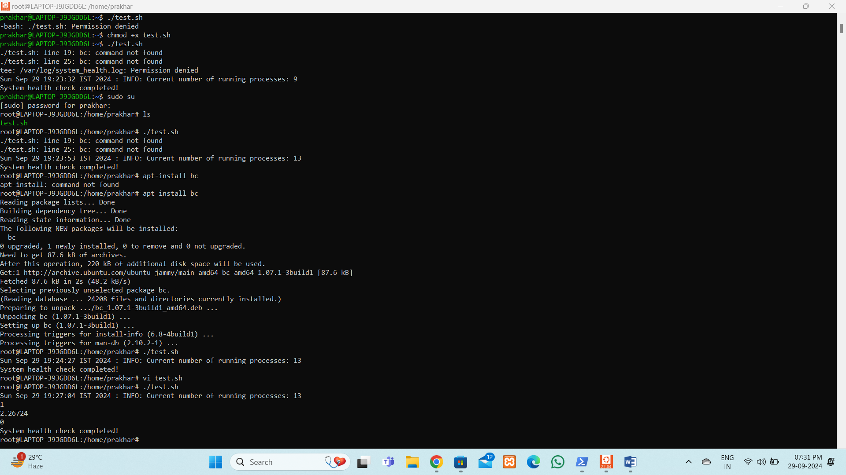

4. Application Health Checker:

Please write a script that can check the uptime of an application and

determine if it is functioning correctly or not. The script must accurately

assess the application's status by checking HTTP status codes. It should be

able to detect if the application is 'up', meaning it is functioning correctly, or

'down', indicating that it is unavailable or not responding.

**Bash Script –**

#!/bin/bash

# Application URL to check

URL="http://your-application-url.com"

# Log file location

LOG_FILE="/var/log/app_health.log"

# Function to log the application status

log_status() {

local message=$1

echo "$(date) : $message" | tee -a $LOG_FILE

}

# Make an HTTP request and get the status code

status_code=$(curl -o /dev/null -s -w "%{http_code}" $URL)

# Check the HTTP status code and determine the application's health

if [ "$status_code" -eq 200 ]; then

log_status "Application is UP. Status code: $status_code"

else

log_status "Application is DOWN or not responding. Status code: $status_code"

fi





