

BHARATI VIDYAPEETH’S
INSTITUTE OF COMPUTER APPLICATIONS & MANAGEMENT
(Affiliated to Guru Gobind Singh Indraprastha University, Approved by AICTE, New Delhi)

Database Management System
(MCA-)
Practical File

Submitted To: Submitted By:
Dr. Sania Kukkar Prakhar Srivastava (T00304426)
MCA 1st Sem, Sec -A
P1Consider the following table:
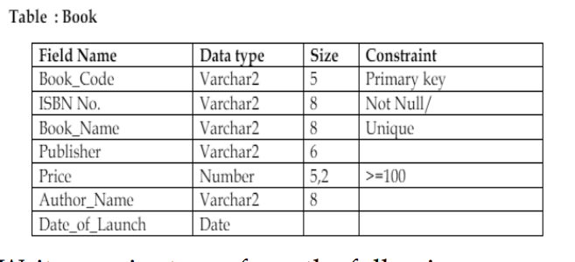

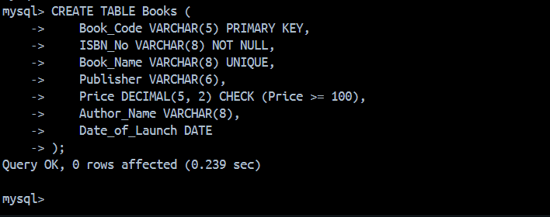
1. Insert few records in it.
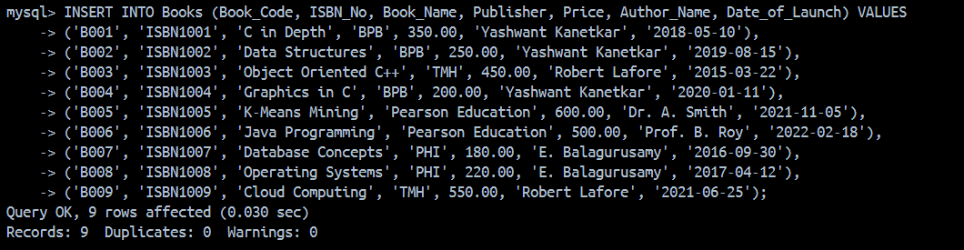

2. Increase the size of the Book_Name field to 10 characters.
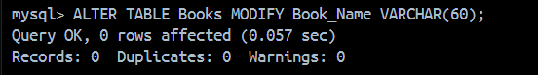

3. Display the total price of all the books of “TMH’ publishing house.
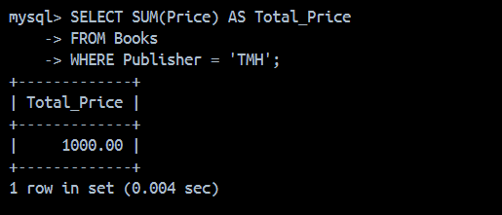

4. Display the details of all the books of author “Yashwant Kanetkar” and “Robert Lafore”.
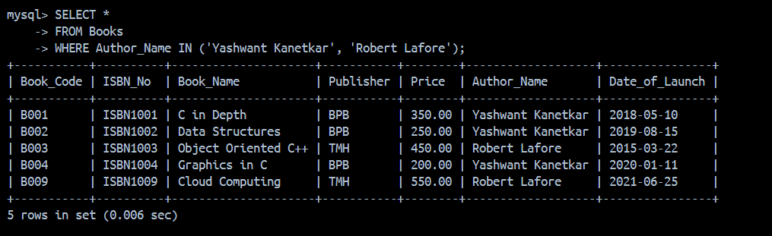

5. Delete all the books belonging to “PHI” publisher.
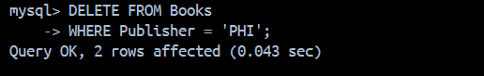

6. Update the price of books by 5% which belong to ‘BPB’ publishers.
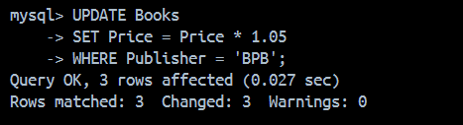

7. Create a new table “Author” with author details such as author id (primary key), Name of the author, subject, contact details, research area etc.
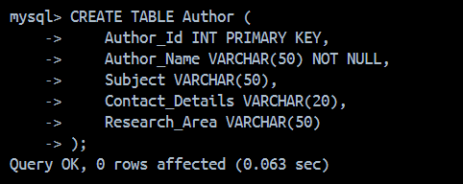

8. Insert records in it and display the records of those authors who have ‘Web mining’ as their research area.
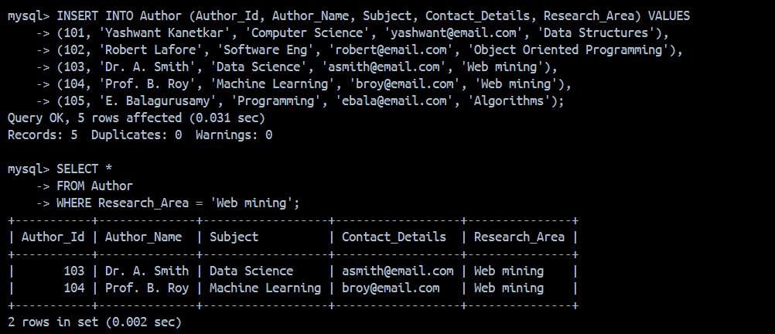

9. Add a new column “Author_Id” in “Book” table and make it a foreign key on “author id” of “Author” table.
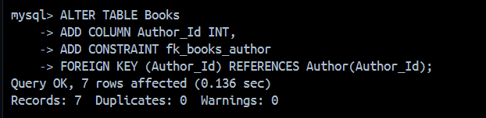

10. Update all the previous records of Book table to add information of author id (newly added column)
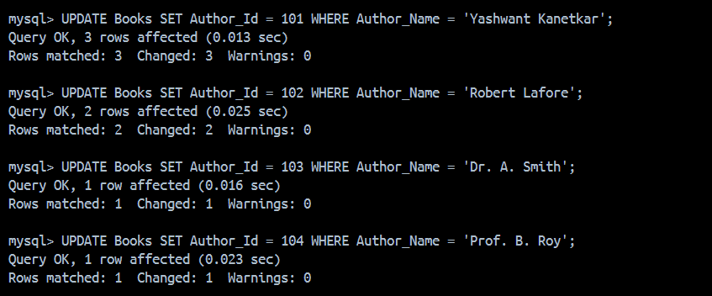

11. Display the records of the books where book name starts with ‘C’ or ‘G’ or ‘K’
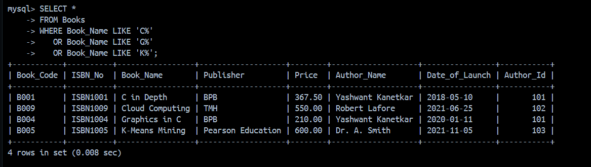

12. Create a view for the user to access the Book Code, Name and Price of books which are published by ‘Pearson Education’.
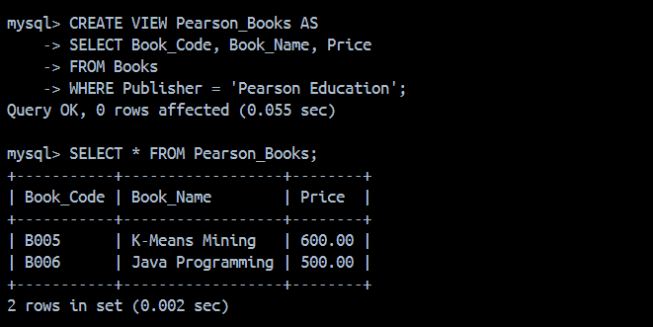

P2 Consider the following table:
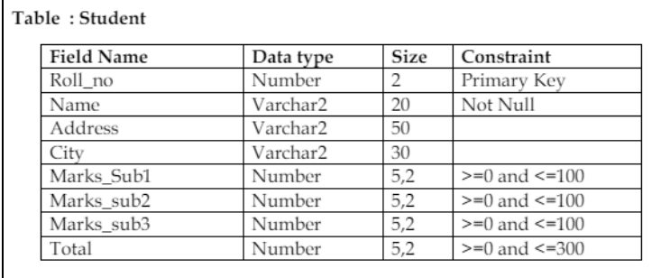

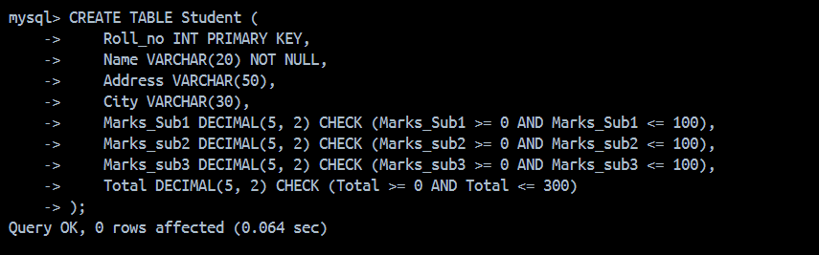

1. Insert few records except total marks
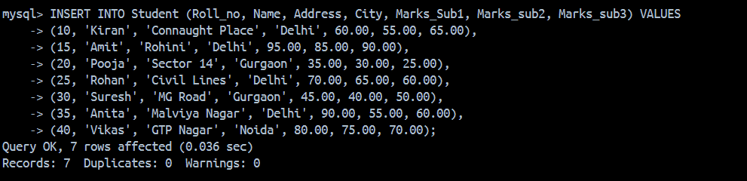

2. Create a view on the table to access roll no, name and total marks of those students who belong to ‘Delhi’
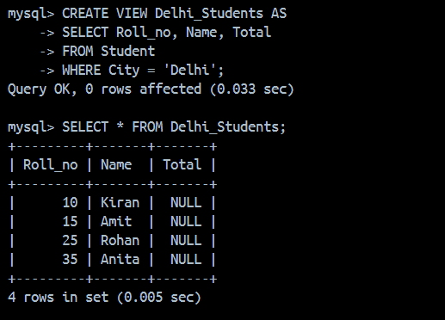

3. Calculate total marks of each student and save it.
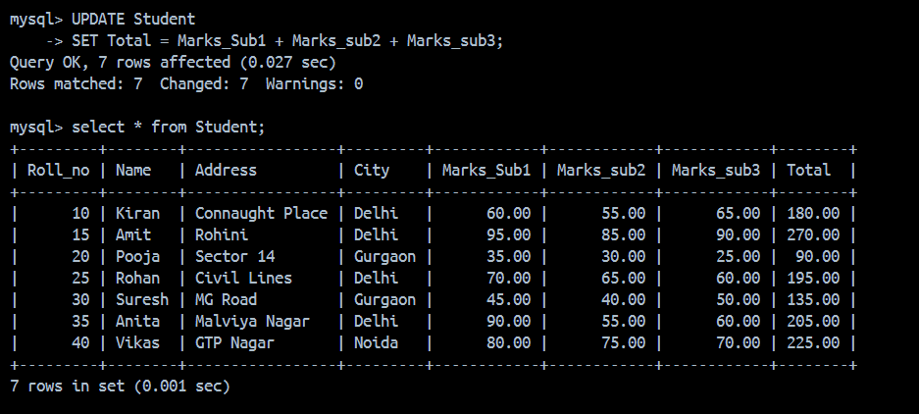

4. Display the name of the student who has got the highest marks.
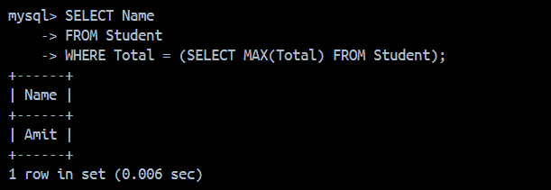

5. Display the records of those students who have got marks more than the marks of ‘Kiran’.
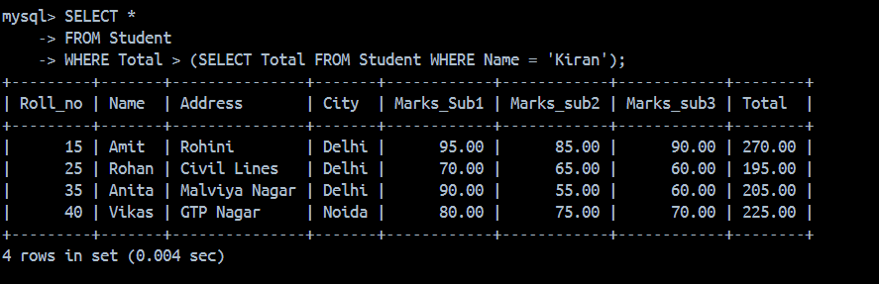

6. Display the percentage of all the students with their names.
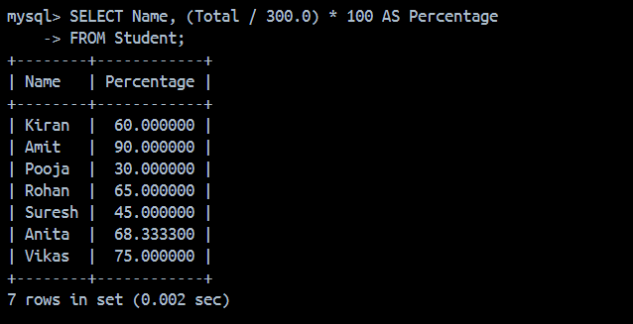

7. Display the names of those students who have got maximum marks in sub1 and more than 50 in sub2 and sub3.
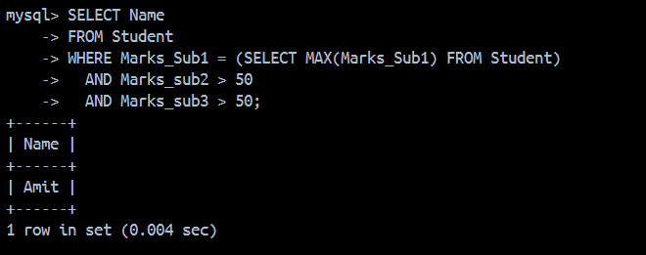

8. Update the marks of all those students who are fail, with grace marks 5. (fail means less than 40)
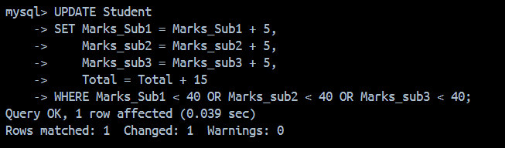

9. Delete the record of student who got minimum marks.

10. Display record of student who got second highest marks.
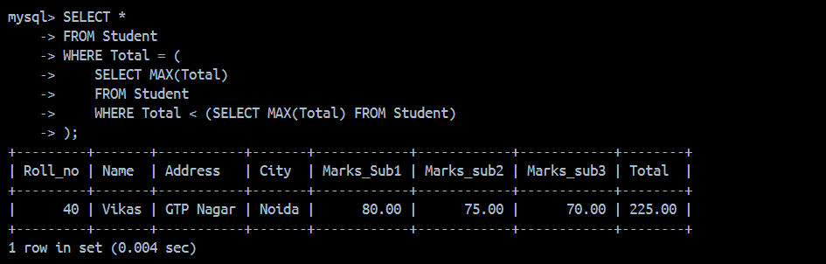

11. Display the average total marks of all the student's city wise excluding the students of ‘Gurgaon’.
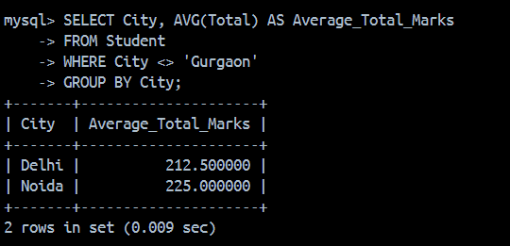
12. Get the names of students with Roll_no less than 30 and whose total marks is more than the total marks of at least one student with Roll_no greater than or equal to 30.
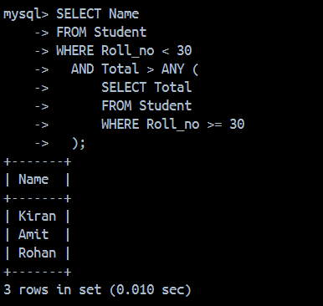
P3 Consider the following three relations:
Primary Keys are indicated by #
Foreign Keys are underlined.
Employee (Eid#, EName, Address, DateOfJoining, Department)
Project (Pid#, PName, StartDate, TerminationDate)
AssignedTo (Eid, Pid)

