

BHARATI VIDYAPEETH’S
INSTITUTE OF COMPUTER APPLICATIONS & MANAGEMENT
(Affiliated to Guru Gobind Singh Indraprastha University, Approved by AICTE, New Delhi)

Object-Oriented Programming and Java
(MCA-167)
Practical File

Submitted To: Submitted By:
Dr. Ritika Wason Prakhar Srivastava (05011604426)
(Deputy Director) MCA 1st Sem, Sec A
INDEX

S. No. | Problem Description | Date of Execution | Sign.
PQ1 | Create a class Student with data members: studentID, studentName, course, and marks.  Include methods to get student details from user and display student details and  calculate grade. Create an array of atleast 10 students and use a loop to read and display  the details of each student. Any new student admitted should have a name and an id.
PQ2 | Create a class Staff with appropriate constructors. Accept details of each staff at his/her  time of hiring using Scanner class. Display these details using appropriate methods.
PQ3 | Create a class Result that implement a switch-case statement to assign grades: A for marks >= 90, B for 75–89, C for 60–74, and F for below 60.
PQ4 | Create a class Person (with subclasses Student and Staff). Include relevant fields and  methods.
PQ5 | Define an interface `Billable` with a method `calculateBill()`. Implement this interface in the `Patient` class to calculate hospital bills.
PQ6 | Write a program that demonstrates dynamic binding by creating an array of `Person`  references, storing both `Patient` and `Doctor` objects, and calling `displayDetails()`..
PQ7 | Create a program that accepts a medical report (string) and counts the number of words, sentences, and occurrences of the word 'disease'.
PQ8 | Create a program to store vital signs (like temperature, BP, sugar level) of patients in a  two-dimensional array. Display them in tabular form.
PQ9 | Create a String array containing the following events: String events[] = { "Coding",  "Debate", "Quiz", "Dance", "Photography"};  Write a program to represent an event. Create appropriate methods to display all  participant details registered for the event, find the participant with the highest score, find  the participant with the lowest score, calculate the average score, display participants  whose score is greater than the average, search for a participant by name.
PQ10 | Simulate a method that can determine how many participants registered for each event  in a case-insensitive manner and allocate a time and venue for event conduction if the  event has atleast 3 participants registered.
PQ11 | The organizing committee has arranged all participants in a 5 × 5 seating area. Represent  the seating arrangement using a two-dimensional integer array. Write a program to:  i. Display the seating arrangement.  ii. Count the total occupied seats.  iii. Count the total vacant seats.  iv. Find the row having the maximum number of participants.  v. Find the column having the maximum number of participants.
PQ12 | The organizers want a visual representation of the seating arrangement which should  always be pyramid shaped. Write a program that asks the number of rows required from  the user and displays the visual representation of the seating arrangement
PQ13 | Create a method to allow searching participant names:  i. Alphabetically  ii. Longest name  iii. Shortest name  iv. Count the names beginning with a particular search letter input by the user  v. For each participant, display the number of vowels in their name.
PQ14 | A banking application stores customer IDs as strings.  The user enters a customer ID that should contain only digits.  Write a program that converts the entered ID into an integer.  For example:  Input: 10245 Output: Customer ID = 10245  If the user enters: 10A45  the application should display: Invalid Customer ID. Please enter digits only.  Note: Use Integer.parseInt(), Handle NumberFormatException, Use try-catch.
PQ15 | Create a class: class Account { int balance; void withdraw(int amount) { //  implementation } }  The application should:  1. Store an initial balance.  2. Accept the withdrawal amount.  3. Check whether the amount is valid.  4. Deduct the amount if possible.  5. Display the remaining balance.
PQ16 | Modify the Account class so that if the customer attempts to withdraw more money than  the available balance, the application generates:  InsufficientBalanceException
PQ17 | CampusConnect receives assignments from students. Create two threads:  AssignmentSubmissionThread  AssignmentEvaluationThread  The submission thread adds student submissions while the evaluation thread processes  them.  Both threads should display:  Student 1 submitted assignment  Student 1 assignment evaluated
PQ18 | A university has only 5 seats available for a workshop.Ten student threads  simultaneously attempt to register.  Create: Workshop and StudentRegistration  Each student thread attempts to reserve one seat.  Challenge:  First implement it without synchronization, then add synchronization and compare the behavior.
PQ19 | Implement:  cancelAdmission(int studentId) and displayWaitingList(String course)  Functional Requirements  The method should:  - Search for the student using studentId.  2. If the student does not exist, display an appropriate message.  3. If the student exists:  o Remove the student from the admitted-student collection.  o Identify the course from which the student cancelled admission.  o Display a cancellation confirmation.  4. Check whether a waiting list exists for that course.  5. If the waiting list is not empty:  o Select the first student from the waiting list.  o Remove that student from the waiting list.  o Admit the student automatically.  o Display the new admission details.  Important Rule  If a seat becomes available because of cancellation:  The first student who entered the waiting list must be admitted first.  Therefore, the waiting list must follow FIFO (First-In-First-Out) behaviour.
PQ20 | Implement a method:  displayStudentsAlphabetically()  The method should display the names of all currently admitted students in  alphabetical order. Use an appropriate collection that automatically maintains unique student names in sorted order. The method should reflect the current admitted  students. Students who have cancelled their admission should not appear in  the output.
PQ21 | Implement:  searchStudent(int studentId)  The method should search for a student using their unique StudentID.
PQ22 | Modify the TCP program to allow multiple students (clients) to connect to the  CampusConnect server. Each client should send its name → Server should acknowledge  with “Hello [Name], you are connected.” Use multithreaded server with Thread for each  client.
PQ23 | Implement a UDP-based group chat where: Multiple clients send messages to the server.  Server broadcasts messages to all connected clients. Each client should run on a separate  thread for simultaneous messaging. .
PQ24 | Ensure that:  • Name and Email fields are not empty when Submit is clicked.  • If any field is empty, show a message dialog or Label with the text:  “Please fill all required fields.”  Hint: Use a simple conditional inside actionPerformed().
PQ25 | Handle window closing events:  • When the user closes the window, show a message:  “Thank you for using EduForm!”  • Exit gracefully using System.exit(0).
PQ26 | Use AWT /Swings to develop a Contact Manager. The GUI application maintains a  simple list of contacts storing contact name and number. It provides basic features of  CRUD (Create, Update, Retrieve and Delete) as per user choice. The application also  supports search feature.
PQ27 | Implement a RMI application. The server object maintains a HashMap of Faculty and  Course names; and provides for a method subjectTaught that takes a faculty name as  parameter. The client should attain a remote reference to the object and call the remote  method to satisfy user queries
PQ28 | Define a functional interface called Calculator with a single abstract method int  calculate(int a, int Use thisfunctional interface in four lambda expressions to perform  addition, subtraction, multiplication, and division operations.
PQ29 | A Java application that uses JDBC to connect to a database containing table that holdsdata for students of your class. The application should allow the user to: a) Add a record  b) Search for a record c) Modify an existing record Make use of Prepared Statement  Extend the application to call a backend procedure/function. The procedure should take  ID field as input parameters and return details of related record.
PQ1. Create a class Student with data members: studentID, studentName, course, and marks.
Include methods to get student details from user and display student details and
calculate grade. Create an array of atleast 10 students and use a loop to read and display
the details of each student. Any new student admitted should have a name and an id.
SOLUTION:
import java.util.*;
class Student
{
String studentName,course;
int studentID,marks;
}
public class StudentRecord extends Student
{
Scanner sc=new Scanner(System.in);
Student arr[]=new Student[10];
int index=0;
public static void main(String[] args)
{
StudentRecord record = new StudentRecord();
int choice = 0;
while (choice != 3) {
System.out.println("\n--- Student Record Menu ---");
System.out.println("1. Insert Student");
System.out.println("2. Fetch Details");
System.out.println("3. Exit");
System.out.print("Enter your choice: ");

if (record.sc.hasNextInt()) {
choice = record.sc.nextInt();
switch (choice) {
case 1:
record.InsertStudent();
break;
case 2:
record.FetchStudents();
break;
case 3:
System.out.println("Exiting program...");
break;
default:
System.out.println("Invalid choice. Please enter 1, 2, or 3.");
}
} else {
System.out.println("Invalid input. Please enter a number.");
record.sc.next(); // clear invalid input
}
}
}
public void InsertStudent()
{
if (index==9)
{
System.out.println("Student Capacitu Reached");
return; }
Student st=new Student();
System.out.print("Enter Name: ");
st.studentName=sc.next();
System.out.println();

System.out.print("Enter Student ID: ");
st.studentID=sc.nextInt();
System.out.println();

System.out.print("Enter Course ");
st.course=sc.next();
System.out.println();

System.out.print("Enter Marks");
st.marks=sc.nextInt();
System.out.println();

arr[index]=st;
index=index+1;
}
public void FetchStudents()
{
if (index==0)
{
System.out.println("No Student Record Found");
return;
}
for (int i = 0; i < index; i++) {
Student rec = arr[i];
System.out.println("Name: "+rec.studentName+" ID: "+rec.studentID+" Course: "+rec.course+" Marks: "+rec.marks);
}
}
}

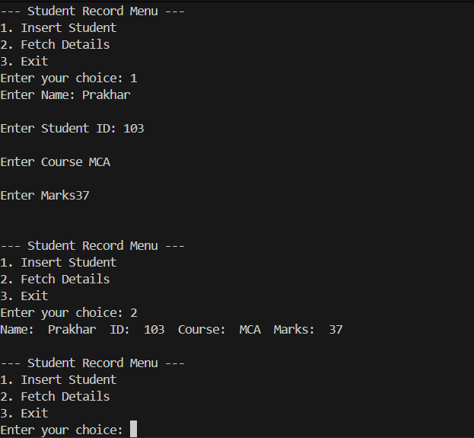

PQ2. Create a class Staff with appropriate constructors. Accept details of each staff at his/her
time of hiring using Scanner class. Display these details using appropriate methods.

SOLUTION:
import java.util.*;
class Staff{
String staffName,dept,Email,hireDate;
int staffID,Phone;
public Staff(String staffName, int staffID, String dept, String Email, int Phone, String hireDate) {
this.staffName = staffName;
this.staffID = staffID;
this.dept = dept;
this.Email = Email;
this.Phone = Phone;
this.hireDate = hireDate;
}
}
public class StaffRecord {
Scanner sc=new Scanner(System.in);
Staff arr[]=new Staff[10];
int index=0;
public static void main(String[] args) {
StaffRecord record = new StaffRecord();
int choice = 0;
while (choice != 3) {
System.out.println("\n--- Staff Record Menu ---");
System.out.println("1. Insert Staff");
System.out.println("2. Fetch Details");
System.out.println("3. Exit");
System.out.print("Enter your choice: ");

if (record.sc.hasNextInt()) {
choice = record.sc.nextInt();
record.sc.nextLine(); // consume the leftover newline
switch (choice) {
case 1:
record.InsertStaffDetails();
break;
case 2:
record.FetchStaff();
break;
case 3:
System.out.println("Exiting program...");
break;
default:
System.out.println("Invalid choice. Please enter 1, 2, or 3.");
}
} else {
System.out.println("Invalid input. Please enter a number.");
record.sc.next(); // clear invalid input
}
}
}
public void InsertStaffDetails(){
if (index == 10) {
System.out.println("Staff Capacity Reached.");
return;
}
System.out.print("Enter Name: ");
String name = sc.nextLine();
System.out.print("Enter Staff ID: ");
int id = sc.nextInt();
sc.nextLine(); // consume newline

System.out.print("Enter Department: ");
String dept = sc.nextLine();

System.out.print("Enter Email: ");
String email = sc.nextLine();

System.out.print("Enter Phone (without country code): ");
int phone = sc.nextInt();
sc.nextLine(); // consume newline

System.out.print("Enter Hire Date (DD/MM/YYYY): ");
String hireDate = sc.nextLine();
Staff st = new Staff(name, id, dept, email, phone, hireDate);
arr[index] = st;
index++;
System.out.println("Staff added successfully!");
}
public void FetchStaff(){
if (index == 0) {
System.out.println("No Staff Record Found.");
return;
}
for (int i = 0; i < index; i++) {
Staff rec = arr[i];
System.out.println("Name: " + rec.staffName + " | ID: " + rec.staffID + " | Dept: " + rec.dept + " | Email: " + rec.Email + " | Phone: " + rec.Phone + " | Hire Date: " + rec.hireDate);
}
}
}
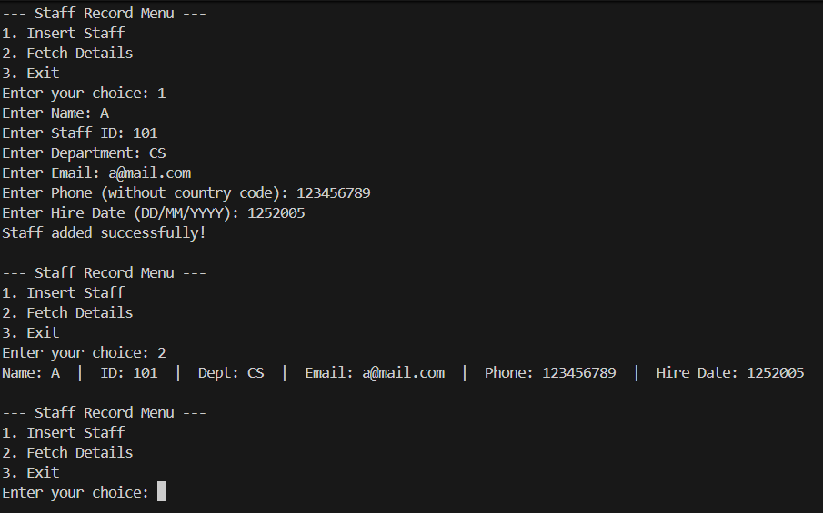

PQ3. Create a class Result that implement a switch-case statement to assign grades: A for marks >= 90,
B for 75–89, C for 60–74, and F for below 60.

SOLUTION:
import java.util.*;
public class Result {
public static void main(String[] args) {
Scanner sc = new Scanner(System.in);
System.out.print("Enter your marks: ");
int marks = sc.nextInt();
char grade = calculateGrade(marks);
System.out.println("Your grade is: " + grade);
sc.close();
}
public static char calculateGrade(int marks) {
int category;
if (marks >= 90 && marks <= 100) {
category = 1;
} else if (marks >= 75 && marks < 90) {
category = 2;
} else if (marks >= 60 && marks < 75) {
category = 3;
} else {
category = 4;
}

switch (category) {
case 1:
return 'A';
case 2:
return 'B';
case 3:
return 'C';
case 4:
return 'F';
default:
return 'F';
}
}
}
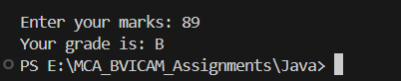

PQ4. Create a class Person (with subclasses Student and Staff). Include relevant fields and
methods.

SOLUTION:

import java.util.*;

public class Person {

public static void main(String[] args) {

Scanner sc = new Scanner(System.in);

int choice = 0;

while (choice != 3) {

System.out.println("\n===== PERSON MANAGEMENT SYSTEM =====");

System.out.println("1. Work with Student Details");

System.out.println("2. Work with Staff Details");

System.out.println("3. Exit");

System.out.print("Enter your choice: ");

if (sc.hasNextInt()) {

choice = sc.nextInt();

switch (choice) {
case 1:

StudentRecord.main(new String[]{});
break;

case 2:
StaffRecord.main(new String[]{});
break;

case 3:
System.out.println("Exiting the main application...");
break;

default:
System.out.println("Invalid choice. Please enter 1, 2, or 3.");
}

} else {

System.out.println("Invalid input. Please enter a number.");
sc.next();

}

}
sc.close();

}
}

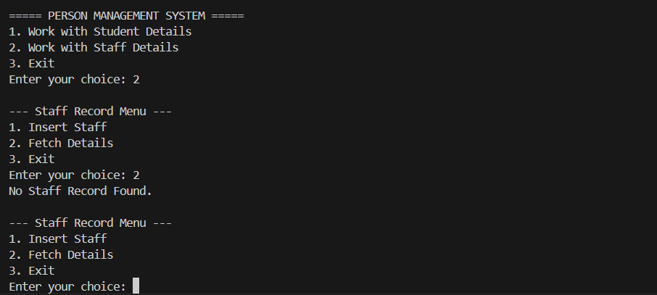

PQ5. Define an interface `Billable` with a method `calculateBill()`. Implement this interface in
the `Patient` class to calculate hospital bills.

SOLUTION:
interface Billable {
public float calculateBill();
}
public class Patient extends Person implements Billable {
double temp;
int bp;
int sugar;

static Patient p_arr[] = new Patient[10];
static int p_count = 0;

void InsertPatientDetails() {
if (i >= 20) {
System.out.println("Max Patient Cpacity reached");
return;
}
Patient p = new Patient();
System.out.print("Enter Patient Name: ");
p.pat_name = sc.next();

System.out.print("Enter Patient's Disease: ");
p.disease = sc.next();

System.out.print("Enter Doc assigned to patient: ");
p.doc_assigned = sc.next();

System.out.print("Enter Patient Age: ");
p.age = sc.nextInt();

det[i] = p;
i = i + 1;
}
public float calculateBill() {
float df, mdf, sf;
System.out.print("Enter Docter's Fee: ");
df = sc.nextFloat();
System.out.print("Enter Medicine cost: ");
mdf = sc.nextFloat();
System.out.print("Enter Medical Scan's/Test Fee: ");
sf = sc.nextFloat();
float bill = df + mdf + sf;
return bill;
}
}
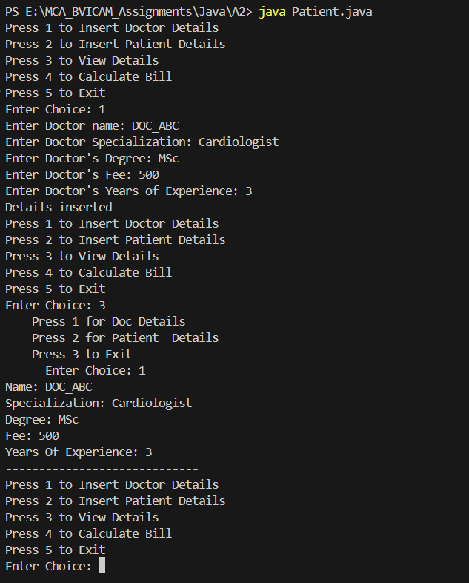

PQ6. Write a program that demonstrates dynamic binding by creating an array of `Person`
references, storing both `Patient` and `Doctor` objects, and calling `displayDetails()`..
SOLUTION:
import java.util.*;
public class Person {
static Scanner sc = new Scanner(System.in);
String doc_name, specialization, degree, pat_name, disease, doc_assigned;
int fee, years_of_exp, age;

static Person det[] = new Person[20];
static int i = 0;

static void DisplayDetails() {
System.out.println(" Press 1 for Doc Details");
System.out.println(" Press 2 for Patient Details");
System.out.println(" Press 3 to Exit");
System.out.print(" Enter Choice: ");
int ch = sc.nextInt();
if (ch == 1) {
for (Person p : det) {
if (p != null && p instanceof Doctor) {
System.out.println("Name: " + p.doc_name);
System.out.println("Specialization: " + p.specialization);
System.out.println("Degree: " + p.degree);
System.out.println("Fee: " + p.fee);
System.out.println("Years Of Experience: " + p.years_of_exp);
System.out.println("-----------------------------");
}
}
} else if (ch == 2) {
for (Person p : det) {
if (p != null && p instanceof Patient) {
System.out.println("Name: " + p.pat_name);
System.out.println("Disease: " + p.disease);
System.out.println("Doc_Assigned: " + p.doc_assigned);
System.out.println("Age: " + p.age);
System.out.println("-----------------------------");
}
}
} else if (ch == 3) {
return;
}
}
public static void main(String[] args) {
while(true){
System.out.println("Press 1 to Insert Doctor Details");
System.out.println("Press 2 to Insert Patient Details");
System.out.println("Press 3 to View Details");
System.out.println("Press 4 to Calculate Bill");
System.out.println("Press 5 to Exit");
System.out.print("Enter Choice: ");
int ch = sc.nextInt();
if (ch == 1) {
Doctor D = new Doctor();
D.InsertDocDetails();
} else if (ch == 2) {
Patient P = new Patient();
P.InsertPatientDetails();
} else if (ch == 3) {
DisplayDetails();
} else if (ch == 4) {
Patient P = new Patient();
P.calculateBill();
} else if (ch == 5) {
System.out.println("Exiting....");
return;
}
}
}
}

public class Doctor extends Person {
void InsertDocDetails() {
if (i >= 20) {
System.out.println("Max Capacity Reached");
return;
}
Doctor D = new Doctor();
System.out.print("Enter Doctor name: ");
D.doc_name = sc.next();

System.out.print("Enter Doctor Specialization: ");
D.specialization = sc.next();

System.out.print("Enter Doctor's Degree: ");
D.degree = sc.next();

System.out.print("Enter Doctor's Fee: ");
D.fee = sc.nextInt();

System.out.print("Enter Doctor's Years of Experience: ");
D.years_of_exp = sc.nextInt();
det[i] = D;
i = i + 1;
System.out.println("Details inserted");
}
}
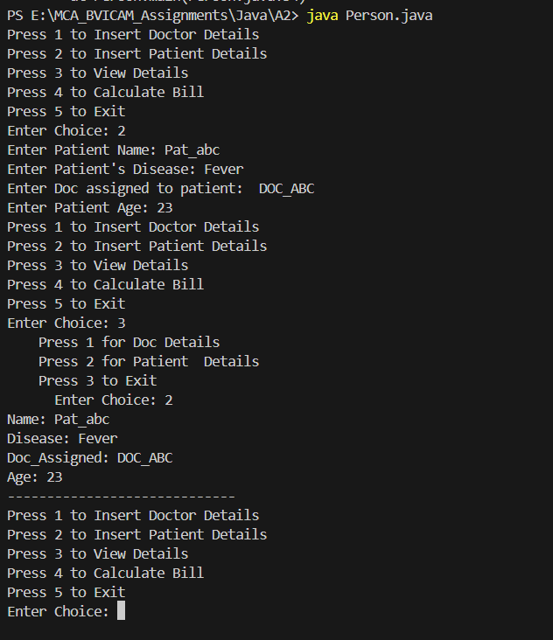

PQ7. Create a program that accepts a medical report (string) and counts the number of words,
sentences, and occurrences of the word 'disease'.
SOLUTION:
import java.util.*;
public class ReportAnalysis {
public static void main(String[] args) {
Scanner sc = new Scanner(System.in);

System.out.println("Enter Medical Report:");
String report = sc.nextLine();

// Count words
String words[] = report.split(" ");
int word_count = words.length;

// Count sentences by splitting on dot (.)
String sentences[] = report.split("\\.");
int sentence_count = sentences.length;

// Count occurrences of 'disease'
int disease_count = 0;
for (int i = 0; i < words.length; i++) {
String temp = words[i].toLowerCase();
if (temp.contains("disease")) {
disease_count++;
}
}

System.out.println("\n--- Report Analysis ---");
System.out.println("Total Words: " + word_count);
System.out.println("Total Sentences: " + sentence_count);
System.out.println("Occurrences of 'disease': " + disease_count);
}
}
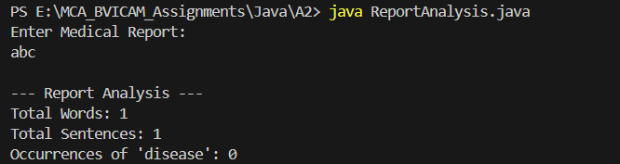

PQ8. Create a program to store vital signs (like temperature, BP, sugar level) of patients in a
two-dimensional array. Display them in tabular form.
SOLUTION:

import java.util.*;

public class Vitals {

// 2D array to store vital signs: [Row = Patient][Col 0: Name, Col 1: Temp, Col 2: BP, Col 3: Sugar]
static String vitals_table[][] = new String[10][4];

// Method to fetch patient objects and store details into 2D array
public static void StoreIn2DArray() {
for (int i = 0; i < Patient.p_count; i++) {
Patient p = Patient.p_arr[i];
if (p != null) {
vitals_table[i][0] = p.pat_name;
vitals_table[i][1] = String.valueOf(p.temp);
vitals_table[i][2] = String.valueOf(p.bp);
vitals_table[i][3] = String.valueOf(p.sugar);
}
}
}

// Method to display the 2D array in tabular form
public static void DisplayVitalsTable() {
StoreIn2DArray();

if (Patient.p_count == 0) {
System.out.println("No patient vitals recorded yet.");
return;
}

System.out.println("\n------------------------------------------------------------------");
System.out.println(" PATIENT VITAL SIGNS REPORT ");
System.out.println("------------------------------------------------------------------");
System.out.printf("%-15s | %-12s | %-10s | %-12s\n", "Patient Name", "Temp (°F)", "BP (mmHg)", "Sugar (mg/dL)");
System.out.println("------------------------------------------------------------------");

for (int i = 0; i < Patient.p_count; i++) {
System.out.printf("%-15s | %-12s | %-10s | %-12s\n",
vitals_table[i][0],
vitals_table[i][1],
vitals_table[i][2],
vitals_table[i][3]);
}
System.out.println("------------------------------------------------------------------");
}

public static void main(String[] args) {
Scanner sc = new Scanner(System.in);

while (true) {
System.out.println("\n--- VITALS MENU ---");
System.out.println("Press 1 to Insert Patient Vitals");
System.out.println("Press 2 to Display Vitals Table");
System.out.println("Press 3 to Exit");
System.out.print("Enter Choice: ");
int ch = sc.nextInt();

if (ch == 1) {
if (Patient.p_count >= 10) {
System.out.println("Patient capacity reached (Max 10).");
continue;
}
Patient p = new Patient();
System.out.print("Enter Patient Name: ");
p.pat_name = sc.next();
System.out.print("Enter Temperature (°F): ");
p.temp = sc.nextDouble();
System.out.print("Enter BP (mmHg): ");
p.bp = sc.nextInt();
System.out.print("Enter Sugar Level (mg/dL): ");
p.sugar = sc.nextInt();

Patient.p_arr[Patient.p_count] = p;
Patient.p_count++;
System.out.println("Vitals successfully inserted!");

} else if (ch == 2) {
DisplayVitalsTable();
} else if (ch == 3) {
System.out.println("Exiting...");
break;
}
}
}
}

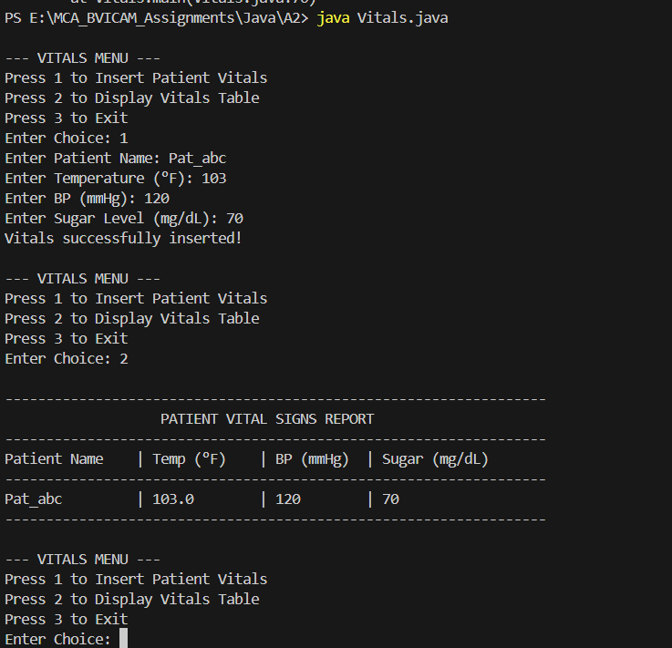

PQ9. Create a String array containing the following events: String events[] = { "Coding",
"Debate", "Quiz", "Dance", "Photography"};
Write a program to represent an event. Create appropriate methods to display all
participant details registered for the event, find the participant with the highest score, find
the participant with the lowest score, calculate the average score, display participants
whose score is greater than the average, search for a participant by name.

SOLUTION:

package A3;
import java.util.*;
public class Event extends SeatAllocate {
Scanner sc=new Scanner(System.in);
String events[] = { "Coding","Debate", "Quiz", "Dance", "Photography"};
String venues[] = {"Auditorium","Seminar Hall", "Room 101", "Room 102", "Room 103"};
String pt[][]=new String[30][4];
int index=0;
int sum=0;
int pt_c=0;
Random rd=new Random();

void Register()
{
if (index>9)
{
System.out.println("Max Participants reached");
return;
}
System.out.print("Enter Participant Name: ");
String n=sc.next();

System.out.print("Event name ('Coding','Debate', 'Quiz, 'Dance', 'Photography'): ");
String e=sc.next();

System.out.print("Score: ");
String s=sc.next();
sum=sum+Integer.parseInt(s);

System.out.println();
System.out.println(" SEATS ARRANGEMENT ");
System.out.println("1 2 3 4 5");
System.out.println("6 7 8 9 10");
System.out.println("11 12 13 14 15");
System.out.println("16 17 18 19 20");
System.out.println("21 22 23 24 25");

boolean chk=true;
String st_st=null;
while (chk)
{
System.out.print("Seelct seat (1-50): ");
String seat=sc.next();

int st_no=Integer.parseInt(seat);
int r=(st_no-1)/5;
int c=(st_no-1)%5;
String res=allocate(r,c);

// Fixed: Always use .equals() for Strings, NOT ==
// Fixed: The string from SeatAllocate was "Seat Taken :(", not "Already Taken :("
if (res.equals("No Seats Left :("))
{
st_st=null;
System.out.println(res);
break;
}
else if (res.equals("Seat Taken :("))
{
System.out.println(res);
}
else
{
st_st=seat;
chk=false;
System.out.println(res); // Print "Booked ! :)"
}
}

String arr[]={n,e,s,st_st};
pt[index]=arr;
index++;
pt_c++;
System.out.println("Registered !!!!");

}
void HighScore()
{
int mx=Integer.parseInt(pt[0][2]);
int i=0;
while (pt[i][2]!=null && i<10)
{
if (Integer.parseInt(pt[i][2])>mx)
{
mx=Integer.parseInt(pt[i][2]);
}
i++;
}
System.out.println("Highest Score: "+mx);
}
void LowScore()
{
int mn=Integer.parseInt(pt[0][2]);
int i=0;
while (pt[i][2]!=null && i<10)
{
if (Integer.parseInt(pt[i][2])<mn)
{
mn=Integer.parseInt(pt[i][2]);
}
i++;
}
System.out.println("Lowest Score: "+mn);
}

void ShowParticipants()
{
int x=0;
while (x<pt_c)
{
System.out.println(pt[x][0]+" "+pt[x][1]+" "+pt[x][2]+" "+pt[x][3]);
x++;
}
}
void Average()
{
int avg=sum/pt_c;
System.out.println("Average Score is: "+avg);
}

public static void main(String[] args) {
Event ev = new Event();
EventAnalyzer analyzer = new EventAnalyzer(); // Instantiate our new helper class!
boolean flag = true;

while (flag)
{
System.out.println();
System.out.println("1 --> Register a participant");
System.out.println("2 --> Show Participants ");
System.out.println("3 --> Highest Score ");
System.out.println("4 --> Lowest Score");
System.out.println("5 --> Average Score");
System.out.println("6 --> Venue Allocation ");
System.out.println("7 --> Check Occupied Seats ");
System.out.println("8 --> Check Available Seats ");
System.out.println("9 --> Check MAX Occupied Row/Column ");
System.out.println("10--> Show seat status ");
System.out.println("11 --> Triangular Seat Arrangement ");
System.out.println("12 --> Search Participants ");
System.out.println("13 --> Exit ");
System.out.print("Enter choice: ");
int ch=ev.sc.nextInt();
System.out.println();

switch (ch) {
case 1:
ev.Register();
break;
case 2:
ev.ShowParticipants();
break;
case 3:
ev.HighScore();
break;
case 4:
ev.LowScore();
break;
case 5:
ev.Average();
break;
case 6:
// Call the method from EventAnalyzer, passing our arrays and counts!
analyzer.VenueAllocate(ev.events, ev.venues, ev.pt, ev.pt_c);
break;
case 7:
ev.CountSeats(1);
break;
case 8:
ev.CountSeats(0);
break;
case 9:
ev.MaxOccupied(1);
ev.MaxOccupied(0);
break;
case 10:
ev.SeatStatus();
break;
case 11:
System.out.print("Enter rows: ");
int r=ev.sc.nextInt();
ev.TriSeat(r);
break;
case 12:
analyzer.SearchParticipants(ev.pt, ev.pt_c, ev.sc);
break;
case 13:
flag = false;
break;
default:
System.out.println("Invalid choice");
}
}
} }

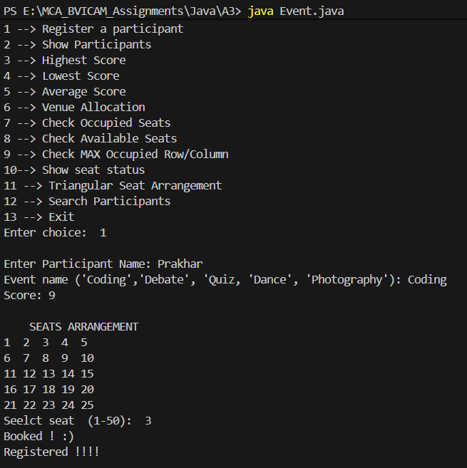

PQ-10 Simulate a method that can determine how many participants registered for each event
in a case-insensitive manner and allocate a time and venue for event conduction if the
event has atleast 3 participants registered.

SOLUTION:

String allocate(int r,int c)
{
if (avl_seat<=0)
return "No Seats Left :(";

if (seat[r][c]!=1)
{
seat[r][c]=1;
avl_seat--;
return "Booked ! :)";

}
else
{
return "Seat Taken :(";
}
}

PQ11 The organizing committee has arranged all participants in a 5 × 5 seating area. Represent
the seating arrangement using a two-dimensional integer array. Write a program to:
i. Display the seating arrangement.
ii. Count the total occupied seats.
iii. Count the total vacant seats.
iv. Find the row having the maximum number of participants.
v. Find the column having the maximum number of participants.

SOLUTION:

package A3;

public class SeatAllocate extends TriangularSeatArrangement {
int seat[][]=new int[5][5];
int avl_seat=25;

String allocate(int r,int c)
{
if (avl_seat<=0)
return "No Seats Left :(";

if (seat[r][c]!=1)
{
seat[r][c]=1;
avl_seat--;
return "Booked ! :)";

}
else
{
return "Seat Taken :(";
}
}
void SeatStatus()
{
System.out.println("1 = Booked");
System.out.println("0 = Available");
for (int i=0;i<5;i++)
{
for (int j=0;j<5;j++)
{
if (seat[i][j]==1){
System.out.print(1+" ");
}
else{
System.out.print(0+" ");
}
}
System.out.println();
}
}

void CountSeats(int x)
{
if (x==1)
{
System.out.println("Total Occupied seats: "+(25-avl_seat));
}
else{
System.out.println("Total Available seats: "+avl_seat);
}
}

void MaxOccupied(int x)
{
if (x==1)
{
int max_r=0;
int r_cnt=0;
for (int i=0;i<5;i++)
{
for (int j=0;j<4;j++)
{
if (seat[i][j]==1)
{
r_cnt++;
}
}
if (r_cnt>max_r)
{
max_r=r_cnt;
max_r=i;
}
}
System.out.println("Row with max Occupied seats: "+(max_r+1));

}
else
{
int max_c=0;
int c_cnt=0;
for (int i=0;i<5;i++)
{
for (int j=0;j<4;j++)
{
if (seat[j][i]==1)
{
c_cnt++;
}
}
if (c_cnt>max_c)
{
max_c=c_cnt;
max_c=i;
}
}
System.out.println("Column with max Occupied seats: "+(max_c+1));

}
}

}

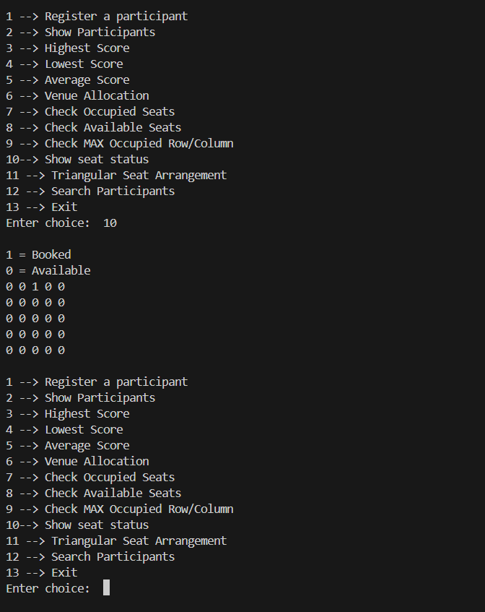

PQ12 The organizers want a visual representation of the seating arrangement which should
always be pyramid shaped. Write a program that asks the number of rows required from
the user and displays the visual representation of the seating arrangement

SOLUTION:

package A3;
public class TriangularSeatArrangement {
void TriSeat(int x)
{
for (int i=1;i<=x;i++)
{
for (int j=i;j<x;j++)
{
System.out.print(" ");
}
for (int j=1;j<=i;j++)
{
System.out.print("[ ]");
}
System.out.println();
}
}

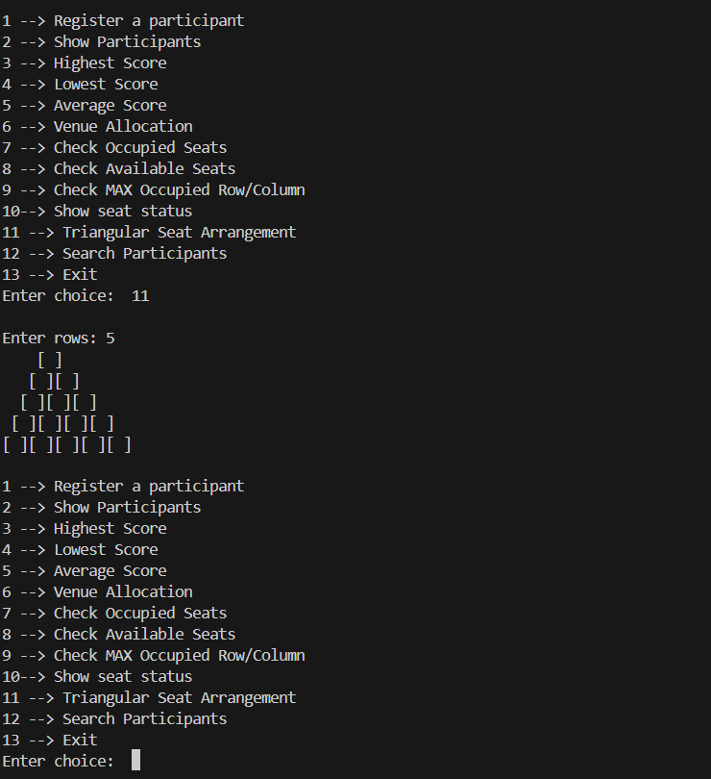

PQ13 Create a method to allow searching participant names:
i. Alphabetically
ii. Longest name
iii. Shortest name
iv. Count the names beginning with a particular search letter input by the user
v. For each participant, display the number of vowels in their name.

SOLUTION:

package A3;

import java.util.Arrays;
import java.util.Scanner;

public class EventAnalyzer {

void VenueAllocate(String[] events, String[] venues, String[][] pt, int pt_c) {
// PQ10: Loop through all events and check case-insensitively
for (int e = 0; e < events.length; e++) {
String event = events[e];
int prt = 0;

// Count participants registered for this event
for (int i = 0; i < pt_c; i++) {
if (pt[i][1].equalsIgnoreCase(event)) {
prt++;
}
}

if (prt >= 3) {
// Allocate corresponding venue and fixed time
System.out.println("Event: " + event + " | Participants: " + prt + " | Venue Allocated: " + venues[e] + " at 10:00 AM");
}
else {
System.out.println("Event: " + event + " | Participants: " + prt + " | Insufficient Participants :( ");
}
}
}

void SearchParticipants(String[][] pt, int pt_c, Scanner sc) {
if (pt_c == 0) {
System.out.println("No participants registered yet!");
return;
}
System.out.println();
System.out.println("1 --> Alphabetically");
System.out.println("2 --> Longest name");
System.out.println("3 --> Shortest name");
System.out.println("4 --> Count by starting letter");
System.out.println("5 --> Vowel count");
System.out.print("Enter choice: ");
int searchCh = sc.nextInt();

switch (searchCh) {
case 1:
String[] names = new String[pt_c];
for (int i = 0; i < pt_c; i++) {
names[i] = pt[i][0];
}
Arrays.sort(names, String.CASE_INSENSITIVE_ORDER);
System.out.println("Names alphabetically:");
for (String n : names) {
System.out.println(n);
}
break;
case 2:
String longest = pt[0][0];
for (int i = 1; i < pt_c; i++) {
if (pt[i][0].length() > longest.length()) {
longest = pt[i][0];
}
}
System.out.println("Longest name: " + longest);
break;
case 3:
String shortest = pt[0][0];
for (int i = 1; i < pt_c; i++) {
if (pt[i][0].length() < shortest.length()) {
shortest = pt[i][0];
}
}
System.out.println("Shortest name: " + shortest);
break;
case 4:
System.out.print("Enter search letter: ");
String letter = sc.next().toLowerCase();
int letterCount = 0;
for (int i = 0; i < pt_c; i++) {
if (pt[i][0].toLowerCase().startsWith(letter)) {
letterCount++;
}
}
System.out.println("Count: " + letterCount);
break;
case 5:
for (int i = 0; i < pt_c; i++) {
String name = pt[i][0];
int vowels = 0;
for (int j = 0; j < name.length(); j++) {
char ch = Character.toLowerCase(name.charAt(j));
if (ch == 'a' || ch == 'e' || ch == 'i' || ch == 'o' || ch == 'u') {
vowels++;
}
}
System.out.println(name + " has " + vowels + " vowels");
}
break;
default:
System.out.println("Invalid search choice");
}
}
}

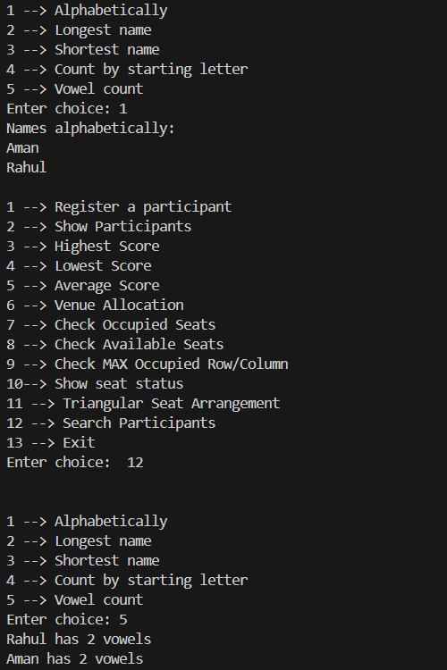

PQ14. A banking application stores customer IDs as strings. The user enters a customer ID that should contain only digits. Write a program that converts the entered ID into an integer.
For example:
Input: 10245 Output: Customer ID = 10245
If the user enters: 10A45
the application should display: Invalid Customer ID. Please enter digits only.
Note: Use Integer.parseInt(), Handle NumberFormatException, Use try-catch.

SOLUTION:

package A4;
import java.util.*;
public class Bank {
public static void main(String[] args) {
Scanner sc=new Scanner(System.in);
try{
System.out.print("Enter the User ID: ");
int id=Integer.parseInt(sc.next());
System.out.println(id);
}
catch(NumberFormatException n)
{
System.out.println("Enter a valid ID ");
main(args);
}
sc.close();
}

}

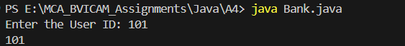

PQ15 Create a class: class Account { int balance; void withdraw(int amount) { //
implementation } }
The application should:
1. Store an initial balance.
2. Accept the withdrawal amount.
3. Check whether the amount is valid.
4. Deduct the amount if possible.
5. Display the remaining balance.

SOLUTION:

package A4;

import java.util.Scanner;

class Account {
int bal=1000;

void withdraw(int amt)
{
if (amt<=bal)
{
bal=bal-amt;
System.out.println("Current balance: "+bal);
}
else{
System.out.println("Insufficient balance !");
}
}

public static void main(String[] args) {
Scanner sc=new Scanner(System.in);
Account acc=new Account();
System.out.print("Enter amount to withdraw: ");
int a=sc.nextInt();
acc.withdraw(a);
sc.close();

}
}

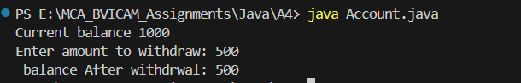

PQ16 Modify the Account class so that if the customer attempts to withdraw more money than
the available balance, the application generates:
InsufficientBalanceException

package A4;
import java.util.*;

class InsufficientBalanceException extends Exception
{
@Override
public String toString() {
return "Insufficient Balance !";
}
}
public class Account
{
int bal=1000;

void withdraw(int amt) throws InsufficientBalanceException
{
if (amt<=bal)
{
bal=bal-amt;
System.out.println("Current balance: "+bal);
}
else{
throw new InsufficientBalanceException();
//
}
}
public static void main(String[] args) {

Scanner sc=new Scanner(System.in);
Account acc=new Account();
try{

System.out.print("Enter amount to withdraw: ");
int a=sc.nextInt();
acc.withdraw(a);
}
catch(InsufficientBalanceException io)
{
System.out.println(io.getMessage());
}

sc.close();
}
}

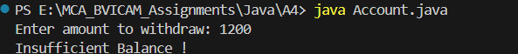

PQ17. CampusConnect receives assignments from students. Create two threads:
AssignmentSubmissionThread
AssignmentEvaluationThread
The submission thread adds student submissions while the evaluation thread processes
them.
Both threads should display:
Student 1 submitted assignment
Student 1 assignment evaluated

SOLUTION:

class AssignmentSubmissionThread extends Thread {
@Override
public void run() {
for (int i = 1; i <= 5; i++) {
System.out.println("Student " + i + " submitted assignment");
// Sleep for half a second to simulate time taken
try { Thread.sleep(500); } catch (Exception e) {}
}
}
}

class AssignmentEvaluationThread extends Thread {
@Override
public void run() {
// Sleep for just a tiny bit at the start so Submitter prints first!
try { Thread.sleep(100); } catch (Exception e) {}

for (int i = 1; i <= 5; i++) {
System.out.println("Student " + i + " assignment evaluated");
// Sleep for half a second to simulate time taken
try { Thread.sleep(500); } catch (Exception e) {}
}
}
}

public class Submit {
public static void main(String[] args) {
AssignmentSubmissionThread submitter = new AssignmentSubmissionThread();
AssignmentEvaluationThread evaluator = new AssignmentEvaluationThread();

submitter.start();
evaluator.start();
}
}

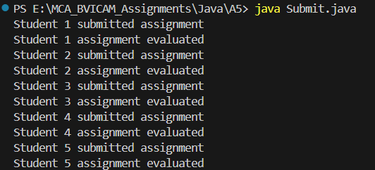

PQ18 A university has only 5 seats available for a workshop.Ten student threads
simultaneously attempt to register. Create: Workshop and StudentRegistration
Each student thread attempts to reserve one seat.
Challenge: First implement it without synchronization, then add synchronization and compare the behavior.

SOLUTION:

class StudentRegistration extends Thread {
int studentId;

StudentRegistration(int id) {
studentId = id;
}

@Override
public void run() {
if (WorkShop.availableSeats > 0) {
WorkShop.availableSeats--;
System.out.println("Student " + studentId + " reserved a seat.");
} else {
System.out.println("Student " + studentId + " failed. No seats.");
}
}
}

// --- SYNCHRONIZED VERSION ---
class StudentRegistration extends Thread {
int studentId;

StudentRegistration(int id) {
studentId = id;
}

@Override
public void run() {
WorkShop.reserveSeat(studentId);
}
}

public class WorkShop {
static int availableSeats = 5;

// By adding "synchronized", Java puts a lock on this method.
// Only ONE thread is allowed to be inside this method at a time!
public static synchronized void reserveSeat(int studentId) {
if (availableSeats > 0) {
availableSeats--;
System.out.println("Student " + studentId + " reserved a seat.");
} else {
System.out.println("Student " + studentId + " failed. No seats.");
}
}

public static void main(String[] args) {
for (int i = 1; i <= 10; i++) {
StudentRegistration student = new StudentRegistration(i);
student.start();
}
}
}

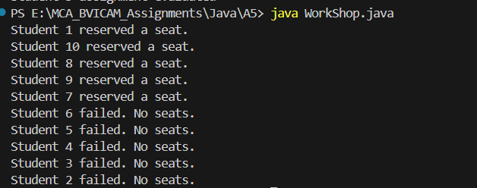

PQ19 Implement: cancelAdmission(int studentId) and displayWaitingList(String course) Functional Requirements
The method should:
- Search for the student using studentId.
2. If the student does not exist, display an appropriate message.
3. If the student exists:
o Remove the student from the admitted-student collection.
o Identify the course from which the student cancelled admission.
o Display a cancellation confirmation.
4. Check whether a waiting list exists for that course.
5. If the waiting list is not empty:
o Select the first student from the waiting list.
o Remove that student from the waiting list.
o Admit the student automatically.
o Display the new admission details.

Important Rule
If a seat becomes available because of cancellation:
The first student who entered the waiting list must be admitted first.
Therefore, the waiting list must follow FIFO (First-In-First-Out) behaviour.

SOLUTION:

import java.util.*;

class Student {
int studentId;
String name;
String course;

Student(int studentId, String name, String course) {
this.studentId = studentId;
this.name = name;
this.course = course;
}

@Override
public String toString() {
return "ID: " + studentId + " | Name: " + name + " | Course: " + course;
}
}

public class AdmissionSystem {

// Collection of currently admitted students
static List<Student> admittedStudents = new ArrayList<>();

// Waiting list for each course following FIFO order (Queue)
static Map<String, Queue<Student>> waitingLists = new HashMap<>();

// Method to display all admitted students
public static void displayAdmittedStudents() {
System.out.println("========== CURRENTLY ADMITTED STUDENTS ==========");
if (admittedStudents.isEmpty()) {
System.out.println("No admitted students.");
} else {
for (Student s : admittedStudents) {
System.out.println(s);
}
}
System.out.println("=================================================\n");
}

// Method to display waiting list for a course
public static void displayWaitingList(String course) {
Queue<Student> waitQueue = waitingLists.get(course);

System.out.println("----- Waiting List for " + course + " -----");
if (waitQueue == null || waitQueue.isEmpty()) {
System.out.println("Waiting list is empty.");
} else {
int position = 1;
for (Student s : waitQueue) {
System.out.println(position + ". ID: " + s.studentId + ", Name: " + s.name);
position++;
}
}
System.out.println();
}

// Method to cancel admission
public static void cancelAdmission(int studentId) {
Student studentToCancel = null;

// 1. Search for student using studentId
for (Student s : admittedStudents) {
if (s.studentId == studentId) {
studentToCancel = s;
break;
}
}

// 2. If the student does not exist, display an appropriate message
if (studentToCancel == null) {
System.out.println("Cancellation Failed: Student with ID " + studentId + " is not found in the admitted list.\n");
return;
}

// 3. If student exists:
// Remove from admitted-student collection
admittedStudents.remove(studentToCancel);
String course = studentToCancel.course;

// Display cancellation confirmation
System.out.println("\n--- Admission Cancelled Successfully ---");
System.out.println("Cancelled Student: " + studentToCancel.name + " (ID: " + studentToCancel.studentId + ") from Course: " + course);

// 4. Check whether a waiting list exists for that course
Queue<Student> waitQueue = waitingLists.get(course);

// 5. If waiting list is not empty, admit first student (FIFO)
if (waitQueue != null && !waitQueue.isEmpty()) {
Student nextStudent = waitQueue.poll(); // Selects and removes first student in FIFO order
admittedStudents.add(nextStudent); // Admit automatically

System.out.println("Seat allocated to next candidate from waiting list:");
System.out.println("Newly Admitted -> ID: " + nextStudent.studentId + ", Name: " + nextStudent.name + ", Course: " + nextStudent.course);
} else {
System.out.println("No students in the waiting list for " + course + ". Seat remains vacant.");
}
System.out.println("----------------------------------------\n");
}

public static void main(String[] args) {
// Pre-stored 5 admitted student records
admittedStudents.add(new Student(101, "Rahul Sharma", "MCA"));
admittedStudents.add(new Student(102, "Priya Verma", "MCA"));
admittedStudents.add(new Student(103, "Amit Singh", "B.Tech"));
admittedStudents.add(new Student(104, "Neha Gupta", "MBA"));
admittedStudents.add(new Student(105, "Vikas Kumar", "MCA"));

// Pre-stored waiting list for MCA (FIFO order using LinkedList Queue)
Queue<Student> mcaWaiting = new LinkedList<>();
mcaWaiting.add(new Student(201, "Aman Gupta", "MCA"));
mcaWaiting.add(new Student(202, "Sneha Patel", "MCA"));
waitingLists.put("MCA", mcaWaiting);

// Pre-stored waiting list for B.Tech
Queue<Student> btechWaiting = new LinkedList<>();
btechWaiting.add(new Student(203, "Rohan Das", "B.Tech"));
waitingLists.put("B.Tech", btechWaiting);

// Empty waiting list for MBA
Queue<Student> mbaWaiting = new LinkedList<>();
waitingLists.put("MBA", mbaWaiting);

// Display initial admitted records and waiting lists
displayAdmittedStudents();
displayWaitingList("MCA");
displayWaitingList("B.Tech");
displayWaitingList("MBA");

// User input to cancel admission
Scanner sc = new Scanner(System.in);
System.out.print("Enter Student ID to cancel admission: ");
int idToCancel = sc.nextInt();

// Perform cancellation
cancelAdmission(idToCancel);

// Display updated lists after cancellation
System.out.println("Updated status after operation:");
displayAdmittedStudents();
displayWaitingList("MCA");
displayWaitingList("B.Tech");
displayWaitingList("MBA");

sc.close();
}
}

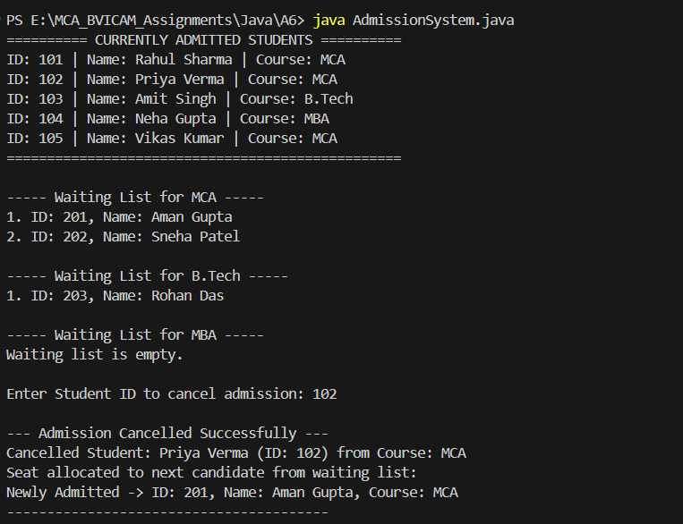

PQ20 Implement a method: displayStudentsAlphabetically() The method should display the names of all currently admitted students in alphabetical order. Use an appropriate collection that automatically maintains unique student names in sorted order. The method should reflect the current admitted students. Students who have cancelled their admission should not appear in
the output.

SOLUTION:

import java.util.*;

class Student {
int studentId;
String name;
String course;

Student(int studentId, String name, String course) {
this.studentId = studentId;
this.name = name;
this.course = course;
}

@Override
public String toString() {
return "ID: " + studentId + " | Name: " + name + " | Course: " + course;
}
}

public class AlphabeticalStudents {

// Collection to store currently admitted students
static List<Student> admittedStudents = new ArrayList<>();

// Method to display names of admitted students in alphabetical order
// Uses TreeSet which automatically maintains unique elements in sorted order
public static void displayStudentsAlphabetically() {
TreeSet<String> sortedNames = new TreeSet<>();

for (Student s : admittedStudents) {
sortedNames.add(s.name);
}

System.out.println("========== ADMITTED STUDENTS (ALPHABETICAL ORDER) ==========");
if (sortedNames.isEmpty()) {
System.out.println("No admitted students found.");
} else {
int rank = 1;
for (String name : sortedNames) {
System.out.println(rank + ". " + name);
rank++;
}
}
System.out.println("============================================================\n");
}

// Method to cancel admission of a student
public static void cancelAdmission(int studentId) {
Student studentToRemove = null;
for (Student s : admittedStudents) {
if (s.studentId == studentId) {
studentToRemove = s;
break;
}
}

if (studentToRemove != null) {
admittedStudents.remove(studentToRemove);
System.out.println("Admission cancelled for: " + studentToRemove.name + " (ID: " + studentId + ")\n");
} else {
System.out.println("Student with ID " + studentId + " not found.\n");
}
}

public static void main(String[] args) {
// Pre-stored 5 admitted student records
admittedStudents.add(new Student(101, "Vikas Kumar", "MCA"));
admittedStudents.add(new Student(102, "Amit Singh", "B.Tech"));
admittedStudents.add(new Student(103, "Rahul Sharma", "MCA"));
admittedStudents.add(new Student(104, "Priya Verma", "MCA"));
admittedStudents.add(new Student(105, "Anjali Mehra", "MBA"));

// Display current admitted list
System.out.println("All Admitted Students:");
for (Student s : admittedStudents) {
System.out.println(s);
}
System.out.println();

// Display students in alphabetical order using TreeSet
displayStudentsAlphabetically();

// User input to cancel admission and verify updated alphabetical list
Scanner sc = new Scanner(System.in);
System.out.print("Enter Student ID to cancel admission: ");
int idToCancel = sc.nextInt();

cancelAdmission(idToCancel);

// Display updated alphabetical order (cancelled student will not appear)
System.out.println("After cancellation:");
displayStudentsAlphabetically();

sc.close();
}
}

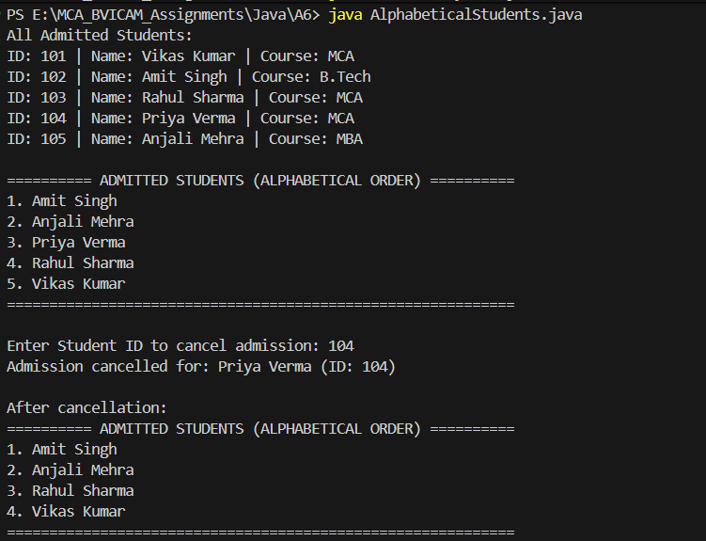

PQ21 Implement: searchStudent(int studentId) The method should search for a student using their unique StudentID.

SOLUTION:

import java.util.*;

class Student {
int studentId;
String name;
String course;

Student(int studentId, String name, String course) {
this.studentId = studentId;
this.name = name;
this.course = course;
}

@Override
public String toString() {
return "Student ID: " + studentId + " | Name: " + name + " | Course: " + course;
}
}

public class SearchStudent {

// Using HashMap for fast, key-based lookup using unique studentId
static Map<Integer, Student> studentRecords = new HashMap<>();

// Method to search student using unique studentId
public static void searchStudent(int studentId) {
if (studentRecords.containsKey(studentId)) {
Student student = studentRecords.get(studentId);
System.out.println("\n--- Student Found ---");
System.out.println("ID : " + student.studentId);
System.out.println("Name : " + student.name);
System.out.println("Course : " + student.course);
System.out.println("---------------------\n");
} else {
System.out.println("\nSearch Failed: Student with ID " + studentId + " not found.\n");
}
}

// Helper method to add a student
public static void addStudent(int id, String name, String course) {
studentRecords.put(id, new Student(id, name, course));
}

public static void main(String[] args) {
// Pre-stored 5 student records
addStudent(101, "Rahul Sharma", "MCA");
addStudent(102, "Priya Verma", "MCA");
addStudent(103, "Amit Singh", "B.Tech");
addStudent(104, "Neha Gupta", "MBA");
addStudent(105, "Vikas Kumar", "MCA");

// Display all available records
System.out.println("========== AVAILABLE STUDENT RECORDS ==========");
for (Student s : studentRecords.values()) {
System.out.println(s);
}
System.out.println("===============================================\n");

// Take studentId from user
Scanner sc = new Scanner(System.in);
System.out.print("Enter Student ID to search: ");
int idToSearch = sc.nextInt();

// Perform search
searchStudent(idToSearch);

sc.close();
}
}

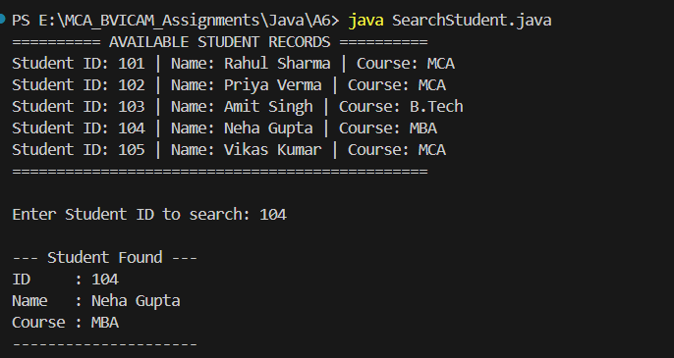

PQ22. Modify the TCP program to allow multiple students (clients) to connect to the
CampusConnect server. Each client should send its name → Server should acknowledge
with “Hello [Name], you are connected.” Use multithreaded server with Thread for each
client.

SOLUTION:

package A7;

import java.io.*;
import java.net.*;

class StudentHandler extends Thread {
private Socket socket;

public StudentHandler(Socket socket) {
this.socket = socket;
}

@Override
public void run() {
try {
BufferedReader reader = new BufferedReader(
new InputStreamReader(socket.getInputStream())
);
PrintWriter writer = new PrintWriter(socket.getOutputStream(), true);

String studentName = reader.readLine();
System.out.println("Student connected: " + studentName);

String response = "Hello " + studentName + ", you are connected.";
writer.println(response);

socket.close();
} catch (IOException e) {
e.printStackTrace();
}
}
}

public class CampusConnectServer {
public static void main(String[] args) {
int port = 5000;

try (ServerSocket serverSocket = new ServerSocket(port)) {
System.out.println("CampusConnect Server started on port " + port);

while (true) {
Socket socket = serverSocket.accept();
StudentHandler handler = new StudentHandler(socket);
handler.start();
}
} catch (IOException e) {
e.printStackTrace();
}
}
}

package A7;

import java.io.*;
import java.net.*;
import java.util.Scanner;

public class CampusConnectClient {
public static void main(String[] args) {
String serverAddress = "127.0.0.1";
int port = 5000;

try (Socket socket = new Socket(serverAddress, port);
Scanner sc = new Scanner(System.in)) {

BufferedReader reader = new BufferedReader(
new InputStreamReader(socket.getInputStream())
);
PrintWriter writer = new PrintWriter(socket.getOutputStream(), true);

String studentName;
if (args.length > 0) {
studentName = args[0];
} else {
System.out.print("Enter student name: ");
studentName = sc.nextLine();
}

writer.println(studentName);

String response = reader.readLine();
System.out.println("Server Response: " + response);

} catch (IOException e) {
e.printStackTrace();
}
}
}

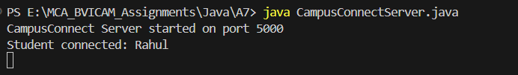

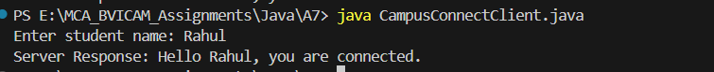

PQ23. Modify the TCP program to allow multiple students (clients) to connect to the
CampusConnect server. Each client should send its name → Server should acknowledge
with “Hello [Name], you are connected.” Use multithreaded server with Thread for each
client.

SOLUTION:

package A7;

import java.io.IOException;
import java.net.DatagramPacket;
import java.net.DatagramSocket;
import java.net.SocketAddress;
import java.util.Collections;
import java.util.HashSet;
import java.util.Set;

/**
* UDP-based Group Chat Server.
* Listens for incoming datagram packets, tracks active clients by SocketAddress,
* and broadcasts messages to all connected clients.
*/
public class GroupChatServer {
private static final int PORT = 9876;
private static final int BUFFER_SIZE = 1024;

// Thread-safe set of connected client addresses (IP + Port)
private static final Set<SocketAddress> clientAddresses = Collections.synchronizedSet(new HashSet<>());

public static void main(String[] args) {
System.out.println("==========================================");
System.out.println(" UDP Group Chat Server Started on Port " + PORT);
System.out.println("==========================================");

try (DatagramSocket serverSocket = new DatagramSocket(PORT)) {
byte[] buffer = new byte[BUFFER_SIZE];

while (true) {
DatagramPacket packet = new DatagramPacket(buffer, buffer.length);
serverSocket.receive(packet); // Wait for incoming datagram

SocketAddress senderAddress = packet.getSocketAddress();
String receivedMessage = new String(packet.getData(), 0, packet.getLength()).trim();

// Process each packet on a separate worker thread for concurrent handling
new Thread(() -> processAndBroadcast(serverSocket, senderAddress, receivedMessage)).start();
}
} catch (IOException e) {
System.err.println("Server exception: " + e.getMessage());
e.printStackTrace();
}
}

private static void processAndBroadcast(DatagramSocket socket, SocketAddress sender, String message) {
// Handle client disconnection
if (message.endsWith(": /leave") || message.endsWith(": exit")) {
clientAddresses.remove(sender);
System.out.println("Client disconnected: " + sender + " (Active clients: " + clientAddresses.size() + ")");
broadcast(socket, "[Server]: A user left the chat.", null);
return;
}

// Register new client address if not already present
boolean isNew = clientAddresses.add(sender);
if (isNew) {
System.out.println("New client joined from " + sender + " (Total active: " + clientAddresses.size() + ")");
}

System.out.println(sender + " -> " + message);

// Broadcast to all clients (exclude sender so they don't see duplicate echoes)
broadcast(socket, message, sender);
}

private static void broadcast(DatagramSocket socket, String message, SocketAddress sender) {
byte[] data = message.getBytes();

synchronized (clientAddresses) {
for (SocketAddress client : clientAddresses) {
// Skip sending message back to the sender
if (sender != null && client.equals(sender)) {
continue;
}
try {
DatagramPacket sendPacket = new DatagramPacket(data, data.length, client);
socket.send(sendPacket);
} catch (IOException e) {
System.err.println("Error sending to " + client + ": " + e.getMessage());
}
}
}
}
}
package A7;

import java.io.IOException;
import java.net.DatagramPacket;
import java.net.DatagramSocket;
import java.net.InetAddress;
import java.util.Scanner;

/**
* UDP-based Group Chat Client.
* Runs two concurrent threads:
* 1. MessageReceiverThread: Continuously listens for broadcast messages from the server.
* 2. MessageSenderThread: Continuously reads console input and sends datagram packets to the server.
*/
public class GroupChatClient {
private static final String SERVER_HOST = "127.0.0.1";
private static final int SERVER_PORT = 9876;
private static final int BUFFER_SIZE = 1024;

public static void main(String[] args) {
Scanner scanner = new Scanner(System.in);
String inputUsername = "";
if (args.length > 0) {
inputUsername = args[0].trim();
} else {
System.out.print("Enter your username for the group chat: ");
inputUsername = scanner.nextLine().trim();
}

final String username = inputUsername.isEmpty()
? "User_" + (System.currentTimeMillis() % 1000)
: inputUsername;

try {
DatagramSocket clientSocket = new DatagramSocket();
InetAddress serverAddress = InetAddress.getByName(SERVER_HOST);

System.out.println("==========================================");
System.out.println(" Connected to UDP Group Chat as [" + username + "]");
System.out.println(" Type your messages and press Enter.");
System.out.println(" Type 'exit' or '/leave' to disconnect.");
System.out.println("==========================================");

// Send initial join packet so the server registers this client
String joinMessage = "[" + username + " joined the chat]";
byte[] joinData = joinMessage.getBytes();
DatagramPacket joinPacket = new DatagramPacket(joinData, joinData.length, serverAddress, SERVER_PORT);
clientSocket.send(joinPacket);

// Thread 1: Listening for incoming messages from the server
Thread receiverThread = new Thread(() -> {
byte[] buffer = new byte[BUFFER_SIZE];
try {
while (!clientSocket.isClosed()) {
DatagramPacket incomingPacket = new DatagramPacket(buffer, buffer.length);
clientSocket.receive(incomingPacket);
String incomingMsg = new String(incomingPacket.getData(), 0, incomingPacket.getLength());
System.out.println(incomingMsg);
}
} catch (IOException e) {
if (!clientSocket.isClosed()) {
System.err.println("Receive error: " + e.getMessage());
}
}
}, "ReceiverThread-" + username);

// Thread 2: Reading user input and sending to the server
Thread senderThread = new Thread(() -> {
try {
while (!clientSocket.isClosed()) {
if (!scanner.hasNextLine()) {
break;
}
String text = scanner.nextLine().trim();
if (text.isEmpty()) {
continue;
}

if (text.equalsIgnoreCase("exit") || text.equalsIgnoreCase("/leave")) {
String leaveMsg = "[" + username + "]: /leave";
byte[] leaveBytes = leaveMsg.getBytes();
DatagramPacket leavePacket = new DatagramPacket(
leaveBytes, leaveBytes.length, serverAddress, SERVER_PORT
);
clientSocket.send(leavePacket);
System.out.println("You have left the chat.");
clientSocket.close();
break;
}

String formattedMsg = "[" + username + "]: " + text;
byte[] sendData = formattedMsg.getBytes();
DatagramPacket packet = new DatagramPacket(
sendData, sendData.length, serverAddress, SERVER_PORT
);
clientSocket.send(packet);
}
} catch (IOException e) {
if (!clientSocket.isClosed()) {
System.err.println("Send error: " + e.getMessage());
}
}
}, "SenderThread-" + username);

// Start both threads for simultaneous messaging
receiverThread.start();
senderThread.start();

// Wait for sender thread to finish (when user exits)
senderThread.join();
clientSocket.close();
receiverThread.interrupt();

} catch (Exception e) {
System.err.println("Client error: " + e.getMessage());
e.printStackTrace();
}
}
}

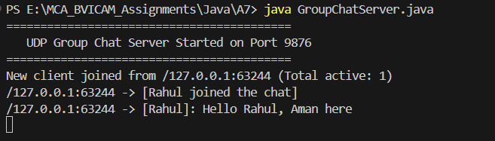

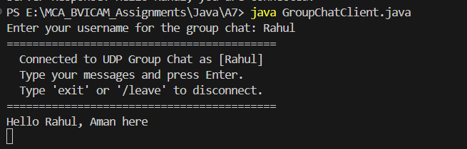

PQ24
Scenaio 1: A small educational startup, “EduForm”, wants to design a desktop-based student feedback
collection system using Java AWT. The software should allow students to enter their details, rate their
course experience, and submit the feedback. The development team must ensure that all user
interactions (button clicks, text field actions, checkbox selections, etc.) respond as expected.
Ensure that:
• Name and Email fields are not empty when Submit is clicked.
• If any field is empty, show a message dialog or Label with the text:
“Please fill all required fields.”
Hint: Use a simple conditional inside actionPerformed().

SOLUTION:

import java.awt.*;
import java.awt.event.*;

public class EduForm extends Frame implements ActionListener, ItemListener {

// Input fields and UI components
private TextField nameField;
private TextField emailField;
private Choice courseChoice;
private CheckboxGroup ratingGroup;
private Checkbox rbExcellent, rbGood, rbAverage;
private Button submitButton;
private Button clearButton;
private Label messageLabel;

public EduForm() {
// Frame properties
setTitle("EduForm - Student Feedback System");
setSize(480, 420);
setLayout(new BorderLayout(10, 10));
setLocationRelativeTo(null);

// Header Title
Label headerLabel = new Label("EduForm - Student Feedback Collection", Label.CENTER);
headerLabel.setFont(new Font("Arial", Font.BOLD, 16));
add(headerLabel, BorderLayout.NORTH);

// Center Panel for Form Controls
Panel formPanel = new Panel();
formPanel.setLayout(new GridLayout(5, 2, 10, 15));

// Name
formPanel.add(new Label("Student Name:"));
nameField = new TextField(20);
formPanel.add(nameField);

// Email
formPanel.add(new Label("Email Address:"));
emailField = new TextField(20);
formPanel.add(emailField);

// Course Choice
formPanel.add(new Label("Select Course:"));
courseChoice = new Choice();
courseChoice.add("MCA");
courseChoice.add("B.Tech");
courseChoice.add("BCA");
courseChoice.add("MBA");
formPanel.add(courseChoice);

// Rating Radio Buttons (CheckboxGroup)
formPanel.add(new Label("Rate Experience:"));
Panel ratingPanel = new Panel(new FlowLayout(FlowLayout.LEFT, 5, 0));
ratingGroup = new CheckboxGroup();
rbExcellent = new Checkbox("Excellent", ratingGroup, true);
rbGood = new Checkbox("Good", ratingGroup, false);
rbAverage = new Checkbox("Average", ratingGroup, false);

rbExcellent.addItemListener(this);
rbGood.addItemListener(this);
rbAverage.addItemListener(this);

ratingPanel.add(rbExcellent);
ratingPanel.add(rbGood);
ratingPanel.add(rbAverage);
formPanel.add(ratingPanel);

// Buttons
submitButton = new Button("Submit");
clearButton = new Button("Clear");
submitButton.addActionListener(this);
clearButton.addActionListener(this);

Panel buttonPanel = new Panel(new FlowLayout(FlowLayout.CENTER, 15, 0));
buttonPanel.add(submitButton);
buttonPanel.add(clearButton);

formPanel.add(new Label("")); // Spacer
formPanel.add(buttonPanel);

add(formPanel, BorderLayout.CENTER);

// Message Label at the bottom
messageLabel = new Label("", Label.CENTER);
messageLabel.setFont(new Font("Arial", Font.BOLD, 13));
add(messageLabel, BorderLayout.SOUTH);

// Window closing handling
addWindowListener(new WindowAdapter() {
@Override
public void windowClosing(WindowEvent e) {
dispose();
System.exit(0);
}
});

setVisible(true);
}

// Displays a modal AWT Dialog message
private void showMessageDialog(String message, String title) {
Dialog dialog = new Dialog(this, title, true);
dialog.setLayout(new FlowLayout(FlowLayout.CENTER, 15, 15));
dialog.setSize(320, 130);
dialog.setLocationRelativeTo(this);

Label dialogLabel = new Label(message, Label.CENTER);
Button okButton = new Button("OK");

okButton.addActionListener(e -> dialog.dispose());

dialog.add(dialogLabel);
dialog.add(okButton);

dialog.addWindowListener(new WindowAdapter() {
@Override
public void windowClosing(WindowEvent we) {
dialog.dispose();
}
});

dialog.setVisible(true);
}

@Override
public void actionPerformed(ActionEvent e) {
if (e.getSource() == submitButton) {
String name = nameField.getText().trim();
String email = emailField.getText().trim();

// Simple conditional to check if any field is empty
if (name.isEmpty() || email.isEmpty()) {
messageLabel.setForeground(Color.RED);
messageLabel.setText("Please fill all required fields.");
showMessageDialog("Please fill all required fields.", "Validation Error");
} else {
Checkbox selectedRating = ratingGroup.getSelectedCheckbox();
String ratingText = (selectedRating != null) ? selectedRating.getLabel() : "None";
String courseText = courseChoice.getSelectedItem();

messageLabel.setForeground(new Color(0, 128, 0));
messageLabel.setText("Feedback submitted successfully!");
showMessageDialog("Feedback submitted successfully for " + name + " (" + courseText + " - " + ratingText + ")", "Success");
}
} else if (e.getSource() == clearButton) {
nameField.setText("");
emailField.setText("");
courseChoice.select(0);
ratingGroup.setSelectedCheckbox(rbExcellent);
messageLabel.setText("");
}
}

@Override
public void itemStateChanged(ItemEvent e) {
// Handle checkbox selection response
Checkbox selected = ratingGroup.getSelectedCheckbox();
if (selected != null) {
messageLabel.setForeground(Color.BLUE);
messageLabel.setText("Selected Rating: " + selected.getLabel());
}
}

public static void main(String[] args) {
new EduForm();
}
}

PQ25 (Scenario is same as PQ24)
Add event handling to the Submit and Clear buttons:

• When Submit is clicked → Display entered details in the console.
• When Clear is clicked → Reset all TextFields and selections.
Hint: Implement ActionListener using either an inner class or anonymous class.

SOLUTION:

import java.awt.*;
import java.awt.event.*;

public class EduForm extends Frame implements ItemListener {

// Input fields and UI components
private TextField nameField;
private TextField emailField;
private Choice courseChoice;
private CheckboxGroup ratingGroup;
private Checkbox rbExcellent, rbGood, rbAverage;
private Button submitButton;
private Button clearButton;
private Label messageLabel;

public EduForm() {
// Frame properties
setTitle("EduForm - Student Feedback System");
setSize(480, 420);
setLayout(new BorderLayout(10, 10));
setLocationRelativeTo(null);

// Header Title
Label headerLabel = new Label("EduForm - Student Feedback Collection", Label.CENTER);
headerLabel.setFont(new Font("Arial", Font.BOLD, 16));
add(headerLabel, BorderLayout.NORTH);

// Center Panel for Form Controls
Panel formPanel = new Panel();
formPanel.setLayout(new GridLayout(5, 2, 10, 15));

// Name
formPanel.add(new Label("Student Name:"));
nameField = new TextField(20);
formPanel.add(nameField);

// Email
formPanel.add(new Label("Email Address:"));
emailField = new TextField(20);
formPanel.add(emailField);

// Course Choice
formPanel.add(new Label("Select Course:"));
courseChoice = new Choice();
courseChoice.add("MCA");
courseChoice.add("B.Tech");
courseChoice.add("BCA");
courseChoice.add("MBA");
formPanel.add(courseChoice);

// Rating Radio Buttons (CheckboxGroup)
formPanel.add(new Label("Rate Experience:"));
Panel ratingPanel = new Panel(new FlowLayout(FlowLayout.LEFT, 5, 0));
ratingGroup = new CheckboxGroup();
rbExcellent = new Checkbox("Excellent", ratingGroup, true);
rbGood = new Checkbox("Good", ratingGroup, false);
rbAverage = new Checkbox("Average", ratingGroup, false);

rbExcellent.addItemListener(this);
rbGood.addItemListener(this);
rbAverage.addItemListener(this);

ratingPanel.add(rbExcellent);
ratingPanel.add(rbGood);
ratingPanel.add(rbAverage);
formPanel.add(ratingPanel);

// Buttons
submitButton = new Button("Submit");
clearButton = new Button("Clear");

// Event Handling for Submit Button using Anonymous Inner Class
submitButton.addActionListener(new ActionListener() {
@Override
public void actionPerformed(ActionEvent e) {
String name = nameField.getText().trim();
String email = emailField.getText().trim();

// Validation: Check if Name or Email is empty
if (name.isEmpty() || email.isEmpty()) {
messageLabel.setForeground(Color.RED);
messageLabel.setText("Please fill all required fields.");
showMessageDialog("Please fill all required fields.", "Validation Error");
} else {
Checkbox selectedRating = ratingGroup.getSelectedCheckbox();
String ratingText = (selectedRating != null) ? selectedRating.getLabel() : "None";
String courseText = courseChoice.getSelectedItem();

// Display entered details in the console
System.out.println("========== FEEDBACK SUBMITTED ==========");
System.out.println("Student Name : " + name);
System.out.println("Email Address: " + email);
System.out.println("Course : " + courseText);
System.out.println("Rating : " + ratingText);
System.out.println("========================================\n");

messageLabel.setForeground(new Color(0, 128, 0));
messageLabel.setText("Feedback submitted successfully!");
showMessageDialog("Feedback submitted successfully!", "Success");
}
}
});

// Event Handling for Clear Button using Anonymous Inner Class
clearButton.addActionListener(new ActionListener() {
@Override
public void actionPerformed(ActionEvent e) {
// Reset all TextFields and selections
nameField.setText("");
emailField.setText("");
courseChoice.select(0);
ratingGroup.setSelectedCheckbox(rbExcellent);
messageLabel.setText("");

System.out.println("Form has been reset.\n");
}
});

Panel buttonPanel = new Panel(new FlowLayout(FlowLayout.CENTER, 15, 0));
buttonPanel.add(submitButton);
buttonPanel.add(clearButton);

formPanel.add(new Label("")); // Spacer
formPanel.add(buttonPanel);

add(formPanel, BorderLayout.CENTER);

// Message Label at the bottom
messageLabel = new Label("", Label.CENTER);
messageLabel.setFont(new Font("Arial", Font.BOLD, 13));
add(messageLabel, BorderLayout.SOUTH);

// Window closing handling
addWindowListener(new WindowAdapter() {
@Override
public void windowClosing(WindowEvent e) {
dispose();
System.exit(0);
}
});

setVisible(true);
}

// Displays a modal AWT Dialog message
private void showMessageDialog(String message, String title) {
Dialog dialog = new Dialog(this, title, true);
dialog.setLayout(new FlowLayout(FlowLayout.CENTER, 15, 15));
dialog.setSize(320, 130);
dialog.setLocationRelativeTo(this);

Label dialogLabel = new Label(message, Label.CENTER);
Button okButton = new Button("OK");

okButton.addActionListener(new ActionListener() {
@Override
public void actionPerformed(ActionEvent e) {
dialog.dispose();
}
});
dialog.add(dialogLabel);
dialog.add(okButton);

dialog.addWindowListener(new WindowAdapter() {
@Override
public void windowClosing(WindowEvent we) {
dialog.dispose();
}
});
dialog.setVisible(true);
}
@Override
public void itemStateChanged(ItemEvent e) {
// Handle checkbox selection response
Checkbox selected = ratingGroup.getSelectedCheckbox();
if (selected != null) {
messageLabel.setForeground(Color.BLUE);
messageLabel.setText("Selected Rating: " + selected.getLabel());
}
}

public static void main(String[] args) {
new EduForm();
}
}

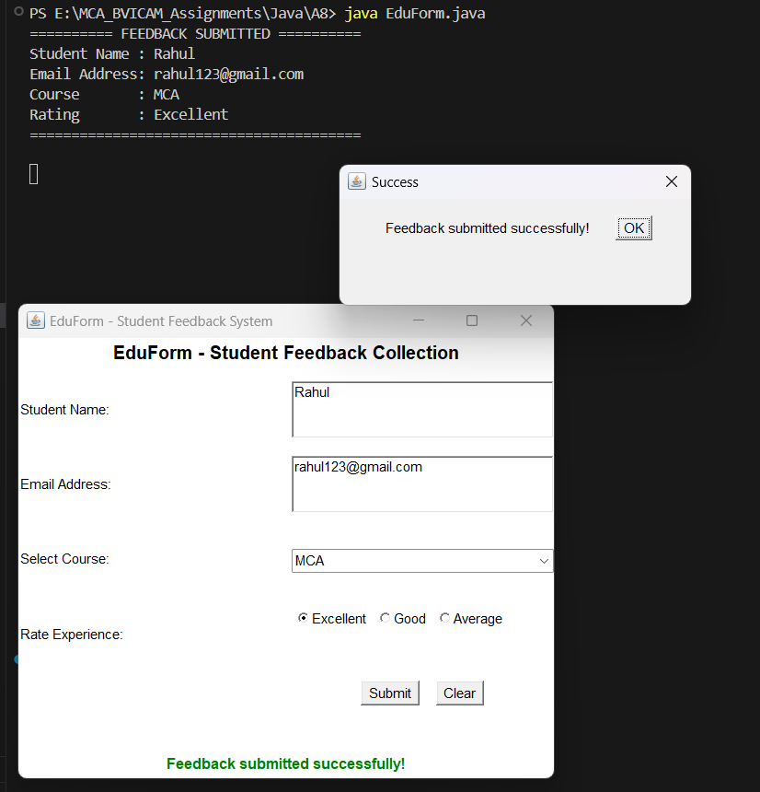

PQ26 Use AWT /Swings to develop a Contact Manager. The GUI application maintains a
simple list of contacts storing contact name and number. It provides basic features of
CRUD (Create, Update, Retrieve and Delete) as per user choice. The application also
supports search feature.

SOLUTION:

import javax.swing.*;
import javax.swing.table.DefaultTableModel;
import java.awt.*;
import java.awt.event.*;
import java.util.ArrayList;
import java.util.List;

class Contact {
String name;
String phone;

public Contact(String name, String phone) {
this.name = name;
this.phone = phone;
}
}

public class ContactManager extends JFrame {

// Contact data list
private List<Contact> contactList = new ArrayList<>();

// GUI Components
private JTextField nameField;
private JTextField phoneField;
private JTextField searchField;
private JTable contactTable;
private DefaultTableModel tableModel;

private JButton btnAdd;
private JButton btnUpdate;
private JButton btnDelete;
private JButton btnClear;
private JButton btnSearch;
private JButton btnShowAll;

public ContactManager() {
setTitle("Contact Manager - CRUD & Search");
setSize(700, 520);
setDefaultCloseOperation(JFrame.EXIT_ON_CLOSE);
setLocationRelativeTo(null);
setLayout(new BorderLayout(10, 10));

// ------------------ Top Input Panel ------------------
JPanel topPanel = new JPanel(new BorderLayout(5, 5));
topPanel.setBorder(BorderFactory.createTitledBorder("Contact Details"));

JPanel formPanel = new JPanel(new GridLayout(2, 2, 10, 8));
formPanel.add(new JLabel(" Contact Name:"));
nameField = new JTextField();
formPanel.add(nameField);

formPanel.add(new JLabel(" Phone Number:"));
phoneField = new JTextField();
formPanel.add(phoneField);

topPanel.add(formPanel, BorderLayout.CENTER);

// Buttons for CRUD
JPanel crudButtonPanel = new JPanel(new FlowLayout(FlowLayout.CENTER, 10, 5));
btnAdd = new JButton("Add (Create)");
btnUpdate = new JButton("Update");
btnDelete = new JButton("Delete");
btnClear = new JButton("Clear Fields");

crudButtonPanel.add(btnAdd);
crudButtonPanel.add(btnUpdate);
crudButtonPanel.add(btnDelete);
crudButtonPanel.add(btnClear);

topPanel.add(crudButtonPanel, BorderLayout.SOUTH);
add(topPanel, BorderLayout.NORTH);

// ------------------ Center Table Panel (Retrieve) ------------------
String[] columnNames = {"Name", "Phone Number"};
tableModel = new DefaultTableModel(columnNames, 0) {
@Override
public boolean isCellEditable(int row, int column) {
return false; // read-only table cells
}
};

contactTable = new JTable(tableModel);
contactTable.setSelectionMode(ListSelectionModel.SINGLE_SELECTION);
JScrollPane scrollPane = new JScrollPane(contactTable);
scrollPane.setBorder(BorderFactory.createTitledBorder("Contact List (Click row to select)"));
add(scrollPane, BorderLayout.CENTER);

// ------------------ Bottom Search Panel ------------------
JPanel searchPanel = new JPanel(new FlowLayout(FlowLayout.CENTER, 10, 8));
searchPanel.setBorder(BorderFactory.createTitledBorder("Search Contacts"));

searchPanel.add(new JLabel("Search (Name / Number):"));
searchField = new JTextField(15);
searchPanel.add(searchField);

btnSearch = new JButton("Search");
btnShowAll = new JButton("Show All");
searchPanel.add(btnSearch);
searchPanel.add(btnShowAll);

add(searchPanel, BorderLayout.SOUTH);

// ------------------ Pre-load Sample Contacts ------------------
addInitialContacts();
refreshTable(contactList);

// ------------------ Event Listeners ------------------

// Table Row Selection Listener (Retrieve into text fields)
contactTable.addMouseListener(new MouseAdapter() {
@Override
public void mouseClicked(MouseEvent e) {
int selectedRow = contactTable.getSelectedRow();
if (selectedRow != -1) {
nameField.setText(tableModel.getValueAt(selectedRow, 0).toString());
phoneField.setText(tableModel.getValueAt(selectedRow, 1).toString());
}
}
});

// 1. CREATE (Add Contact)
btnAdd.addActionListener(new ActionListener() {
@Override
public void actionPerformed(ActionEvent e) {
String name = nameField.getText().trim();
String phone = phoneField.getText().trim();

if (name.isEmpty() || phone.isEmpty()) {
JOptionPane.showMessageDialog(ContactManager.this, "Please enter both Name and Phone Number.", "Input Error", JOptionPane.WARNING_MESSAGE);
return;
}

// Check for duplicate number
for (Contact c : contactList) {
if (c.phone.equals(phone)) {
JOptionPane.showMessageDialog(ContactManager.this, "A contact with this phone number already exists.", "Duplicate Error", JOptionPane.ERROR_MESSAGE);
return;
}
}

Contact newContact = new Contact(name, phone);
contactList.add(newContact);
refreshTable(contactList);
clearInputFields();
JOptionPane.showMessageDialog(ContactManager.this, "Contact added successfully!", "Success", JOptionPane.INFORMATION_MESSAGE);
}
});

// 2. UPDATE Contact
btnUpdate.addActionListener(new ActionListener() {
@Override
public void actionPerformed(ActionEvent e) {
int selectedRow = contactTable.getSelectedRow();
if (selectedRow == -1) {
JOptionPane.showMessageDialog(ContactManager.this, "Please select a contact from the table to update.", "Selection Required", JOptionPane.WARNING_MESSAGE);
return;
}

String newName = nameField.getText().trim();
String newPhone = phoneField.getText().trim();

if (newName.isEmpty() || newPhone.isEmpty()) {
JOptionPane.showMessageDialog(ContactManager.this, "Name and Phone Number cannot be empty.", "Input Error", JOptionPane.WARNING_MESSAGE);
return;
}

String currentPhone = tableModel.getValueAt(selectedRow, 1).toString();

// Find contact in main list
for (Contact c : contactList) {
if (c.phone.equals(currentPhone)) {
c.name = newName;
c.phone = newPhone;
break;
}
}

refreshTable(contactList);
clearInputFields();
JOptionPane.showMessageDialog(ContactManager.this, "Contact updated successfully!", "Success", JOptionPane.INFORMATION_MESSAGE);
}
});

// 3. DELETE Contact
btnDelete.addActionListener(new ActionListener() {
@Override
public void actionPerformed(ActionEvent e) {
int selectedRow = contactTable.getSelectedRow();
if (selectedRow == -1) {
JOptionPane.showMessageDialog(ContactManager.this, "Please select a contact from the table to delete.", "Selection Required", JOptionPane.WARNING_MESSAGE);
return;
}

String phoneToDelete = tableModel.getValueAt(selectedRow, 1).toString();
String nameToDelete = tableModel.getValueAt(selectedRow, 0).toString();

int confirm = JOptionPane.showConfirmDialog(ContactManager.this,
"Are you sure you want to delete contact: " + nameToDelete + " (" + phoneToDelete + ")?",
"Confirm Delete", JOptionPane.YES_NO_OPTION);

if (confirm == JOptionPane.YES_OPTION) {
contactList.removeIf(c -> c.phone.equals(phoneToDelete));
refreshTable(contactList);
clearInputFields();
JOptionPane.showMessageDialog(ContactManager.this, "Contact deleted successfully!", "Deleted", JOptionPane.INFORMATION_MESSAGE);
}
}
});

// CLEAR Input Fields
btnClear.addActionListener(new ActionListener() {
@Override
public void actionPerformed(ActionEvent e) {
clearInputFields();
contactTable.clearSelection();
}
});

// 4. SEARCH Contact
btnSearch.addActionListener(new ActionListener() {
@Override
public void actionPerformed(ActionEvent e) {
String query = searchField.getText().trim().toLowerCase();
if (query.isEmpty()) {
JOptionPane.showMessageDialog(ContactManager.this, "Please enter a name or phone number to search.", "Search Query Empty", JOptionPane.WARNING_MESSAGE);
return;
}

List<Contact> matchingContacts = new ArrayList<>();
for (Contact c : contactList) {
if (c.name.toLowerCase().contains(query) || c.phone.contains(query)) {
matchingContacts.add(c);
}
}

if (matchingContacts.isEmpty()) {
JOptionPane.showMessageDialog(ContactManager.this, "No contact found matching: " + query, "No Results", JOptionPane.INFORMATION_MESSAGE);
} else {
refreshTable(matchingContacts);
JOptionPane.showMessageDialog(ContactManager.this, "Found " + matchingContacts.size() + " contact(s).", "Search Results", JOptionPane.INFORMATION_MESSAGE);
}
}
});

// RESET / SHOW ALL Contacts
btnShowAll.addActionListener(new ActionListener() {
@Override
public void actionPerformed(ActionEvent e) {
searchField.setText("");
refreshTable(contactList);
}
});

setVisible(true);
}

// Refresh table rows with given list of contacts
private void refreshTable(List<Contact> list) {
tableModel.setRowCount(0);
for (Contact c : list) {
tableModel.addRow(new Object[]{c.name, c.phone});
}
}

// Clear input text fields
private void clearInputFields() {
nameField.setText("");
phoneField.setText("");
}

// Sample pre-stored contacts
private void addInitialContacts() {
contactList.add(new Contact("Rahul Sharma", "9876543210"));
contactList.add(new Contact("Priya Verma", "9812345678"));
contactList.add(new Contact("Amit Singh", "9123456789"));
contactList.add(new Contact("Neha Gupta", "9988776655"));
contactList.add(new Contact("Vikas Kumar", "9765432109"));
}

public static void main(String[] args) {
SwingUtilities.invokeLater(new Runnable() {
@Override
public void run() {
new ContactManager();
}
});
} }

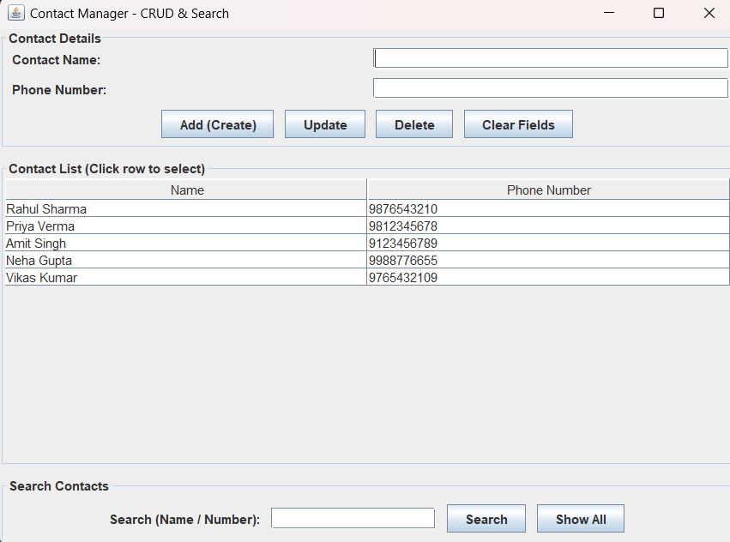

PQ27 Implement a RMI application. The server object maintains a HashMap of Faculty and
Course names; and provides for a method subjectTaught that takes a faculty name as
parameter. The client should attain a remote reference to the object and call the remote
method to satisfy user queries

SOLUTION:

FacultyServer.java
import java.rmi.RemoteException;
import java.rmi.registry.LocateRegistry;
import java.rmi.registry.Registry;
import java.rmi.server.UnicastRemoteObject;
import java.util.HashMap;
import java.util.Map;

public class FacultyServer extends UnicastRemoteObject implements FacultyService {

// Server maintains a HashMap of Faculty Name -> Course Name
private Map<String, String> facultyCourseMap;

public FacultyServer() throws RemoteException {
super();
facultyCourseMap = new HashMap<>();

// Pre-populating Faculty and Course records
facultyCourseMap.put("Dr. Ritika Wason", "Object Oriented Programming using Java");
facultyCourseMap.put("Dr. M. N. Hoda", "Software Engineering");
facultyCourseMap.put("Prof. Parul Arora", "Discrete Structures");
facultyCourseMap.put("Prof. Arpita Nagpal", "Computer Networks");
facultyCourseMap.put("Prof. Sunil Pratap Singh", "Operating Systems");
}

// Remote method implementation
@Override
public String subjectTaught(String facultyName) throws RemoteException {
System.out.println("[Server] Received query for faculty: " + facultyName);

// Case-insensitive lookup in HashMap
for (Map.Entry<String, String> entry : facultyCourseMap.entrySet()) {
if (entry.getKey().equalsIgnoreCase(facultyName.trim())) {
return "Course/Subject: " + entry.getValue() + " (Faculty: " + entry.getKey() + ")";
}
}

return "No subject found for faculty: " + facultyName;
}

public static void main(String[] args) {
try {
// Create RMI registry on default port 1099
Registry registry;
try {
registry = LocateRegistry.createRegistry(1099);
System.out.println("RMI registry created on port 1099.");
} catch (Exception e) {
// If registry is already running, get existing registry
registry = LocateRegistry.getRegistry(1099);
System.out.println("Using existing RMI registry on port 1099.");
}

// Create remote object instance
FacultyServer serverObj = new FacultyServer();

// Bind remote object to registry
registry.rebind("FacultyService", serverObj);

System.out.println("=================================================");
System.out.println("Faculty RMI Server is running and waiting for clients...");
System.out.println("=================================================");

} catch (Exception e) {
System.err.println("Server exception: " + e.getMessage());
e.printStackTrace();
}
}
}

FacultyClient.java

import java.rmi.registry.LocateRegistry;
import java.rmi.registry.Registry;
import java.util.Scanner;

public class FacultyClient {

public static void main(String[] args) {
try {
// Locate the RMI registry on localhost:1099
Registry registry = LocateRegistry.getRegistry("localhost", 1099);

// Obtain remote reference to the server object
FacultyService service = (FacultyService) registry.lookup("FacultyService");

Scanner scanner = new Scanner(System.in);
System.out.println("=================================================");
System.out.println("Connected to Faculty RMI Server!");
System.out.println("Type faculty name to query the subject taught.");
System.out.println("Type 'exit' to quit.");
System.out.println("=================================================");

while (true) {
System.out.print("\nEnter Faculty Name: ");
String facultyName = scanner.nextLine().trim();

if (facultyName.equalsIgnoreCase("exit")) {
System.out.println("Exiting Faculty Query Client. Goodbye!");
break;
}

if (facultyName.isEmpty()) {
System.out.println("Please enter a valid faculty name.");
continue;
}

// Invoke remote method
String response = service.subjectTaught(facultyName);
System.out.println("Result -> " + response);
}

scanner.close();

} catch (Exception e) {
System.err.println("Client exception: " + e.getMessage());
e.printStackTrace();
}
}
}

FacultyService.java

import java.rmi.Remote;
import java.rmi.RemoteException;

// Remote interface defining the remote method
public interface FacultyService extends Remote {
String subjectTaught(String facultyName) throws RemoteException;
}

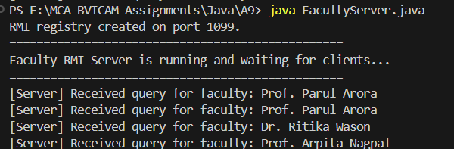

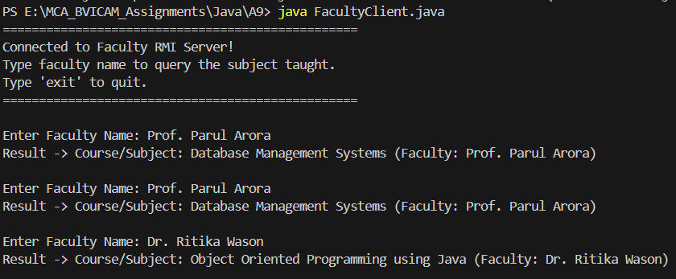

PQ28 Define a functional interface called Calculator with a single abstract method int
calculate(int a, int Use thisfunctional interface in four lambda expressions to perform
addition, subtraction, multiplication, and division operations.

SOLUTION:

import java.util.Scanner;

// Functional Interface with a single abstract method
@FunctionalInterface
interface Calculator {
int calculate(int a, int b);
}

public class LambdaCalculator {

public static void main(String[] args) {
// 1. Lambda expression for Addition
Calculator addition = (a, b) -> a + b;

// 2. Lambda expression for Subtraction
Calculator subtraction = (a, b) -> a - b;

// 3. Lambda expression for Multiplication
Calculator multiplication = (a, b) -> a * b;

// 4. Lambda expression for Division (handles division by zero)
Calculator division = (a, b) -> {
if (b == 0) {
System.out.println("Error: Division by zero is not allowed.");
return 0;
}
return a / b;
};

// User Input
Scanner sc = new Scanner(System.in);
System.out.println("========== LAMBDA CALCULATOR ==========");
System.out.print("Enter first number (a) : ");
int a = sc.nextInt();
System.out.print("Enter second number (b): ");
int b = sc.nextInt();
System.out.println("=======================================");

// Executing operations via lambda expressions
System.out.println("Addition (" + a + " + " + b + ") = " + addition.calculate(a, b));
System.out.println("Subtraction (" + a + " - " + b + ") = " + subtraction.calculate(a, b));
System.out.println("Multiplication (" + a + " * " + b + ") = " + multiplication.calculate(a, b));
System.out.println("Division (" + a + " / " + b + ") = " + division.calculate(a, b));
System.out.println("=======================================");

sc.close();
}
}

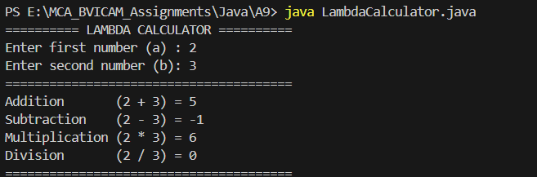

PQ29 A Java application that uses JDBC to connect to a database containing table that holds data for students of your class. The application should allow the user to: a) Add a record b) Search for a record c) Modify an existing record Make use of Prepared Statement
Extend the application to call a backend procedure/function. The procedure should take
ID field as input parameters and return details of related record.

SOLUTION:

import java.sql.*;
import java.util.Scanner;

/*
* Simple SQL Table Setup:
*
* CREATE DATABASE IF NOT EXISTS prakhar;
* USE prakhar;
*
* CREATE TABLE IF NOT EXISTS student (
* id INT PRIMARY KEY,
* name VARCHAR(50) NOT NULL,
* course VARCHAR(50) NOT NULL,
* email VARCHAR(50) NOT NULL
* );
*/

public class StudentJDBC {

// Database connection parameters
private static final String DB_URL = "jdbc:mysql://localhost:3306/prakhar?createDatabaseIfNotExist=true&useSSL=false&allowPublicKeyRetrieval=true";
private static final String USER = "root";
private static final String PASSWORD = "bvicam";

private static Connection getConnection() throws SQLException {
return DriverManager.getConnection(DB_URL, USER, PASSWORD);
}

// Helper: Initialize table if not exists
private static void initializeDatabase() {
String sql = "CREATE TABLE IF NOT EXISTS student (" +
"id INT PRIMARY KEY, " +
"name VARCHAR(50) NOT NULL, " +
"course VARCHAR(50) NOT NULL, " +
"email VARCHAR(50) NOT NULL)";
try (Connection conn = getConnection();
Statement stmt = conn.createStatement()) {
stmt.executeUpdate(sql);
} catch (SQLException e) {
System.err.println("Database notice: " + e.getMessage());
}
}

// a) Add a record using PreparedStatement
public static void addRecord(Scanner sc) {
System.out.println("\n--- Add Student Record ---");
System.out.print("Enter Student ID: ");
int id = sc.nextInt();
sc.nextLine(); // consume newline
System.out.print("Enter Student Name: ");
String name = sc.nextLine().trim();
System.out.print("Enter Course: ");
String course = sc.nextLine().trim();
System.out.print("Enter Email: ");
String email = sc.nextLine().trim();

String insertQuery = "INSERT INTO student (id, name, course, email) VALUES (?, ?, ?, ?)";

try (Connection conn = getConnection();
PreparedStatement pstmt = conn.prepareStatement(insertQuery)) {

pstmt.setInt(1, id);
pstmt.setString(2, name);
pstmt.setString(3, course);
pstmt.setString(4, email);

int rowsAffected = pstmt.executeUpdate();
if (rowsAffected > 0) {
System.out.println(">> Student record added successfully!\n");
}
} catch (SQLException e) {
System.err.println("Error adding record: " + e.getMessage() + "\n");
}
}

// b) Search for a record using PreparedStatement
public static void searchRecord(Scanner sc) {
System.out.println("\n--- Search Student Record ---");
System.out.print("Enter Student ID to search: ");
int id = sc.nextInt();

String searchQuery = "SELECT id, name, course, email FROM student WHERE id = ?";

try (Connection conn = getConnection();
PreparedStatement pstmt = conn.prepareStatement(searchQuery)) {

pstmt.setInt(1, id);

try (ResultSet rs = pstmt.executeQuery()) {
if (rs.next()) {
System.out.println("\n========== STUDENT DETAILS FOUND ==========");
System.out.println("ID : " + rs.getInt("id"));
System.out.println("Name : " + rs.getString("name"));
System.out.println("Course : " + rs.getString("course"));
System.out.println("Email : " + rs.getString("email"));
System.out.println("===========================================\n");
} else {
System.out.println(">> No student record found with ID: " + id + "\n");
}
}
} catch (SQLException e) {
System.err.println("Error searching record: " + e.getMessage() + "\n");
}
}

// c) Modify an existing record using PreparedStatement
public static void modifyRecord(Scanner sc) {
System.out.println("\n--- Modify Student Record ---");
System.out.print("Enter Student ID to modify: ");
int id = sc.nextInt();
sc.nextLine(); // consume newline

// Check if student exists
String checkQuery = "SELECT id FROM student WHERE id = ?";
try (Connection conn = getConnection();
PreparedStatement checkStmt = conn.prepareStatement(checkQuery)) {

checkStmt.setInt(1, id);
ResultSet rs = checkStmt.executeQuery();
if (!rs.next()) {
System.out.println(">> Student with ID " + id + " does not exist.\n");
return;
}
} catch (SQLException e) {
System.err.println("Error checking record: " + e.getMessage() + "\n");
return;
}

System.out.print("Enter New Name: ");
String newName = sc.nextLine().trim();
System.out.print("Enter New Course: ");
String newCourse = sc.nextLine().trim();
System.out.print("Enter New Email: ");
String newEmail = sc.nextLine().trim();

String updateQuery = "UPDATE student SET name = ?, course = ?, email = ? WHERE id = ?";

try (Connection conn = getConnection();
PreparedStatement pstmt = conn.prepareStatement(updateQuery)) {

pstmt.setString(1, newName);
pstmt.setString(2, newCourse);
pstmt.setString(3, newEmail);
pstmt.setInt(4, id);

int rows = pstmt.executeUpdate();
if (rows > 0) {
System.out.println(">> Student record updated successfully!\n");
}
} catch (SQLException e) {
System.err.println("Error modifying record: " + e.getMessage() + "\n");
}
}

// Display all records
public static void displayAllRecords() {
String query = "SELECT id, name, course, email FROM student";
try (Connection conn = getConnection();
Statement stmt = conn.createStatement();
ResultSet rs = stmt.executeQuery(query)) {

System.out.println("\n===================== ALL STUDENTS =====================");
boolean found = false;
while (rs.next()) {
found = true;
System.out.printf("ID: %-5d | Name: %-15s | Course: %-10s | Email: %s%n",
rs.getInt("id"),
rs.getString("name"),
rs.getString("course"),
rs.getString("email"));
}
if (!found) {
System.out.println("No records found in table.");
}
System.out.println("========================================================\n");
} catch (SQLException e) {
System.err.println("Error fetching records: " + e.getMessage() + "\n");
}
}

public static void main(String[] args) {
initializeDatabase();

Scanner sc = new Scanner(System.in);
while (true) {
System.out.println("==================================================");
System.out.println(" STUDENT DATABASE MANAGEMENT (JDBC)");
System.out.println("==================================================");
System.out.println("1. Add a Record (PreparedStatement)");
System.out.println("2. Search for a Record (PreparedStatement)");
System.out.println("3. Modify an Existing Record (PreparedStatement)");
System.out.println("4. Display All Records");
System.out.println("5. Exit");
System.out.print("Enter your choice (1-5): ");

int choice;
if (sc.hasNextInt()) {
choice = sc.nextInt();
} else {
System.out.println("Invalid input. Please enter a number.\n");
sc.next();
continue;
}

switch (choice) {
case 1:
addRecord(sc);
break;
case 2:
searchRecord(sc);
break;
case 3:
modifyRecord(sc);
break;
case 4:
displayAllRecords();
break;
case 5:
System.out.println("Exiting Application. Goodbye!");
sc.close();
return;
default:
System.out.println("Invalid choice! Please choose between 1 and 5.\n");
}
}
}
}

