##### NETWORK PROGRAMMING

**CSX-354**

**LAB PRACTICALS RECORD**

**COMPUTER SCIENCE AND ENGINEERING**



**DEPARTMENT OF COMPUTER SCIENCE AND ENGINEERING**

**Dr. B R AMBEDKAR NATIONAL INSTITUTE OF TECHNOLOGY**

**JALANDHAR – 144011, PUNJAB (INDIA)**

###### **Submitted To: Submitted By:**

Mr. MANOJ KUMAR SHRAVAN KUMAR

Asst. Professor 13103045

Department of CSE 6th Semester

|  |  |  |  |  |
| --- | --- | --- | --- | --- |
| **S.No** | **Programs Name** | **Page No** | **Date** | **Signature** |
| 01. | Client Server Communication using TCP | 2 | 12/01/2016 |  |
| 02. | TCP iterative client and server application to reverse given input | 6 | 19/01/2016 |  |
| 03. | TCP Sockets Date and Time Server | 13 | 09/02/2016 |  |
| 04. | TCP client and server application to transfer a file | 18 | 16/02/2016 |  |
| 05. | UDP client and server application to transfer a file | 24 | 01/03/2016 |  |
| 06. | Creation of one way pipe in single process | 27 | 08/03/2016 |  |
| 07. | To make a Server client for receiving and sending messages using fifo | 29 | 15/03/2016 |  |
| 08. | Program to implement message queue (to transfer a file or any) | 33 | 22/03/2016 |  |
| 09. | To perform Semaphore Operations | 36 | 12/04/2016 |  |
| 10. | DNS Server to resolve a given host name | 42 | 19/04/2016 |  |

**INDEX:**

**PROGRAM-1**

Client Server Communication using TCP

**Server Program :**

#include <stdio.h>

#include <stdlib.h>

#include <string.h>

#include <unistd.h>

#include <sys/types.h>

#include <sys/socket.h>

#include <netinet/in.h>

void error(const char *msg)

{

perror(msg);

exit(1);

}

int main(int argc, char *argv[])

{

int sockfd, newsockfd, portno;

socklen_t clilen;

char buffer[256];

struct sockaddr_in serv_addr, cli_addr;

int n;

if (argc < 2) {

fprintf(stderr,"ERROR, no port provided\n");

exit(1);

}

sockfd = socket(AF_INET, SOCK_STREAM, 0);

if (sockfd < 0)

error("ERROR opening socket");

bzero((char *) &serv_addr, sizeof(serv_addr));

portno = atoi(argv[1]);

serv_addr.sin_family = AF_INET;

serv_addr.sin_addr.s_addr = INADDR_ANY;

serv_addr.sin_port = htons(portno);

if (bind(sockfd, (struct sockaddr *) &serv_addr,

sizeof(serv_addr)) < 0)

error("ERROR on binding");

listen(sockfd,5);

clilen = sizeof(cli_addr);

newsockfd = accept(sockfd,

(struct sockaddr *) &cli_addr,

&clilen);

if (newsockfd < 0)

error("ERROR on accept");

bzero(buffer,256);

n = read(newsockfd,buffer,255);

if (n < 0) error("ERROR reading from socket");

printf("Here is the message: %s\n",buffer);

n = write(newsockfd,"I got your message",18);

if (n < 0) error("ERROR writing to socket");

close(newsockfd);

close(sockfd);

return 0;

}

**Client Program :**

#include <stdio.h>

#include <stdlib.h>

#include <unistd.h>

#include <string.h>

#include <sys/types.h>

#include <sys/socket.h>

#include <netinet/in.h>

#include <netdb.h>

void error(const char *msg)

{

perror(msg);

exit(0);

}

int main(int argc, char *argv[])

{

int sockfd, portno, n;

struct sockaddr_in serv_addr;

struct hostent *server;

char buffer[256];

if (argc < 3) {

fprintf(stderr,"usage %s hostname port\n", argv[0]);

exit(0);

}

portno = atoi(argv[2]);

sockfd = socket(AF_INET, SOCK_STREAM, 0);

if (sockfd < 0)

error("ERROR opening socket");

server = gethostbyname(argv[1]);

if (server == NULL) {

fprintf(stderr,"ERROR, no such host\n");

exit(0);

}

bzero((char *) &serv_addr, sizeof(serv_addr));

serv_addr.sin_family = AF_INET;

bcopy((char *)server->h_addr,

(char *)&serv_addr.sin_addr.s_addr,

server->h_length);

serv_addr.sin_port = htons(portno);

if (connect(sockfd,(struct sockaddr *) &serv_addr,sizeof(serv_addr)) < 0)

error("ERROR connecting");

printf("Please enter the message: ");

bzero(buffer,256);

fgets(buffer,255,stdin);

n = write(sockfd,buffer,strlen(buffer));

if (n < 0)

error("ERROR writing to socket");

bzero(buffer,256);

n = read(sockfd,buffer,255);

if (n < 0)

error("ERROR reading from socket");

printf("%s\n",buffer);

close(sockfd);

return 0;

}

**Output:**

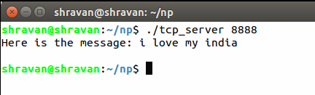

**Figure:Server**

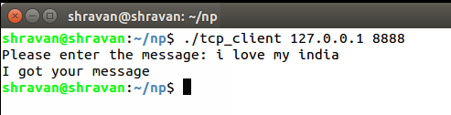

**Figure:Client**

**PROGRAM 2**

Design TCP iterative client and server application to reverse a given input string.

**Server Program :**

#include<stdio.h>

#include<string.h>

#include<sys/un.h>

#include<unistd.h>

#include<pthread.h>

#include<arpa/inet.h>

#include<netinet/in.h>

#define size 1024

#define PORT 9925

char rbuf[size];

void *retval;

int server_fd, c_fd, ret, c_len, bytes, ret;

struct sockaddr_in server_addrobj, c_addrobj;

void strrev(char *s)

{

int i, j;

char t;

for(i=0; s[i]!='\0'; i++);

j=0;i--;

while(j<i)

{

t = s[i];

s[i] = s[j];

s[j] = t;

j++;i--;

}

}

int main()

{

int true = 1;

/*************************** Unlink *********************************/

unlink("SOCKET SERVER");

/******************************* Socket **********************************/

server_fd = socket(AF_INET, SOCK_STREAM, 0);

setsockopt(server_fd, SOL_SOCKET, SO_REUSEADDR, &true, sizeof(int));

if(server_fd == -1)

perror("Socket creation failed!!!\n");

else

printf("Socket created successfully\n");

/****************************** Bind ***************************************/

server_addrobj.sin_family = AF_INET;

server_addrobj.sin_port = htons(PORT);

server_addrobj.sin_addr.s_addr = htonl(INADDR_ANY);

ret = bind(server_fd, (const struct sockaddr *)&server_addrobj, sizeof(server_addrobj));

if(ret==-1)

perror("Binding failed !!!!\n");

else

printf("Binding Successfull\n");

/**************************** Listen *************************************/

ret = listen(server_fd, 5);

if(ret==-1)

perror("Listening failed!!!\n");

else

printf("Listening successfull\n");

/*********************************** Accept *********************************/

while(1)

{

bzero(rbuf, size);

printf("\nWaiting for client request.......\n");

c_len=sizeof(c_addrobj);

c_fd = accept(server_fd, (struct sockaddr *)&c_addrobj, &c_len);

if(c_fd == -1)

perror("Accept system call failed!!!\n");

else

printf("Connection established successfully \n");

/*****************************Conversation*****************************/

bzero(rbuf, size);

while(strncmp(rbuf, "end", 3) != 0 )

{

bzero(rbuf, size);

bytes = recv(c_fd, rbuf, size, 0);

if(bytes == -1)

perror("Writing by the server failed!!!\n");

strrev(rbuf);

bytes = send(c_fd, rbuf, sizeof(rbuf), 0);

if(bytes == -1)

perror("\nWriting by the server failed!!!\n");

else

printf("\nString reversed and sent \n");

}

printf("\n***************** Conversation Over *******************\n");

close(c_fd);

}

close(server_fd);

return 0;

}

**Client Program :**

#include<stdio.h>

#include<sys/types.h>

#include<sys/socket.h>

#include<string.h>

#include<sys/un.h>

#include<unistd.h>

#include<arpa/inet.h>

#include<netinet/in.h>

#define size 1024

#define PORT 9925

char rbuf[size], buf[size];

int client_fd, ret, bytes, ret;

struct sockaddr_in client_addrobj;

void *retval;

int main()

{

/**************************** Socket **********************************/

client_fd = socket(AF_INET, SOCK_STREAM, 0);

if(client_fd == -1)

perror("Socket creation failed !!!\n");

else

printf("Socket created successfully \n\n");

/*************************** Naming the socket **********************************/

client_addrobj.sin_family = AF_INET;

client_addrobj.sin_port = htons(PORT);

client_addrobj.sin_addr.s_addr = inet_addr("127.0.0.1");

/**************************** Connect *********************************/

ret = connect(client_fd, (struct sockaddr *)&client_addrobj, sizeof(client_addrobj) );

if(ret == -1)

perror("Connection failed !!!\n");

else

printf("Connection established successfully \n\n");

/***************************** Conversation **********************************/

bzero(rbuf, size);

while(strncmp(rbuf, "end", 3) != 0 )

{

bzero(rbuf, size);

printf("\nEnter the message from client....\n");

fgets(rbuf, size, stdin);

bytes = send(client_fd, rbuf, sizeof(rbuf), 0);

if(bytes == -1)

perror("Writing by the client failed!!!\n");

else

printf("String sent\n");

bzero(buf, size);

bytes = recv(client_fd, buf, size, 0);

if(bytes == -1)

perror("Reading from server failed!!!\n");

else

printf("\nYou got the reversed string from server :\n %s \n", buf);

}

printf("\n***************** Conversation Over *******************\n");

close(client_fd);

return 0;

}

**OUTPUT :**

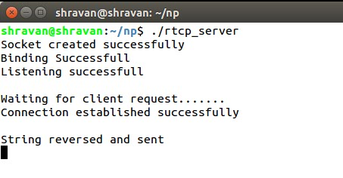

**Figure:Server**

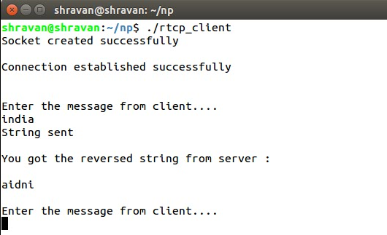

**Figure:Client**

**PROGRAM 3**

Program for date and time server using TCP sockets.

**Server Program :**

#include<stdio.h>

#include<string.h>

#include<sys/un.h>

#include<unistd.h>

#include<pthread.h>

#include<arpa/inet.h>

#include<netinet/in.h>

#include<time.h>

#define size 1024

#define PORT 9925

char str[size];

void *retval;

int server_fd, c_fd, ret, c_len, bytes, ret;

struct sockaddr_in server_addrobj, c_addrobj;

time_t tick;

int main()

{

int true = 1;

/***************************** Unlink ***********************************/

unlink("SOCKET SERVER");

/***************************** Socket ***********************************/

server_fd = socket(AF_INET, SOCK_STREAM, 0);

setsockopt(server_fd, SOL_SOCKET, SO_REUSEADDR, &true, sizeof(int));

if(server_fd == -1)

perror("Socket creation failed!!!\n");

else

printf("Socket created successfully\n");

/*************************** Bind ************************************/

server_addrobj.sin_family = AF_INET;

server_addrobj.sin_port = htons(PORT);

server_addrobj.sin_addr.s_addr = htonl(INADDR_ANY);

ret = bind(server_fd, (const struct sockaddr *)&server_addrobj, sizeof(server_addrobj));

if(ret==-1)

perror("Binding failed !!!!\n");

else

printf("Binding Successfull\n");

/************************* Listen ********************************/

ret = listen(server_fd, 5);

if(ret==-1)

perror("Listening failed!!!\n");

else

printf("Listening successfull\n");

/*********************** Accept *********************************/

while(1)

{

printf("\nWaiting for client request.......\n");

c_len=sizeof(c_addrobj);

c_fd = accept(server_fd, (struct sockaddr *)&c_addrobj, &c_len);

if(c_fd == -1)

perror("Accept system call failed!!!\n");

else

printf("Connection established successfully \n");

/********************** Conversation **********************************/

bzero(str, size);

tick=time(NULL);

snprintf(str,sizeof(str),"%s",ctime(&tick));

printf("%s",str);

write(c_fd,str,100);

bytes = send(c_fd, str, sizeof(str), 0);

if(bytes == -1)

perror("\nWriting by the server failed!!!\n");

close(c_fd);

}

close(server_fd);

return 0;

}

**Client Program :**

#include<stdio.h>

#include<sys/types.h>

#include<sys/socket.h>

#include<string.h>

#include<sys/un.h>

#include<unistd.h>

#include<arpa/inet.h>

#include<netinet/in.h>

#define size 1024

#define PORT 9925

char rbuf[size], buf[size];

int client_fd, ret, bytes, ret;

struct sockaddr_in client_addrobj;

void *retval;

int main()

{

/***************************** Socket ******************************/

client_fd = socket(AF_INET, SOCK_STREAM, 0);

if(client_fd == -1)

perror("Socket creation failed !!!\n");

else

printf("Socket created successfully \n\n");

/************************* Naming the socket *********************************/

client_addrobj.sin_family = AF_INET;

client_addrobj.sin_port = htons(PORT);

client_addrobj.sin_addr.s_addr = inet_addr("127.0.0.1");

/************************** Connect ***********************************/

ret = connect(client_fd, (struct sockaddr *)&client_addrobj, sizeof(client_addrobj) );

if(ret == -1)

perror("Connection failed !!!\n");

else

printf("Connection established successfully \n\n");

/************************** Conversation *******************************/

bzero(buf, size);

bytes = recv(client_fd, buf, size, 0);

if(bytes == -1)

perror("Reading from server failed!!!\n");

else

printf("\n %s \n", buf);

close(client_fd);

return 0;

}

**OUTPUT :**

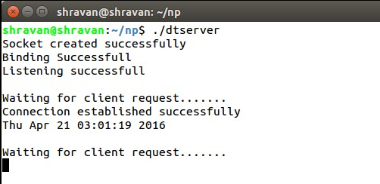

**Figure:Server**

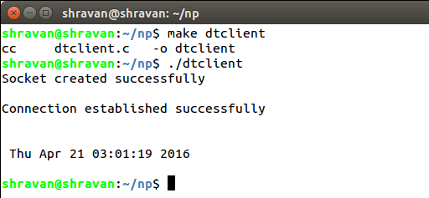

**Figure:Client**

**PROGRAM 4**

Design TCP client and server application to transfer a file.

**Server Program :**

#include<stdio.h>

#include<stdlib.h>

#include<string.h>

#include<sys/socket.h>

#include<sys/types.h>

#include<sys/un.h>

#include<unistd.h>

#include<pthread.h>

#include<arpa/inet.h>

#include<netinet/in.h>

#define PORT 7777

#define SIZE 1024

void * thread_function(void *);

int server_fd, client_fd, ret, c_len;

struct sockaddr_in server_addrobj, client_addrobj;

pthread_t thread_id;

char buf[SIZE];

FILE *fp, *fp1;

size_t bytes;

int main()

{

int true = 1;

/******************* Unlink ************************/

unlink("SOCKET SERVER");

/******************* Socket ***********************/

server_fd = socket(AF_INET, SOCK_STREAM, 0);

setsockopt(server_fd, SOL_SOCKET, SO_REUSEADDR, &true, sizeof(int));

if(server_fd == -1)

{

perror("Socket creation failed!!!\n");

exit(0);

}

else

printf("Socket created successfully\n");

/********************** Binding **************************/

server_addrobj.sin_family = AF_INET;

server_addrobj.sin_port = htons(PORT);

server_addrobj.sin_addr.s_addr = htonl(INADDR_ANY);

ret = bind(server_fd, (const struct sockaddr *)&server_addrobj, sizeof(server_addrobj));

if(ret == -1)

{

perror("Binding failed!!!!\n");

exit(1);

}

else

printf("Binding successful\n");

/********************** Listening ******************************/

ret = listen(server_fd, 5);

if(ret == -1)

{

perror("Listening failed!!!!\n");

exit(2);

}

else

printf("Listening successful\n");

/***************** Accepting ****************************/

while(1)

{

printf("\nWaiting for client request.......\n");

c_len = sizeof(client_addrobj);

client_fd = accept(server_fd, (struct sockaddr *)&client_addrobj, &c_len);

if(ret == -1)

{

perror("Accept system call failed!!!!\n");

exit(3);

}

else

printf("Connection established successfully\n");

fp = fopen("abc.txt", "r");

printf("\nSending file .......\n");

/********************* Sending the file *****************************/

while(!feof(fp))

{

bytes = fread(buf, sizeof(char), sizeof(buf), fp);

if(bytes < 0)

{

perror("Error");

exit(0);

}

ret = send(client_fd, buf, sizeof(buf), 0);

if(ret < 0)

perror("Sending failed\n");

}

fclose(fp);

close(client_fd);

}

close(server_fd);

return 0;

}

**Client Program :**

#include<stdio.h>

#include<sys/types.h>

#include<sys/socket.h>

#include<string.h>

#include<sys/un.h>

#include<unistd.h>

#include<stdlib.h>

#include<pthread.h>

#include<arpa/inet.h>

#include<netinet/in.h>

#define SIZE 1024

#define PORT 7777

int client_fd, ret, true=1;

size_t bytes;

struct sockaddr_in server_addrobj, client_addrobj;

char buf[SIZE];

int main()

{

/***************************** Socket ***********************************/

client_fd = socket(AF_INET, SOCK_STREAM, 0);

setsockopt(client_fd, SOL_SOCKET, SO_REUSEADDR, &true, sizeof(int));

if(client_fd == -1)

perror("Socket creation failed !!!\n");

else

printf("Socket created successfully \n\n");

/****************************** Binding **********************************/

client_addrobj.sin_family = AF_INET;

client_addrobj.sin_port = htons(PORT);

client_addrobj.sin_addr.s_addr = inet_addr("127.0.0.1");

/***************************** Connecting **********************************/

ret = connect(client_fd, (struct sockaddr *)&client_addrobj, sizeof(client_addrobj) );

if(ret == -1)

perror("Connection failed !!!\n");

else

printf("Connection established successfully \n\n");

FILE *fp = fopen("abc1.txt", "w");

bzero(buf, SIZE);

printf("\n Receiving file ........\n");

/************************** Receiving the file *************************/

while( bytes = recv(client_fd, buf, sizeof(buf), 0) > 0)

{

fprintf(fp, "%s", buf);

bzero(buf, SIZE);

}

fclose(fp);

close(client_fd);

return 0;

}

**Output:**

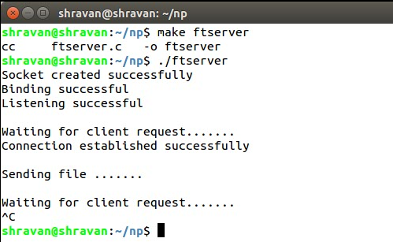

**Figure:Server**

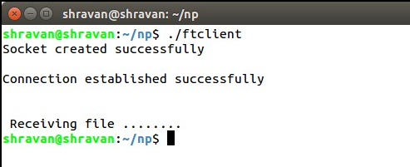

**Figure:Client**

 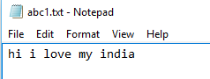

**File to be sent** **Received File**

**PROGRAM 5**

UDP client and server application to transfer a file

**Server Program:**

#include <stdio.h>

#include <stdlib.h>

#include <unistd.h>

#include <string.h>

#include <sys/types.h>

#include <sys/socket.h>

#include <netinet/in.h>

#include <netdb.h>

int main(int argc,char* argv[])

{

int sockfd,newsockfd;

socklen_t clilen;

char file[100],line[100];

struct sockaddr_in serv_addr,cli_addr;

bzero((char*) &serv_addr,sizeof(serv_addr));

serv_addr.sin_family = AF_INET;

serv_addr.sin_port = htons(atoi(argv[1]));

serv_addr.sin_addr.s_addr = INADDR_ANY;

sockfd = socket(AF_INET,SOCK_STREAM,0);

bind(sockfd,(struct sockaddr*) &serv_addr,sizeof(serv_addr));

listen(sockfd,5);

clilen = sizeof(cli_addr);

if((newsockfd = accept(sockfd,(struct sockaddr*) &cli_addr,&clilen))<0) error("Couldn't accept");

recvfrom(newsockfd,file,100,0,(struct sockaddr*) &cli_addr,&clilen);

FILE *fp;

if((fp = fopen(file,"r")) < 0 ) error("Couldn't open file");

printf("Contents of file are:\n");

while(fgets(line,100,fp)!=NULL)

{

printf("%s",line);

}

fclose(fp);

return 0;

}

**Client Program:**

#include <stdio.h>

#include <stdlib.h>

#include <unistd.h>

#include <string.h>

#include <sys/types.h>

#include <sys/socket.h>

#include <netinet/in.h>

#include <netdb.h>

void error(char *msg)

{

perror(msg);

exit(1);

}

int main(int argc,char* argv[])

{

int sockfd;

char file[100];

printf("Enter the file name.\n");

scanf("%s",file);

FILE* fp;

if((fp = fopen(file,"r"))<0) error("File Couldn't found");

struct sockaddr_in serv_addr;

struct hostent *server;

bzero((char*) &serv_addr,sizeof(serv_addr));

serv_addr.sin_family = AF_INET;

serv_addr.sin_port = htons(atoi(argv[2]));

server = gethostbyname(argv[1]);

bcopy((char*)server->h_addr,(char*) &serv_addr.sin_addr.s_addr,server->h_length);

sockfd = socket(AF_INET,SOCK_STREAM,0);

if(connect(sockfd,(struct sockaddr *) &serv_addr,sizeof(serv_addr)) < 0 ) error("Couldn't connect");

sendto(sockfd,file,strlen(file),0,(struct sockaddr *) &serv_addr,sizeof(serv_addr));

printf("Done sending file. Exiting..");

return 0;

}

**Output:**

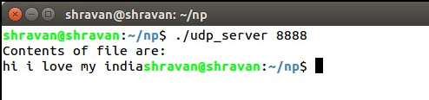

**Figure:Server**

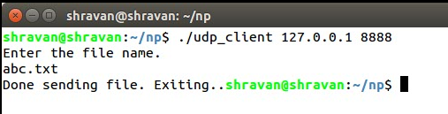

**Figure:Client**



**File to be sent**

**PROGRAM 6**

Creation of a one way pipe in a single process.

**Program :**

#include<stdio.h>

#include<unistd.h>

#include<string.h>

int main()

{

char source[20]="Hello",dest[20];

int fd[2],ret,data_bytes;

ret=pipe(fd);

if(ret==-1)

perror("Pipe creation failed!!!\n");

else

printf("Pipe created successfully!!!\n");

data_bytes=write(fd[1],source,strlen(source));

if(data_bytes==-1)

perror("Error!!\n");

else

printf("No. of bytes wrote = %d\n",data_bytes);

memset(dest,'\0',sizeof(dest));

data_bytes=read(fd[0],dest,sizeof(dest));

if(data_bytes==-1)

perror("Error!!\n");

else

printf("No. of bytes read = %d as %s \n",data_bytes,dest);

return 0;

}

**OUTPUT :**

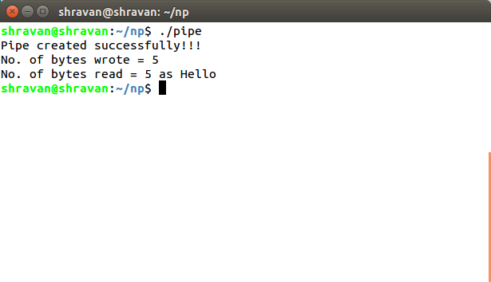

**PROGRAM 7**

To make a Server client for receiving and sending messages using FIFO

**Program For Creating FIFO:**

#include<stdio.h>

#include<fcntl.h>

#include<stdlib.h>

main()

{

int file1,file2;

int fd;

char str[256];

char temp[4]="how";

char temp1[4];

file1 = mkfifo("fifo_server",0666);

if(file1<0) {

printf("Unable to create a fifo");

exit(-1);

}

file2 = mkfifo("fifo_client",0666);

if(file1<0) {

printf("Unable to create a fifo");

exit(-1);

}

printf("fifos server and child created successfuly\n");

}

**Output:**

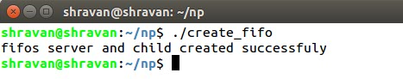

**Server Program:**

#include<stdio.h>

#include<fcntl.h>

main()

{

FILE *file1;

int fifo_server,fifo_client;

int choice;

char *buf;

fifo_server = open("fifo_server",O_RDWR);

if(fifo_server<1) {

printf("Error opening file");

}

read(fifo_server,&choice,sizeof(int));

sleep(10);

fifo_client = open("fifo_client",O_RDWR);

if(fifo_server<1) {

printf("Error opening file");

}

switch(choice) {

case 1:

buf="Linux";

write(fifo_client,buf,10*sizeof(char));

printf("\n Data sent to client \n");

break;

case 2:

buf="debian";

write(fifo_client,buf,10*sizeof(char));

printf("\nData sent to client\n");

break;

case 3:

buf="2.6.32";

write(fifo_client,buf,10*sizeof(char));

printf("\nData sent to client\n");

}

close(fifo_server);

close(fifo_client);

}

**Client Program:**

#include<stdio.h>

#include<fcntl.h>

#include<stdlib.h>

main()

{

FILE *file1;

int fifo_server,fifo_client;

char str[256];

char *buf;

int choice=1;

printf("Choose the request to be sent to server from options below");

printf("\n\t\t Enter 1 for O.S.Name \n \

Enter 2 for Distribution \n \

Enter 3 for Kernel version \n");

scanf("%d",&choice);

fifo_server=open("fifo_server",O_RDWR);

if(fifo_server < 0) {

printf("Error in opening file");

exit(-1);

}

write(fifo_server,&choice,sizeof(int));

fifo_client=open("fifo_client",O_RDWR);

if(fifo_client < 0) {

printf("Error in opening file");

exit(-1);

}

buf=malloc(10*sizeof(char));

read (fifo_client,buf,10*sizeof(char));

printf("\n ***Reply from server is %s***\n",buf);

close(fifo_server);

close(fifo_client);

}

**Output:**

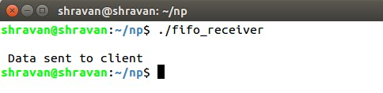

**Figure:Server**

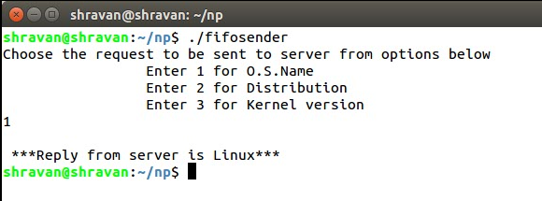

**Figure:Client**

**PROGRAM 8**

Program to implement message queue (to transfer a file or any)

**Server Program:**

#include<sys/wait.h>

#include<stdio.h>

#include<stdlib.h>

#include<string.h>

#include<fcntl.h>

#include<sys/types.h>

#include<sys/msg.h>

#include<sys/ipc.h>

#include<errno.h>

#include<sys/stat.h>

struct msgbuf

{

long mtype;

char mtext[80];

};

int main(int argc,char *argv[])

{

int msqid;

int msgflg = IPC_CREAT | 0666;

int key = 1234;

struct msgbuf rcvbuffer;

if(msqid = msgget(key,msgflg) < 0)

perror("msgget");

msgrcv(msqid,&rcvbuffer,80,1,0);

printf("Message received : %s\n",rcvbuffer.mtext);

return 0;

}

**Client Program:**

#include<sys/wait.h>

#include<stdio.h>

#include<stdlib.h>

#include<string.h>

#include<fcntl.h>

#include<sys/types.h>

#include<sys/msg.h>

#include<sys/ipc.h>

#include<errno.h>

#include<sys/stat.h>

struct msgbuf

{

long mtype;

char mtext[80];

};

int main(int argc,char *argv[])

{

int msqid;

int msgflg = IPC_CREAT | 0666;

int key = 1234;

struct msgbuf sbuf;

if(msqid = msgget(key,msgflg) < 0)

perror("msgget");

sbuf.mtype = 1;

printf("Enter a message:\n");

scanf("%s",sbuf.mtext);

int len = strlen(sbuf.mtext)+1;

msgsnd(msqid,&sbuf,len,IPC_NOWAIT);

return 0;

}

**Output:**

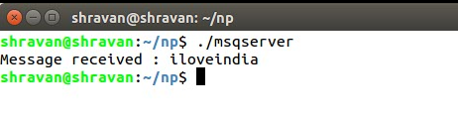

**Figure:Server**

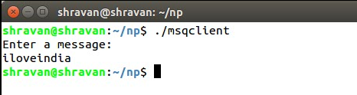

**Figure:Client**

**PROGRAM 9**

To perform Semaphore Operations

**Semaphore Server Program:**

#include <stdio.h>

#include <stdlib.h>

#include <sys/ipc.h>

#include <fcntl.h>

#include <sys/sem.h>

#include <unistd.h>

#include <string.h>

#include <sys/wait.h>

#include <sys/types.h>

#include <errno.h>

#include "common.h"

#define CLIENT_PATH_BUFSIZE 255

int main(int argc, char *argv[]) {

key_t sem_key;

int sem_id;

int sem_fd;

char client_exe[CLIENT_PATH_BUFSIZE];

int dir_len;

int i;

struct sembuf sop;

int pid;

int status;

sem_key = ftok("./sem_server.c", 42);

// Write the key to a file for children to pick it up

sem_fd = open(SEM_KEY_FILE, O_WRONLY | O_TRUNC | O_EXCL | O_CREAT, 0644);

if (sem_fd < 0) {

perror("Could not open sem.key");

exit(1);

}

// Actual write of the key

if (write(sem_fd, &sem_key, sizeof(key_t)) < 0) {

perror("Could not write key to file");

exit(2);

}

// Done with the key

close(sem_fd);

// Create the semaphore

sem_id = semget(sem_key, 1, IPC_CREAT | IPC_EXCL | 0600);

if (sem_id < 0) {

perror("Could not create sem");

unlink(SEM_KEY_FILE);

exit(3);

}

if (semctl(sem_id, 0, SETVAL, 0) < 0) {

perror("Could not set value of semaphore");

exit(4);

}

// Now create some clients

// First create the path to the client exec

getcwd(client_exe, CLIENT_PATH_BUFSIZE);

dir_len = strlen(client_exe);

strcpy(client_exe + dir_len, "/sem_client");

printf("%s\n", client_exe);

for (i = 0; i < 5; ++i) {

if ((pid = fork()) < 0) {

perror("Could not fork, please create clients manually");

}

else if (pid == 0) {

// We're in the child process, start a client

execl(client_exe, "sem_client", (char*)0);

_exit(127);

}

}

printf("Done creating clients, sleeping for a while\n");

sleep(5);

printf("Increasing sem count\n");

sop.sem_num = 0;

sop.sem_op = 1;

sop.sem_flg = 0;

if (semop(sem_id, &sop, 1)) {

perror("Could not increment semaphore");

exit(5);

}

// Wait for all children to finish

for (;;) {

// Remove the zombie process, and get the pid and return code

pid = wait(&status);

if (pid < 0) {

if (errno == ECHILD) {

printf("All children have exited\n");

break;

}

else {

perror("Could not wait");

}

}

else {

printf("Child %d exited with status %d\n", pid, status);

}

}

// Delete semaphore and file

if (unlink(SEM_KEY_FILE) < 0) {

perror("Could not unlink key file");

}

if (semctl(sem_id, 0, IPC_RMID) < 0) {

perror("Could not delete semaphore");

}

exit(0);

}

**Semaphore Client Program:**

#include <stdio.h>

#include <stdlib.h>

#include <sys/sem.h>

#include <fcntl.h>

#include <unistd.h>

#include "common.h"

int main(int argc, char *argv[]) {

int sem_fd;

key_t sem_key;

int sem_id;

int i;

struct sembuf sop;

// Recover the sem_key from file

sem_fd = open(SEM_KEY_FILE, O_RDONLY);

if (sem_fd < 0) {

perror("Could not open sem key for reading");

exit(1);

}

// Technically speaking, the read could read less than sizeof(key_t)

// Which would be wrong.

// But in our case, it is not likely to happen...

if (read(sem_fd, &sem_key, sizeof(key_t)) != sizeof(key_t)) {

perror("Error reading the semaphore key");

exit(2);

}

// Done getting the semaphore key

close(sem_fd);

// Now obtain the (hopefully) existing sem

sem_id = semget(sem_key, 0, 0);

if (sem_id < 0) {

perror("Could not obtain semaphore");

exit(3);

}

for (i = 0; i < 5; ++i) {

sop.sem_num = 0;

sop.sem_op = -1;

sop.sem_flg = SEM_UNDO;

printf("Client #%d waiting\n", getpid());

semop(sem_id, &sop, 1);

printf("Client #%d acquired. Sleeping\n", getpid());

sleep(1);

printf("Client #%d releasing\n", getpid());

sop.sem_op = 1;

semop(sem_id, &sop, 1);

}

exit(0);

}

**Output:**

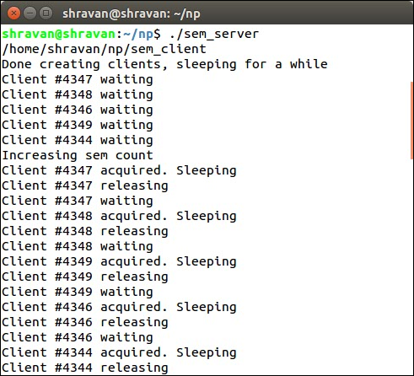

**Figure:Server**

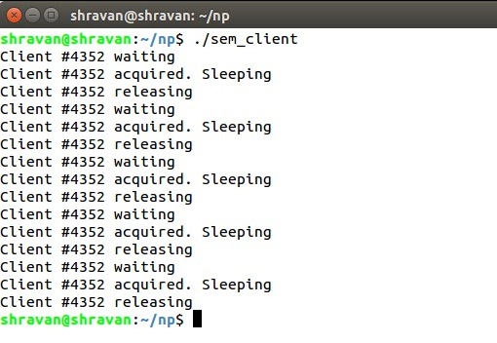

**Figure:Client**

**PROGRAM 10**

DNS Server to resolve a given host name:

**Program:**

#include<stdio.h>

#include<netdb.h>

#include<arpa/inet.h>

#include<netinet/in.h>

int main(int argc,char** argv)

{

char h_name;

int h_type;

struct hostent* host;

struct in_addr h_addr;

if(argc!=2)

{

fprintf(stderr,"USAGE:nslookup\n");

}

if((host=gethostbyname(argv[1]))==NULL)

{

fprintf(stderr,"(mini)nslookup failed on %s\n",argv[1]);

}

h_addr.s_addr=*((unsigned long*)host->h_addr_list[0]);

printf("\nIP ADDRESS=%s\n",inet_ntoa(h_addr));

printf("\nHOST NAME=%s\n",host->h_name);

printf("ADDRESS LENGTH=%d\n",host->h_length);

printf("ADDRESS TYPE=%d\n",host->h_addrtype);

printf("\nLIST OF ADDRESS=%s\n",inet_ntoa(h_addr_list[0]));

}

**Output:**

