NAME | Prakhar Gupta
UID | 2021300040
BATCH | C
SUBJECT | DAA
EXPERIMENT NO | 3
DATE OF PERFORMANCE | 27-02-2023
DATE OF SUBMISSION | 06-03-2023
AIM | To understand and implement Strassen’s Matrix Multiplication.
THEORY | Given two square matrices A and B of size n x n each, find their multiplication matrix.  Naive Method takes the Time Complexity of O(N3).  Divide and Conquer :  Following is a simple Divide and Conquer method to multiply two square matrices.  - Divide matrices A and B in 4 sub-matrices of size N/2 x N/2 as shown in the below diagram.  - Calculate following values recursively. ae + bg, af + bh, ce + dg and cf + dh.  Simple Divide and Conquer also leads to O(N3), can there be a better way?  In the above divide and conquer method, the main component for high time complexity is 8 recursive calls. The idea of Strassen’s method is to reduce the number of recursive calls to 7. Strassen’s method is similar to above simple divide and conquer method in the sense that this method also divide matrices to sub-matrices of size N/2 x N/2 as shown in the above diagram, but in Strassen’s method, the four sub-matrices of result are calculated using following formulae.  Time Complexity of Strassen’s Method  Addition and Subtraction of two matrices takes O(N2) time. So time complexity can be written as  T(N) = 7T(N/2) + O(N2)  Generally Strassen’s Method is not preferred for practical applications for the following reasons.  The constants used in Strassen’s method are high and for a typical application Naive method works better. For Sparse matrices, there are better methods especially designed for them.  The submatrices in recursion take extra space.  Because of the limited precision of computer arithmetic on non-integer values, larger errors accumulate in Strassen’s algorithm than in Naive Method.
ALGORITHM | - Start  - Declare two matrices A and B and take the values from the user.  - Find S1 to S10 using provided formulae.  - Find P1 to P7 using provided formulae.  - Find the elements of matrix C which is the multiplication of A and B.  - Print the result.
PROGRAM | #include<stdio.h>  #include<time.h>  void main()  {  int i,j;  int a[2][2],b[2][2],c[2][2];  int s[10],p[7];  clock_t start,end;  printf("\nEnter matrix A in order - a11, a12, a21, a22 : ");  for(i=0;i<2;i++)  {  for(j=0;j<2;j++)  {  scanf("%d",&a[i][j]);  }  }  printf("\nEnter matrix B in order - b11, b12, b21, b22 : ");  for(i=0;i<2;i++)  {  for(j=0;j<2;j++)  {  scanf("%d",&b[i][j]);  }  }  start=clock();  s[0]=b[0][1]-b[1][1];  s[1]=a[0][0]+a[0][1];  s[2]=a[1][0]+a[1][1];  s[3]=b[1][0]-b[0][0];  s[4]=a[0][0]+a[1][1];  s[5]=b[0][0]+b[1][1];  s[6]=a[0][1]-a[1][1];  s[7]=b[1][0]+b[1][1];  s[8]=a[0][0]-a[1][0];  s[9]=b[0][0]+b[0][1];  printf("\n");  for(i=0;i<10;i++)  {  printf("\nS%d = %d",(i+1),s[i]);  }  p[0]=s[0]*a[0][0];  p[1]=s[1]*b[1][1];  p[2]=s[2]*b[0][0];  p[3]=s[3]*a[1][1];  p[4]=s[4]*s[5];  p[5]=s[6]*s[7];  p[6]=s[8]*s[9];  printf("\n");  for(i=0;i<7;i++)  {  printf("\nP%d = %d",(i+1),p[i]);  }  c[0][0]=p[4]+p[3]-p[1]+p[5];  c[0][1]=p[0]+p[1];  c[1][0]=p[2]+p[3];  c[1][1]=p[4]+p[0]-p[2]-p[6];  printf("\n\nMatrix A =");  for(i=0;i<2;i++)  {  printf("\n");  for(j=0;j<2;j++)  {  printf("%d\t",a[i][j]);  }  }  printf("\n\nMatrix B =");  for(i=0;i<2;i++)  {  printf("\n");  for(j=0;j<2;j++)  {  printf("%d\t",b[i][j]);  }  }  printf("\n\nMatrix C =");  for(i=0;i<2;i++)  {  printf("\n");  for(j=0;j<2;j++)  {  printf("%d\t",c[i][j]);  }  }  printf("\n");  end=clock();  printf("Time taken = %lf\n",(double)(end-start)/CLOCKS_PER_SEC);  }
RESULT ( SNAPSHOT):

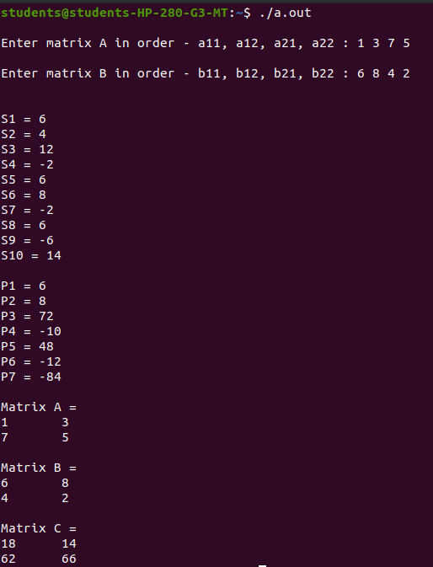

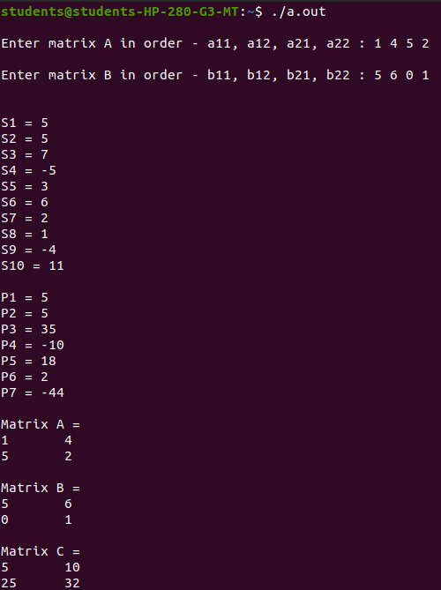

CONCLUSION :
With the help of this experiment, I was successfully able to understand and implement the concept of Strassen’s multiplication.

